
Title:
Subtitle:

Ramco Aviation Solution
Version 5.8
WorkSpace Configuration

DISCLAIMER
©2016 Ramco Systems Ltd. All rights reserved. All trademarks acknowledged.

This document is published by Ramco Systems Ltd. without any warranty. No part of this document may be reproduced or transmitted in any form or by any means, electronic or mechanical, for any purpose without the written permission of Ramco Systems Limited.
Improvements and changes to this text necessitated by typographical errors, inaccuracies of current information or improvements to software programs and/or equipment, may be made by Ramco Systems Limited, at any time and without notice. Such changes will, however, be incorporated into new editions of this document. Any hard copies of this document are to be regarded as temporary reference copies only.
The documentation has been provided for the entire Aviation solution, although only a part of the entire solution may be deployed at the customer site, in accordance with the license agreement between the customer and Ramco Systems Limited. Therefore, the documentation made available to the customer may refer to features that are not present in the solution purchased / deployed at the customer site.

Table of Contents

1.0 Steps to Enable Workspace in M&E Application 5

- Steps to Enable Workspace in M&E Application
- Ensure the component PortalMapping is mapped in deployment workbench using “adminuser” login credentials.

- In the Screen “Map Database Asset to Organization Units”, map the following two mandatory system workspaces.
- “PortalAdmin” workspace to AdminOU with primary database name as “PortalAdminDB”
- “VW_Workspace” workspace to be mapped to all OUs except AdminOU. Primary database name as should be given as respective OUs Database Name specified in “Map to Resource Manager” screen

- Map the user workspaces required to be applicable OU and primary database name.

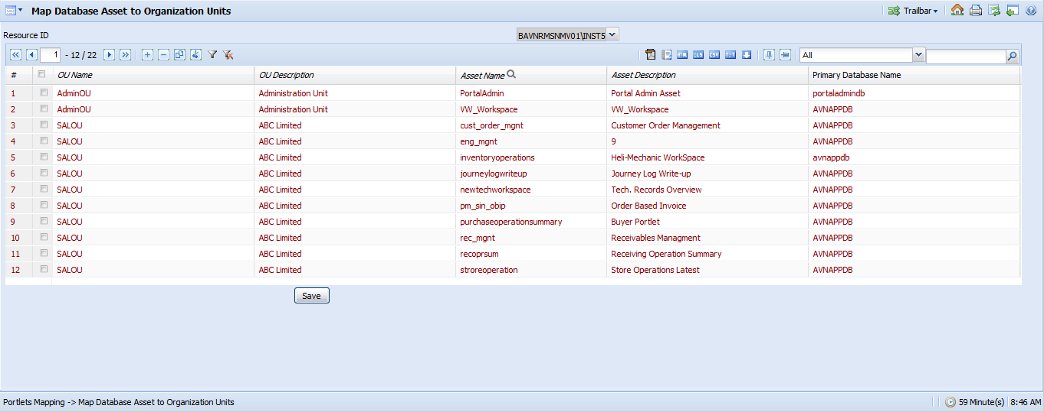

- Using the screen “Portlets Mapping -> Specify Portlets Permissions”, map the user workspaces to required ROLE and OU as specified in the below screenshot.
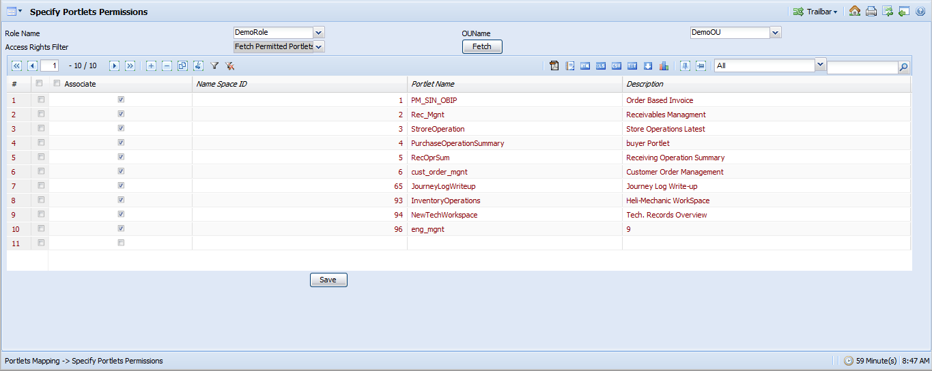

- Ensure following parameters are set to “True” in ApplicationSettings.js file available under the folder …\IIS\ExtUi

usePdkAsDefaultPage = true;
pdkBannerCollapse = true;
bannerCollapse = true;
hideToolBarsForPortal = true;
If above mentioned parameters are not available, add the same and set it to “True”

- Value for the ChartSchemaPath key needs to be changed in Portal.config available under …\VirtualWorks\IIS of WEB Server.
<!-- Folder Path of Fusion Chart Schema Xml file [FusionChart_Schema.xml]-->
<add key="ChartSchemaPath" value="E:\Program Files (x86)\VirtualWorks\IIS"/>
And also ensure that the file named “FusionChart_Schema.xml” is available under …\VirtualWorks\IIS of WEB Server.
- Following settings are required for Finance and Sales related Workspaces
Order based invoice -> There is an user preference table for order based invoice workspace. Ref # Table : role_preference_dtl.
The following information to be populated for the login user to get the data in workspace - Supplier

Sample Scripts:
insert into role_preference_dtl
(ou_id, role, parameter_category, parameter_code, parameter_text )
(Available OU ids, Available role, 'ROLESUPP', 'SUPPLIER', Valid Supplier code)

Receivables -> There is an user preference table for receivables workspace. Ref # Table : role_preference_dtl.
The following information to be populated for the login user to get the data in workspace - Customer
Sample Scripts:
insert into role_preference_dtl
(ou_id, role, parameter_category, parameter_code, parameter_text )
(Available OU ids, Available role, 'ROLECUST', 'CUSTOMER', Valid customer code)

- Once all the above steps are done, Generate and Deploy Config Dlls in WEB and APP servers.

Corporate Office and R&D Center
Ramco Systems Limited,
64, Sardar Patel Road, Taramani ,
Chennai – 600 113, India
Office + 91 44 2235 4510 / 3090 4000
Fax +91 44 2235 2884
Website - www.ramco.com

