

Ramco Aviation Solution
Version 5.8
Task Level Security Implementation

DISCLAIMER
©2016 Ramco Systems Ltd. All rights reserved. All trademarks acknowledged.

This document is published by Ramco Systems Ltd. without any warranty. No part of this document may be reproduced or transmitted in any form or by any means, electronic or mechanical, for any purpose without the written permission of Ramco Systems Limited.
Improvements and changes to this text necessitated by typographical errors, inaccuracies of current information or improvements to software programs and/or equipment, may be made by Ramco Systems Limited, at any time and without notice. Such changes will, however, be incorporated into new editions of this document. Any hard copies of this document are to be regarded as temporary reference copies only.
The documentation has been provided for the entire Aviation solution, although only a part of the entire solution may be deployed at the customer site, in accordance with the license agreement between the customer and Ramco Systems Limited. Therefore, the documentation made available to the customer may refer to features that are not present in the solution purchased / deployed at the customer site.

Prepared by: | Karthik R
Designation: | Manager
Date: | 07th Mar 2012
Location: | RSL, Chennai

Revision History
Version | Date | Author | Description
1.0 | 07/Mar/2012 | Karthik | Created

Task Level Security - Implementation

Task Level Security is a provision by which the application administrator can enable / disable permissions for the users at every task level. Permissions can be set for the tasks of types: Submit, Trans and Link. This feature can be enabled by setting the value for Security flag to “ON” while generating the AppConfig DLL through Config Generator.

A new screen – Revoke Task Privileges has been implemented which will help the application administrator to map those tasks for which the user should not have access to for a given Role – OU combination. This screen will be available under the Implementation Component.

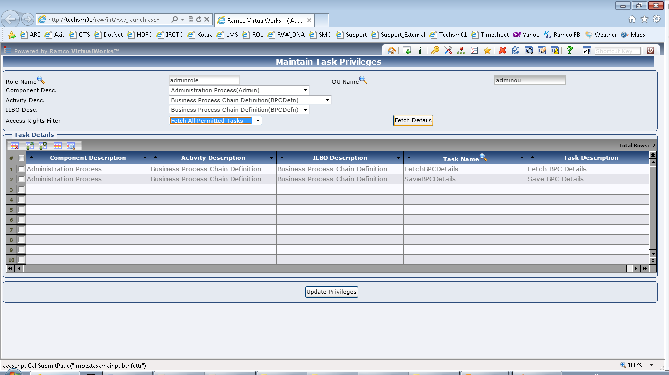

In the above screen, select the Role and OU combination, Component, Activity and ILBO. Choosing a value from the Access Rights filter combo will fetch the rows according to the value chosen. Choosing the value “Fetch Details” will fetch all the tasks (for the selected Role-OU-Component-Activity-ILBO) for which the user has access to and vice versa.

The data that is saved in this screen will be saved in the table fw_admin_role_activity_task. Any task that finds an entry in this table would mean that all the users mapped to the Role-OU combination (for which that task is mapped under) will not have permission to access and will get an error “You are not authorized to execute this task”. User will be able to provide or revoke permissions only for those tasks of type Link, Trans and Submit. Permissions for all other task types will be allowed for all Role / OU combinations by default.

Follow the table given below for various types of operations possible through this screen:

# | Value in Access Rights Combo | Action Performed | Behavior
1. | Fetch Permitted Activities | User selects a row and saves. | The selected row will be inserted into fw_admin_role_activity_task.
2. | Fetch Permitted Activities | User selects a row, deletes it and saves. | No action will happen.
2. | Fetch Permitted Activities | User selects a row, deletes it and saves. | No action will happen.
3. | Fetch Permitted Activities | Take Help on Task from the multiline and transfer a any row and click on Save. | The selected row (if exists in the table fw_admin_role_activity_task) will be deleted.
4. | Fetch UnPermitted Activities | User selects a row and saves. | The selected row will be deleted from fw_admin_role_activity_task.
5. | Fetch UnPermitted Activities | User selects a row, deletes it and saves. | The selected row will be deleted from fw_admin_role_activity_task.
6. | Fetch UnPermitted Activities | Take Help on Task from the multiline and transfer a any row and click on Save. | The selected row (if not exists in the table fw_admin_role_activity_task) will be inserted.

The fix will also include an SP (fw_imp_taskdetails_update.sql) which should be run only once on any environment where Task Level Security is enabled. This SP takes one parameter (@tasklevelsec_flag). The batch file which applies this feature on any environment will just compile this SP. It is up to the application administrator to execute this SP. The parameter to this SP would be either ON or OFF depending on whether the Task Level Security feature is implemented for that setup or not. Running this SP on an environment where Task Level Security feature is enabled, will delete all the existing rows from the table fw_admin_role_activity_task and insert its mutually exclusive set of rows in to the same for all Role / OU combinations.

More importantly, if this feature is deployed on an environment where Task Level Security is currently ON, it is mandatory to immediately execute the SP fw_imp_taskdetails_update to alter the existing data in the fw_admin_role_activity_task. If this SP execution is not done, then system will thrown errors for all the existing tasks which are mapped to any Role / OU combination.

- End of Document -

Corporate Office and R&D Center
Ramco Systems Limited,
64, Sardar Patel Road, Taramani ,
Chennai – 600 113, India
Office + 91 44 2235 4510 / 3090 4000
Fax +91 44 2235 2884
Website - www.ramco.com

