

Ramco Aviation Solution
Version 5.8
DW-Manual Deployment- Steps
DISCLAIMER
©2016 Ramco Systems Ltd. All rights reserved. All trademarks acknowledged.

This document is published by Ramco Systems Ltd. without any warranty. No part of this document may be reproduced or transmitted in any form or by any means, electronic or mechanical, for any purpose without the written permission of Ramco Systems Limited.
Improvements and changes to this text necessitated by typographical errors, inaccuracies of current information or improvements to software programs and/or equipment, may be made by Ramco Systems Limited, at any time and without notice. Such changes will, however, be incorporated into new editions of this document. Any hard copies of this document are to be regarded as temporary reference copies only.
The documentation has been provided for the entire Aviation solution, although only a part of the entire solution may be deployed at the customer site, in accordance with the license agreement between the customer and Ramco Systems Limited. Therefore, the documentation made available to the customer may refer to features that are not present in the solution purchased / deployed at the customer site.

Manual Settings in Report Configuration

- Deploy the file named "arc.bmp" manually into the folder ...\Ramco DecisionWorks\DW\DW_REFACTOR\Report Files

- Manual Settings for Ramco Advanced Reports

Configure the M&E server details DEPDB against the datasource name “VW_DEPDB” in Decision Works Application. This is required for launching the reports from M&E Application.

Steps
~~~~~
    - Login into Decision Works application as admin.
    - Goto Configure -> Datasource Definitions -> Datasource in the Menu Bar.
    - Add new DataSource in the name VW_DEPDB and click in Help Icon in the Settings column.
    - Provide the M&E RM Server details with Database/Service ID as DEPDB.
    - Click on OK and Save button to save the newly created datasource.

- For enabling the DW Launch in M&E Application, following parameters to be modified in the web.config file available under ..\IIS
<add key="DWVirtualDirName" value="<DWVirtualDirectory>" />
<add key="DWPortNo" value="<PortNo>" />
<add key="DWServerName" value="<DWServerName>" />
<add key="EnableRDW" value="Y">
(E.g)
<add key="DWVirtualDirName" value="reimsweb" />
<add key="DWPortNo" value="80" />
<add key="DWServerName" value="avnbl01" />
<add key="EnableRDW" value="Y">
Please create the respective logins in RDW Application to launch DW Application Dashboard from M&E Application. Provide necessary access rights for the logins created.

- For defining company specified report logos, please follow the below steps:
Step 1 : Save your company logo in the name of your company code (example : your company name XYZ means your logo name should be XYZ )
Step 2 : Add this file into below mentioned Path
Step 3 : Ensure that your logo should be in .BMP Format
Report Logo files should be deployed under the folder ...\Ramco DecisionWorks\DW\DW_REFACTOR\ReportFiles of DecisionWorks Web Server.
Save Company logo as name of reportlogo.bmp add the same into above mentioned path

5. Steps to Configure Excel Report:

Step: 1
Go to Deployment process-> Report Customisation Component -> Report Configuration Component and Click the link Report configuration definition.
Step: 2
Select mode as Add and select below values
Component name -> Flight log,
Activity -> Generate flight summary report,
User interface -> Flight summary report
Step: 3
Select the Activity and Task under Task Details Multiline.
Step: 4
Select the applicable role and organization unit under Role and Organisation Unit mappings multiline.
Step: 5
Enter the report configuration details (Available in Report configuration default values screen)

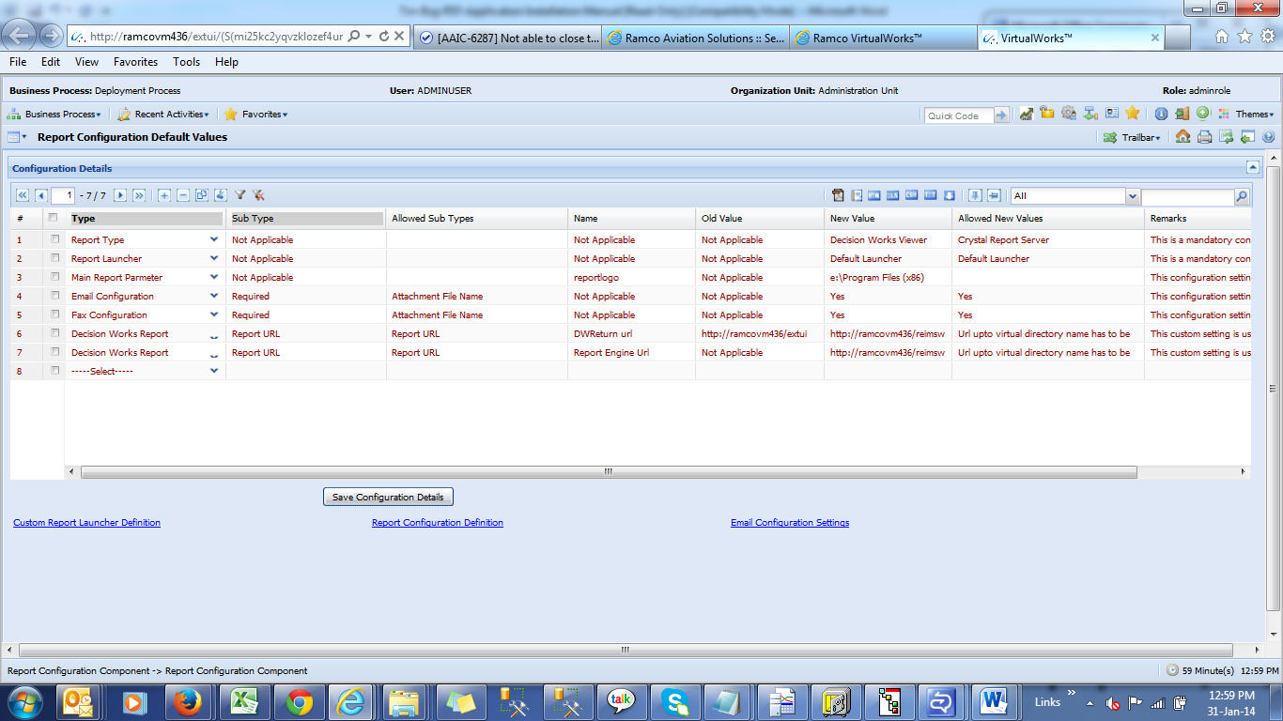

Enter the Report type new value as “Decision Works Excel” and save the details.

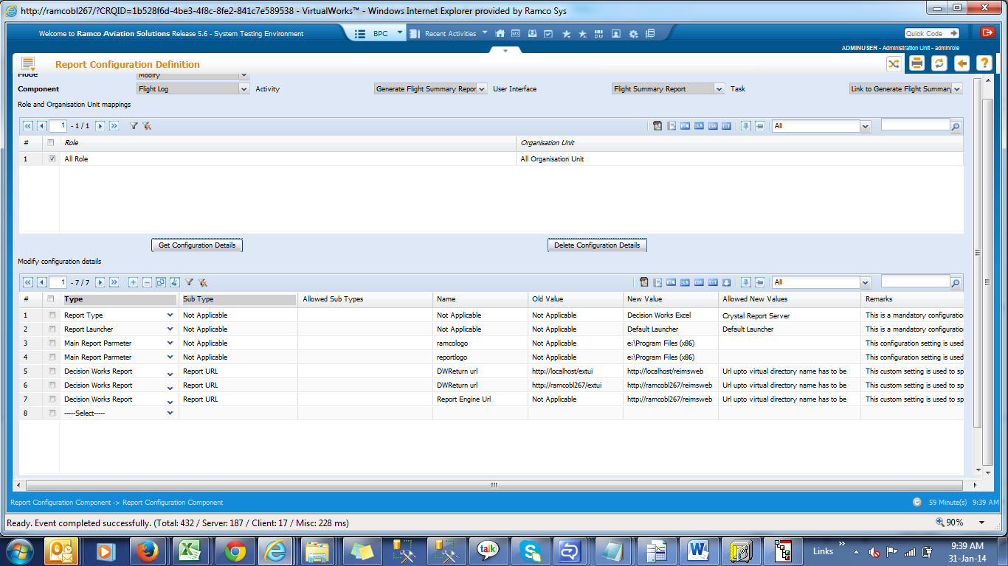
Report type - Value should be set as Decision Works Excel

2. ER Data Source Change

- Configure →Data source Definitions → Data Source
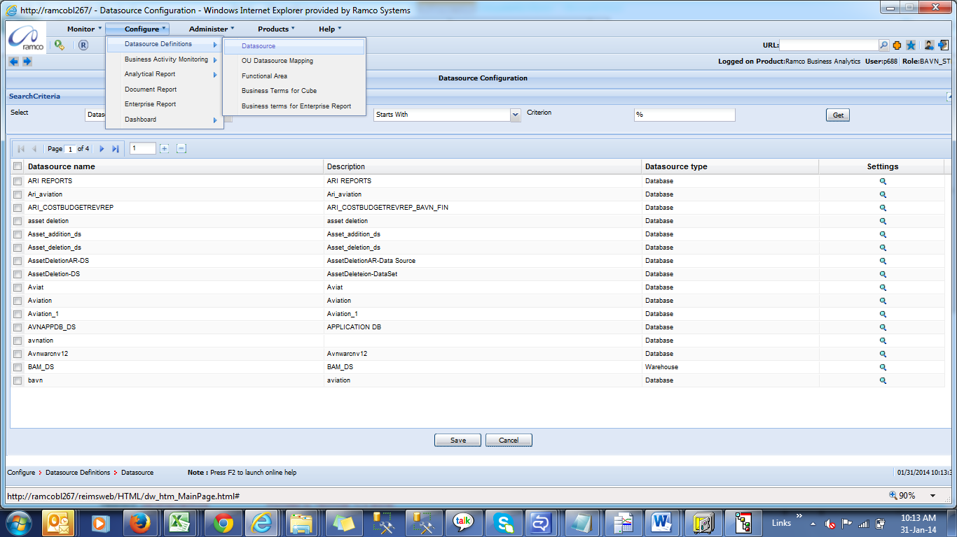

- Click on Get to list all the data sources
- Select the AVNAPPDB_DS data source and click on the Lens Icon in the Settings column.

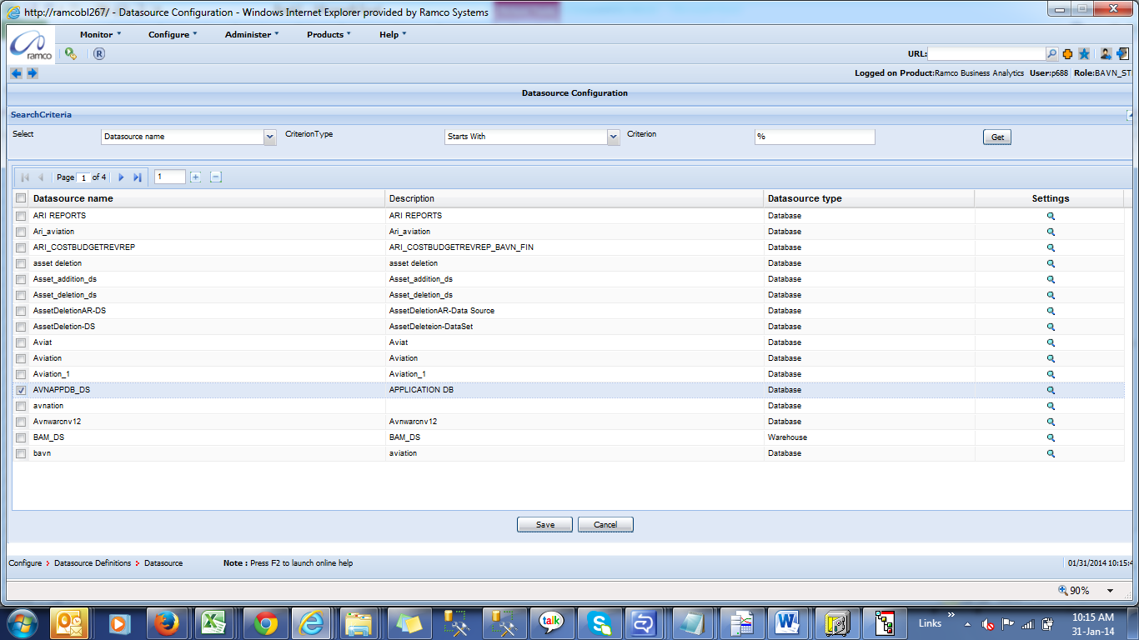

The following screen is launched
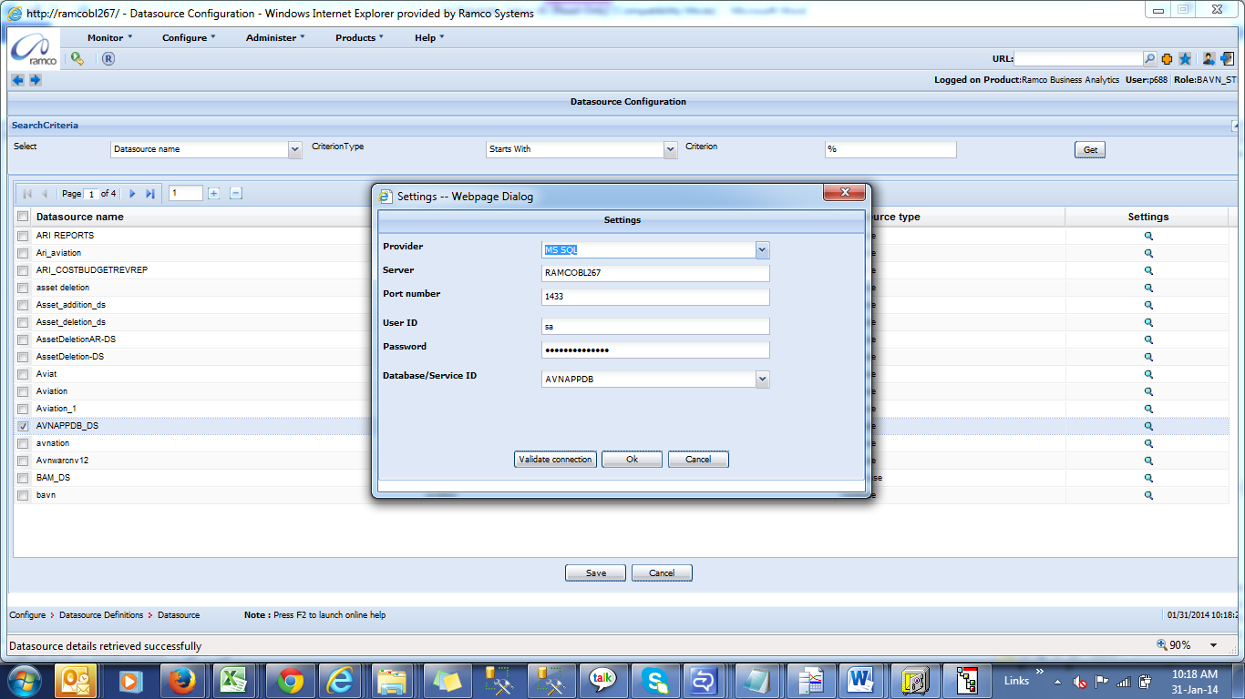

- Specify values for the following
Provider: MS SQL
Server : <Database Server>
Port number: SQL Server Port Number
User ID: SQL Username
Password: SQL Username’s Password
Database / Service ID: Application Database (e.g.) AVNAPPDB

- Click on “Validate Connection” and Click OK.

- Click on save button to save the data sources.

6. Steps to Configure ARI
- Import the AR deliverables in the respective server
- (http://<webservername>/reimsweb)
- Go to Configure →Data source Definitions → Data Source
- Click on Get to list all the data sources
- Select the Smn_Stk_Inquiry_ARI_Rpt_SP_DS data source and click on the Lenses Icon in the Settings column
- Specify values for the following
  - Provider as MSSQL
  - Server as Local host
  - Port number as respective server Port number
  - User ID
  - Password
  - Database / Service ID (RM server and database (Avnappdb) details)
  - Click on “Validate Connection” and Click OK
- Go to Configure →Data source Definitions → Data Source
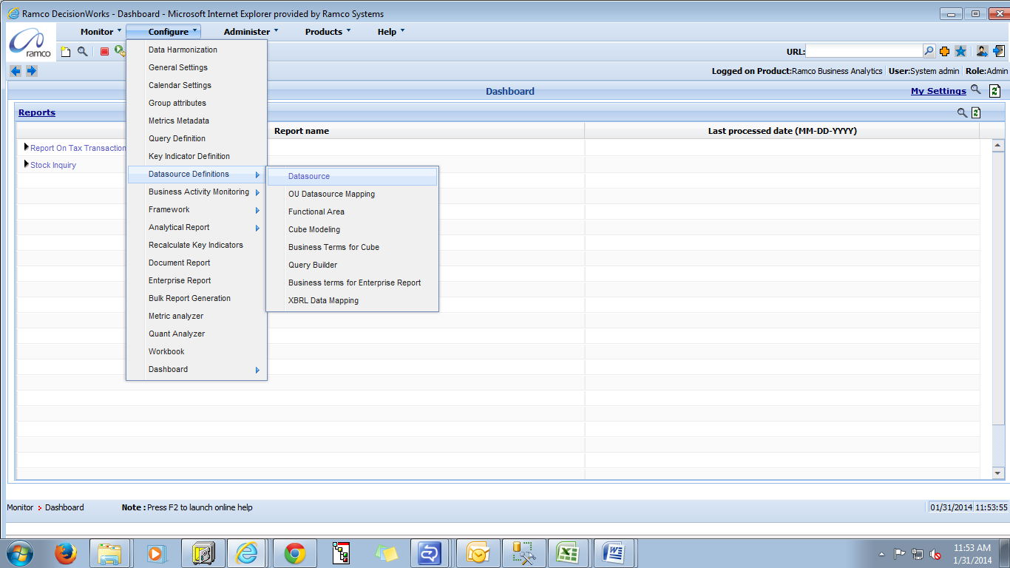

- Click on Get to list all the data sources
- Select the Smn_Stk_Inquiry_ARI_Rpt_SP_DS data source and click on the Lenses Icon in the Settings column

- Specify values for the following
  - Provider as MSSQL
  - Server as Local host
  - Port number as respective server Port number
  - User ID
  - Password
  - Database / Service ID (RM server and database (Avnappdb) details)
  - Click on “Validate Connection” and Click OK
Security Mapping for New Analytic Reports
Enabling Security Mapping for New Analytic Reports
- Select the Security mapping menu option from the Administer menu
- Enter the user id in search Criterion
- Click the Get button to fetch the required details.
- Click on the Lenses Icon in the Settings column for respective user
- Expand the tree product → Ramco Business Analytics → Module→Configure →Screen →Report design →Stock inquiry ARI Report →Data → Stock Inquiry
For Enabling Security Mapping for Analytic Report from Dashboard
- Expand the tree product → Ramco Business Analytics → Module → Screen→ Analytic Report → Stock inquiry ARI Report →data → Stock Inquiry

- Click Save button

- Please find the below screen shot
- Select the Security mapping menu option from the Administer menu
- Enter the user id in search Criterion
- Click the Get button to fetch the required details.
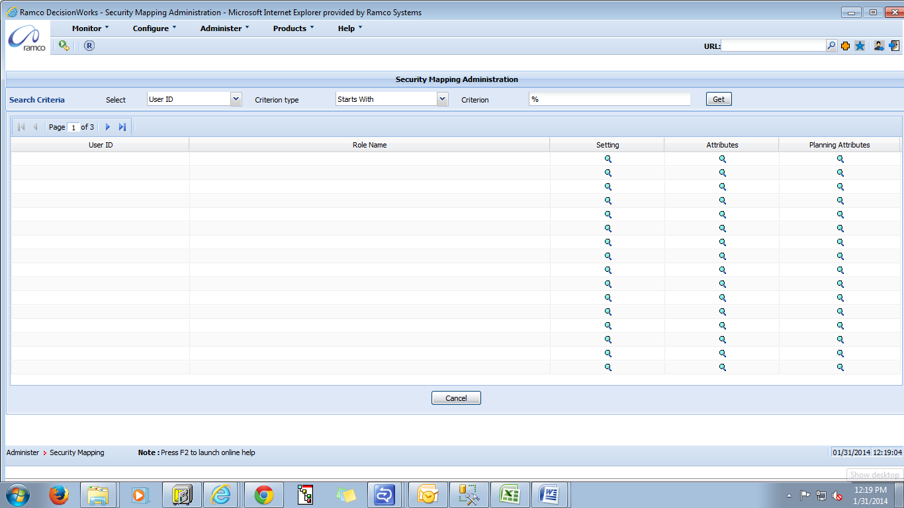

- Click on the Lenses Icon in the Settings column for respective user
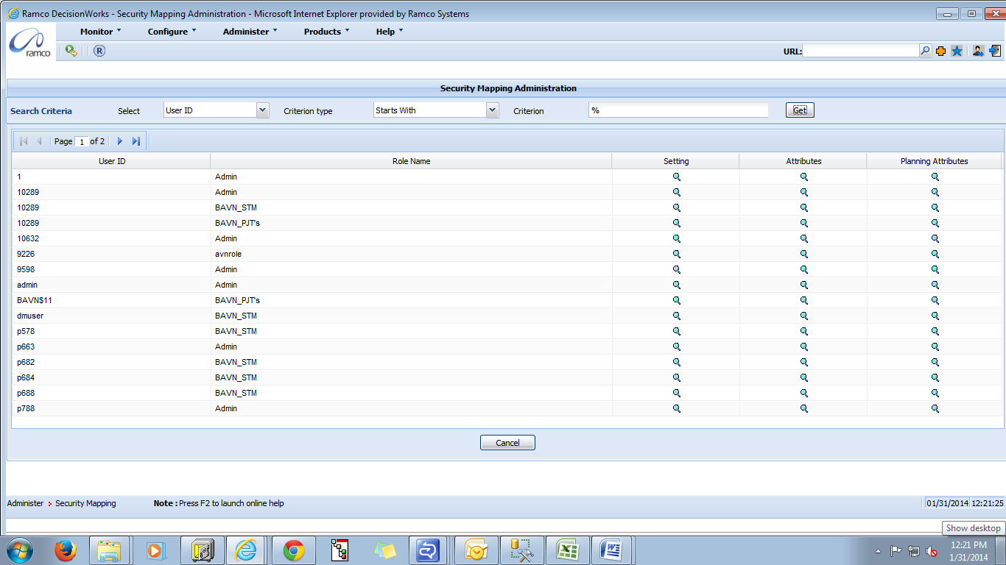

- Expand the Tree
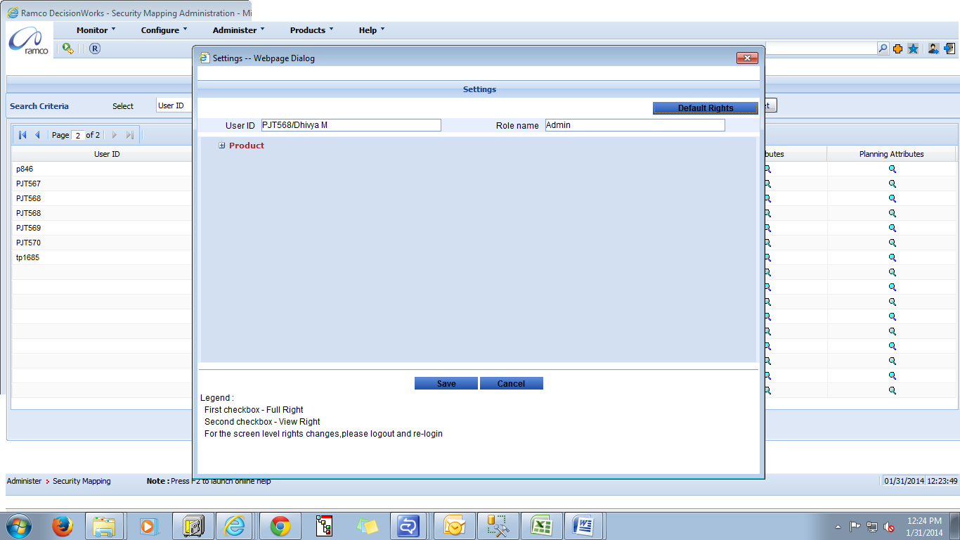

- Expand the tree product → Ramco Business Analytics → Module→Configure →Screen →Report design →Stock inquiry ARI Report →Data → Stock Inquiry

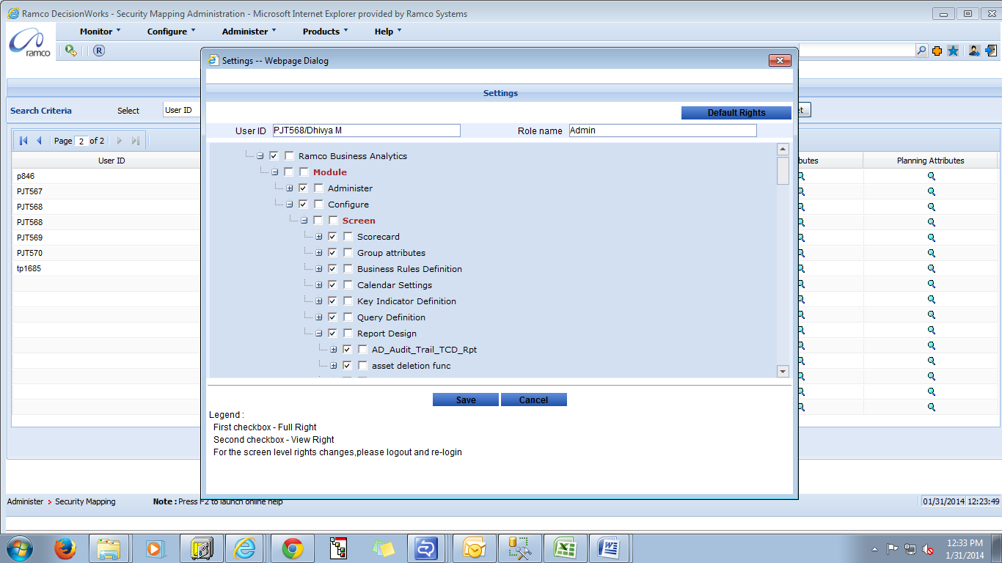

For Enabling Analytic Report from Dashboard Security Mapping
- Expand the tree product → Ramco Business Analytics → Module → Screen→ Analytic Report → Stock inquiry ARI Report →data → Stock Inquiry
- Click Save button

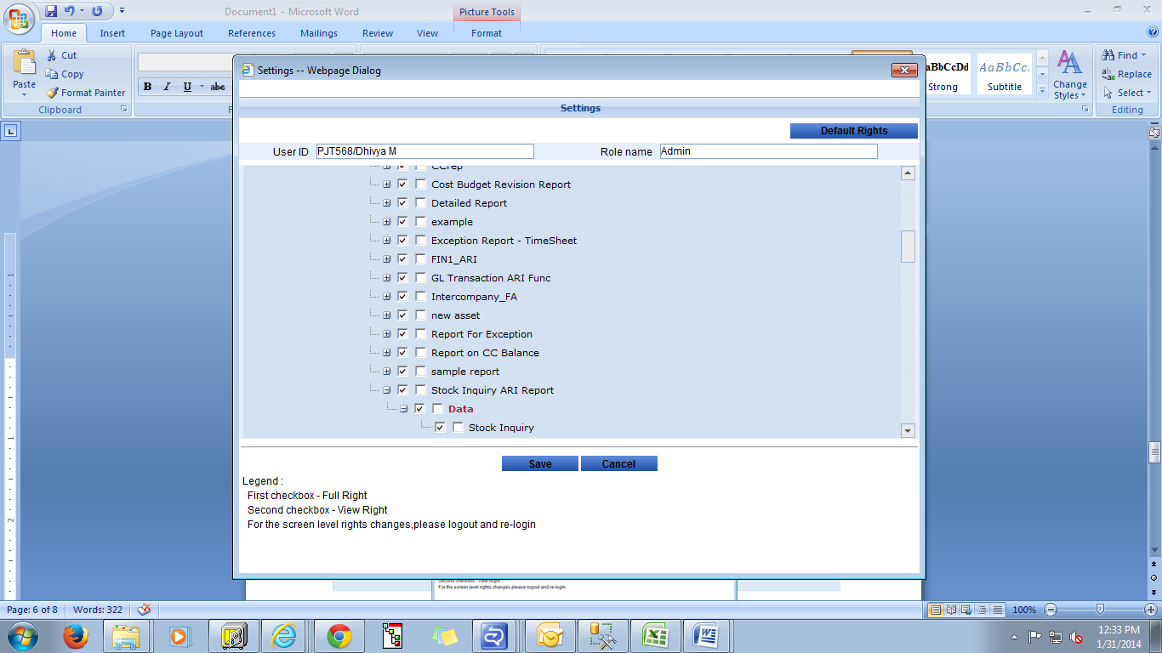
Note:
- Click the first check box next to the group to assign full access control to the user. This indicates that the user has permissions to carry out add, modify and delete operations for the selected Report.
- Click the second next to the group check box to assign view only permission to the user.
- Click this tick box based on user access
For Analytic Report from Dashboard
- Select the Dashboard menu option from the Monitor menu
- Click on report link
- Expand the tree Report → Analytic Report → Stock inquiry ARI Report → Stock Inquiry
- Click this tick box and save
Please find the below screen shot for reference
- Select the Dashboard menu option from the Monitor menu
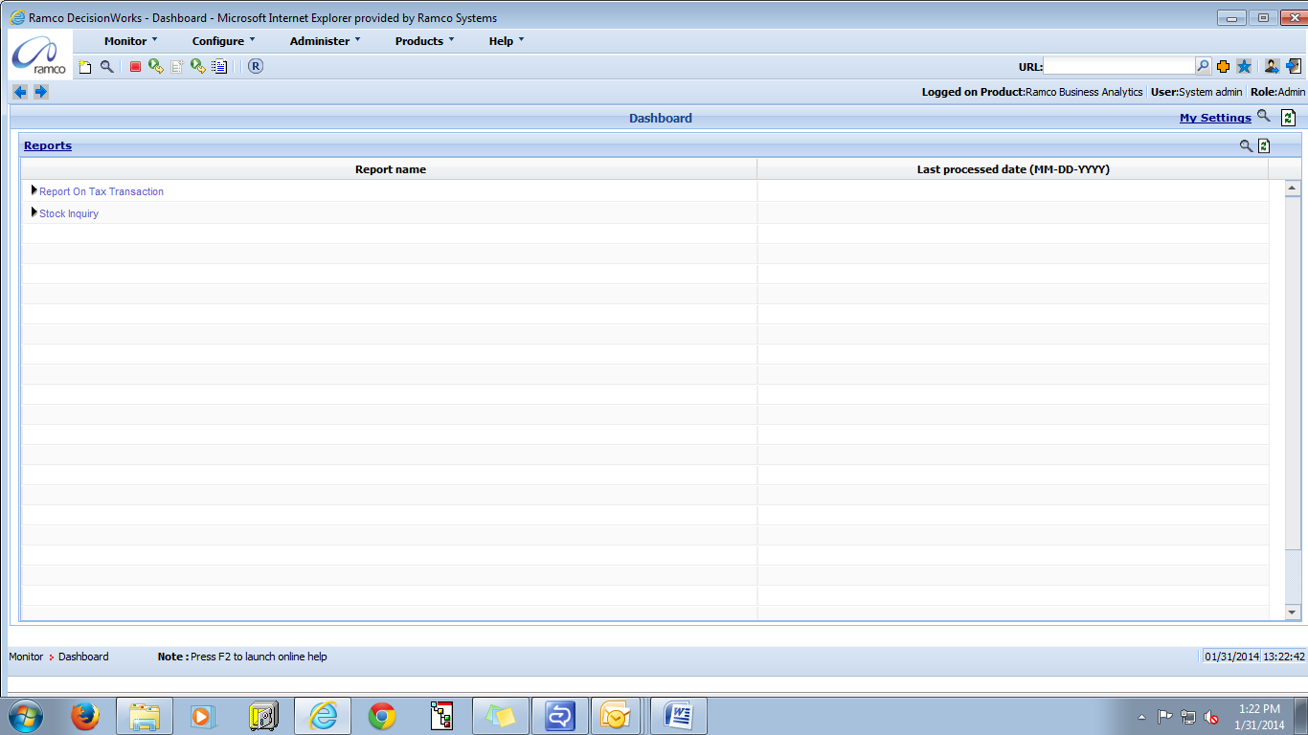

- Click on Report link
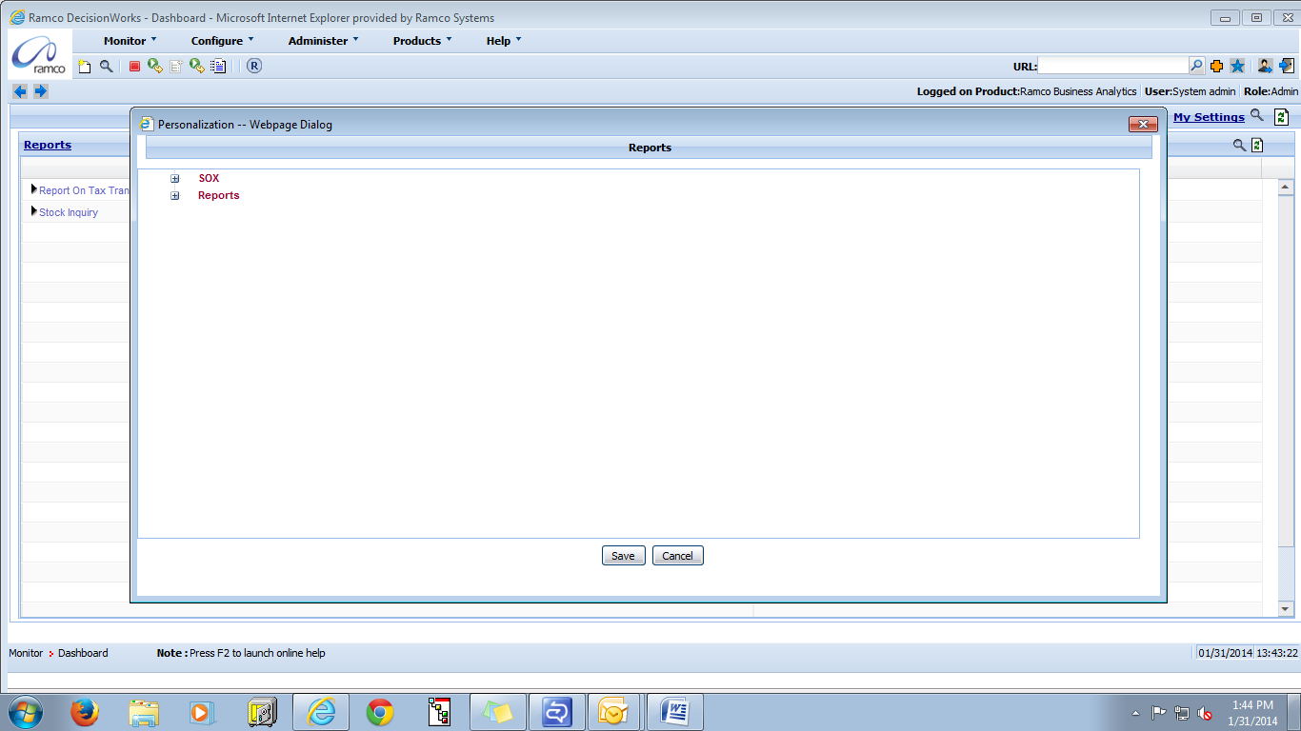

- Expand the Tree Report → Analytic Report → Stock inquiry ARI Report → Stock Inquiry Click this tick box and save
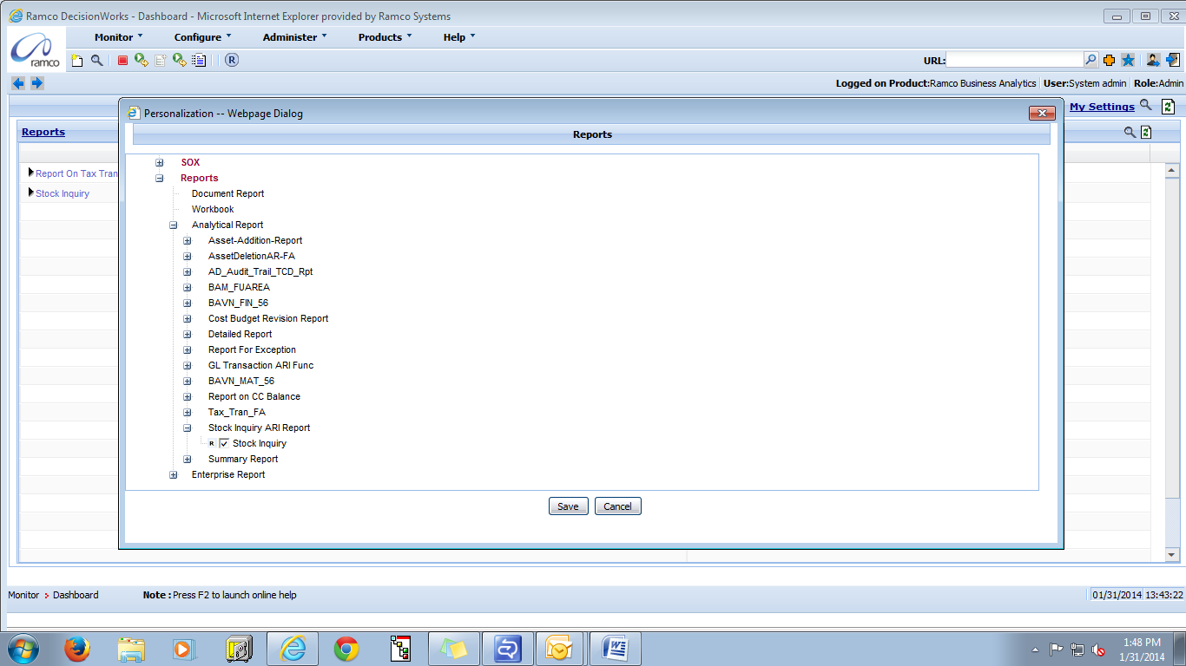

To map Dimensions and Measure for User ID and Role for Analytic Report
- Select the Analytic Report menu option from the Configure menu
- Enter the Stock inquiry in search Criterion
- Click the Get button to fetch the required details.
- Click on the Stock inquiry
- Provide note, click on save button and click next button
- In BT mapping tab select analysis name save it and click on next button
- Provide security mapping for dimensions and measures for roles and user column for respective user and click cancel button for exit

Screen shot for your reference
- Select the Analytic Report menu option from the Configure menu
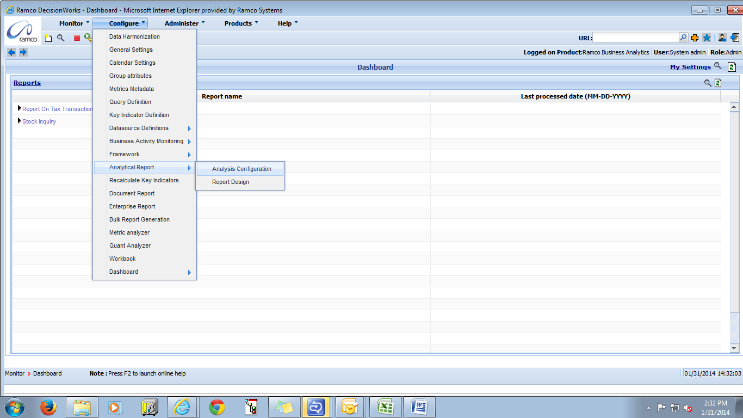
- Enter the Stock inquiry in search Criterion
- Click the Get button to fetch the required details.
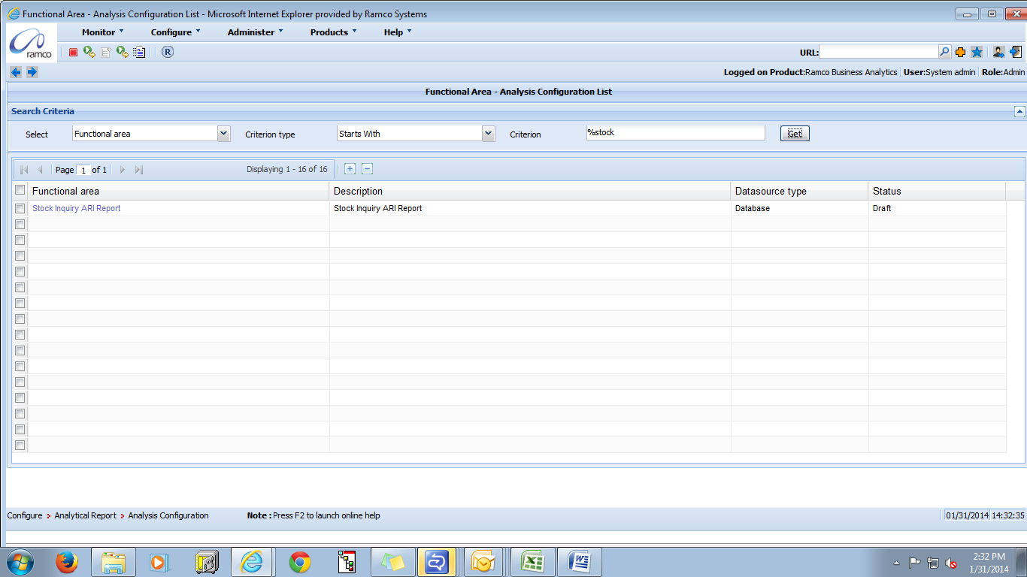

- Click on the Stock inquiry
- Provide note, click on save button and click next button
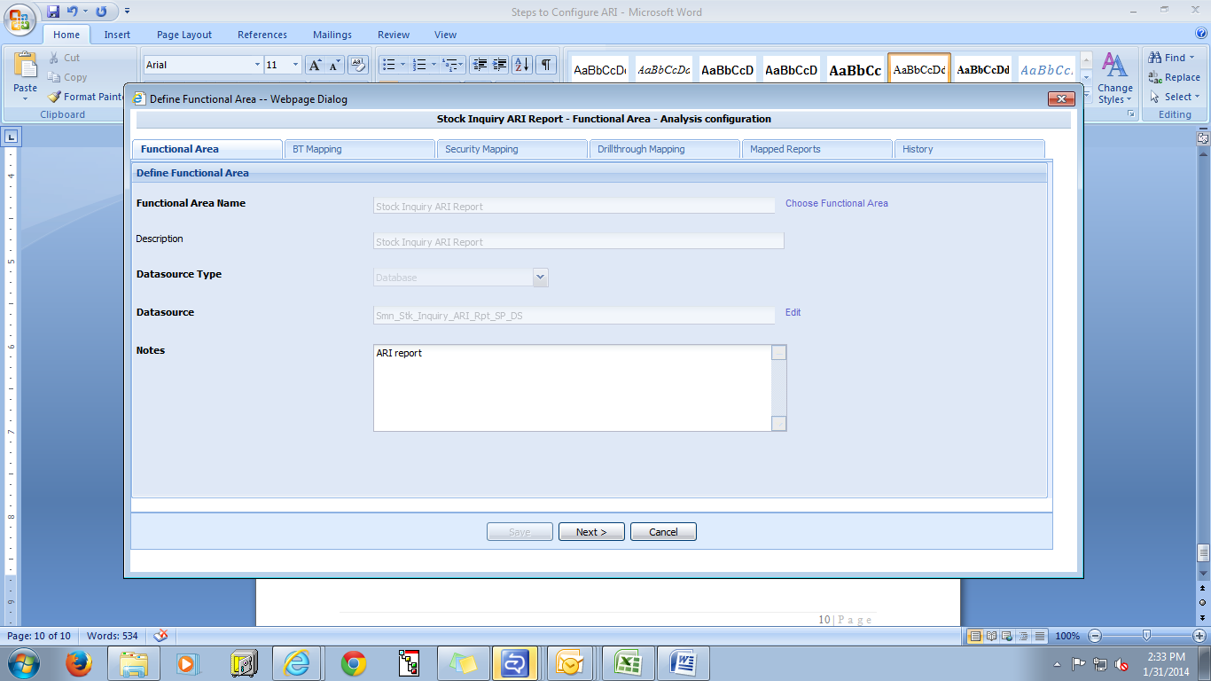
- In BT mapping tab select analysis name save it and click next button
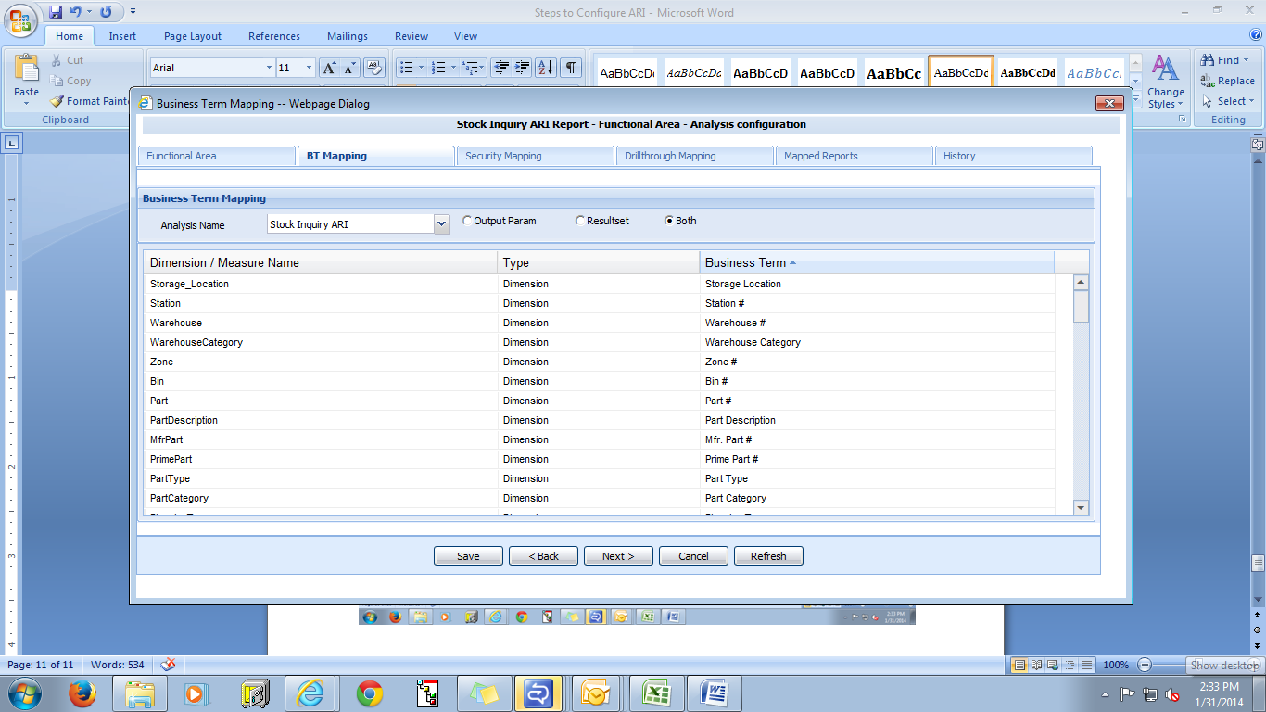

- Provide security mapping for dimensions and measures for roles and user column for respective user and click cancel button for exit
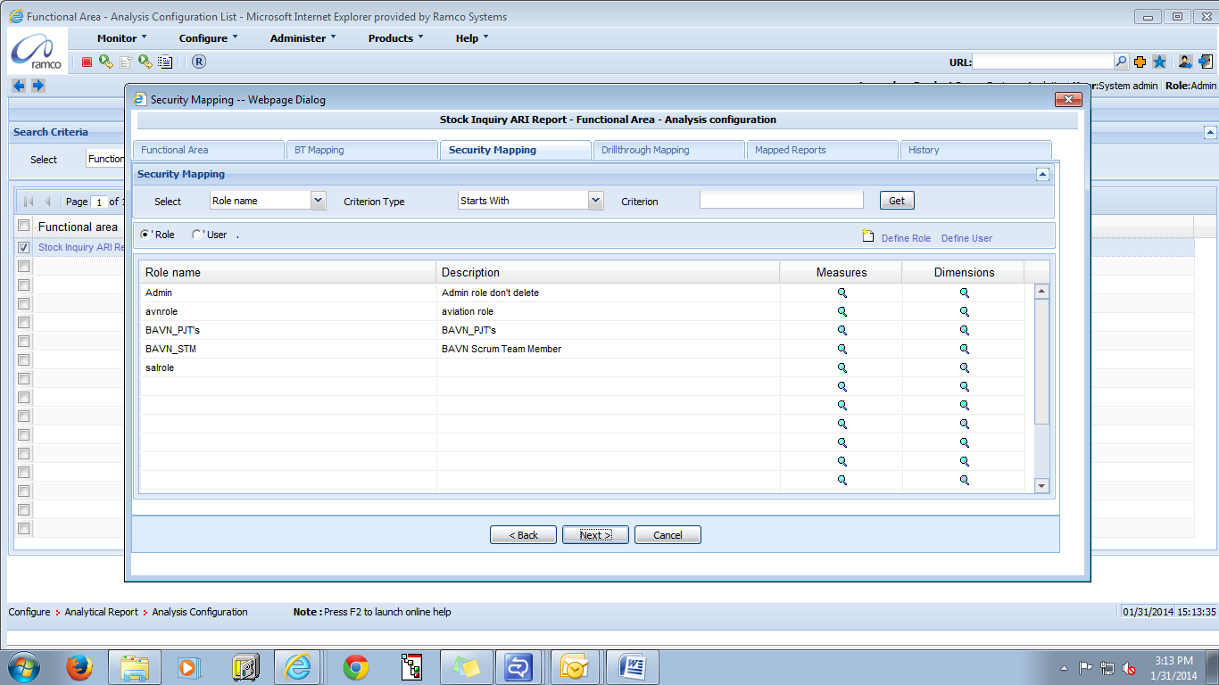

Configuration to Export data from Analytic Report
- While publishing report need to check user button
- System will fetch respective user then click on Access to export data box to Export data from Analytic Report and then click publish button
Screen shot for your reference
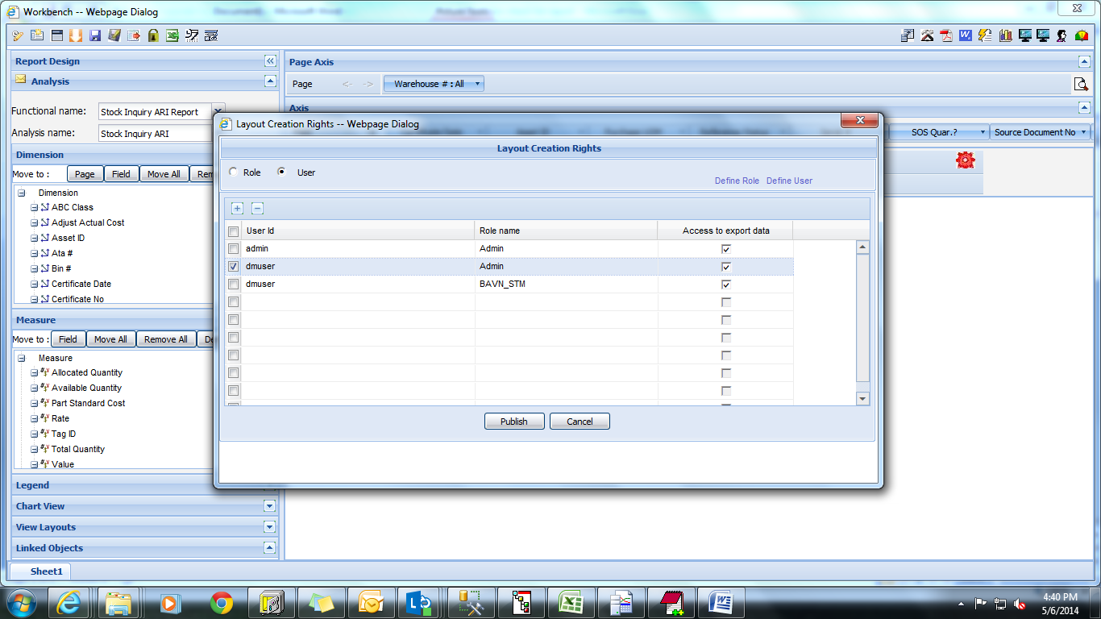

Corporate Office and R&D Center
Ramco Systems Limited,
64, Sardar Patel Road, Taramani ,
Chennai – 600 113, India
Office + 91 44 2235 4510 / 3090 4000
Fax +91 44 2235 2884
Website - www.ramco.com

