Application Supplementary Configurations

DISCLAIMER
©2012 Ramco Systems Ltd. All rights reserved. All trademarks acknowledged.

This document is published by Ramco Systems Ltd. without any warranty. No part of this document may be reproduced or transmitted in any form or by any means, electronic or mechanical, for any purpose without the written permission of Ramco Systems Limited.
Improvements and changes to this text necessitated by typographical errors, inaccuracies of current information or improvements to software programs and/or equipment, may be made by Ramco Systems Limited, at any time and without notice. Such changes will, however, be incorporated into new editions of this document. Any hard copies of this document are to be regarded as temporary reference copies only.
The documentation has been provided for the entire Aviation solution, although only a part of the entire solution may be deployed at the customer site, in accordance with the license agreement between the customer and Ramco Systems Limited. Therefore, the documentation made available to the customer may refer to features that are not present in the solution purchased / deployed at the customer site.

Table of Contents
1.0 Introduction 4
2.0 MIME Settings 4
3.0 SQL Database Mail 6
4.0 Reliability Analysis Report Settings 13
5.0 Non RVW Report Settings 24
6.0 Email & Fax Integration 24
6.1 Email Interface 24
6.2 Fax Interface 28
7.0 Reports 35
8.0 Manage Consolidated Financial Statements Package 42
9.0 Automatic Material Movement Document (AutoMMD) Printing 42
10.0 Barcode Label Printing 48
11.0 Ezee View 54
12.0 MCR Status Report Client Settings 54
13.0 Netronics Client Settings 54
14.0 Object Attachments Settings 55
15.0 Schedulers to be configured 59
16.0 Scripts to be run 62
17.0 Synonym Scripts deployment 63
18.0 MDCF Settings 64
19.0 Planning Board Client Level Settings 67
20.0 Favorite Activities Settings 69
21.0 Paper Size Settings for Reports 69

1.0 Introduction
This installation guide provides necessary guidelines and steps that have to be followed for configuring the supporting utilities for Ramco Aviation application suite in Server and Client machines
This comprises the following configurations:
- Server side settings
- MIME Settings (Web Server)
- SQL Database Mail (RM Server)
- Reliability Analysis Reporting Tool Setup
- Non RVW Reports Settings (Web Server)
- Email & Fax Integration (Web Server)
- Reports ((Web Server)0
- Manage Consolidated Financial Statements Package
- Automatic Material Movement Document (AutoMMD) Settings (Web Server & RM Server)
- Bar Code Label Printing
- Ezee View
- MDCF Settings

- Client side Settings
- MCR Status Report Client Settings
- Netronics Client Settings
- Object attachment Client Settings

- Others

- Schedulers to be configured
- Scripts to be run
- Synonym Scripts deployment

MIME Settings
Go to Internet Information Services (IIS) Manager, Select Extui virtual directory under Default Websites section.

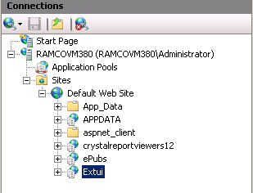

In Extui Home Page in IIS select Group Type as Area. Under IIS tab right click MIME Types and select Open Feature option.
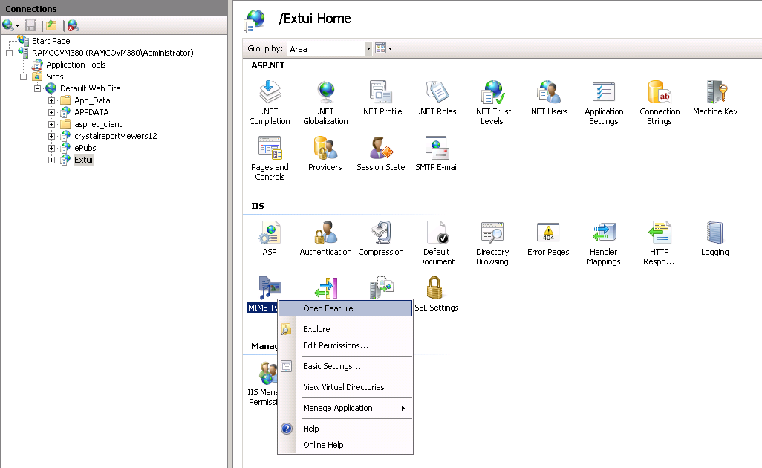

Right click and add
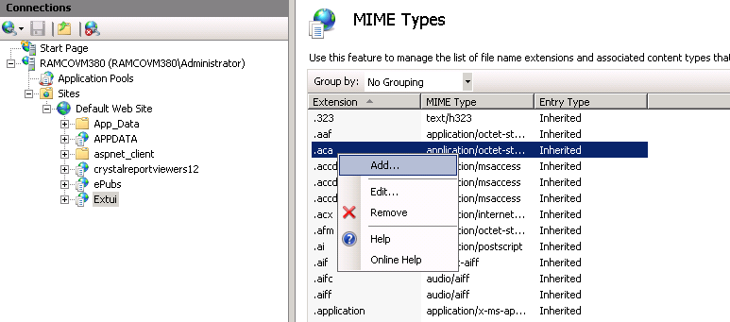

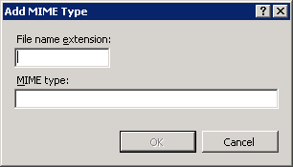

(1) Give File name extension as .ini and MIME type as text/xml
(2) Give File name extension as .ifd and MIME type as text/xml
(3) Give File name extension as .mpt and MIME type as application\vnd.ms-project

SQL Database Mail
To enable workflow alert mails from the Ramco Aviation Application, SQL Database mail should be enabled in the RM (Database) Server.
Steps for Configuring a Database Mail :-
Prerequisite: SMTP Port 25 should be enabled in the database server.
- Connect SQL Server 2008 through SQL Server Management Studio (SSMS)
- Open a blank window and run the following scripts
USE Master
GO
sp_configure 'show advanced options', 1;
GO
RECONFIGURE;
GO
sp_configure 'Database Mail XPs', 1;
GO
RECONFIGURE
GO

- In the left pane, go to <ServerName>→ Management →Database Mail
- Double Click “Database Mail” as highlighted in the below screenshot
- A configuration wizard will be open as shown in the below screenshot

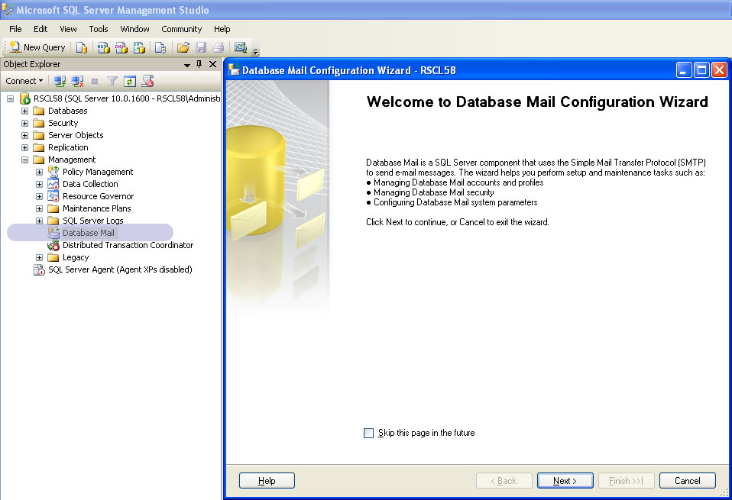

- Click Next

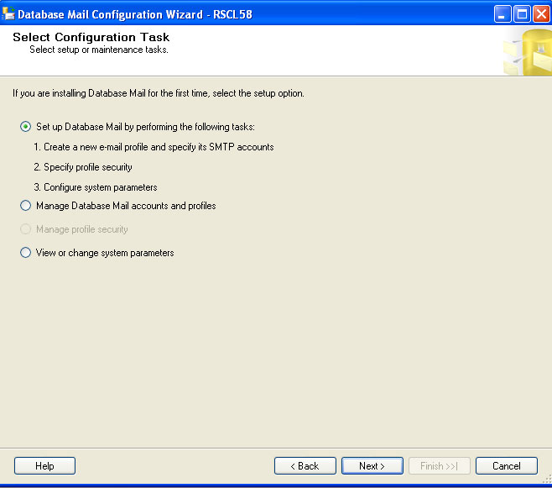

- A new profile will be open, as shown in the below screenshot

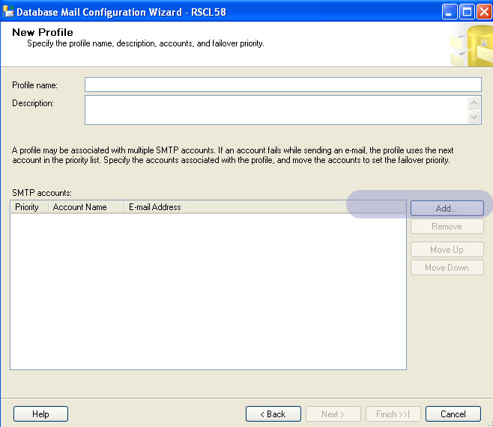

- Provide Profile Name and Click Add in the SMTP Accounts
- In the window opened, provide Account Name, Email Address, Servername as shown in the below screenshot. Retain default values for all other fields.

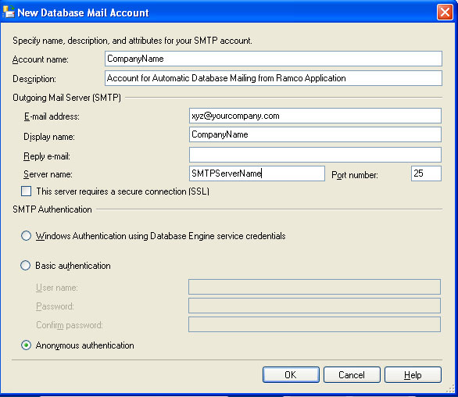

Click “Ok”
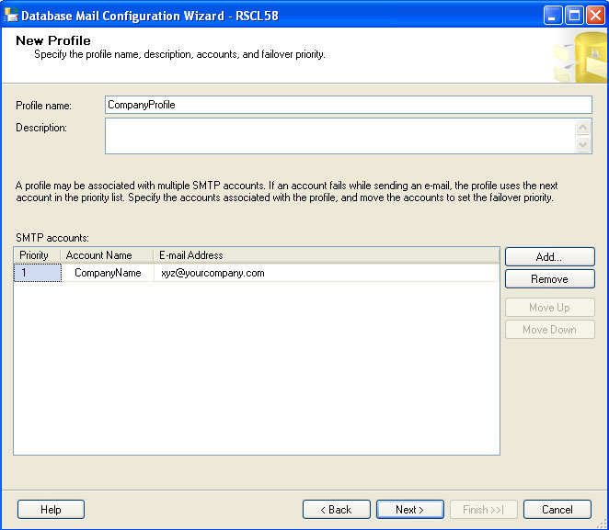

- Click on Next, following screen will appear.

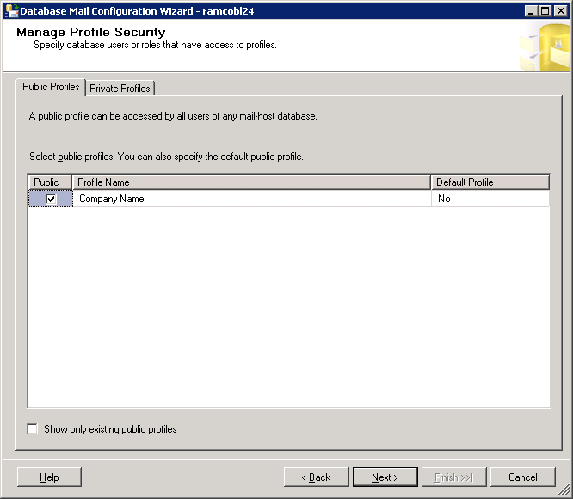

- Select the Profile Type as either Public or Private. Click on Next, following screen will appear.

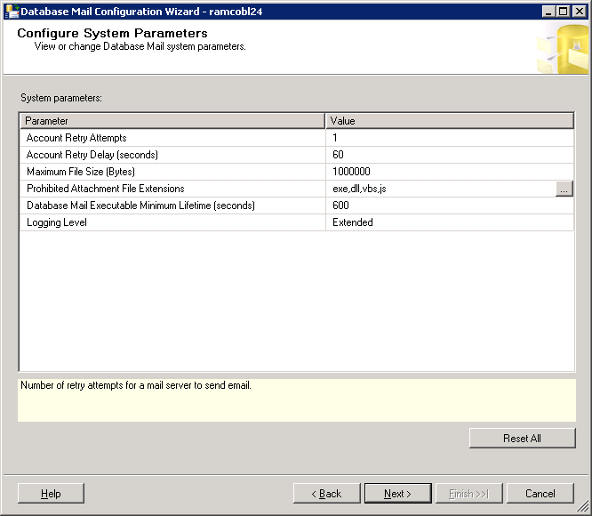

- Click on Next, following screen will appear.
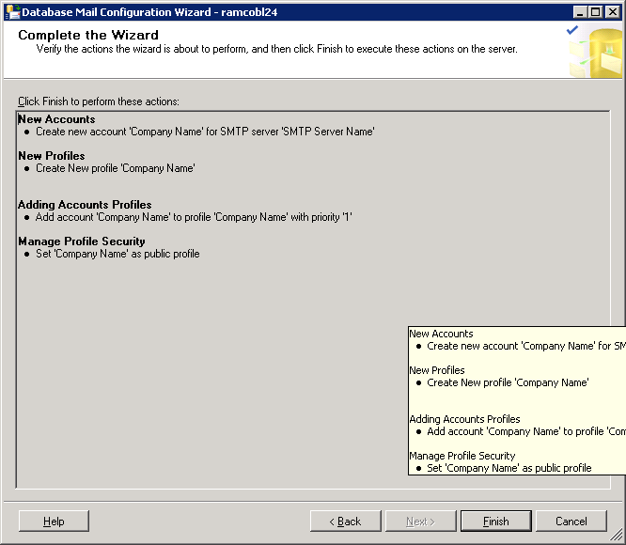

- Complete the wizard by clicking on “Finish” button. On completion of the settings you will find the Database Mail Account with Status shown as “Success”.

After Configuring Database Mail, you can Test the Database Mail by sending “Test Email”
- To “Send Test Email”, goto SSMS → <ServerName>→ Management→Database Mail→ Right Click and select “Send Test Email”. (as highlighted in the below screenshot).
- Provide your mail id in the “To:” field and click Sent Test E Mail.
- You will receive mail id if it’s successfully configured.
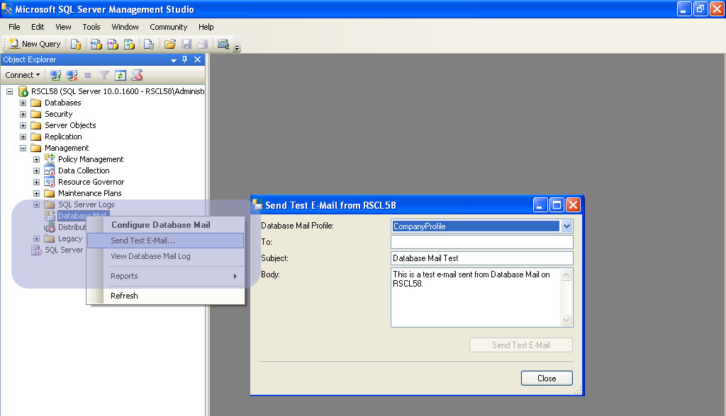

Reliability Analysis Report Settings
Macro Security level should be set as “Medium” and in Trusted Publishers Tab “Trusted Access to Visual-Basic Project” should be enabled in the Web server. If the server has multiple login users, then these excel setting are to be done for all the login users.
Step 1: In Microsoft Excel, go to Tools --> Macro --> Security option.
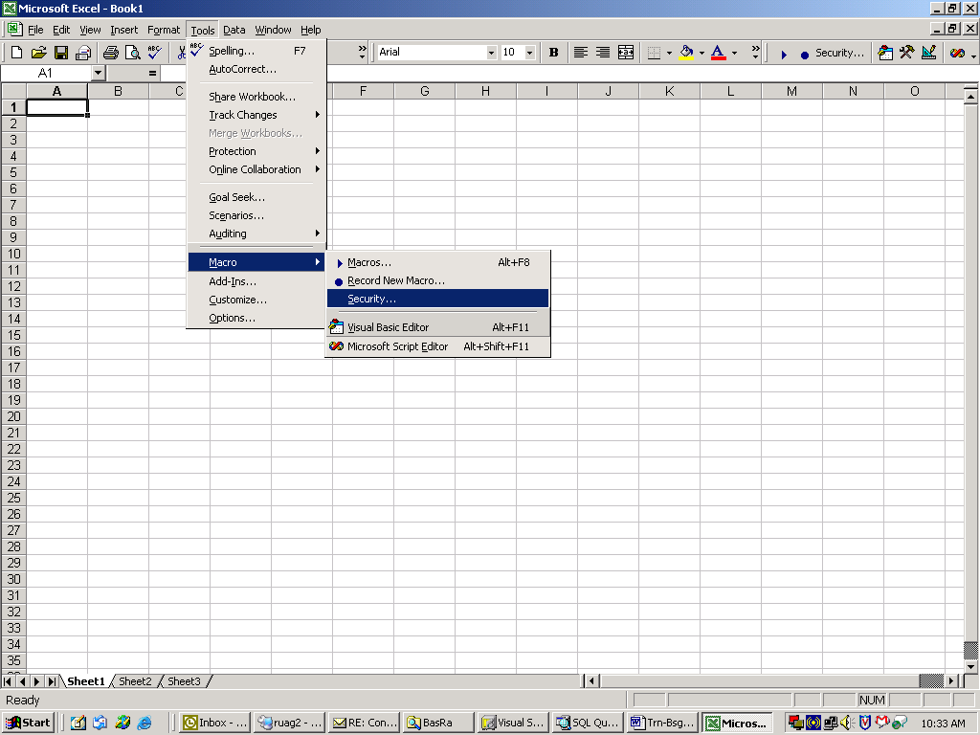

Step 2: In the Security Level tab, choose the option “Medium”.

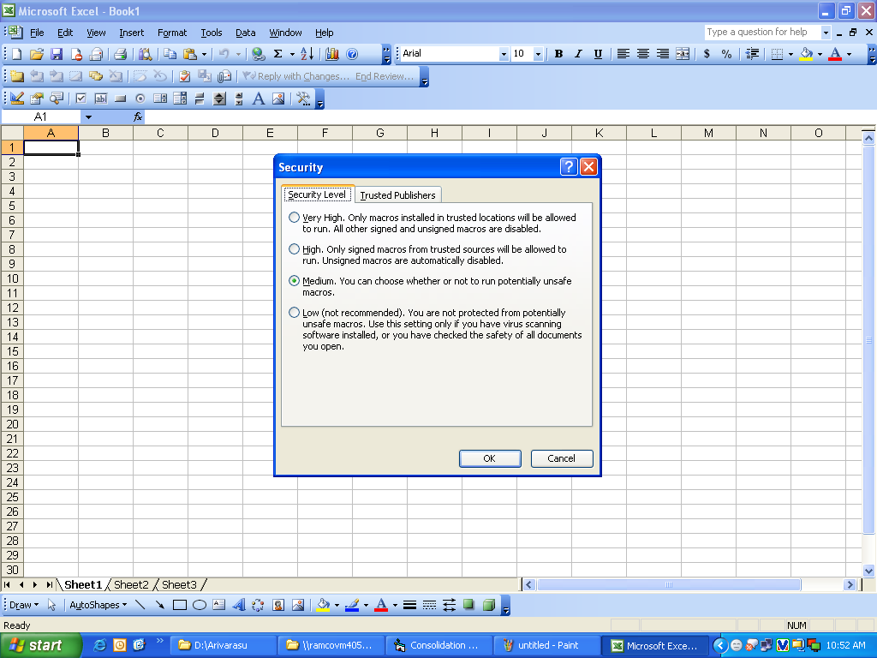
Step 3: In the Trusted Publishers tab, enable the “Trust access to Visual Basic Project” option.
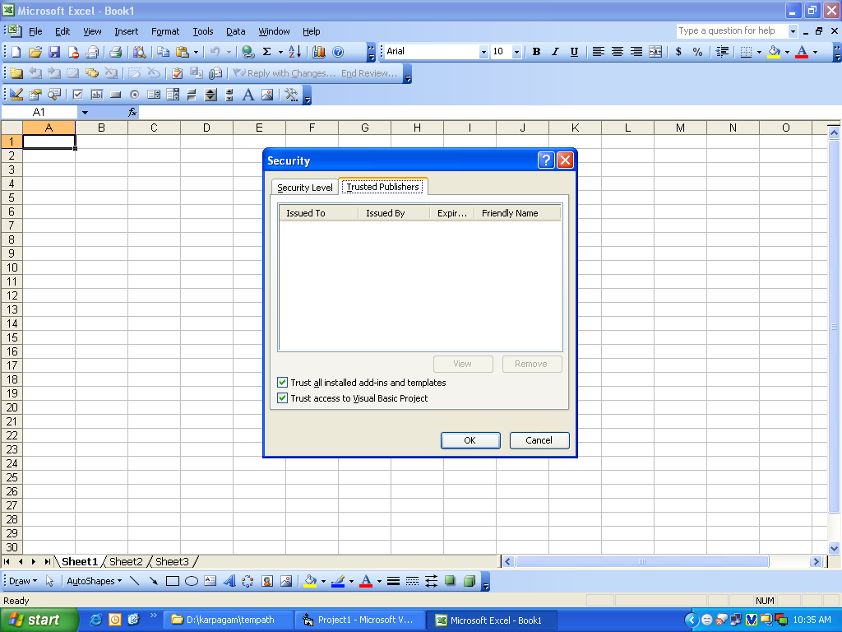

A folder called Reliability has to be created under IIS\Docs where the generated output excels will be placed.
Configuring Deploy.ini file
Reliability Analysis reports work based on the values provided in Deploy.ini file.
Provide following details in the deploy.ini file available under ‘IIS\BASRa\deploy.ini’.
<Servername>
<username>
<password>
AVNAPPDB
<Basra Component full path> (ex.) E:\Program Files\VirtualWorks\IIS\BasRa
Configuring Reliability Analysis Scheduler
ReliabilityAnalysis.exe is the tool that needs to be configured in Windows Scheduler to run on a daily basis for every 30 minutes (Configuration steps given below). The Tool obtains server details and template path information from the Deploy.ini file.
ReliabilityAnalysis.exe will be available under ..\\VirtualWorks\IIS\BASRA.
Steps to Configure ReliabilityAnalysis.exe file in Windows Scheduler: -
Step 1:- To start Windows Scheduler Task, Start → Run → Type “control schedtasks” → Click Ok
In the Task Scheduler, click the Actions “Create Task” given on the right pane. A new window will open as shown in the below screenshot.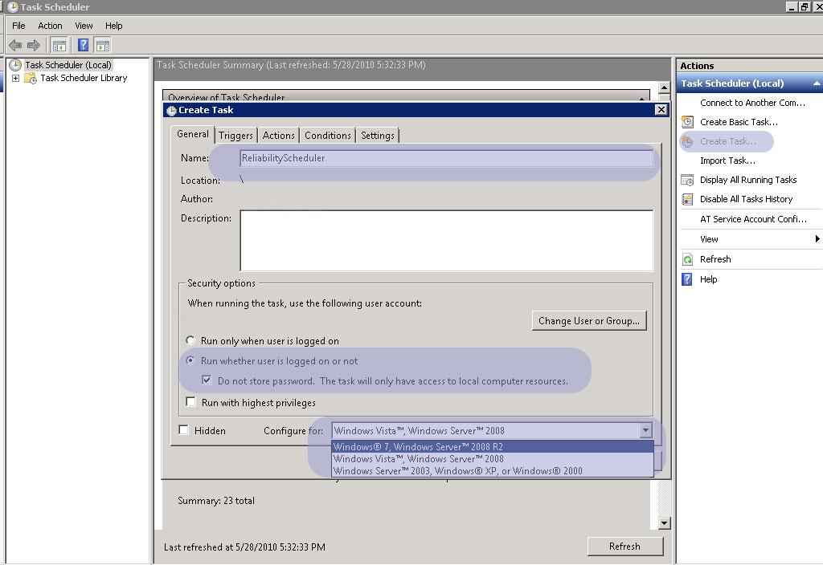
As highlighted in the “General” Tab
1. provide “Name”
2.Select the option “Run whether user is logged on or not”
3. Check the option “Do not store password. The Task will only have access to local computer resources”
4. Select the dropdown “Configure for” to Windows 7, Windows Server 2008 R2 or Windows Vista, Windows Server 2008 based on the operating system it is getting installed.

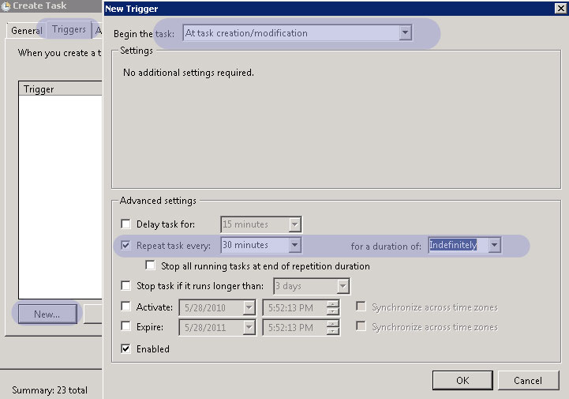

- As highlighted in the “Trigger” tabSet the drop down “Begin the Task” as “At task creation/modification”
- In the Advanced settings check the “Repeat task every”, select 30 minutes and “for a duration of” as “Indefinitely”

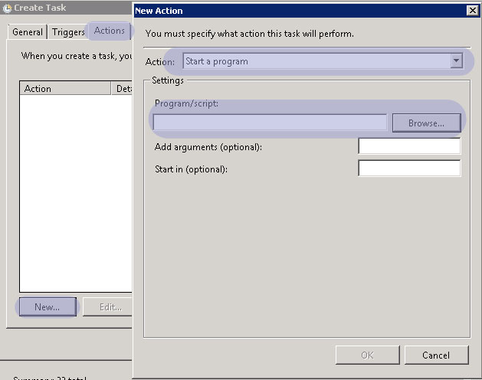
As highlighted in the “Actions” Tab
- Set “Action” as “Start a Program”
- In the Settings frame Click Browse button and select ReliabilityAnalysis.exe from the path “..\\VirtualWorks\IIS\BASRA”

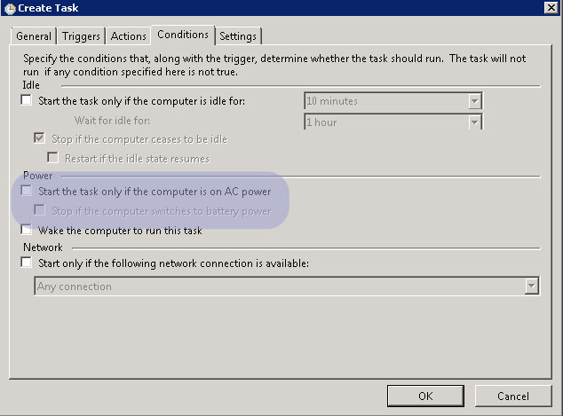

As highlighted in the “Conditions” tab, uncheck “Start the task only if the computer is on AC power”

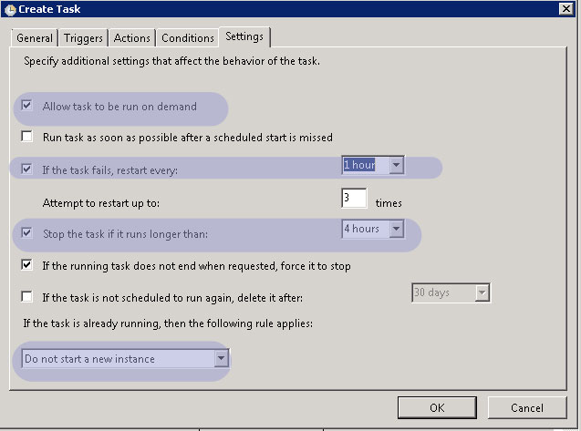
As highlighted in above screenshot, complete the “Settings” tab which ends the completion of Task Scheduler for Reliability,

Configuring Folder for saving Reliability Analysis Reports
- Visit the screen under the BPC ‘Utilities ‘--> Component ‘Object Attachment ‘--> Activity ‘Set Options’.
- Note the path mentioned under ‘Path in Server’. If not defined, set a path.
- Create a folder within the above path in the web server to download Reliability reports.
- Provide write permission to the above folders for everyone/ the user account - ‘Iusr_<servername>’
- The folder created above needs to be defined for Reliability Analysis component in the multiline separately.
- All the .bmp files available in IIS\Reports folder should be copied to the folder ‘IIS\BasRA’ also.
- Company Logo should be available as .bmp file with the naming convention as <Company Name>.bmp (Company Name as defined in the application) in the folder ‘IIS\BasRA’.
- In case of enabling Reliability Analysis in a server with multiple databases, the scheduler needs to be configured separately for each database. The path of the RelReports.exe file will vary for each database. The corresponding Deploy.ini, Reliability Report templates, ReliabilityReports.xml files will be configured along with .exe file. The Stored Procedures and Table objects need to be compiled in each database.
Pre-requisites for executing ReliabilityAnalysis.exe file
- Atleast one printer driver needs to be installed in Web server for the generation of Reliability reports.
- Ensure that the following assemblies are available in Global Assembly Cache path (C:\Windows\Assembly)
  - Microsoft.Office.Interop.Excel
  - Microsoft.Office.Interop.Word
If the above-mentioned assemblies are not available, do the following settings,Click Start-> Settings -> Control Panel -> Open Add/Remove Programs and select MS Office Installation.
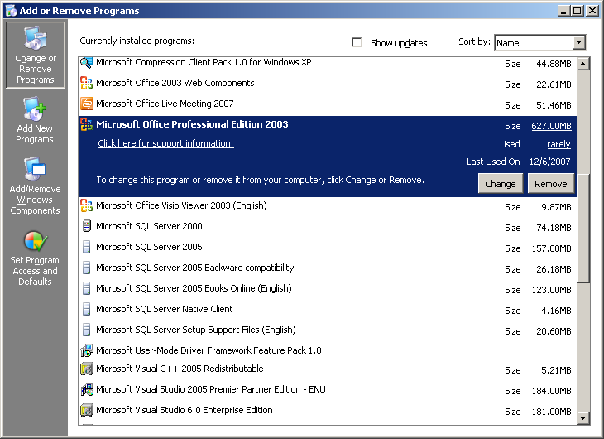
Click Change button. Select Add/Remove Features option and Click Next.

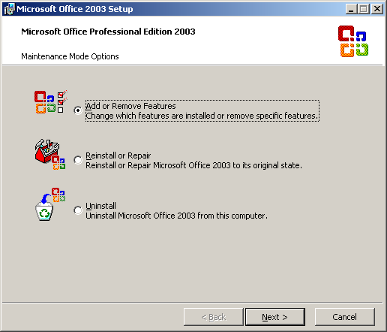
- Check the option ‘Choose Advanced customization of applications’ and click Next.

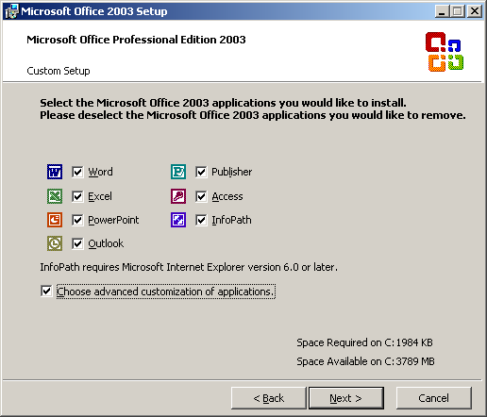

- Select the option as mentioned in the below screen shot and Click Update.

=
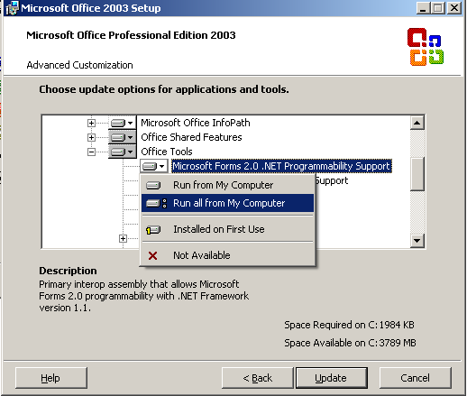

Now the assemblies added in the Assembly.
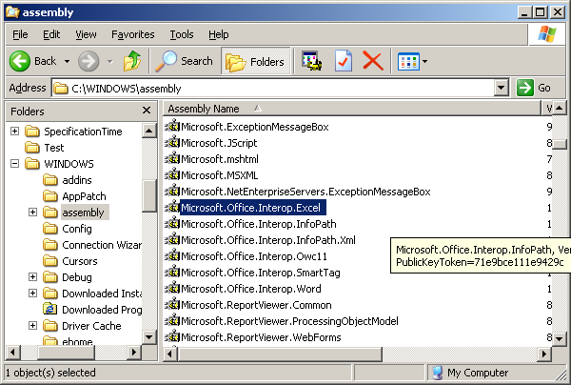

Non RVW Report Settings
The database connection details required for launching Non Rvw reports are obtained from Deploy.ini file available in the web server under the path .\Program Files(X86)\Virtualworks\IIS\Extui\NonRVW” . Provide the following details with respect to the database server.
<Server Name>
<SQL User ID>
<SQL Password>
<Application Database>

Email & Fax Integration

Email Interface
The email interface would generally be associated with application transaction reports.
(e.g.) After viewing a purchase order report in Crystal Reports viewer, the report can be emailed to the supplier. So the emailing interface (In Crystal Reports viewer) is provided with a “send email” button which enables the system to take the “to email id” from the transaction details (masters) of the report and send the generated PO report as an attachment with the email.
Assumptions
The email interface needs following things to be pre-configured

- MS Outlook 2003 mail client needs to be installed in the Application server.
- One common Email account (Email administrator account for Ramco Aviation Solution) needs to be configured for sending emails. All mails will be sent using this account.
- The outlook email profile should be active and open in application server.
- Report will be exported to PDF format and this will be attached to the mail.
Architecture
Email interfacing is provided with Crystal reports ActiveX viewer in Ramco Aviation Solution.
The users can open the report for viewing from the various screens of the application. On clicking the report link, system opens those reports in the crystal reports viewer.
The crystal reports viewer is provided with a “Send email button” on the top and this viewer is used as an Email interface.
When the user clicks the “send mail” button on top of the report viewer for sending email, the system pops up the below shown dialog.

System defaults the senders mail id in the “From “field provided. This information is derived from the login user’s information.
- Recipients mail id will be taken from the transaction data available in the report launched in the viewer and the same will be defaulted in the “To“ field.
- User can add any text in the subject and Body fields [optional]. System includes the default message.
- User can add additional recipients in the CC and BCC fields etc.
- On Completion of the email form user can choose the send mail button in the Form.
- The Web Server exports the reports to PDF document using Crystal reports RDC (Report Designer Component).
- The Email administrator mail profile will be configured in the application server’s Outlook 2003 Client.
- System uses this Outlook Client Profile and sends an automatic mail to the identified recipients with the generated PDF report as an attachment.

Implementation of Email Integration
Email integration approach is implemented using Crystal reports designer. Steps involved in the process explained below.
Pre-requisites:
- An Email account for sending emails should be created in the exchange server.
- Outlook Client needs to be configured in the application server and it should be active.
- Installation of Ramco Aviation Solution needs to be completed.

Installing Advance Security Outlook 2003
Install “Advance security for outlook 2003” in the Application server.
Please refer to the “Installation Manual (Readme.txt)” for more help on Installation procedure.
The outlook2003 client needs to be restarted after the installation of Advance Security.
Configuring
Launch the Ramco Aviation Application and Open the report where the Email Integration is enabled.
Try sending a test report which will prompt the outlook advance Security warning as shown in the below picture.

Select “Allow Access” and option and Check the Checkbox provided in the bottom for “Always perform this action for this file”
On selecting “OK” will set a action for Ramco Aviation Application as a trusted application for outlook for sending a Email via outlook 2003 client.
Hardware and Software Requirements
Web Server
- Internet Information Server with Crystal Reports Enterprise Edition 9.0 or above
Application Server
- Outlook Exchange server Client 2003 needs to be configured for the email administrator account of Ramco Aviation Solution.
- Outlook Advanced Security Component needs to be installed in the web server and include the Ramco aviation application as a trusted application.This is required to avoid security warnings from Outlook Object model guard while outlook automation.
Outlook Advance Security is a wrapper application for Outlook 2003 Client from mapilab.
Other Details:
Web site : http://mapilab.com/outlook/security/
Product Name : Advanced Security for Outlook (version 1.3)
License : freeware
(Advanced Security for Outlook is free for commercial and non-commercial use.)
Client
Crystal ActiveX Viewer for Viewing the Crystal reports

List of Transactions
In the following transactions the email interface will be enabled.
Sl. No. | Business Component | Transaction
1 | Sales | Customer Order
2 | Procurement | Purchase Order
3 | Procurement | Repair Order
4 | Procurement | Pack Slip
5 | Inventory | Stock Issue
6 | Sales | Customer Goods Receipt
7 | Procurement | RFQ
8 | Finance | Remittance Advice Report
9 | Finance | Payment Advice Report
10 | Finance | Prepayment Invoice
11 | Finance | Customer Order based Invoice

Fax Interface
The Fax interface would generally be associated with application transaction reports.
(e.g.) After viewing a purchase order report in Crystal viewer, the report can be sent as a fax to the supplier so the Fax interface (In Crystal Reports viewer) is provided with a “send fax” button which enables the system to take the “Fax number” from the transaction details (masters) of the report and send the generated PO report as a fax.

Assumptions
The Fax Integration assumes and expects following things to be pre-configured.
The application from GFI Fax Maker will be used for sending fax.
So this application works along with the Exchange server 2003.
- GFI Fax maker Software needs to be installed in the Exchange server.
- (This can be installed in a separate machine and it can be configured in the exchange server. Please refer to the Fax Maker Installation manual)
- MS Outlook 2003 mail client needs to be installed in the Application server.
- One common Email account (Fax administrator account for Ramco Aviation Solution) needs to be configured for sending emails. All mails will be sent using this account.
- (Fax Integration expects an email to sent to the Fax number instead of email)
- The outlook email profile should be active and open in application server.
- Report will be exported to PDF format and this will be attached to the mail.

Architecture
Fax interfacing is provided with Crystal reports ActiveX viewer in Ramco Aviation Solution.

Fax interfacing is provided with Crystal reports ActiveX viewer in Ramco Aviation Solution.
The users can open the report for viewing from the various screens of the application. On clicking the report link, system opens those reports in the crystal reports viewer.
The crystal reports viewer is provided with a “Send Fax button” on the top and this viewer is used as fax interface.
When the user clicks the “send fax” button on top of the report viewer for sending a fax, the system pops up the below shown dialog.

System defaults the recipient’s fax number information in the “To” field provided. This information is derived from the Transaction details of the report.
- User can add any additional text in the subject and Body fields [optional]. System includes the default message.
- User can add additional Fax recipients.
- On Completion of the form user can choose the send button in the Form.
- On Clicking the “send” button, the web server exports the reports to PDF document using Crystal reports RDC (Report Designer Component).
- The Email/Fax administrator email profile will be configured in the application server’s Outlook 2003 Client.
- System uses this Outlook Client profile and sends an automatic mail to the Fax Number specified in the “To” field.
- The GFI Fax maker installs an add-on at Microsoft exchange server. This add-on enables the exchange server to receive fax requests along with email.
- The user can send a fax by sending an email to fax number instead of a mail id. Application server sends an email with fax number as a recipient.
- The fax request received by the Exchange server will be redirected to Fax maker server by Fax maker add-on.
- The Fax Maker Software will be configured with a modem, telephone line and other software and hardware required.
- The Fax maker processes the request and sends the fax using the modem connected to it.

Implementation of Fax Integration
Fax integration approach is implemented using Crystal reports designer. Steps involved in the process explained below.
Pre-requisites:
- An Email account for sending email/Fax should be created in the exchange server.
- Outlook Client needs to be configured in the application server and it should be active.
- Installation of Ramco Aviation Solution needs to be completed.

Installing Advance Security Outlook 2003
Install “Advance security for outlook 2003” in the Application server.
Please refer to the “Installation Manual (Readme.txt)” for more help on Installation procedure.
The outlook2003 client needs to be restarted after the installation of Advance Security.
Configuring Advance Security
Launch the Ramco Aviation Application and Open the report where the Email Integration is enabled.
Try sending a test report which will prompt the outlook advance Security warning as shown in the below picture.

GFI Fax Maker’s Exchange server add-on needs to be installed and configured.
Select “Allow Access” and option and Check the Checkbox provided in the bottom for “Always perform this action for this file”
On selecting “OK” will set an action for Ramco Aviation Application as a trusted application for outlook for sending a Email via outlook 2003 client.
Installing Fax Maker
Fax maker Software can be installed in Exchange Server itself or I can be installed in a separate server and the same can be configured in the Exchange server
Please refer to the Fax Maker Installation Manual for Installation Procedure.

Hard ware and Software Requirements
Web Server
- Crystal Reports Enterprise Edition 9.0 or above
Application Server
- Outlook Exchange server Client 2003 needs to be configured for the email administrator account of Ramco Aviation Solution.
- Outlook Advanced Security Component needs to be installed in the web server and include the Ramco aviation application as a trusted application.
This is required to avoid security warnings from Outlook Object model guard while outlook automation.
Outlook Advance Security is a wrapper application for Outlook 2003 Client from mapilab.
Other Details:
Web site : http://mapilab.com/outlook/security/
Product Name : Advanced Security for Outlook (version 1.3)
License : freeware
(Advanced Security for Outlook is free for commercial and non-commercial use.)
Exchange Server
Fax Maker Server
- GFI Fax Maker
- Modem (connected to a Fax machine)
- Telephone Connection for sending a Fax
- Fax drivers (if any)
Fax Maker Vendor Details
Vendor Name : GFI
Product Name : GFI FAX maker for Exchange/SMTP (version 12)
URL : http://www.gfi.com/faxmaker/
Pricing Details
No of Users | Package | Price
10 users | FAX10 | $695
25 users | FAX25 | $1,250
- 50 users | FAX50 | $1,995
100 users | FAX100 | $2,495
250 users | FAX250 | $3,450
500 users | FAX500 | $4,250
Unlimited users | FAXUNL | $5,995

More Details:
GFI offers a fully working evaluation version for 30 days.
(This can be extended for another 30 days)
- Best fax integration available for mail server
- Minimal administration and user training required
- The most popular fax server, voted #1 by Windows IT Pro readers for 3 years.
- Supports Windows 2000/XP/2003 running Exchange 5.5/2000/2003 and Lotus Notes
For latest information on pricing and feature list is available on the GFI’s web site.
Client
Crystal ActiveX Viewer for Viewing the Crystal reports
List of Transactions
In the following transactions the email interface will be enabled.
Transaction | Business Process
Customer Order | Sales
Purchase Order | Procurement
Repair Order | Procurement
Pack Slip | Procurement
Stock Issue | Inventory
Customer Goods Receipt | Sales
RFQ | Procurement
Remittance Advice Report | Finance
Payment Advice Report | Finance
Prepayment Invoice | Finance
Customer Order based Invoice | Finance

Reports
To display logo in the base reports following settings has to be done in web server:
- For other than Finance reports, logo can be placed in any folder and the path to be configured in the CustomReporting.xml.
Please follow the below steps to configure this

Step 1).Create a folder in the path "\Program Files\VirtualWorks\IIS\Extui\". Suggest to create folder with the name ReportLogo.

Step 2).Place the company logo file under the folder created in the Step 1.

Step 3).In the xml CustomReporting.xml which will be available in the path "..\Program
Files\VirtualWorks\IIS\Extui\ilrt", search for the report parameter "reportlogo" and the attribute Value to be replaced with the path created in the Step 1.

Find the below example for the same:

<ReportDefaultParameters>
<ReportParameters>
<ReportParameter Name="reportlogo" Value="D:\Program Files\VirtualWorks\IIS\Extui\ReportLogo\reportlogo.bmp" SubReportName="" />
</ReportParameters>
</ReportDefaultParameters>

In this example the folder created with the name ReportLogo and the logo file name is reportlogo.bmp

- For Finance reports following settings has to done.
Business Processess : Finance Setup
Component : Organization setup
Activity : View OU-Company Mapping

Field : Logo File Name - > Log file name will contains the drive and file name of the logo.
For eg in this case, the logo file name displays the value “E:\RAH1.bmp” where “E:” represents the drive and “RAH1.bmp” represents the file name.
Using the above information, the folder has to be created in E drive as E:\Program Files\Active Marshal\IIS\Logo. And place the RAH1.bmp file in the same folder.
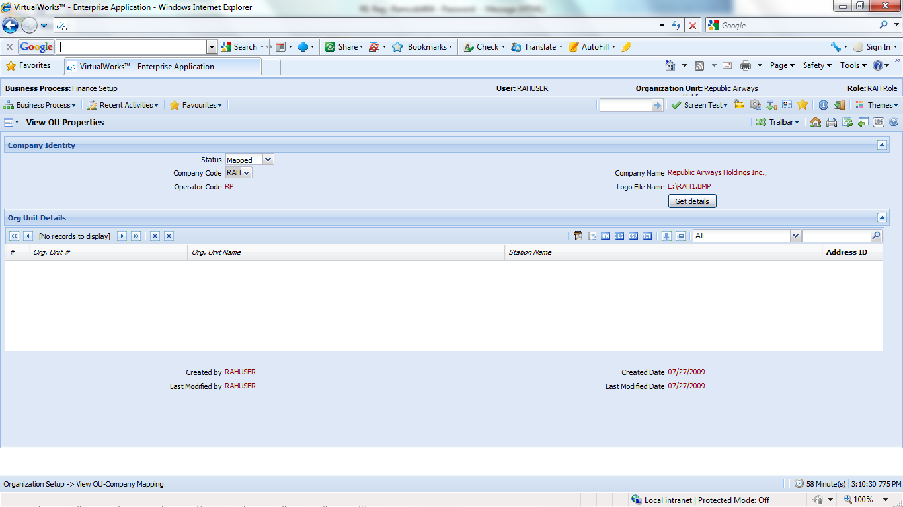
- For Non RVW reports, place the logos under C:\Windows\Temp

Ensure to give network service rights to the above folders mentioned in point a) and b) and follow the steps below to provide the rights.

Steps FOR giving rights to Network Service
- Right click the folder C:\Windows\Temp and select Properties option.

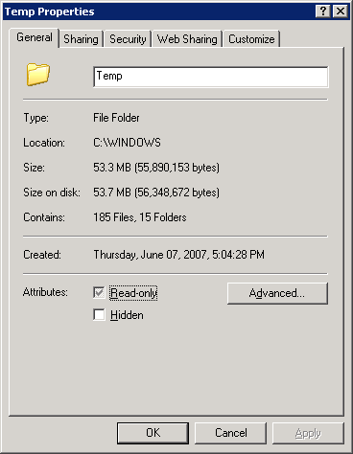

- Click the security tab in Temp folder properties window.

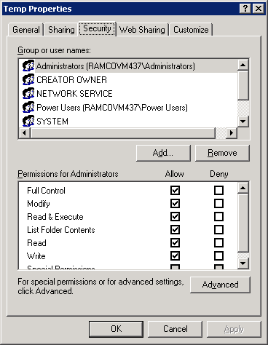
- Ensure that Network Service under Group or user names: section is having following checkboxes are enabled under permissions section.
  - Read & Execute
  - List Folder Contents
  - Read

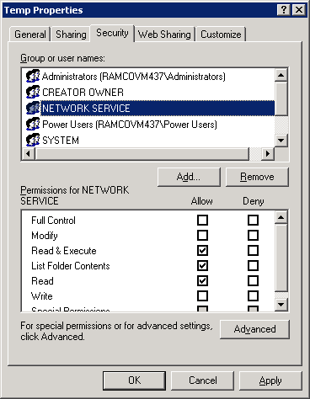

- If the network service not exists under Group or user names: section, then click Add.. button.
- Enter “network service” in the text field as mentioned below and click Check Names button.

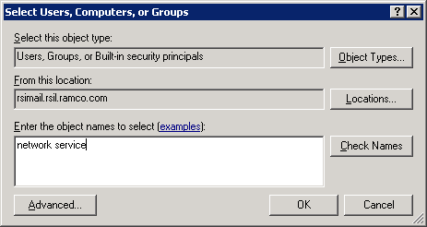

- Give network user name and password and click OK.

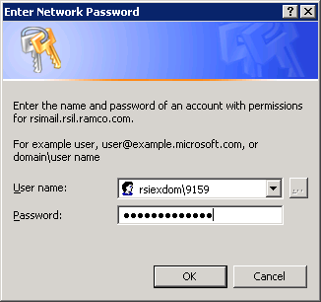

- And also ensure that Network Service is having following checkboxes are enabled under permissions section.
  - Read & Execute

  - List Folder Contents
  - Read

- Click OK.

Manage Consolidated Financial Statements Package
Refer the attached document for configuration and settings

Automatic Material Movement Document (AutoMMD) Printing
The MMD Printing is associated with a material movement transactions like material issue, after a material movement document is authorized, the respective warehouse in-charge will get notified by a document printed at the printer located in that warehouse.
The notification can be an email to the warehouse in-charge.
Architecture
Building MMD Print Queue
On Clicking the MMD Printing for selected transaction from the Ramco aviation Solution, The system identifies the report associated with that particular transaction and finds the warehouse –zone information associated with that transaction (warehouse printer).
The warehouse – Printer mapping information is maintained in the server. Using this metadata the system identifies the warehouse –zone and printer where the document needs to be printed and updates the information in a MMD Print queue. The MMD Print queue collects all the MMD print requests and maintains the same.
MMD Processing
MMD processing is executed by a scheduler.
A Scheduler will be designed to process MMD queue in will be installed and configured with a time interval to process the MMD queue.
The scheduler processes the queue by creating Crystal reports Object and opens and executes the reports identified in the MMD queue.
The queue also contains the information like warehouse/zone and printer information.
Scheduler prints the selected report in the specified warehouse printer.
Sequence
- Application Clients request for MMD printing.
- Data base find the warehouse and printer information add the request to the MMD queue.
- A scheduler will be installed in the web server to processes the MMD queue and prints the report in appropriate printer.
- Database maintains the metadata for Warehouse-Printer mapping for all the identified warehouses.
- All the warehouse/zone printers will be shared or drivers will be installed in the web server.
- The Crystal reports RDC (Report Designer Component) will be used by the scheduler to process and generate the report and to send it to the appropriate printer.

Hard ware and Software Requirements
Hardware
All the warehouse printers to be shared or printer drivers needs to be installed and configured in the web server.
All network warehouse printers need to be part of the same intranet.
Software
Web Server:
- Printer drivers for all the printers to be installed and configured in the web server.
- Crystal Reports and Crystal RDC Component.

Implementation of MMD printing
MMD printing is implemented by configuring all the warehouse printers in the web server.
- Share the printers located in the warehouses where the MMD printing is enabled.
- Configure the printers the in the web server as a Network Printers of the warehouses.
- Install Printer drivers in the web server for printers where installation of printer drivers is mandatory.
- Please print the test page for each printer before using MMD. This is to ensure the printer driver installation completeness.
- Prepare and upload the metadata for warehouse- printer mapping for all the printers and warehouses.
- Printer Name in the metadata should be same as the printer name configured in the web server.(any change in this name should be updated in the metadata table)
- Install and configure the scheduler in the web server.
- Add code to insert MMD request in to the MMD queue table in the database where the MMD printing needs to be enabled.

MMD Approach
Automatic MMD printing is developed for printing the MMD document in the warehouse/Zone printer as and when the document is authorized. Following are the main points.
MDCF excel sheets are used to capture the following option setup and printer setup information.
- 1) Metadata: - Transaction type is metadata

- 2) Option setup: - captures the details like printing level, transaction type printing, report name, printing enabled (yes or no) etc

- 3) Printer setup: - captures the details of the printers mapped to warehouse and zone

Following are the important advantages.
- 1) Document can be printed in multiple printers based on the printer setup for warehouse / zone
- 2) Transaction based printing: - If transaction based printing is specified for a particular transaction then separate printer can be specified for this transaction at warehouse/ zone level. Otherwise irrespective of the document type, printing will happen in the printer(s) specified for the warehouse/Zone
- 3) Printing level can be specified as warehouse or zone level for each document type. If printing level is warehouse for a document then printing will happen in printer(s) mapped for that warehouse.
- 4) If printing level is zone and printer is mapped for the zone then printing will happen in zone printer, if printer is not mapped for the zone then printing will happen in warehouse printer(s)
- 5) Separate report format can be used for each document type.

How auto MMD works
Setup information captured in following tables
MMD_MMDTRNTYPE_TRANS_TYPE metadata
MMD_MMDOPTSET_OPTION_SETTING Option setup
MMD_PRINTER_SETUP Printer setup
Steps
During the authorization of the document the sp MMD_DOCUMENT_LOG_INSERT_SP is called which will insert the details of the document in the table MMD_DOCUMENT_LOG with flag either as ‘W’ (Waiting for printing) or ‘H’ (Hold)
MMD scheduler has to be executed from App server. This can be configured to run continuously or in fixed interval. The scheduler calls the sp MMD_Document_Fet_SP, this will fetch the details like document no, document type, line no ( if any), printer name etc if printer is mapped for the warehouse/ zone and MMD printing is enabled , otherwise the flag is set to ‘E’ (Error)
Scheduler will pass the output of the sp to crystal report file and it will call the sp MMD_RPT_MMDDOC_SP, this will populate the data for the reports. Now the report is ready with data
Scheduler will send the report to the printer(s) (returned by the sp) and the document will get printed in the printer(s). If the printer is not physically available then the scheduler will update the flag to ‘E’ (Error) else the flag is updated to ‘P’ (printed).

Capturing master data using MMD MDCF
1) Provide RM server login information in the login page of MDCF
2) In the option setup page specify options for each transaction type as follows
Transaction type - Combo loaded with metadata.
OU - OU Instance
MMD Enabled - Combo loaded with Y and N.
Level - Combo loaded with WH and ZONE. Based on this MMD will be printed In WH or Zone for the transaction type.
Report Name - Enter complete path of the report file. (Provision for using different report file for each transaction type is provided).
For tran type ‘GRCPT’ report name is GRSDoc_F_Ent_CreateRetWH.rpt.
For tran type ‘MRAOG’ report name is Pending_AOGMR_Automatic.rpt.
For tran type other than the above mentioned the report name is StockManagementReports_Automatic.rpt.
Transaction Based Printing – Combo loaded with Y and N. Select whether the printing is based on transaction or not.
Modeflag- Select modeflag based on the task

In the printer setup page provide following details
Warehouse # - Warehouse No
Transaction Type – Combo loaded with metadata. Select the transaction type only if the transaction based printing is selected in the option setup
Warehouse OU – OU instance of the warehouse
Zone #- Zone number. (For the warehouse printer leave zone # as blank)
Printer Name – Name of the printer (In case of network printer give printer name alone. In case of shared printer give \\machinename\printername). Use printers option in the control panel for identifying printer names
Use Fetch, Upload and Validate buttons for the corresponding task.

How to configure MMD scheduler
1) Install windows service based MMD scheduler in the web server by referring the Readme.txt available in the folder ..\ CD6 – Tools\ MMD\MMD SERVICE
2) Run the table scripts under the table folder in RM server in the database avnappdb (This may be already installed as part of database dump restoration or script based installation)
3) Run SP scripts under SP folder in RM server in the database avnappdb (This may be already installed as part of database dump restoration or script based installation)
4) Run metadata script under the folder Metadata in RM server (This may be already installed as part of database dump restoration or script based installation)
5) Copy the relevant rpt file under the folder path mentioned in the table MMD_MMDOPTSET_OPTION_SETTING in web server
6) Automatic MMD can be printed in both network printer and shared printer. Install network printers in app server using correct printer driver and establish connection to the shared printers
7) Launch the application after uploading configuration information through MDCF.
8) Check the MMD service(RamcoAutoPrintMMDService ) is started and MMD will be printed in the printers based on the configuration and the document.
Trouble shooting Guide
- Make sure that option setup is provided
- Make sure that printer setup is provided
- Check any record is available in the table MMD_DOCUMENT_LOG with value ‘W’ in the MMD_FLAG column.
- If record available in step 3 then execute the sp MMD_Document_Fet_SP in the RM server. This will show the records that will be printed by the scheduler. If it is not giving any records as output then problem with printer setup or option setup. Check the MMD_FLAG of the records, it will be updated to ‘E’ (Error)
- If records available in step4 then execute the sp MMD_RPT_MMDDOC_SP with the output of step4. If this is not giving any records. Problem with document.
- If record available in step 5 then either the name of the printer specified is incorrect or the printer is not physically available.

10.0 Barcode Label Printing
The Barcode printing process would generally be associated with a business transaction (e.g.) After a pack slip is created for shipments to a customer, a bar-coded pallet shipping label needs to be printed and fixed on the carton. Ramco Aviation Solution has Barcode labels linked with transactions.
To print the label through these screens, user has to select the transaction details, (for example, the Pack slip number) and then press the Barcode printing button, to print the Barcoded label.
Before making use of the feature, the Barcode label printing software (DYMO label writer printer and Printer drivers) has to be installed and configured
Architecture

Initially a barcode label design layout is created using Crystal Reports Designer. This will be deployed as a report in the web server. This is a WYSIWYG interface for the barcode label.
On clicking the barcode label-printing button on the Ramco Aviation application client, the web server receives the request and processes the same by interfacing with the Application server and database.
The database and application server fetches the data required for generating barcode label. Then the web server sends the data to Crystal reports server.
The Crystal reports server uses the deployed barcode label report and generates the barcode label.
The generate barcode label would be sent back to Ramco Aviation Solution client and Crystal reports Active X Viewer would be used for displaying the report to the end user.
The Crystal Reports Active X viewer is provided with a “Print” button, this can be used for printing the label to DYMO label printer configured in the network.
The report generates separate printable page for each label.
When the user selects the label report for printing in the ActiveX Viewer, the system prompts dialog box with the printers configured in the user’s client machine.
User needs to choose appropriate DYMO label printer to print the barcode label.

Hard ware and Software Requirements
HARDWARE
Web Server:
- DYMO Label writer (Label printing device)
(Model DYMO Label Writer 330 Turbo)
Printers can be configured in different workstations and can be accessed via other workstations connected in the same network.
SOFTWARE
Web Server
- Internet Information Server with Crystal Reports Enterprise Edition 9.0 or above.
Client
- DYMO Label Printer Drivers.(Model DYMO Label Writer 330 Turbo)
(Drivers version should match with the network DYMO printer model)
- Crystal Reports ActiveX Viewer.
- Barcode font

Installing the DYMO Label Writer
DYMO Label Writer printer shipped with a Quick Start Guide and User Guide.
Follow the instructions in the Quick Start Guide and User Guide to install your DYMO label printer.
Implementation of Barcode
Barcode integration approach is implemented using Crystal reports designer. Steps involved in the process explained below.
Prerequisites
- DYMO Printer drivers for Turbo 330 to be installed in the machine where the report is designed.
- Barcode Font Example: Free 3 of 9 Extended
- TTX file for Database connection with sample data.
Report Design
1. Use a new report from file menu of the Crystal report and follow the sequence explained below.
The following popup window appears and choose Mail Label wizard.
2. Proceed with the mail label wizard and specify the appropriate ttx file for (Filed Definitions File) the report and choose next.
Choose label type in the next step in the wizard.
3. Specify the following setting in the wizard
Label Size:
Height : 2.31
Width : 4.00
Horizontal Gap Between Labels: 0.313
Page Margins:
Left Margin: 0
Right Margin: 0
Top Margin: 0
Bottom Margin: 0
4. Paint the Report as per Business Rule and follow the following important steps to get the label in each page.
5. In Report menu select Section Expert, select details and in common option check the option a) New Page Before and b) New Page After, to get the each Label in page wise.
6. Specify the following printer setting.
1. Paper Size: 30256 Shipping
2. Orientation: Landscape
Save the report and complete the barcode label report.
7. Sample Label Report is attached for reference.
Accessing and Printing Label
Login into Ramco Aviation Solution and Navigate to the transaction where barcode printing has been enabled.
Click on the link to launch the report.
The generated barcode report can be viewed in web browser (as shown in the below picture)

On Selecting the print button system prompts for the printer to choose.(see the picture below)

From the list of printers choose appropriate DYMO printer and click on OK to complete the printing.

List of Transactions
In the following transactions the barcode printing will be enabled.
Business Process | Business Component
Procurement | Goods Receipt
Inventory | Stock Issue
Maintenance | Component Work Order Report
Maintenance | Hangar Work Order Report
Maintenance | CWO Time Sheet Booking
Maintenance | HWO Time Sheet Booking

11.0 Ezee View
Ezee view feature is used to develop Part Supply Chain Performance feature. In order to make this feature enable new component “SPEXECUTOR” has also been provided. For this new component, Ouinstance to component mapping need to be provided through Deployment work bench. Once the mapping for this new component is completed, ensure to generate the config generator deliverables and deploy the same.

12.0 MCR Status Report Client Settings
To View MCR Status report, Microsoft Office (Version 2003) is required in client machines. While installing Microsoft Office 2003, the Option “Install Microsoft Office Web Components” should be selected.
Note: Microsoft office web components come as an Add-in package with Office 2003 Installation CD.
If Microsoft Office 2007 is already installed, then the Microsoft Office Web components can be installed through Control Panel -> “Add or Remove Components” program option.

13.0 Netronics Client Settings
Applications that intend to use Netronic Gannt Chart - Planning board function, have to install the following viewer utility in all Client machines.
Run the installation package “vcredist_vs2005sp1_x86.exe” available in the folder ..\CD4 - Manual Deployment\Netronics-Client in all client machines where NETRONICS Gannt chart is required.
If Netronics Gannt chart is already present in client machines, follow the below steps to uninstall the older version:
a. If the control is manually installed from vcgantt.cab file; then manually unregister the corresponding vcgantt.ocx file and delete all associated files.
b. If the control is automatically installed to Downloaded Internet Programs; then it has to be manually uninstalled by visiting IE’s Downloaded Programs page.
When next time user visits a page containing NETRONIC ActiveX object embedded in it, the control will get automatically installed to Downloaded Programs space of IE.
Note: Please note that before this step ensure to complete the steps mentioned under the section 5.5 Object Attachments Client Settings

14.0 Object Attachments Settings
For Object Attachments feature, a folder to be created for storing the document repository in the FTP server. If the application is hosted, FTP server also needs to be hosted.

The following Client Settings need to be done for Object Attachment.

- Setting up Internet Explorer options
At the onset, you must define the Client settings in the IE 6.0 and above as listed below.
- From the Internet Explorer, select Tools menu.
- From the Tools menu, click the Internet Options.
- From the General tab, select the Settings in the Browsing History cluster.

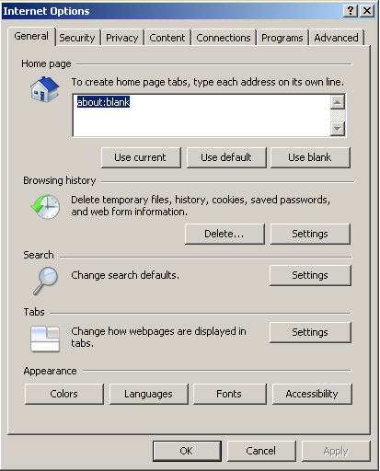

- Select the ‘Check for newer versions of Stored Pages’ as “Every time I Visit the webpage”

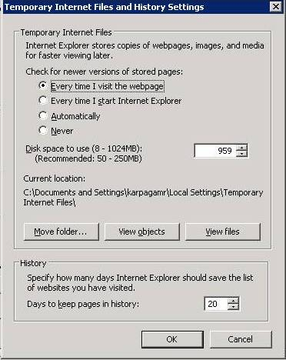

- From the Security tab, select the Trusted sites and then click Sites button.
- Add the application URL and FTP server URL to the list of trusted websites.

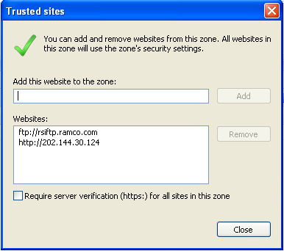
- From the Security tab, select the Trusted sites and click Custom level… button.

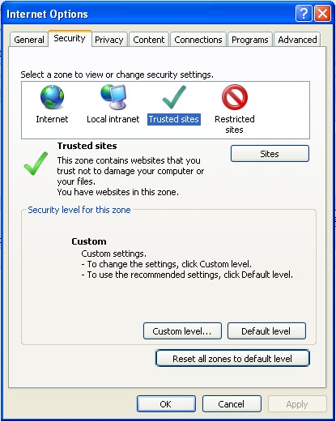

- In Reset custom settings, select the “Reset to:” to Medium-low or Low and click the Reset button.
- Enable all ActiveX controls and Plug-ins as shown in the next picture.

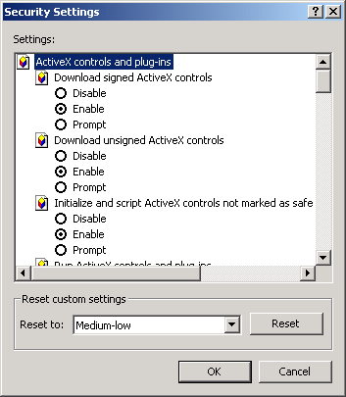
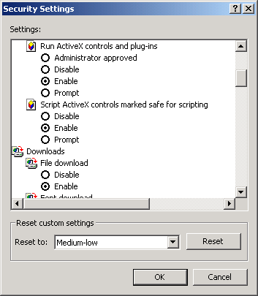
- From the Advanced Tab, select the Allow Software to run or install even if signature is invalid check box.

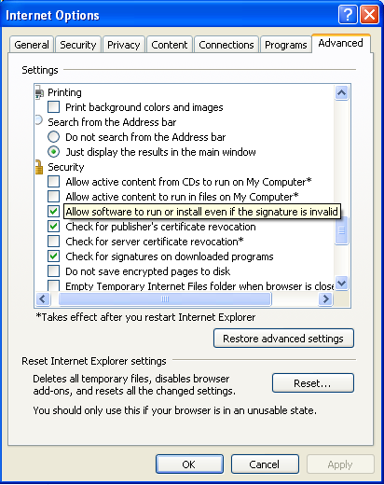
- Select Pop-up Blocker in the Tools menu.
- Select the Turn-off Pop-up Blocker, if it is turned on.

15.0 Schedulers to be configured
The list of schedulers as mentioned in ‘Scheduler Job List’ annexure document need to be configured as SQL Job in RM Server.
To create a new Job, Follow the steps below:
a. Connect to SQL 2008 Object Explorer using sa user.
b. Start the SQL Server Agent. If it is in stopped status, then right click on SQL Server Agent and
Click Start
c. Expand SQL Server Agent, right click on Jobs. Give the name of the Job in the “Name” text box.

d. Click on “Steps” from the left pane of the new window job. Click on “New” push button.
step window pops up. Give the Step name and select the Database from the database combo.
Command text field, specify command to be executed and click on OK push button.

e. Click on Schedules from the left pane of “New Job” window and click on “New” push button. A
“New job Schedule” window pops up. Specify the name of the job in the Name text field. Ensure that
Enabled check box has been enabled. In the frequency section, specify the frequency of occurrence
from the Occurs combo. In the Daily Frequency section, click on “Occurs every” radio button and
specify the required timings from corresponding list boxes and combo. Under Duration section,
specify the start date and required End date and click on OK.

f. Click on OK to finish the Job.

16.0 Scripts to be run
- Below Script to be run in RM server in master database for providing permission to 'OLE Automation Procedures',
The below script to be run if the feature in component “Issue Tools” under Facility Management and if “Authentication for Tools Issue” is set as Required.

sp_configure 'show advanced options', 1
GO
RECONFIGURE
GO
sp_configure 'Ole Automation Procedures', 1
GO
RECONFIGURE
GO

- Permissions to set

use msdb
GRANT EXEC ON sp_add_job TO PUBLIC
GRANT EXEC ON sp_add_jobstep TO PUBLIC
GRANT EXEC ON sp_add_jobserver TO PUBLIC
GRANT EXEC ON sp_start_job TO PUBLIC

- Service broker

The Service Broker infrastructure has been implemented for forecast operations in order to schedule & perform the voluminous data processing operations by using multiple asynchronous queues with scheduled conversation handle/ delays in order to manage maintenance operations without using SQL Server Agent. This gives provision for flexible scheduling of work, which can translate to big improvements in both performance and scalability.
- Stop and start the sql service
- Execute below queries in application db

Declare @DBname nvarchar(50)
SELECT @DBname = DB_NAME()
exec ('ALTER DATABASE ' + @DBname + ' SET TRUSTWORTHY ON')
exec ('ALTER DATABASE ' + @DBname + ' SET ENABLE_BROKER')

17.0 Synonym Scripts deployment
If the restored Database names for Aviation application, Workflow and HRMS application are different (other than “Avnappdb”,”WFM40” and “HRMS40” ) then the following synonym scripts need to be executed in mentioned order.
The scripts need to be run in a specific sequence and in specific databases as mentioned below:
1. Manual_Deploy_R63C_GEN_01_SP1 - To be executed in HRMS database if the database name is other than HRMS40
2. Manual_Deploy_R63C_GEN_01_SP2 - To be executed in Aviation Application database if the database name is other than AVNAPPDB
3. Manual_Deploy_R63C_GEN_01_SP3 - To be executed in Aviation Application database if the database name is other than AVNAPPDB
4. Manual_Deploy_R63C_GEN_01_SP4 - To be executed in Aviation Application database if the database name is other than AVNAPPDB
5. Manual_Deploy_R63C_GEN_02_SP1 - To be executed in Aviation Application database if the database name is other than AVNAPPDB
6. Manual_Deploy_R63C_GEN_02_SP2 - To be executed in HRMS database if the database name is other than HRMS40

18.0 MDCF Settings
Steps to be followed for MDCF Upload
This is a utility that can be used to upload data in Virtual Works environment. It can be very useful for upload of master data. This would simulate firing of a RVW Service. This will not do screen navigation of any sort.
Server prerequisites:
- MS Office to be installed in the Web server.
- Upload should be performed from WEB SERVER only.
- Before Registering the Dlls in Web Server, DLL reference should be removed from Macro References in Excel.

Settings in Web server:
1. Make sure the Clientsocket assembly and the VirtualWorksRT assemblies are present in the GAC - c:\windows\assembly.
2. Register these two assemblies using the REGASM command. Refer the physical files under the GAC_MSIL folders.
e.g.,
For 32 Bit Servers
In the command prompt: for registering clientsocket assembly
c:\>cd c:\windows\assembly\gac_msil
C:\WINDOWS\assembly\GAC_MSIL>cd clientsocket\1*
C:\WINDOWS\assembly\GAC_MSIL\Clientsocket\1.4.3.12__3a721247b727f8b9>regasm /tlb:clientsocket.tlb clientsocket.dll
Microsoft (R) .NET Framework Assembly Registration Utility 2.0.50727.42
Copyright (C) Microsoft Corporation 1998-2004. All rights reserved.
Types registered successfully
Assembly exported to 'C:\WINDOWS\assembly\GAC_MSIL\Clientsocket\1.4.3.12__3a7212
47b727f8b9\clentsocket.tlb', and the type library was registered successfully
3) Register the Virtualworksrt assembly also as shown above.
4) If there are any issues - Check in the Macro project references whether these two assemblies are selected.
5) EXCEL.EXE.config needs to be copied into the folder where EXCEL.exe is present
(This step should not be done for MS Excel 2007 and later versions)
For 64-Bit Servers:
(Note the difference in the path from where REGASM.EXE is invoked)
In the command prompt: for registering clientsocket assembly
c:\>cd c:\windows\assembly\gac_msil
C:\WINDOWS\assembly\GAC_MSIL>cd clientsocket\1*
C:\WINDOWS\assembly\GAC_MSIL\Clientsocket\1.4.3.12__3a721247b727f8b9>"C:\WINDOWS\microsoft.net\Framework\v2.0.50727\regasm.exe" /tlb:clientsocket.tlb clientsocket.dll
Microsoft (R) .NET Framework Assembly Registration Utility 2.0.50727.42
Copyright (C) Microsoft Corporation 1998-2004. All rights reserved.
Types registered successfully
Assembly exported to 'C:\WINDOWS\assembly\GAC_MSIL\Clientsocket\1.4.3.12__3a7212
47b727f8b9\clientsocket.tlb', and the type library was registered successfully
3) Register the Virtualworksrt assembly also as shown above.
4) If there are any issues - Check in the Macro project references whether these two assemblies are selected.

5) EXCEL.EXE.config needs to be copied into the folder where EXCEL.exe is present (This step should not be done for MS Excel 2007 and later versions)
After doing the above setting, DLL reference are not there in the Macro References then do the following settings else ignore the below settings.
Registering DLLs with RegDllApp Exe
- Copy the embedded exe into your Web Server and run the same.
- Click the button Register – REGASM button under VirtualWorksRT DLL Path.
- Click the button Register – REGASM button under CleintSocket DLL Path.

19.0 Planning Board Client Level Settings
In IE 8, by default it has been set with a IE 7 Compatibility for Intranet Sites. Please do the following settings in IE 8 to remove this.

Click Tools -> Compatibility View Settings

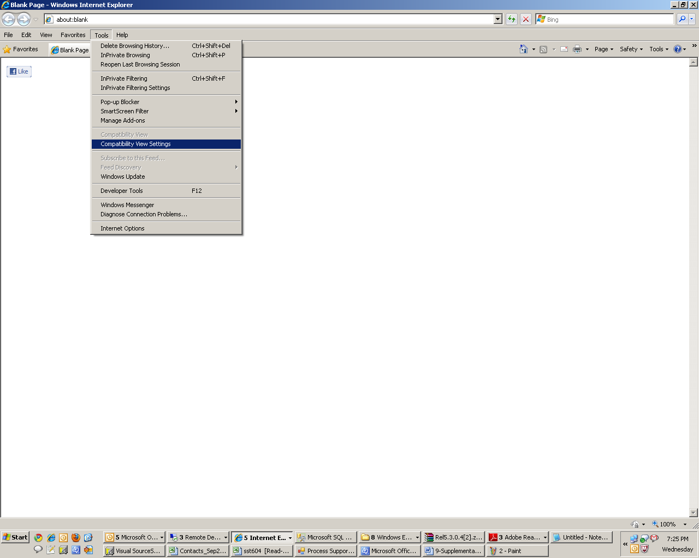

Un-check all the three check boxes in Compatibility View Settings page and make sure that application URL is not exists in the list of Web Sites added for Compatibility View.

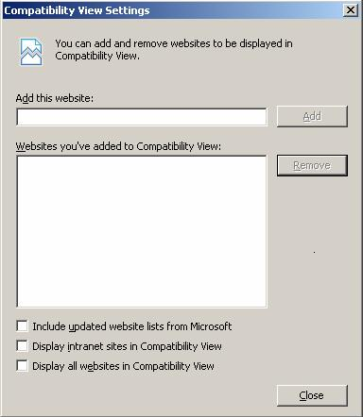
Remove the application URL from this list if already exists.
Un-check all the check boxes.

20.0 Favorite Activities Settings
By default the count for the no. of favorites would be set to 10. This can be increased by changing the "ParameterValue" for the ParameterName “UserFavoritesCount” in "FW_Admin_System_Parameters" table in deployment database.

21.0 Paper Size Settings for Reports
Corporate Office and R&D Center
Ramco Systems Limited, 64, Sardar Patel Road, Taramani Chennai – 600 113, India
Tel: +91 (44) 2235 4510. Fax +91 (44) 2235 2884
www.ramco.com
Following settings to be done for the Paper size for Reports:
(1) Setting needs to be modified in CustomReporting.xml configuration file available under ...IIS\EXTUI\ILRT.
(e.g.) E:\Program Files (x86)\VirtualWorks\IIS\ExtUi\ILRT\CustomReporting.xml
(2) If you want to set "PaperA3" as your default paper size then its correspinding value is "8" (Note: This value can be obtained from the above xml based on the paper size)
(3) Traverse to this XML node <NewPaperSizeForAllReports>.
(4) New NewReportPaperSize value needs to be changed as 8 under XML node <NewPaperSizeDefault>.
(e.g.)
- <NewPaperSizeDefault>
<New NewReportPaperSize="8" />
</NewPaperSizeDefault>

(5) The above settings will be applicable for all reports irrespective of OU, Role. Report paper size can be set Role Specific, OU Specific and both Role OU Specific and also report specific.

