Internet Information Server (IIS) 7.0 Settings – Ramco Aviation Solution

DISCLAIMER
©2012 Ramco Systems Ltd. All rights reserved. All trademarks acknowledged.

This document is published by Ramco Systems Ltd. without any warranty. No part of this document may be reproduced or transmitted in any form or by any means, electronic or mechanical, for any purpose without the written permission of Ramco Systems Limited.
Improvements and changes to this text necessitated by typographical errors, inaccuracies of current information or improvements to software programs and/or equipment, may be made by Ramco Systems Limited, at any time and without notice. Such changes will, however, be incorporated into new editions of this document. Any hard copies of this document are to be regarded as temporary reference copies only.
The documentation has been provided for the entire Aviation solution, although only a part of the entire solution may be deployed at the customer site, in accordance with the license agreement between the customer and Ramco Systems Limited. Therefore, the documentation made available to the customer may refer to features that are not present in the solution purchased / deployed at the customer site.

Table of Contents

1. Introduction 4
1.1 Creating and Setting Properties for Application Pool 4
1.2 Creating and Setting Properties for Virtual Directory 7
1.3 Settings Required to Enable Asynchronous Processing 9
1.4 Default Document Settings 12
1.5 Mime Type Settings 13
1.6 Changes to be made in WEB Server 14
1.7 ASP Session Timeout Settings 15
1.8 Configuration DLL Generation 16

1. Introduction
This installation guide provides necessary guidelines and steps that have to be followed for configuring the Internet Information Server (IIS) 7.0 related to the Ramco Aviation Solution. IIS could be launched through Start → Administrative Tools → Internet Information Service(IIS) Manager (or) Start → Run → Type “inetmgr” → Click Ok.
This comprises the following configurations:
- Creating and Settings properties for Application Pool
- Creating and Settings properties for Virtual Directory
- Default Document Settings
- Mime Type Settings

Creating and Setting Properties for Application Pool
To create Application Pool in IIS, Expand the Server menu from the Connection Tree (in the left pane) and click “Application Pools”, as shown in the below screenshot.
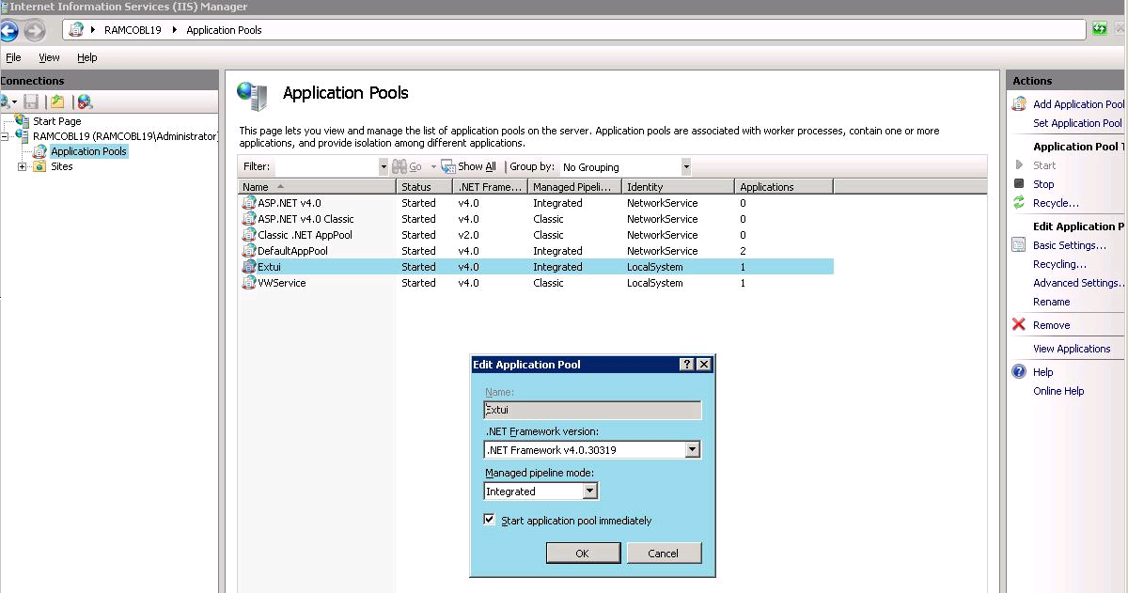

- Click “Add Application Pool…”
- Provide Application Pool name as “EXTUI”
- Set .Net Framework Version as “.Net Framework V4.0.30319”. This is mandatory to make EXTUI work with Windows 2008/ 2008 R2 server.
- Set the Managed pipeline mode to “Integrated”

Once the Application Pool is created, select the “Application pool” Name and click Advanced Settings. It will open a properties window as shown in the below screenshot.

Set the properties as highlighted.

- .Net Framework Version to v4.0
- Enable 32-Bit Applications to True. This is required to enable crystal report 2008 in the server, as this support 32 bit only.
- Ensure Managed Pipeline Mode to “Integrated”.
- Under the Process Model, set “Identity” to “LocalSystem”.
- Set ‘Idle Time-out (Minutes)’ to 60 (recommended value). It can be changed as required.

Continue the settings as shown in the below screenshot with the

- Rapid-Fail Protection – “Enabled” to False
- Expand “Generate Recycle Event Log Entry” and set “Regular Time Interval” to False
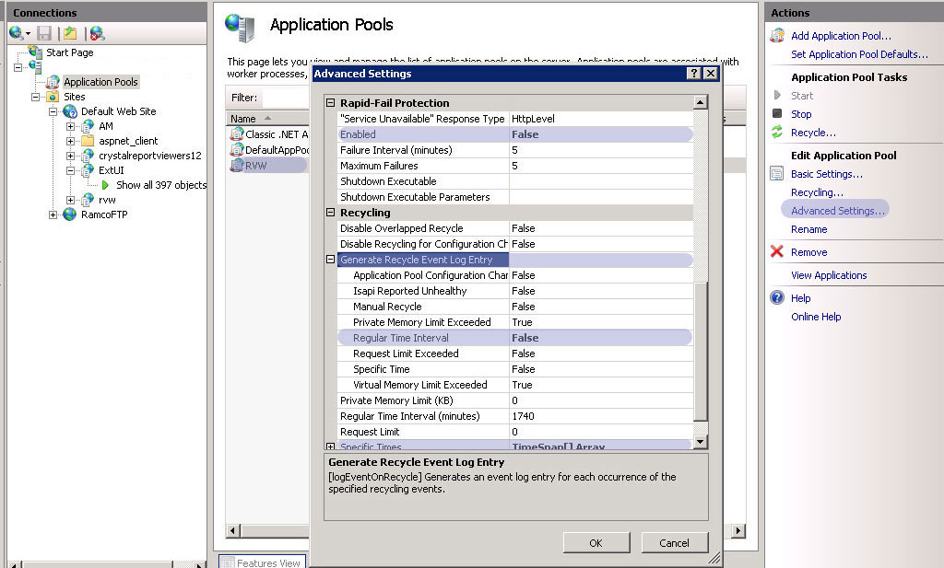

Expand “Specific Times” and Click the button enable on the right corner. It opens a new window as shown in the below screenshot.

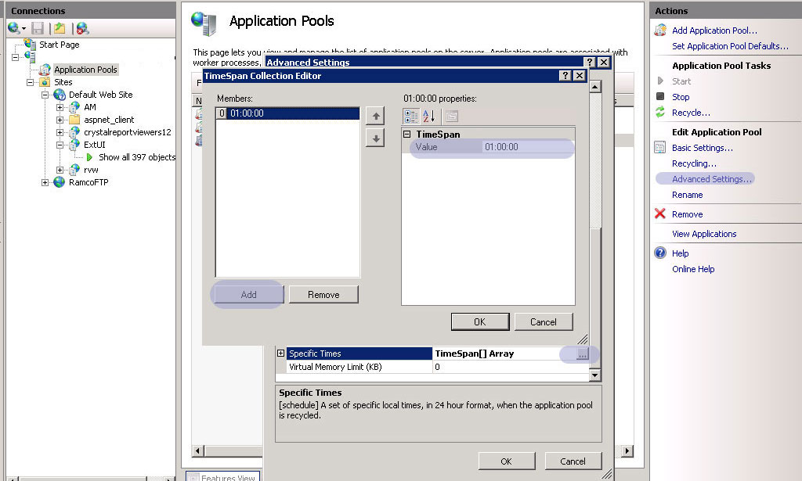

Add TimeSpan with the value “01:00:00” and click ok.

This completes Adding “Application Pool” and setting the required properties.

Creating and Setting Properties for Virtual Directory
To create Virtual Directory, Right click “Default Web Site” and click “Add Virtual Directory…”. It will open a window as shown in the below Screenshot.

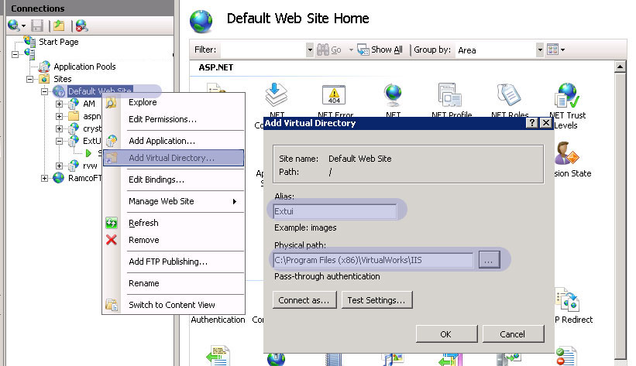

- Provide an Alias name. It can be any name with which the application can be launched in Internet Explore with the convention <http://servername/aliasname>
- Provide the Physical Path as full path of “IIS” folder available in the “Program Files (x86)\VirtualWorks” and click Ok.

This creates the virtual directory.

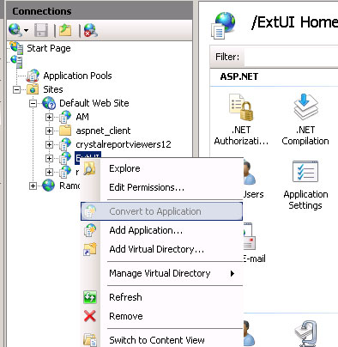

As shown in the above screenshot, right click on the virtual directory and click “Convert to Application”.

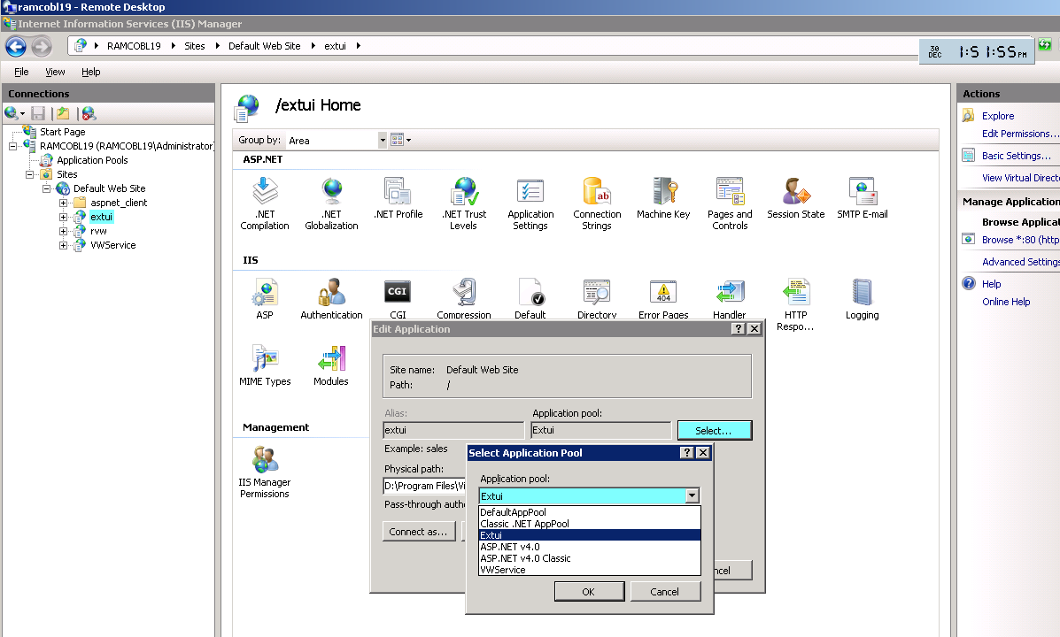

As shown in the above Screenshot, Select the virtual Directory and click “Basic Settings”.
- Click “Select” button against the Application Pool.
- From the dropdown, Select the Application Pool “EXTUI” and click Ok.

This completes the Virtual Directory creation and setting its property.

Settings Required to Enable Asynchronous Processing
Please note that this feature is available only from RT Patch 10. There are two parts to this feature:
- Enabling Asynchronous processing in WEB Layer:
Once the installation of RT Patch in web server is completed, launch Inetmgr and map the Virtual Directory RVW to the Extui application pool.
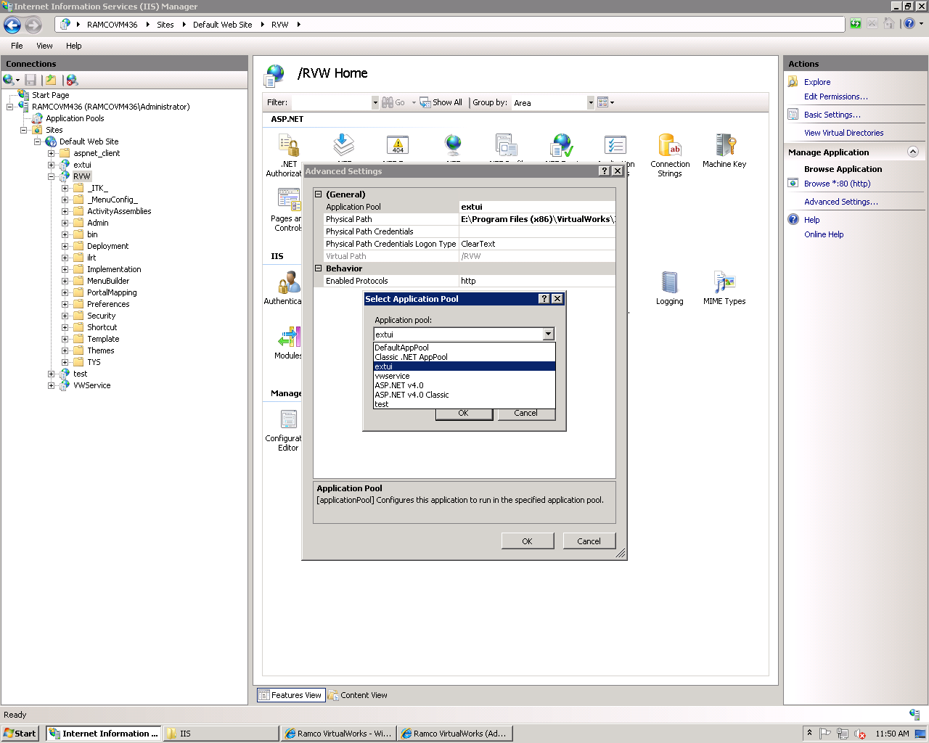

- Enabling usage of WCF in APP Layer:
This feature will be enabled by setting the value of the key <add key="CommunicatorType" value="1"> to 1 in the WEB.Config file (). By enabling this, all calls to the App Layer will be routed through WCF and will by-pass COM+ thus removing the need to deploy application components in COM+. This will reduce the time of the respective component getting loaded in memory for the first call. It is recommended to enable this option only if the servers (WEB and APP) are loaded with Win 2008 / Win 2008 R2 since this functionality works only with IIS 7.0. So this feature requires IIS 7.0 (Web Server Role) to be installed in APP Layer.
While enabling WEB Server Role in the APP Layer (through Server Manager), install the following Features also.
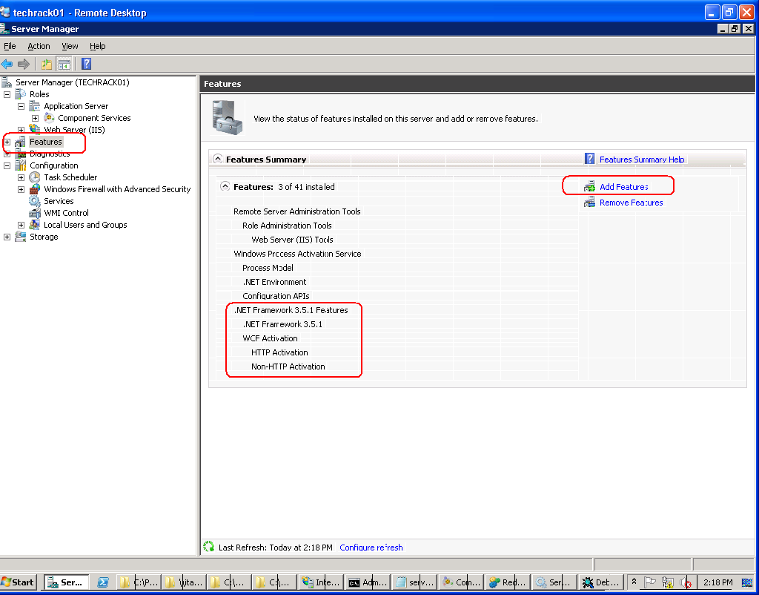
Please note that these features will be available for installation only if .Net Framework 3.5 SP1 is installed.
Once the installation of RT Patch in App server is completed, launch Inetmgr:
  - Map the Virtual Directory VWService to the VWService application pool. If the “VWService” application pool does not exist create the same and make it under the “Local System” Account. (Refer Section 1.2 for Mapping Virtual Directory and 1.1 for Creating Application Pool)

  - Click on VWService virtual Directory and click on the “Advanced Settings” available on the right pane. On the window that gets opened, go to enabled protocols and append the values net.tcp, net.pipe (separated by comma).

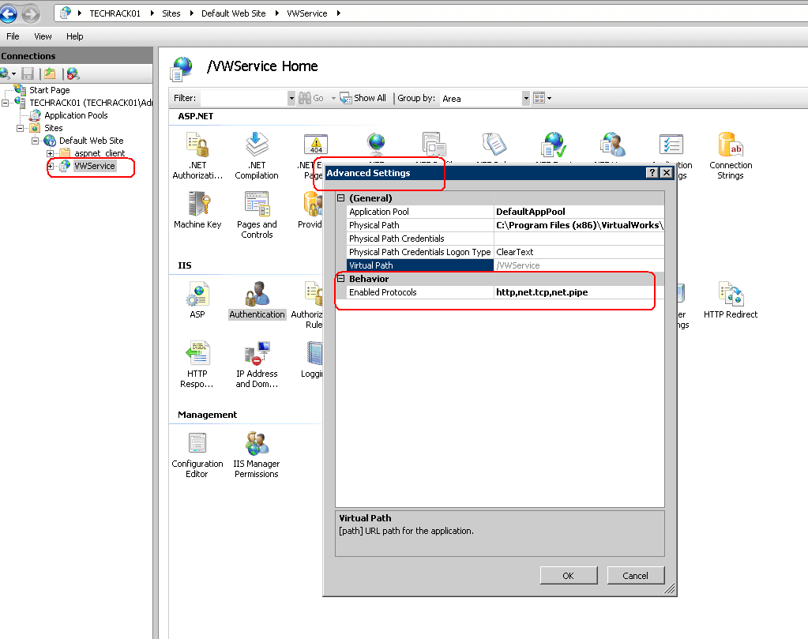
Make sure that the following services are running in the APP Layer:
- Net.Pipe Listener Adapter
- Net.Tcp Listener Adapter
- Ramco.VW.RT.GatewayServerHost

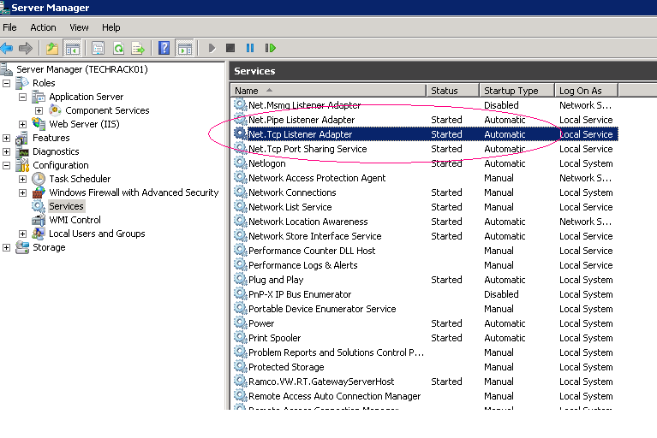

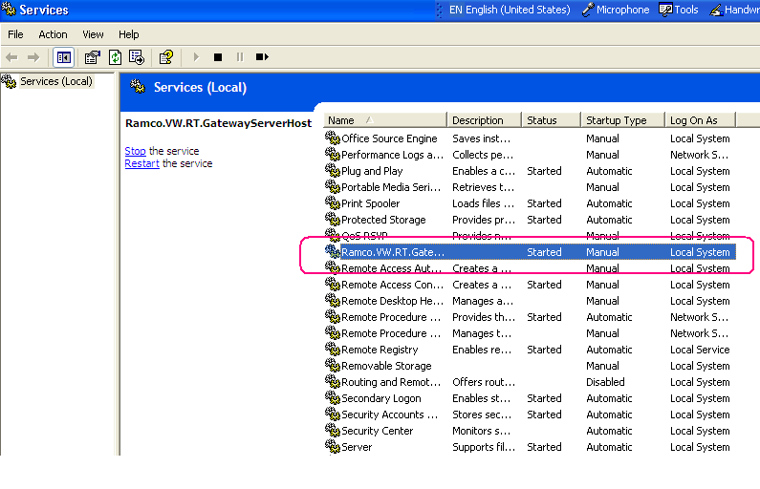

Default Document Settings
Ramco’s RVW uses “extui.aspx” as the startup/default document. To set this, double click the Virtual Directory. In the center pane, under “IIS”, double click the “Default Document”, as shown in the below screenshot:
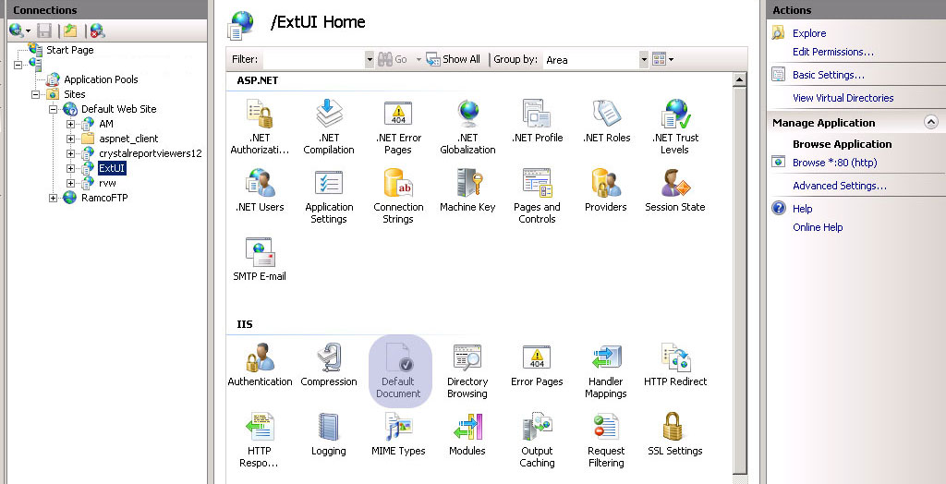

A new window will open, listed with all the default documents, as shown in the below screenshot:
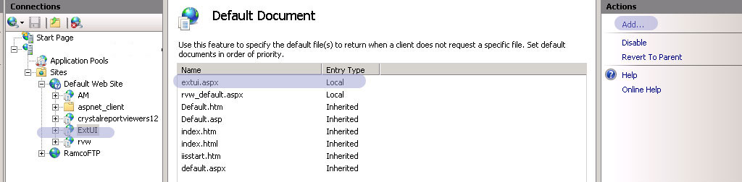

Click “Add…” link given on the right pane and provide Name as “extui.aspx”.

Ensure that the default document name “extui.aspx” is on first among the list.

Mime Type Settings
Ramco Aviation application is integrated with Nertronics Varchart (Gantt chart Control) and also Microsoft Project. To enable these plugin’s in Internet explorer, we need to add respective mime types in the IIS.

To set this, double click the Virtual Directory. In the center pane, under “IIS”, double click the “Mime Types”, as shown in the below screenshot.

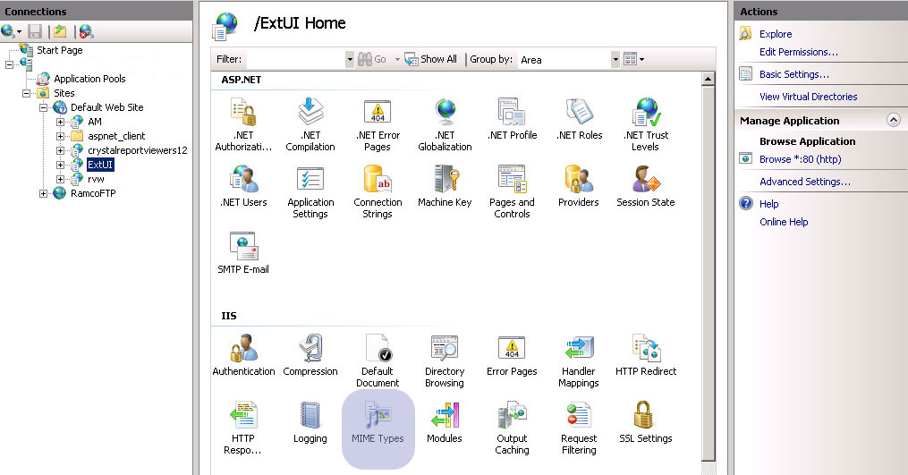

As shown in the below screenshot, in the Mime Type Window, Click “Add…” link.

Add the following Mime types one by one.

- File Name Extension : “.ifd”; Mime Type: “text/xml”
- File Name Extension : “.ini”; Mime Type: “text/xml”
- File Name Extension : “.mpp”; Mime Type: “application/vnd.ms-project”
- File Name Extension : “.mpt”; Mime Type: “application/vnd.ms-project”

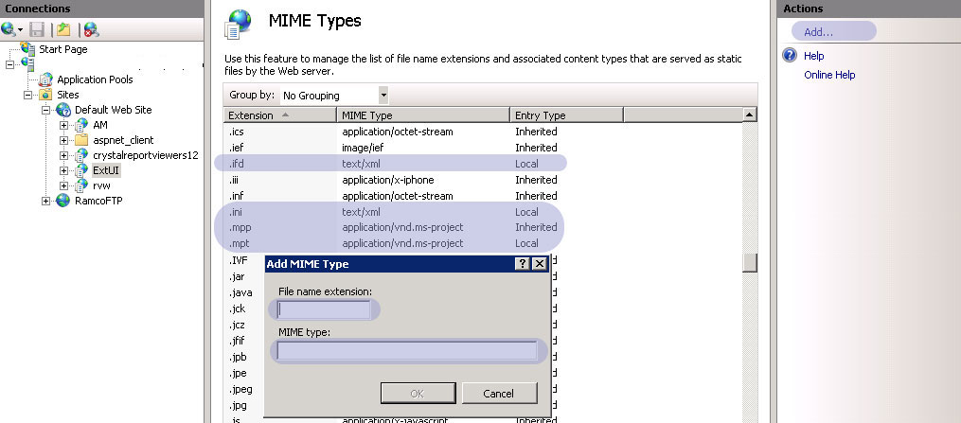

Changes to be made in WEB Server
Open the WEB.Config file (This file can be opened in notepad application itself) available in the WEB Server under ..\Program Files\VirtualWorks\IIS folder and look for the entry:
<sessionState mode="InProc" cookieless="false" timeout="20" />
Change this to:
<sessionState mode="InProc" cookieless="true" timeout="60" />
Save the changes and restart IIS in the WEB Server.

ASP Session Timeout Settings
Modify the ASP Session timeout option for RVW Virtual directory from 20 minutes to 1 hour.
  - To modify this setting, open IIS and click on the “RVW” virtual directory. (for EXTUI based environment, setting needs to be done for EXTUI virtual directory).

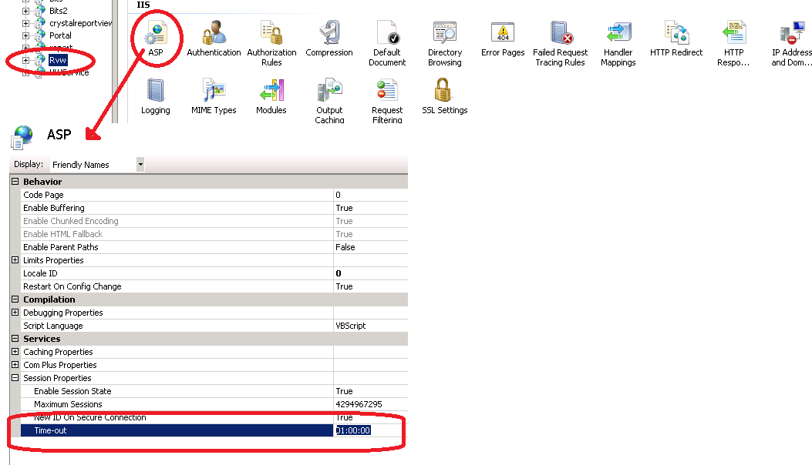
  - Increase the value of “Time-out” under “Session properties” section from 20 minutes to 60 minutes.

Configuration DLL Generation
After the above settings, configuration dlls needs to be re-generated and needs to be deployed in GAC. Please refer the step by step document below for Configuration Dll generation.

Document Name | Document Attachment | Reference Sections
11-Configuration DLL Generation.docx |  | All

- End of Document -

\

Corporate Office and R&D Center
Ramco Systems Limited, 64, Sardar Patel Road, Taramani, Chennai – 600 113, India
Tel: +91 (44) 2235 4510. Fax +91 (44) 2235 2884
www.ramco.com

