VirtualWorksTM Runtime Dot Net Installation Document – RM (Database) Server

DISCLAIMER

**©2009 Ramco Systems Ltd. All rights reserved. All trademarks acknowledged.**

This document is published by **Ramco Systems Ltd.** without any warranty. No part of this document may be reproduced or transmitted in any form or by any means, electronic or mechanical, for any purpose without the written permission of **Ramco Systems Limited.**

Improvements and changes to this text necessitated by typographical errors, inaccuracies of current information or improvements to software programs and/or equipment, may be made by Ramco Systems Limited, at any time and without notice. Such changes will, however, be incorporated into new editions of this document. Any hard copies of this document are to be regarded as temporary reference copies only.

The documentation has been provided for the entire Aviation solution, although only a part of the entire solution may be deployed at the customer site, in accordance with the license agreement between the customer and Ramco Systems Limited. Therefore, the documentation made available to the customer may refer to features that are not present in the solution purchased / deployed at the customer site.

Revision History

|  |  |  |  |
| --- | --- | --- | --- |
| Version | Date | Author | Description |
| 1.0 | 22/12/2009 | Karthik R | Created |
| 1.1 | 21/04/2010 | Manigandan R | Modified |
|  |  |  |  |
|  |  |  |  |
|  |  |  |  |

**Table of Contents**

1.1 RM Server Installation – Deployment Components 4

**VirtualWorksTM** **DotNet Runtime – RM Server Installation**

This document walks through the steps for installing VirtualWorksTM .Net Runtime (Microsoft Version).

# 1.1 RM Server Installation – Deployment Components

1. If File Server is a separate machine, then launch the share path “\\File Serve Name\Deploy\Installer”. If there is no separate file server, then go to the folder “Web Server Name\Deploy\Installer folder and run the file DeploymentSetup.MSI. Click “Next” on the Introduction screen.

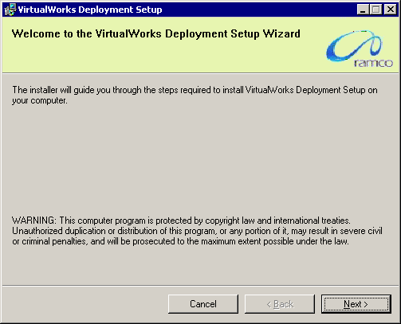

1. Clicking Next, will redirect to the Resource Manager Database Details Screen where Database Server details will be prompted for. Provide the server name which will represent the Database Server name. Provide the SA password, database file path. The temporary file path will be defaulted which need not be modified. Click on Next to proceed further.

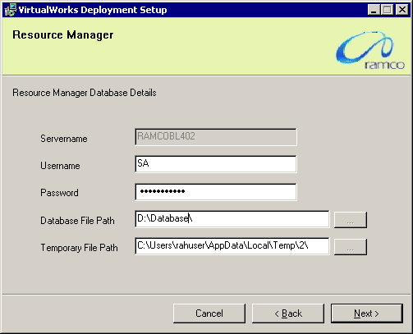

1. Clicking Next will display the confirmation screen which will display list of Deployment components to be deployed as part of the database layer.

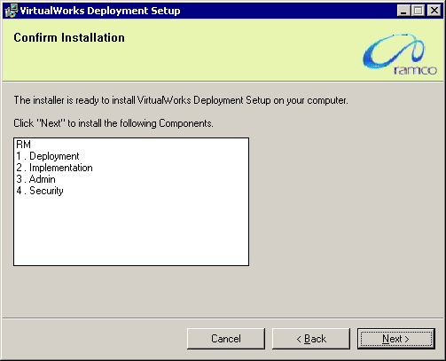

1. Clicking Next will complete the installation of RM Layer Deployment components.

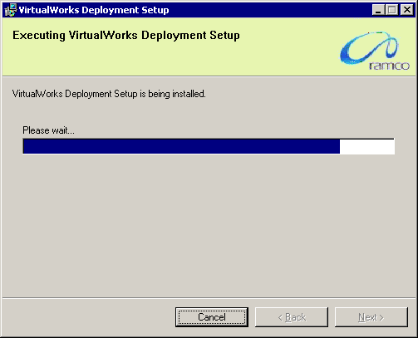

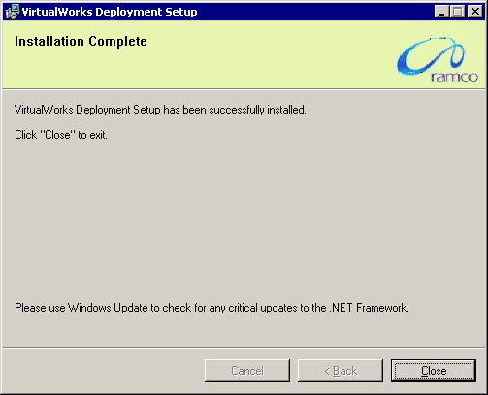

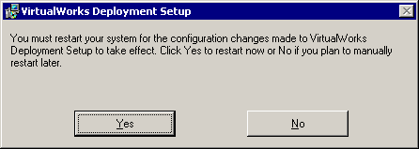

1. Once the installation is complete, system will prompt for restarting the server. Please restart the server now. This completes the installation of RM (Database) Layer Deployment components. Proceed with VirtualWorksTM Runtime Patch Installation.

**- End of Document -**

Corporate Office and R&D Center

Ramco Systems Limited, 64, Sardar Patel Road, Taramani Chennai – 600 113, India

Tel: +91 (44) 2235 4510. Fax +91 (44) 2235 2884

www.ramco.com