VirtualWorksTM Runtime Dot Net Installation Document – WEB Server Installation

DISCLAIMER

**©2009 Ramco Systems Ltd. All rights reserved. All trademarks acknowledged.**

This document is published by **Ramco Systems Ltd.** without any warranty. No part of this document may be reproduced or transmitted in any form or by any means, electronic or mechanical, for any purpose without the written permission of **Ramco Systems Limited.**

Improvements and changes to this text necessitated by typographical errors, inaccuracies of current information or improvements to software programs and/or equipment, may be made by Ramco Systems Limited, at any time and without notice. Such changes will, however, be incorporated into new editions of this document. Any hard copies of this document are to be regarded as temporary reference copies only.

The documentation has been provided for the entire Aviation solution, although only a part of the entire solution may be deployed at the customer site, in accordance with the license agreement between the customer and Ramco Systems Limited. Therefore, the documentation made available to the customer may refer to features that are not present in the solution purchased / deployed at the customer site.

Revision History

|  |  |  |  |
| --- | --- | --- | --- |
| Version | Date | Author | Description |
| 1.0 | 22/12/2009 | Karthik R | Created |
| 1.1 | 21/04/2010 | Manigandan R | Modified |
|  |  |  |  |
|  |  |  |  |
|  |  |  |  |

**Table of Contents**

1.1 WEB Server Installation – Core RT Components 4

1.2 WEB Server Installation – Deployment Components 6

**VirtualWorksTM** **DotNet Runtime – WEB Server Installation**

# 1.1 WEB Server Installation – Core RT Components

1. If File Server is a separate machine, then launch the share path “\\File Serve Name\Deploy\Installer”. If there is no separate file server, then go to the folder “DriveName\Program Files(x86)\Virtualworks\ADS\Installer folder and run the file RuntimeSetup.MSI. Click “Next” on the Introduction screen.

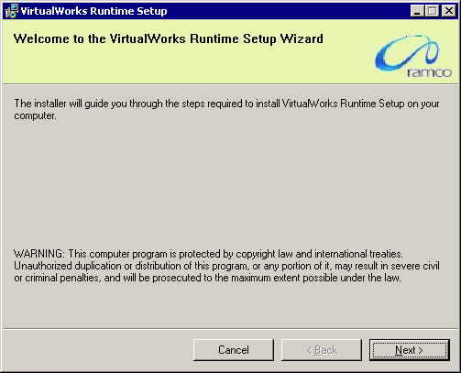

1. Clicking Next, will redirect to the Confirm Installation Screen where the list of layers appropriate for this server would be listed. This information depends on the data that was given in the Deployment Wizard application under File Server installation. Currently the assumption is that the WEB and the APP Layers are installed in two separate machines and this document will guide through the WEB Server installation steps. So this screen would list only the WEB layer.

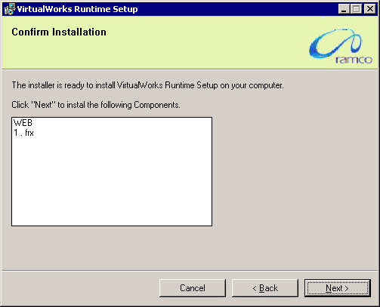

1. Clicking Next will complete the installation of WEB Layer components.

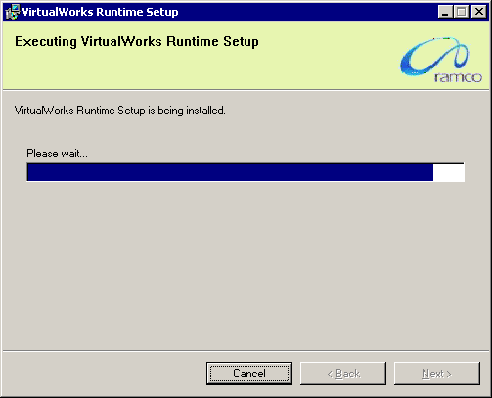

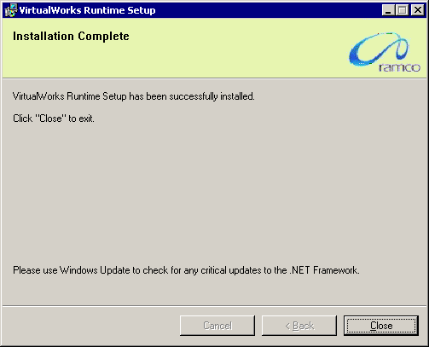

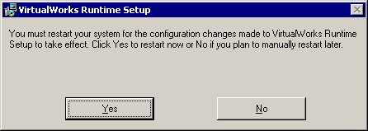

1. Once the installation is complete, system will prompt for restarting the server. Please do not restart the server now. This completes the installation of WEB Layer core Runtime components.

# 1.2 WEB Server Installation – Deployment Components

1. If File Server is a separate machine, then launch the share path “\\File Serve Name\Deploy\Installer”. If there is no separate file server, then go to the folder “DriveName\Program Files(x86)\Virtualworks\ADS\Installer folder and run the file DeploymentSetup.MSI. Click Next on the Introduction screen.

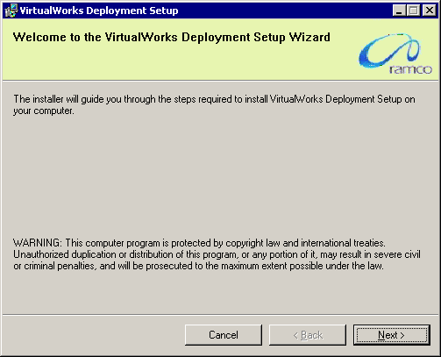

1. Clicking Next, will redirect to the Confirm Installation Screen where the list of components for Layer appropriate for this server would be listed. This information again depends on the data that was given in the Deployment Wizard application under File Server installation. As specified above this screen would list only the WEB layer components.

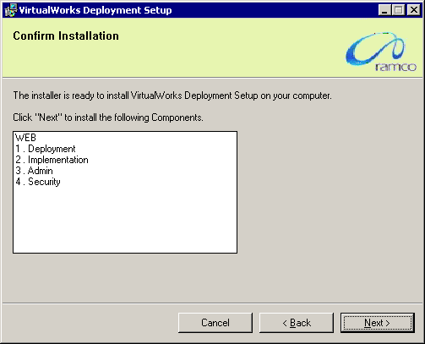

1. Clicking Next will complete the installation of WEB Layer Deployment components.

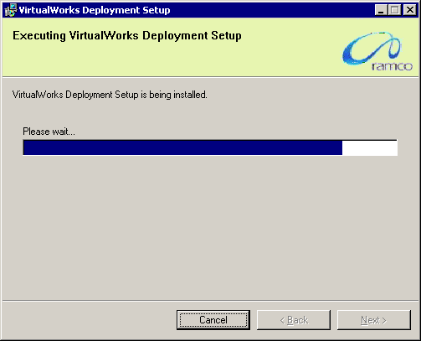

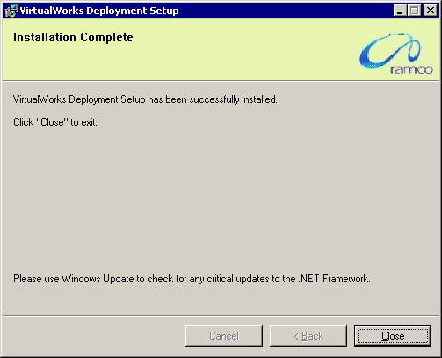

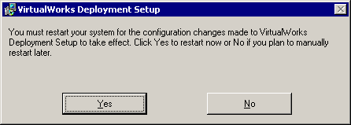

1. Once the installation is complete, system will prompt for restarting the server. Please restart the server now. This completes the installation of WEB Layer Deployment components. Proceed with VirtualWorksTM App Layer Installation.

**- End of Document -**

Corporate Office and R&D Center

Ramco Systems Limited, 64, Sardar Patel Road, Taramani Chennai – 600 113, India

Tel: +91 (44) 2235 4510. Fax +91 (44) 2235 2884

www.ramco.com