Installation Manual for Manage consolidated financial statements package.

DISCLAIMER
©2012 Ramco Systems Ltd. All rights reserved. All trademarks acknowledged.

This document is published by Ramco Systems Ltd. without any warranty. No part of this document may be reproduced or transmitted in any form or by any means, electronic or mechanical, for any purpose without the written permission of Ramco Systems Limited.
Improvements and changes to this text necessitated by typographical errors, inaccuracies of current information or improvements to software programs and/or equipment, may be made by Ramco Systems Limited, at any time and without notice. Such changes will, however, be incorporated into new editions of this document. Any hard copies of this document are to be regarded as temporary reference copies only.
The documentation has been provided for the entire Aviation solution, although only a part of the entire solution may be deployed at the customer site, in accordance with the license agreement between the customer and Ramco Systems Limited. Therefore, the documentation made available to the customer may refer to features that are not present in the solution purchased / deployed at the customer site.

Table of Contents

1. Introduction 4
2. Prerequisite for Installation 4
3. Deployment 5
4. System Configuration and Manual settings 8

1. Introduction

This installation guide provides necessary guidelines and steps that have to be followed for installing the necessary components required for the ‘Consolidated Financial Reporting’ function.

The installation comprises of the following
- FinancialReport.msi (This will install the ‘exe’ which needs to be run in the web server)
- Backend scheduler jobs ( Instructions will be provided in the manual to configure the same )

2. Prerequisite for Installation

- MS Office 2007 in the Web Server.
Please verify that Microsoft.Office.Interop.Excel assembly is available in C:\Windows\Assembly
- .net framework 2.0 or above in the Web Server

3. Deployment
- Run the FinanceReport.msi file to initiate the installation .This file will be available in the folder - IIS\EXTUI\REP
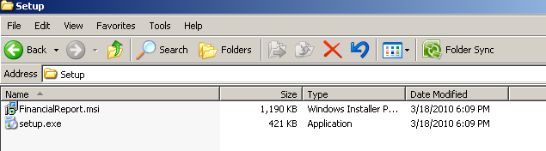

The Following screen shots will guide through the installation.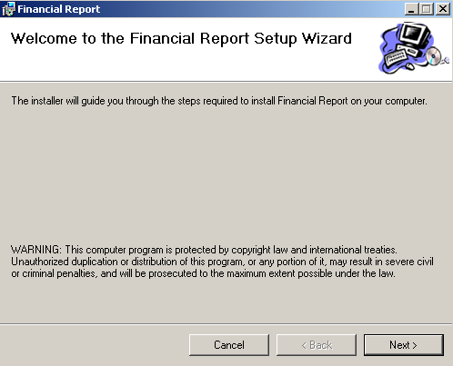

Click “Next” to continue
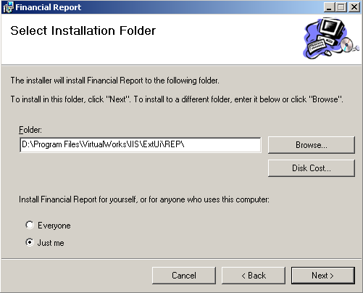

Provide the same installation path as shown in the above screen shot, referring to the drive where IIS is installed.
Click “Next” to continue
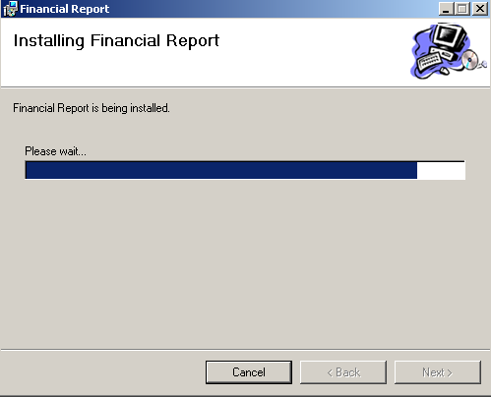
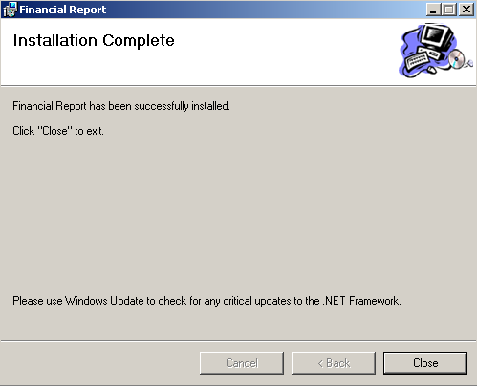

4. System Configuration and Manual settings
- Configuring Deploy.ini file
Financial Report exe will work based on the details provided in Deploy.ini file., located in ‘..IIS\EXTUI\REP\deploy.ini’ (path in which the exe was installed).
Provide following details in the deploy.ini file.
<Server name>: The RM Server name
<Username>: Username with read permission
<Password>
<Application database name>
<Input pathname (Report template and Report input xml file to be placed) >: D:\Program Files\VirtualWorks\IIS\Extui\REP

<Output pathname (Report outputs generation path) >:
D:\Program Files\VirtualWorks\IIS\Extui\REP
<Report-Input Xml file name> : FDP-ReportList.xml

<Report Generation Template file name> : FDP-Template.xlsm

Sample settings in Deploy.ini have been provided below for reference:
Ramcovm430
Rvwuser
Rvw
AVNAPPDB
E:\Program Files\VirtualWorks\IIS\Extui\REP
E:\Program Files\VirtualWorks\IIS\Extui\REP

FDP-ReportList.xml

FDP-Template.xlsm

- Macro Settings
Open an excel application
Select excel options from the menu as show in the below screen shot

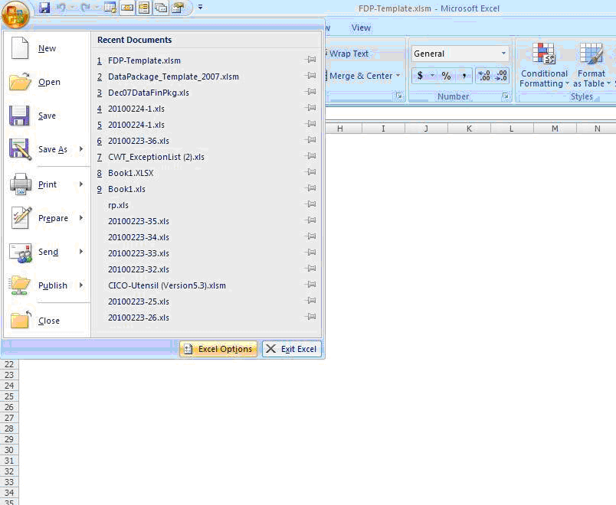

In the Trust Center tab --> Macro settings select the below option
Disable all macros except digitally signed.
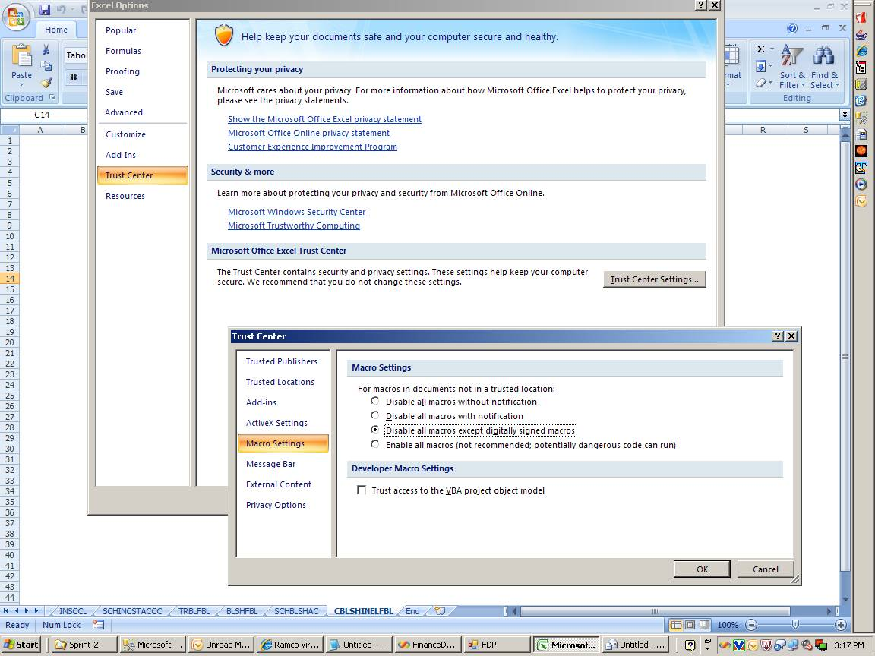

Click “Ok” to apply the settings
- CIM Interactions
Kindly ensure that the CIM interactions are provided as per the excel provided in the shipment.
- New activity role mapping
Kindly do the role mappings for the new activity mentioned in the excel provided in the shipment.
- Option settings in the application.
Launch the set option screen from
Utilities --> Doc attachment --> Set options
Provide Reports keeping’s FTP destination folder in the multiline for the Financial Reports as shown in the below screen shot.
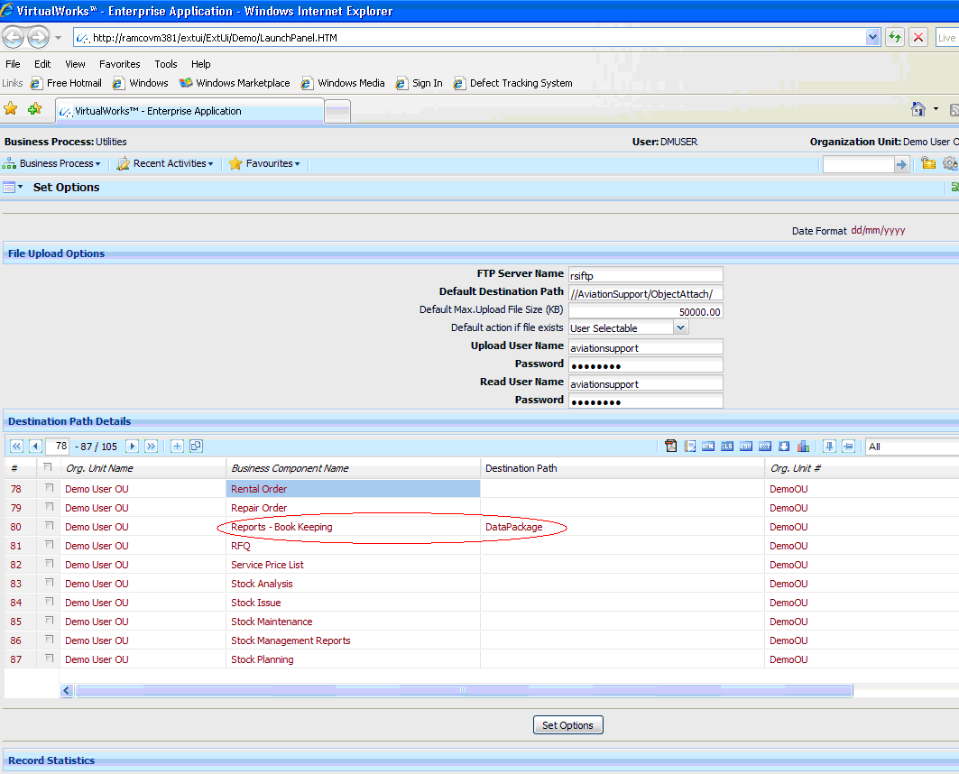

- Setting up of scheduler jobs
Create and enable the jobs for following sps:
SP Name | Purpose
Dtpkg_main_sceduler | Job to initiate business logic for reports
Dtpkg_TrialBal_Main_SP | Trial Balance Report
Dtpkg_BalSheet_Main_SP | Balance Sheet Report
Dtpkg_incstmtfb_Main_SP | Income statement Report
dtpkg_incomestmnt_main_sp | Cost Center profitability Report
Dtpkg_output_data_popln_sch | Job to assess the readiness of data package Ref # for “Export to Excel”

Corporate Office and R&D Center
Ramco Systems Limited, 64, Sardar Patel Road, Taramani, Chennai – 600 113, India
Tel: +91 (44) 2235 4510. Fax +91 (44) 2235 2884
www.ramco.com

