Application Client Side Settings

DISCLAIMER
©2012 Ramco Systems Ltd. All rights reserved. All trademarks acknowledged.

This document is published by Ramco Systems Ltd. without any warranty. No part of this document may be reproduced or transmitted in any form or by any means, electronic or mechanical, for any purpose without the written permission of Ramco Systems Limited.
Improvements and changes to this text necessitated by typographical errors, inaccuracies of current information or improvements to software programs and/or equipment, may be made by Ramco Systems Limited, at any time and without notice. Such changes will, however, be incorporated into new editions of this document. Any hard copies of this document are to be regarded as temporary reference copies only.
The documentation has been provided for the entire Aviation solution, although only a part of the entire solution may be deployed at the customer site, in accordance with the license agreement between the customer and Ramco Systems Limited. Therefore, the documentation made available to the customer may refer to features that are not present in the solution purchased / deployed at the customer site.

Table of Contents

1. Introduction 4
1.1 Steps for Client Setting Configuration 4
1.2 Information on Ramco Client Utility Changes to the Client 17

Introduction
This installation guide provides necessary guidelines and steps that have to be followed for configuring the supporting utilities for Ramco Aviation application suite client machines.
In addition to the minimum client settings, advanced client side settings for enabling the following features are also documented below:
- Planning Board
- Work Monitoring and Control
- MS project Integration
- Object Attachment
- Smart Card
- Crystal Report Viewer
- MCR Status Report

Note: Please refer the COTS for recommended browser version.

1.1 Steps for Client Setting Configuration
Following are the two steps for client settings:

Step1:
Two options are available for performing step1:

Option 1 –Using RamcoClientUtility.Exe, after executing this exe in all the client machines required settings will get enabled.
Note: Refer the section “Information on Ramco Client Utility Changes to the Client” for details of changes done by the utility to the client machine.
Option 2 – Manual Steps, Follow the instructions as given below.
Note: Skip the manual steps, if RamcoClientUtility.exe is used for client settings.
Following steps are required to download and Register the ActiveX controls and supporting Dlls from Web Server.

Note: These settings are common for Planning Board, Work Monitoring & Control, MSP Integration, Object Attachment and Smart Card.

Open Internet Explorer
Go to Tools -> Internet Option

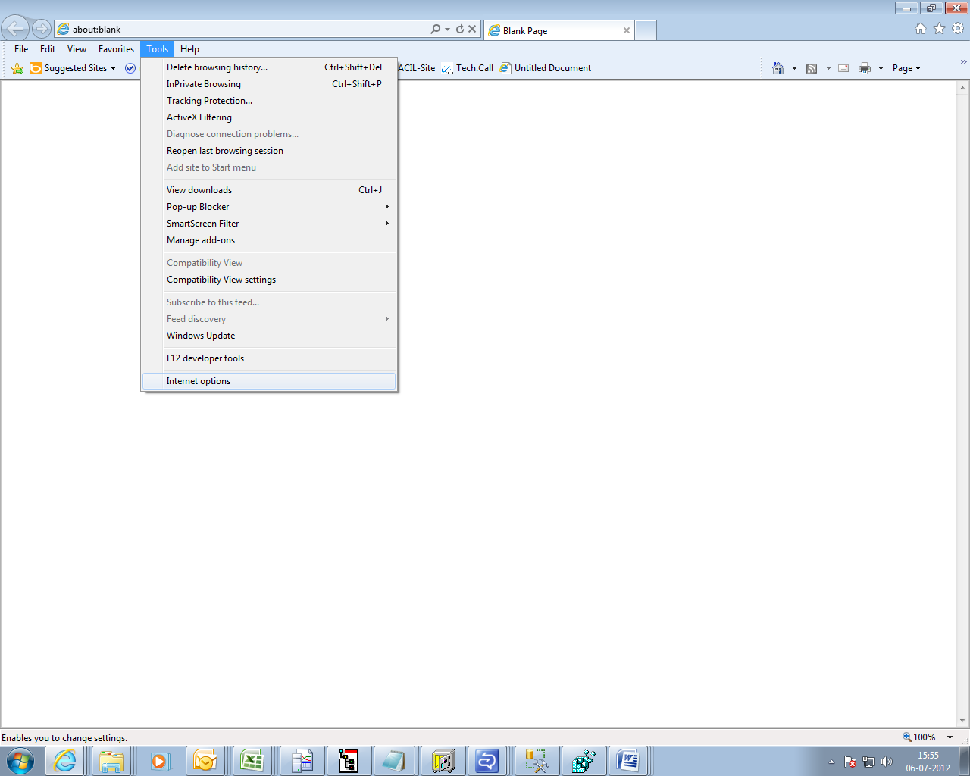

Click on Security Tab

Select Trusted Sites

Click on Custom Level
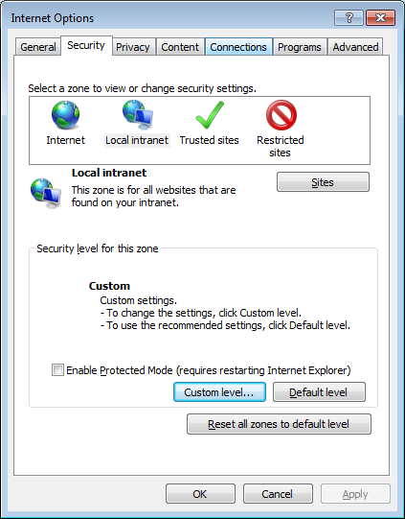

Select Enable option in Download signed ActiveX controls under the group ActiveX controls and Plug-ins.

Note: This setting is common for Planning Board, Work Monitoring & Control, MSP Integration,Object Attachment and Smart Card

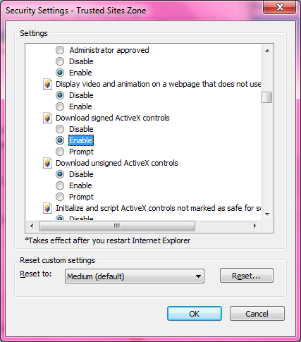

2. Allow the browser to initiate the ActiveX control and scripting it

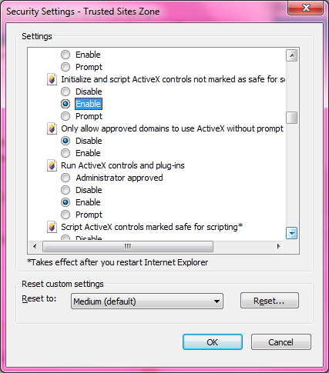

Step2:
This step to be performed, after completing step 1, covers additional settings required

- From the Internet Explorer, select Tools menu.
- From the Tools menu, click the Internet Options.
- From the General tab, select the Settings in the ‘Browsing History’ cluster.

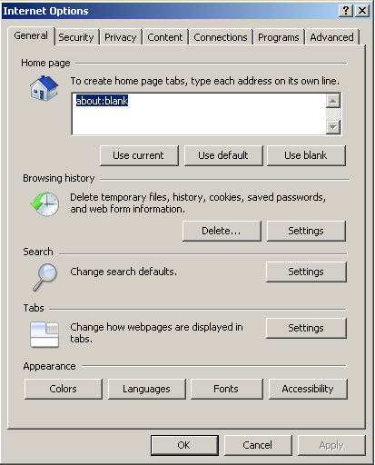

- Enable the option “Every time I Visit the webpage” under “Check for newer versions of Stored Pages”.
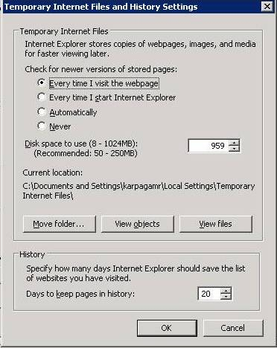

- From the Security tab, select the ‘trusted sites’ and then click Sites button.
- From the Security tab, select the Trusted sites and click Custom level… button

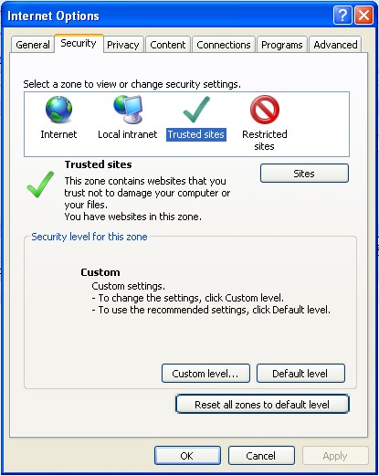

- Add the application URL and FTP server URL to the list of trusted websites.

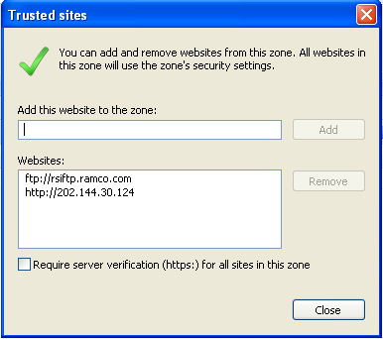

- In Reset custom settings, select the “Reset to:” to Medium-low or Low and click the Reset button.

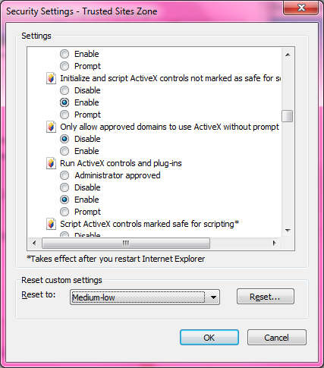
- From the Advanced Tab, select the Allow Software to run or install even if signature is invalid check box.

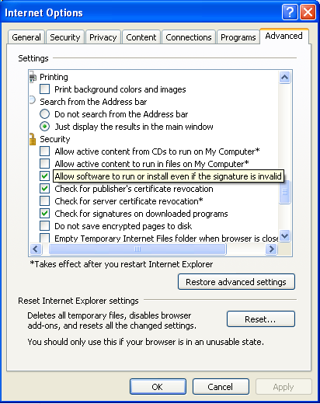

- Select Pop-up Blocker in the Tools menu.
- Select the Turn-off Pop-up Blocker, if it is turned on.
- Click on Tools -> Compatibility View Settings option. On the dialog that gets opened (Refer image below), uncheck all the three check boxes at the bottom of the dialog as shown below.

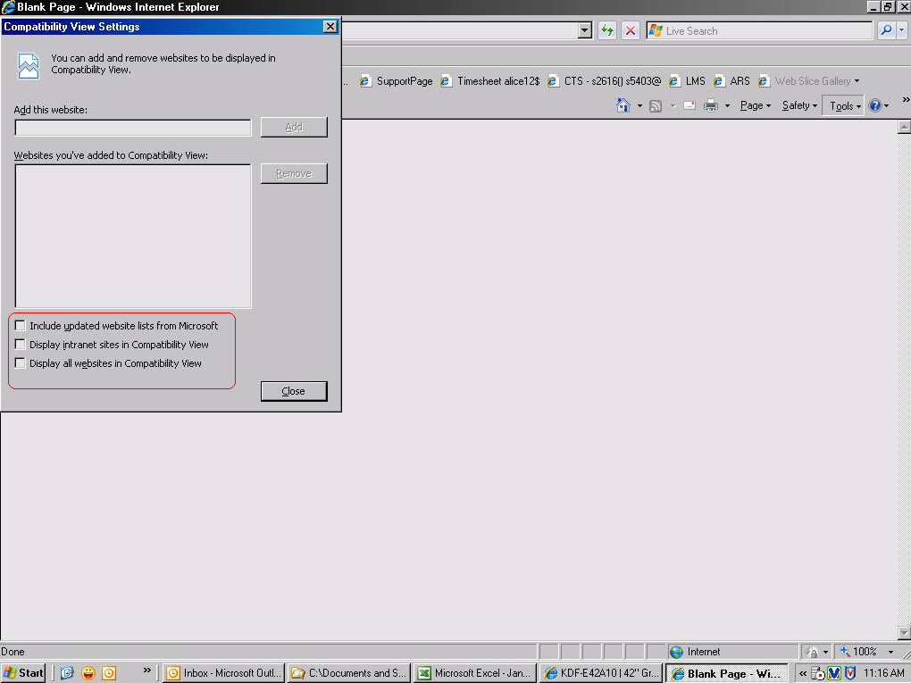

- Go to Tools -> Internet Options -> Advanced Tab
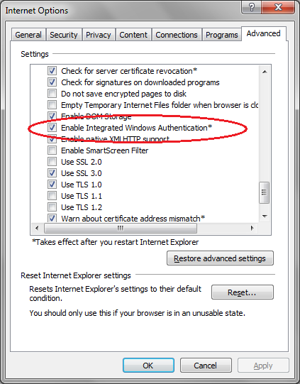
- Enable the “Enable Integrated Windows Authentication (requires restart)” option. (This option is required only if Single SignOn with AD Integration feature is on in Ramco VirtualWorksTM)
- Enable the “Empty Temporary Internet Files Folder when browser is closed” option as shown in the above picture.
- Click on Ok and Restart Internet Explorer.

For displaying success messages in the status bar:
- Go to Tools -> Internet Options -> Security Tab -> Choose Trusted Sites Zone -> Custom Level.
- Search for the option "Allow Status Bar Updates via Scripts". By default, this option would be disabled. Enable this option. (Refer the image below)
- For .Net based Runtime installations, this setting would be required only if the application is configured to run under Standard (non-Deluxe) Menu (Deluxe Menu is introduced post .Net RT Patch 8)

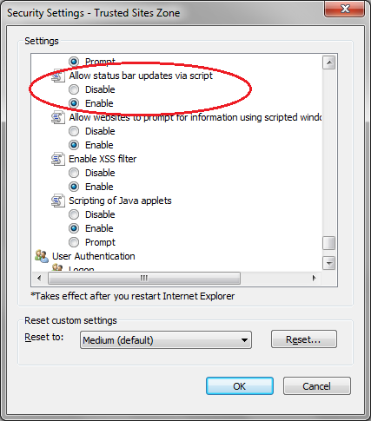

Following Settings to be done for the feature MCR Status Report:
To View MCR Status report, Microsoft Office (Version 2003) is required in client machines. While installing Microsoft Office 2003, the Option “Install Microsoft Office Web Components” should be selected.
Note: Microsoft office web components come as an Add-in package with Office 2003 Installation CD.
If Microsoft Office 2007 is already installed, then the Microsoft Office Web components can be installed through Control Panel -> “Add or Remove Components” program option.

Smart Card Settings:
Refer the attached Smart Card Installation document to enable setting related to Smart Card feature:

Other Recommendations:
- Remove Yahoo Toolbar, Google toolbar if installed.
- Turn off popup blocker for the Trusted Sites security zone on which the site is being launched.

End of Client Settings Process.

1.2 Information on Ramco Client Utility Changes to the Client
RamcoClientUtility.exe is an MSI package generated and distributed along Ramco Aviation Solutions.
This MSI package will do the following client side settings.

- Downloading and Registering the below listed ActiveX controls and supporting Dlls.
  - Planning Board and Work Monitoring & Control
    - gdiplus.dll
    - mfc80u.dll
    - Microsoft.VC80.CRT.manifest
    - Microsoft.VC80.MFC.manifest
    - msvcp80.dll
    - msvcr80.dll
    - opsaps.dll
    - OverlapActiveX.inf
    - OverlapActiveX.ocx
    - vcgantt.ifd
    - vcgantt.inf
    - vcgantt.ini
    - vcgantt.ocx
    - vcganttd.dll
    - vcpane32u.dll
    - vcprct32u.dll
    - vcwin32u.dll
    - vxcsv32u.dll
  - MSP Integration
    - LaunchMSP.dll
    - LaunchMSP.INF
    - MSPRJ.OLB
    - msvcrt.dll
    - msxml6.dll
    - winhttp.dll
    - wmiscriptutils.dll
  - Object Attachment
    - DocAttach.dll
    - DocAttach.INF
    - MAJODIO.DLL
    - myFTP.INF
  - Smart Card
    - Scardi_Admin.dll
    - Scardi_Admin.INF
    - SCardLibRamcoAdmin.dll
    - SCardLibRamcoUser.dll
  - Crystal Viewer
    - csprintdlg.dll
    - DependencyInstaller
    - gdiplus.dll
    - LCIDTable
    - Microsoft.VC80.CRT.manifest
    - msvcr80.dll
    - PrintControl.zip
    - PrintControl.dll
    - PrintControl
    - pvlocale-1-0.dll
    - usp10.dll
    - xerces-c_2_7.dll

2. To enable the settings “Initialize and script ActiveX controls not marked as safe for scripting” appropriate entries in the system registry is done.

Corporate Office and R&D Center
Ramco Systems Limited, 64, Sardar Patel Road, Taramani, Chennai – 600 113, India
Tel: +91 (44) 2235 4510. Fax +91 (44) 2235 2884
www.ramco.com

