Admin Settings

DISCLAIMER

**©2009 Ramco Systems Ltd. All rights reserved. All trademarks acknowledged.**

This document is published by **Ramco Systems Ltd.** without any warranty. No part of this document may be reproduced or transmitted in any form or by any means, electronic or mechanical, for any purpose without the written permission of **Ramco Systems Limited.**

Improvements and changes to this text necessitated by typographical errors, inaccuracies of current information or improvements to software programs and/or equipment, may be made by Ramco Systems Limited, at any time and without notice. Such changes will, however, be incorporated into new editions of this document. Any hard copies of this document are to be regarded as temporary reference copies only.

The documentation has been provided for the entire Aviation solution, although only a part of the entire solution may be deployed at the customer site, in accordance with the license agreement between the customer and Ramco Systems Limited. Therefore, the documentation made available to the customer may refer to features that are not present in the solution purchased / deployed at the customer site.

# Administration Activities

The following is the pre-requisite for the configuration of component using deployment workbench:

* ‘Deployment meta data scripts’ for components to be executed in the application deployment database (i.e., depdb)
* Ensure the application web server is running
* Identify Organization Unit (OU) Instances for the application
* Identify Roles for the application
* Identify Users for the application
* Identify Resources for the application

Once the prerequisites are verified, the components would be available for the application.

For execution of Deployment Workbench, launch Internet Explorer. Provide the “Address” as ‘http ://<webservername>/rvw’, the “Web Server Name” as entered for deployment during RVW runtime installation. Enter the login (Application administrator) details specified during installation of the deployment workbench (Initial Role Specific screen, See Figure 26). Then click the Login Option.

The deployment workbench process is divided into three processes namely:

* Implementation process: Identify the functional units of an application. The functional unit is then associated to the business components, which carry out the required business functionality. The information flow among the various functional units carrying out several business functions in the application is then captured. The various roles and their responsibilities in the application are defined.
* Deployment process: The computing resources of an application are defined. The connectivity among the computing resources is also defined. The business functions performed by the functional units of an application are associated to the computing resources.
* Administration process: The users of the application are defined. Users will be assigned to the roles created to carry out the activities provided by the business components in the various functional units of an application. Business process chain definitions are defined. Precision definitions are defined.

The step below shows the setup of application for a new installation, i.e., Registering Ou, Roles, Users, Resources And Its Relationship, Component And Its Relationship With User – Role – Ou etc.,

Step 1: Activity: Organization Unit Instance Details (Implementation process)

This activity is used for maintaining OU (functional Unit) instances of an enterprise, where one or more business functions are performed.

Click the activity. The main page appears

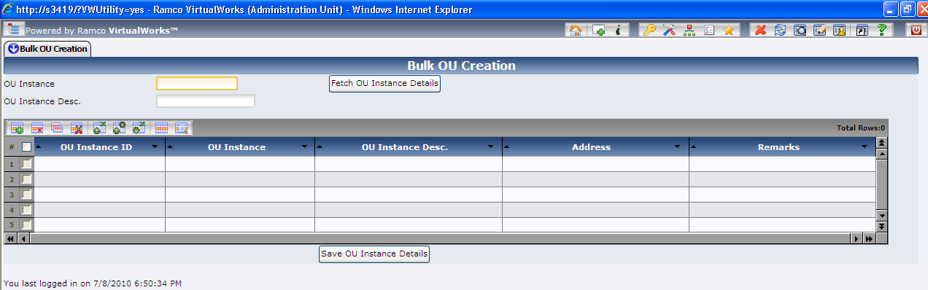

|  |  |
| --- | --- |
| Screen Elements | |
| Field | Description |
| OU Instance | Enter the name of organization unit already defined for retrieving OU Instance details. |
| OU Instance Desc. | Enter the description of the organization unit already defined for retrieving OU Instance details. |
| OU Instance ID (ML) | It is a number and non-editable field. |
| OU Instance (ML) | Enter the name of organization unit. The OU Name can be "16” characters long and consist of alphanumeric characters only. |
| OU Instance Desc. (ML) | Enter the description of the organization unit. The OU description can be “128” characters long and consist of alphanumeric characters only. |
| Address (ML) | Enter the address of the organization unit. The address can be “256” characters long. |
| Remarks (ML) | Enter the remarks of the organization unit. The remarks can be “256” characters long. The remark is not mandatory. |

ML: denotes Multiline screen elements

To Save OU Instance Details.

Enter the OU Instance (ML), OU Instance Desc. (ML), Address (ML) and Remarks (ML) in the multiline and press the “Save OU Instance Details” button.

To retrieve OU Instance Details

Enter the OU Instance, OU Instance Desc. And press ‘Fetch OU Instance Details’, if no data is entered; the system retrieves all the OU Instance details define in the application.

To Delete OU Instance Details

Retrieve the OU Instance details, select check box against OU Instance, press multiline grid ‘Delete’ Icon and press the “Save OU Instance Details” button.

Step 2: Activity: Perform OU Instance - Component Mapping (Implementation process)

This activity is used to select the required business components and associate them to the OU Instances.

Click on the activity. The main page appears

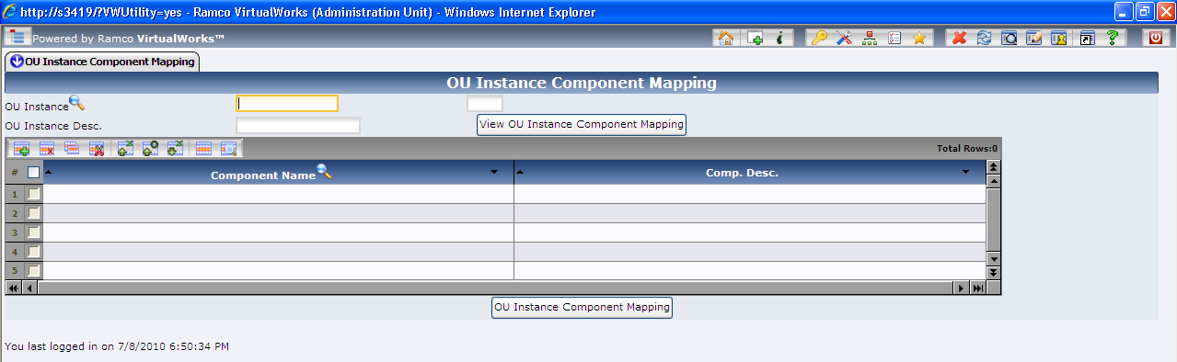

|  |  |
| --- | --- |
| Screen Elements | |
| Field | Description |
| OU Instance | Enter the name of organization unit already defined for retrieving OU – Component-mapping details. Help icon is provided to get ‘Help on OU’ |

|  |  |
| --- | --- |
| OU Instance Desc. | Enter the description of the organization unit already defined for retrieving OU– Component-mapping details. |
| Component Name (ML) | Editable field for specifying component name |
| Component Desc (ML) | Non editable field to display component description |

ML: denotes multiline screen elements

To retrieve OU Instance – Component Mapping Details

Enter the mandatory ‘OU Instance’ and press ‘View OU Instance Component Mapping’ button

To Save OU Instance – Component Mapping Details

Enter the mandatory ‘OU Instance’, Component Name (ML) and press the “OU Instance Component Mapping” button. If component name is not known, click ‘Help for Components’ (refer the section below titled ‘Help on Components’).

To Delete OU Instance Details

Retrieve OU Instance – Component Mapping details, select the check box and click the ‘Delete’ icon above the multiline and press the “OU Instance Component Mapping” button.

Help on Components

This activity retrieves all the components available in the repository.

Select a component and press ‘OK’. This will transfer the business component name to the parent screen.

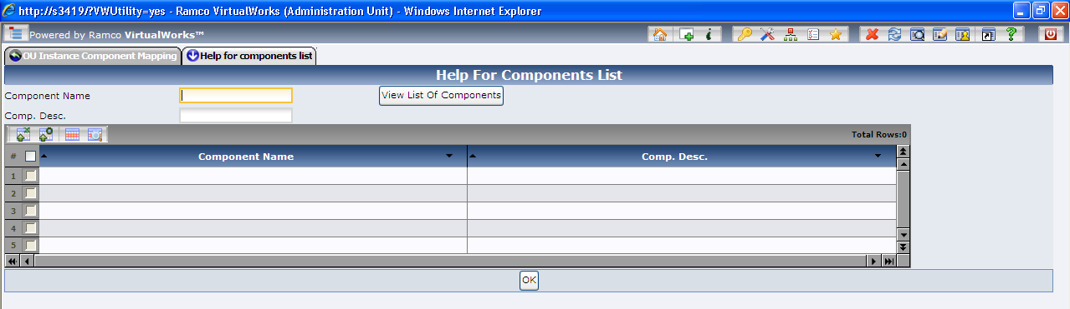

To retrieve the list of Components

103. Enter the ‘Component Name’ or ‘Component Desc.’ and press ‘View List of Components’; if no data is entered, the system displays all the components available in the application.

To transfer a component to the parent screen

104. Select a check box against a Component Name (ML) and press ‘OK’.

|  |  |
| --- | --- |
| Screen Elements | |
| Field | Description |
| Component Name | Enter the name of component for viewing its details. |
| Comp. Desc. | Enter the description of component for viewing its details. |
| Component Name (ML) | Non editable field to display component name |
| Comp. Desc. (ML) | Non editable field to display component description |

ML: denotes Multiline screen elements

Step 3: Activity: Role Master (Implementation process)

This activity provides a facility to define security roles for the application. Click on the activity. The main page appears.

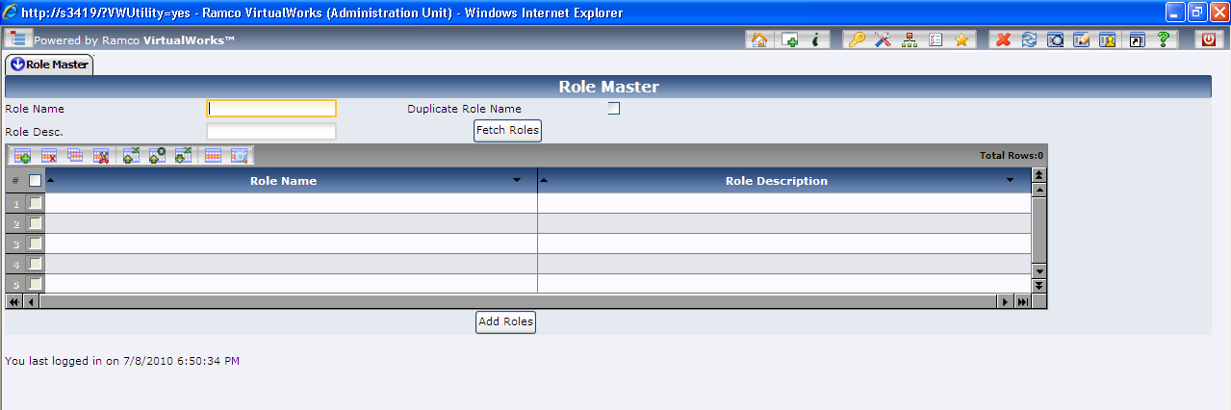

|  |  |
| --- | --- |
| Screen Elements | |
| Field | Description |
| Role Name | Enter the name of the Role. |
| Role Desc. | Enter the description of the Role. |
| Duplicate Role Name (Check Box) | Check this control create a new role by duplicating and existing Role. |
| Role Name (ML) | Enter the name of the Role. The Role Name can be “20” characters long and consist of alphanumeric characters. |
| Role Description (ML) | Enter the description of the Role. The Role description can be “60” characters long and consist of alphanumeric characters only. |

ML: denotes multiline screen elements

To retrieve the Roles defined

105. Enter the ‘Role Name’ or ‘Role Desc.’ and press ‘Fetch Roles’; if no data is entered, the system displays all the Roles defined in the application.

To Save a New Role

106. Enter the Role Name (ML), Role Description (ML) and press ‘Add Roles’ button.

106a. To Duplicate a New Role from an existing role – Enter an existing Role Name in the Role Name (Header control) and enter a new Role name(ML) and Role Description (ML) and press ‘Add Roles’ button.

To Delete a Role

107. Retrieve the roles defined in the application, select check box against a role, select the ‘Delete’ icon above the multiline and press ‘Add Roles’ button.

Step 4: Activity: Map Enterprise Roles (Implementation process)

This activity is used to set permissions for roles. Each role defined in the application can perform a set of activities provided by the business components. This activity provides a way to map the role name to a combination of OU instance, business component and activity name. The OU instance to business component name association should have been done earlier.

Note: You can set permissions for roles, only if OU Instances, Roles, Components, Activities and OU-Component combination is already defined for the organization unit.

108. Click the activity. The system displays in the main page.

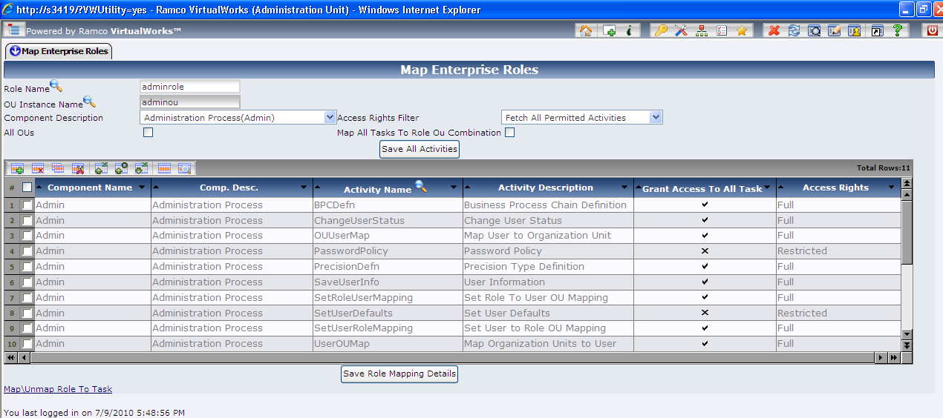

|  |  |
| --- | --- |
| Screen Elements | |
| Field | Description |
| Role Name | Enter the name of the Role. Help Icon is provided to fetch Roles already defined. |
| OU Instance | Enter the name of organization unit. Help Icon is provided to retrieve OU instances already defined. |
| Component Description | Fetches all the components mapped to the OU through “Perform OU Instance to component mapping” screen. |
| Access Rights Filter | To fetch all permitted / unpermitted for the given role/OU/component combination |
| All Ous | An Option that can be used during Save to specify that the mapping (insert / update / delete) must be done for all the OU’s and the given role. |
| Map All tasks to Role OU Combination | To cascade insert all Task level data also for all the activities that are mapped in this screen against the provided Role/OU/Component combination |
| Component Name [ML] | Provide a valid Component Name that is associated with the OU Instance given in the header. |
| Comp. Desc. (ML) | Displays the description of component. |
| Activity (ML) | Provide a valid Activity name that is associated with the component given. |
| Activity Description (ML) | Displays the description of Activity. |
| Grant Access To All Tasks (ML) | To provide task level permission to all ilbo /task combinations for a specific Activity for the given role/OU/Component. |
| Access Rights (ML) | Depending upon the Grant Access To All Tasks (ML) column, this will have the values “Full” or “Restricted”. |

ML: denotes Multi line screen elements

To add New Role – OU – Component – Activity Mapping

109. Enter the 'Role Name' and 'OU Instance' name and select 'Help on Component-Activity' link. This will take you to the 'Help on Component-Activity Details' screen. See Figure 69. Now enter the 'Component Name' and select 'Fetch Components And Activities For Given OU'. This retrieves a list of components and activities mapped for the given OU in the Perform OUInstance – Component Mapping activity. Select the required activities, click on the “OK” pushbutton. Once the details are transferred click the ‘Save Role Mapping Details’ in the Map Enterprise Roles page. If the Activity has to be mapped to all the OU’s for the given role, then the All OU’s option must be selected and the OU Instance name must not be provided.

*Note: Multiple transfers are possible from the “Help on Component – Activity” page to the “Map Enterprise” page.*

To retrieve Role – OU – Component – Activity Mapping

110. To retrieve the Role Mapping details, enter valid role and OU instance in the header click on 'Fetch role mapping details' pushbutton.

To delete Role – OU – Component – Activity Mapping

111. Enter ‘Role Name’, ‘OU Instance’ name and fetch the data by clicking on 'Fetch role mapping details' button. Select the Activity that you want to delete and click the 'Delete’ icon above the multiline and click 'Save Role Mapping Details' button. If the Activity mapping must be deleted for all the OU’s for a given role, then the All OU’s must be selected and the OU Instance name must not be provided.

Help on Component-Activity Details

This activity provides list of component–activity for the given OU Instance and component.

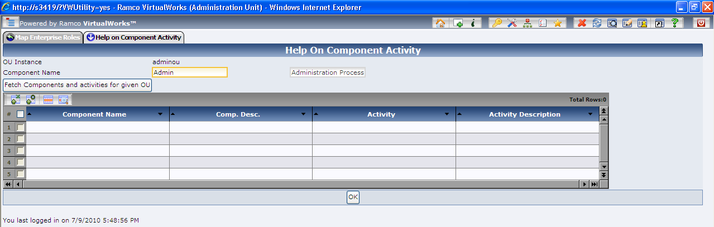

|  |  |
| --- | --- |
| Screen Elements | |
| Field | Description |
| OU Instance | Enter the name of organization unit. |
| Component Name | Provide a valid Component Name that is associated with the OU Instance to fetch corresponding activities |
| Component Name [ML] | Displays the Component Name as a result of fetch. |
| Comp. Desc. (ML) | Displays the description of components. |
| Activity (ML) | Displays the Activity names that are associated for the component. |
| Activity Description (ML) | Displays the description of Activity. |

ML: denotes Multi line screen elements

To retrieve Component – Activity Details

112. Provide Component name for which the activity details are needed and press ‘Fetch Components And Activities for Given OU’. If the OU Instance and component name are empty, the system lists the entire Component–Activity details. OU Instance is taken from previous page.

To transfer Component – Activity Details

113. Fetch Component – Activity Details, select the required check boxes against the component - activities and press ‘OK’ button to transfer.

Step 5:Activity: Resource Details (Deployment process)

This activity is used to register every machine (server) and its role in the business component deployment in the enterprise is created as a resource. Resources can be of type Web server,

Application Installation Guide

Gateway, Application (App) server and Resource Manager (RM) server. Resources of the type Client and File Server are not required for installation of web-based business components.

*Note: The resource details must have already been defined while installing deployment workbench.*

114. Click the activity. The main page appears.

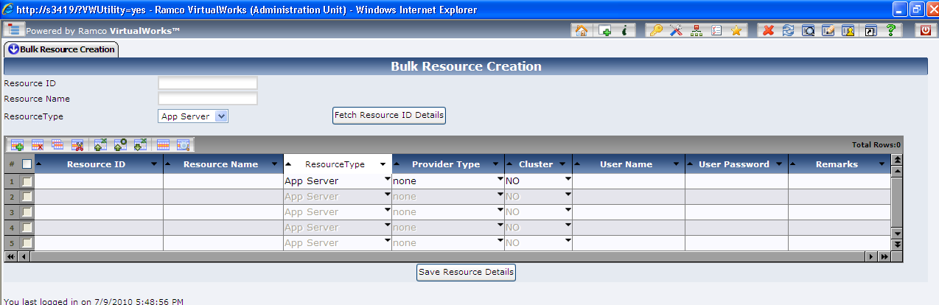

|  |  |
| --- | --- |
| Screen Elements | |
| Field | Description |
| Resource ID | Enter the Resource Id that you want to retrieve. This field is optional. |
| Resource Name | Enter the Resource Name that you want to retrieve. This field is optional. |
| Resource Type | This field specifies the type of the resource like Client, Web server, Gateway, File Server, App Server, RM Server etc. |
| Resource ID (ML) | Enter the Resource ID. It can be 32 characters long and can be alphanumeric. |
| Resource Name (ML) | Resource Name is the description of the Resource. It can 40 characters long and can be alphanumeric. |
| Resource Type (ML) | This field specifies the type of the resource like Client, Web server, Gateway, File Server, App Server, RM Server etc. |
| Provider Type (ML) | This field specifies the provider type of RM server resource like SQL Server, Oracle, None |
| Cluster (ML) | This column was introduced for future enhancements. Currently the value for this column should be set to “No” only. |
| User Name | Enter the SQL User name (if the Resource Type (ML) value is selected as RM Server) with which back end connections to the RM Server will be made. |
| User Password | Enter the SQL User Password (if the Resource Type (ML) value is selected as RM Server) with which back end connections to the RM Server will be made. |
| Remarks (ML) | Enter the remarks of the Resource. The remarks can be 40 characters long. The remark is not mandatory |

ML: denotes Multiline screen elements

To retrieve Resource details

115. Enter Resource ID, Resource Name (both are optional), select mandatory Resource Type and press ‘Fetch Resource ID Details’. The resource details are displayed in the multiline.

To add Resource details

116. Enter Resource ID (ML), Resource Name (ML), select Resource Type (ML), if Resource Type (ML) is ‘RM Server’; select Provider Type [ML) as ‘SQL Server’ for the remaining resource type select Provider Type [ML) as ‘None’. Enter optional Remarks (ML) and press ‘Save Resource Details’.

To delete Resource details

117. Fetch the resource details by clicking on 'Fetch Resource Details' button, select the check box against the Resource ID (ML) that needs to de deleted and click the “Delete” icon above the multiline and click 'Save Resource Details' button.

To update Resource details

118. Retrieve the resource details by clicking on 'Fetch Resource ID Details' button, select the Resource ID (ML) row that you want to update, the following fields can be updated ‘Resource Name (ML)’, ‘Resource Type (ML)’, ‘Provider Type (ML)’ and ‘Remarks (ML)’ and click ‘Save Resource Details’ button.

Step 6:Activity: Configure Resource Relationship (Deployment process)

This activity is used to define the connectivity details between resources of the enterprise. The connectivity between resources can be of the following combinations:

* Web Server to Gateway / Gateway to Web Server
* Gateway to App Server / App Server to Gateway
* App Server to RM Server / RM Server to App Server

In case of first time installation Web Server to Gateway mapping alone will be needed, the other mappings will already be existing as they are defined while installing deployment workbench. Check for existence of mapping between AppServer and Gateway Server, Appserver to RM server, Gateway to Webserver etc. exist. If the mappings are not defined, then create the mappings.

*Note: Ensure that resources are defined.*

119. Click the activity. The main page appears.

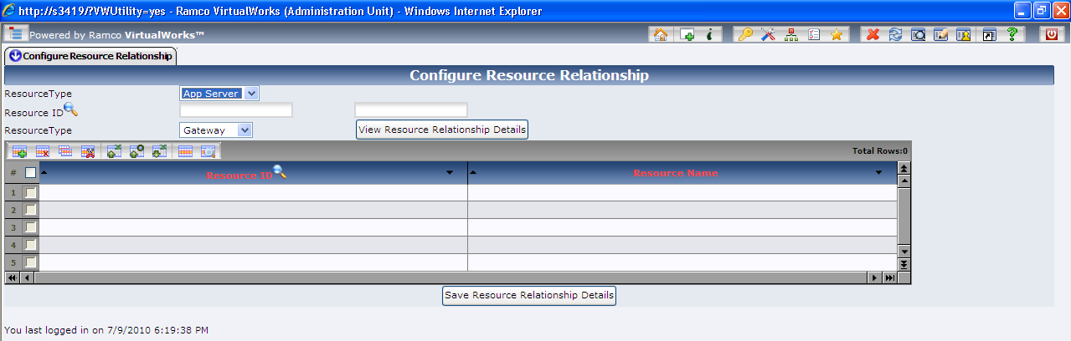

|  |  |
| --- | --- |
| Screen Elements | |
| Field | Description |
| Resource Type (Source) | This combo box lists all the available resource types for the source. |
| Resource ID | This field expects the Resource ID for the source resource. It is a mandatory field. |
| Resource Type (Destination) | This combo box displays the destination resource types applicable for the selected source resource type. When the source resource type is changed, the destination resource type combo is reloaded. |
| Resource ID (ML) | This field expects the Resource ID for the destination resource. It is a mandatory field |
| Resource Name (ML) | This field expects the Resource Description for the destination resource. |

ML: denotes Multi line screen elements

To add Configure Resource relationship

120. Select the first source "Resource Type" using the drop down box, based on the source Resource type selected the destination "Resource Type" drop down box will be loaded. Select an appropriate Resource type and enter the Resource ID (Help icon is provided if 'Help on Resource ID" is required). Click 'View Resource Relationship' will display the destination resource details in the multiline. If the "Resource ID (ML)" is blank, enter the details and click on “Save Resource Relationship” button to save the resource relationship.

To view Configure Resource relationship:

121. Select the source resource and destination resource type. Enter the source resource ID; retrieve the mapped target resource details using the ‘View Resource Relationship’ button.

To delete Configure Resource relationship:

122. Retrieve the destination resource details using the “View Resource Relationship” and select the check box against the mapped target Resource ID and click the “Delete” icon above the multiline and click on “Save Resource Relationship” button.

Step 7:Activity: Map Components to RM Server (Deployment Process)

A business component will have database objects such as tables, stored procedures etc. to be installed in the database server. This activity comprises mapping an RM Server ID to an OU Instance - Component Name combination, providing a Primary DB name as input.

*Note: Ensure the following:*

*A resource of type RM Server should be defined.*

*A mapping must have been defined between the OU Instance and Component.*

1. 1. Click the activity. The main page appears.

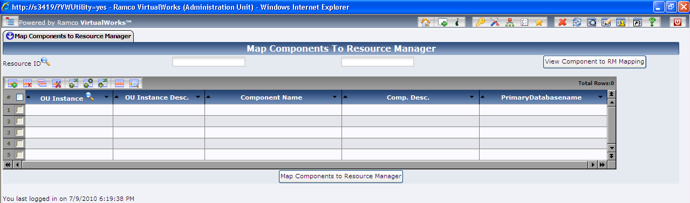

|  |  |
| --- | --- |
| Screen Elements | |
| Field | Description |
| Resource ID | This field expects the Resource ID for the RM resource type. It is a mandatory field. |
| OU Instance (ML) | Enter the OU Instance ID. Note that OU Instance should have mapped to the Component. |
| OU Instance Desc. (ML) | A non-Mandatory field that displays the description of the OU Instance |
| Component Name (ML) | Enter the Component that has already been mapped to the RM Server resource |
| Comp. Desc. (ML) | A non-Mandatory field that displays the description of the Component |
| Primary Database Name (ML) | Enter the Name of the Primary Database |

ML: denotes Multi line screen elements

To view RM Server to an OU Instance - Component mapping:

2. Enter the RM Resource ID (Help Icon is provided to get help on Resources of type Resource Manager) and click ‘View Component to RM Mapping’ button.

To delete RM Server to an OU Instance – Component mapping:

3. Fetch the RM server to an OU Instance – Component mapping, select the check box against the OU Instance – Component mapping row, click the “Delete” icon above the multiline and click ‘Map Components to RM Server’

To ADD RM Server to an OU Instance – Component mapping:

4. Enter Resource ID, OU Instance (ML), Component Name (ML), and Primary Database Name (ML); click ‘Map Components to RM Server’. If OU Instance and Component mapping is not known ‘Help on OU Instance – Component’ link is provided. Click on the link ‘Help on Organization Unit instance and Component mappings’ page will appear, enter OU Instance (or) Component name and click ‘Fetch OU Instance-Component Mapping Details’ will retrieve the details in the multiline. Select the rows and press ‘OK’ to transfer the data to parent page.

To update primary database server name:

5. Retrieve the RM server to an OU Instance – Component mapping, select the row and change the primary database name.

Step 8:Activity: Map Components to App server (Deployment Process)

A business component has middle layer software objects such as BRO DLL, BE error files, service files etc. to be installed in the Application server. This activity provides mapping between the resource of type application Server and the OU–Component–Shadow mapping.

*Note: Ensure the following:*

*A resource of type App Server is defined.*

*The OUInstance and Component mapping exists.*

* Map Component to RM server is defined.*

1. 123. Click the activity. The main page appears.

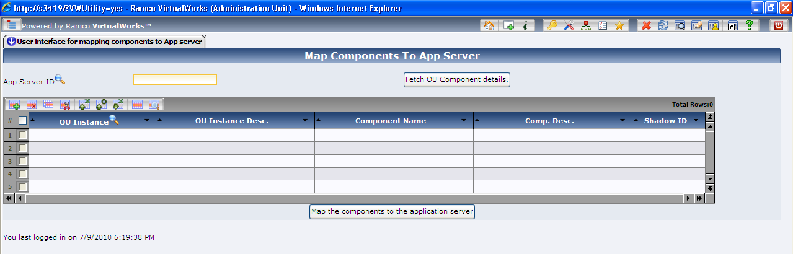

|  |  |
| --- | --- |
| Screen Elements | |
| Field | Description |
| App Server ID | Enter the Resource ID, which is of type App Server. |
| OU Instance (ML) | Enter the OU Instance ID. Ensure that OU Instance is mapped to the Component. |
| OU Instance Desc. (ML) | A non-Mandatory field which displays the description of the OU Instance |
| Component Name (ML) | Enter the Component that has already been mapped to the RM Server resource |
| Comp. Desc. (ML) | A non-Mandatory field which displays the description of the Component |
| Shadow ID (ML) | Enter the Shadow ID. (Currently Shadow ID cannot have any value other than zero) |

ML: denotes Multiline screen elements

To view App Server and the OU Instance – Component mapping:

1. 124. Enter the App Server ID (Help Icon is provided to get help on Resources of type Application server) and click ‘Fetch OU Component Details’ button.

To delete App Server and the OU Instance – Component mapping:

1. 125. Fetch App server and the OU Instance – Component-mapping details by providing App server details. In the multiline select the row against the OU Instance and Component combination, click the “Delete” icon above the multiline and click ‘Map The Components To The Application Server’.

To add App Server and the OU Instance – Component mapping:

1. 126. Enter App Server ID, OU Instance (ML), Component Name (ML), and Shadow ID (ML); click ‘Map The Components To The Application Server’. If OU Instance and Component mapping is not known ‘Help on OU–Component–Shadow’ link is provided. Click on the link ‘Help on OU Instance - Component Name - Shadow ID Combination’ page will appear, enter optional OU Instance, Component name, Shadow ID, RM Server ID, Primary database name and click ‘Fetch OU Instance-Component Shadow Mapping’ will fetch the details in the multiline. Select the rows and press ‘OK’ to transfer data to parent page.

Step 9: Activity: Perform Web Server – Role mapping (Deployment Process)

A business component has web based software objects such as ASP, FE error files etc. to be installed in the web server. The roles are associated to resources of type “Web Server” in this activity.

*Note: Ensure that the Web Server and the roles are already defined.*

127. Click the activity. The main page appears.

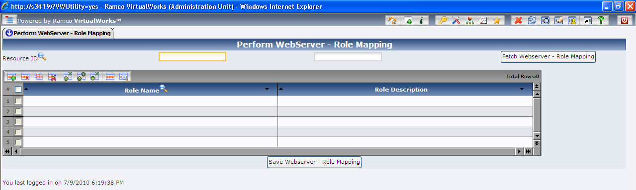

|  |  |
| --- | --- |
| Screen Elements | |
| Field | Description |
| Resource ID | Enter the Resource ID, which is of type Web Server. |
| Role Name (ML) | Enter the Role Name. The role name can be “20” characters long and consist of alphanumeric characters. |
| Role Description (ML) | A Display field which shows description of Role |

ML: Denotes Multiline screen elements

To view Web server – Role Mapping:

128. Enter the Resource ID of web server resource type, click ‘Fetch Webserver – Role Mapping’ button.

To delete Web server – Role Mapping:

129. Retrieve the Web server – Role mapping details, select the row against the Role Name in the multiline, click delete icon and press ‘Save Webserver – Role Mapping’ button.

To add Web server – Role Mapping:

130. Enter the Resource ID of web server resource type, enter Role Name in the multiline if known otherwise click ‘Help on Role Name’ to get help on Role details and select appropriate role and transfer back the details to this page. Click ‘Save Webserver – Role Mapping’ button.

Step 10:Activity: User Information (Administration Process)

This activity is used to create and maintain user information.

131. Click the activity. The main page appears.

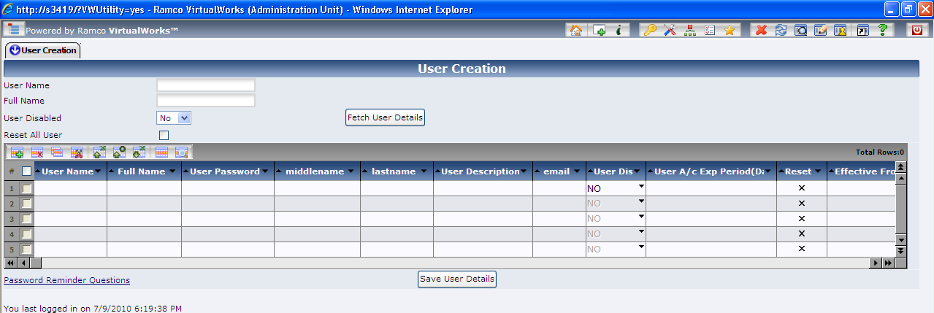

|  |  |
| --- | --- |
| Screen Elements | |
| Field | Description |
| User Name | Enter the name of the User [Optional). |
| Full Name | Enter the full name of the User (Optional). |
| User Disabled | Select the type of user in this field. If ‘Yes’ is selected, all disabled users will be fetched. If ‘No’ is selected, all enabled users will be fetched. |
| Reset All User (Check Box) | All existing users will be reset to their initial setting – this would make them behave like a newly created user. |
| User Name (ML) | Enter the name of the User. The User Name can be “12” characters long and can consist of alphanumeric characters. |
| Full Name (ML) | Enter the full name of the User. Full User Name can be “255” characters long and can consist of alphanumeric characters. |
| User Password (ML) | Enter the password of the user here. The Password can be “25” characters long. |
| Middlename (ML) | Enter the middle name of the User. |
| lastname (ML) | Enter the last name of the User. |
| User Description (ML) | Enter the description of the user here. The User description can be “255” characters long and can consist of alphanumeric characters. |
| Email (ML) | Enter the email id of the User. |
| User Disabled (ML) | Enter the type of user in this field. If ‘Yes’ is entered, it signifies that the user is disabled. If ‘No’ is selected, is signifies that the user is enabled. |
| User A/c Exp Period (Days) (ML) | Enter the Number of Days a user is entitled to access the system. This is optional. |
| Reset All User (ML) | The user’s behavior will be reset to their initial setting – this would make the user will behave like a newly created user. |
| Effective From Date (ML) | Specify a date from which the user will be valid |
| Effective To Date (ML) | Specify a date until which the user will be valid |

ML: denotes Multi line screen elements

To view User Details:

1. 132. To view the User details click on the “Fetch User Details” button. The User Name, Full Name and User Disabled fields in the header can be used as filters to fetch the data in the multiline.

To add User Details:

1. 133. Provide user information in the multiline like User Name, Full Name, User Description, User Password, User Disabled, optional ‘User account expiry period’ and default ‘Is Theme User’. Click ‘Save User Details’ button.

To update User Details:

1. 134. To update User details, retrieve the data by clicking on “Fetch User Details” button and modifying the data available in the multiline except for User Name. Then click the “Save User Details” button to save.

Step 11: Activity: Map Organization Units to User (Administration Process)

The activity provides the facility to map the User with various Organization Units.

*Note: Ensure that the Users and OU’s have been defined:*

135. Click the activity. The main page appears.

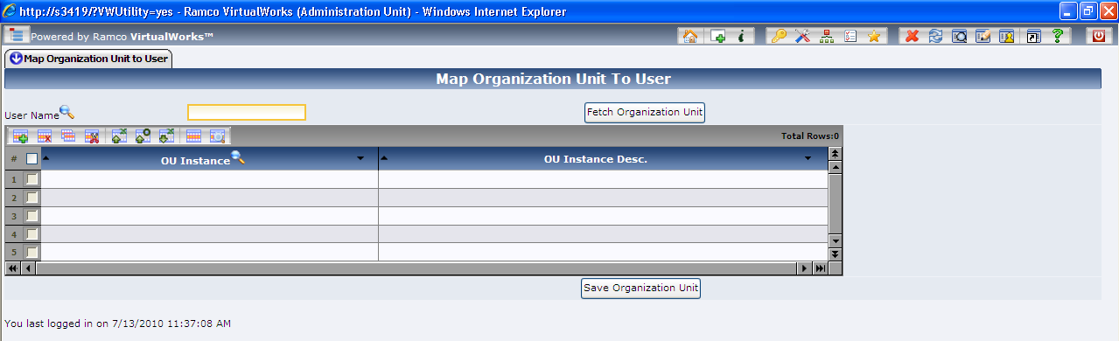

|  |  |
| --- | --- |
| Screen Elements | |
| Field | Description |
| User Name | Enter the name of the User. Help icon is provided to get help on Users |
| OU Instance (ML) | Enter the OU’s, which are to be mapped to the User. The OU Instance Name can be 16 characters long and can consist of alphanumeric characters. Help link ‘Help on OU Instance’ is provided to get help on OU Instance details. |
| OU Instance Desc. (ML) | The OU Instance Desc is a read only field. It gets populated when an OU is mapped and fetched. |

ML: denotes Multiline screen elements

To view the OU’s mapped to User:

136. Provide user name in the header field and click on ‘Fetch Organization Unit’ button. The various OU’s mapped to the user are retrieved in the multiline. If User Name is not known, ‘Help on User Name’ icon is provided to get help on User name.

To map the User to OU’s:

137. Provide user name in the header field, valid OU’s in the multiline and click on 'Save Organization Unit' button. If OU instance are not known, ‘Help for OU Instance’ link is provided to get help on OU Instances.

To delete the Users map to OU’s:

138. Fetch the OU’s mapped to the User and delete the particular OU using the “Delete” icon above the multiline and click on 'Save Organization Unit' button

Step 12:Activities: Set Role To User OU Mapping / Set User to Role OU Mapping (Administration Process)

You can either use the “Set Role To User OU Mapping” or “Set User to Role OU Mapping” to Map Users, Roles and OU’s, based on which the business component and activities will be available for the login user. Lets proceed with the activity ‘Set Role To User OU Mapping’.

*Note: Ensure the following:*

* User’s should have been defined and OU’s should have been mapped to this User’s*

* Roles should have been defined and the Roles should have been mapped to the activities of the Component.*

139. Select the ‘Set Role To User OU Mapping’ activity. The main page appears.

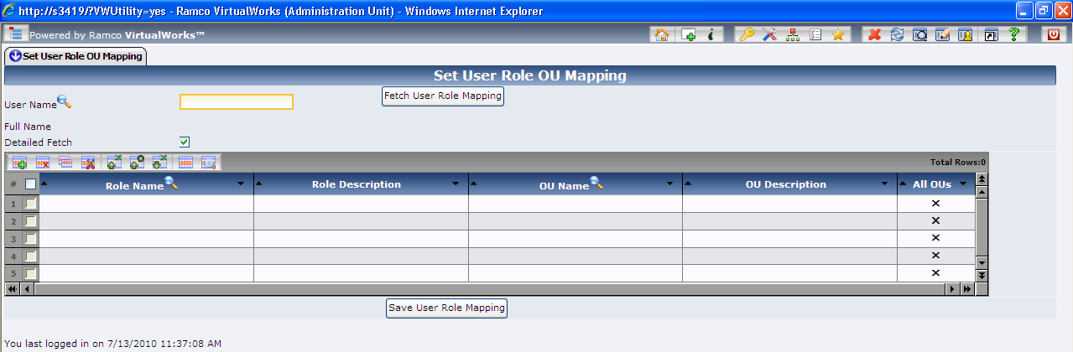

|  |  |
| --- | --- |
| Screen Elements | |
| Field | Description |
| User Name | Enter the name of User. ‘Help on User’ is provided |
| Full Name | The Full Name as entered while creating the User, will be displayed. |
| Detailed Fetch | By default it is checked. If checked, the detailed information of user role OU combination is retrieved. |
| Role Name (ML) | Enter the valid Role Name, which has already been created using Role Master Activity. ‘Help on Role’ link is provided to get help on role names already defined in the application. |
| Role Description (ML) | Displays the description of the Role Name. |
| OU Name (ML) | Enter the valid OU Name, which has already been created and mapped to User. |
| OU Description (ML) | Displays the description of the OU Name. |
| All OUs (ML) | While saving if this is checked, then user will be mapped to all OUs under the given role Provided the User-OU mapping exists. While retrieving this will be checked, if user is mapped to all OUs under the given role. |

ML: denotes Multiline screen elements

To view Role-OU mapped for a particular user:

1. 140. Enter a valid user name and click on the ‘Fetch User Role Mapping’ button. If details of all Role-OU combination check the Detail Fetch check box and click the ‘Fetch User Role Mapping’ button.

To save User – OU – Role mapping:

1. 141. Enter a valid user name in the header, role name, OU name in the multiline and all OU’s checkbox uncheck and click on ‘Save User Role Mapping’. If the user want to map all the OU’s that is mapped to both user and role he has to enter user name in the header, role name in the multiline and Check all OU’s checkbox and Click on the ‘save user role mapping button’.

To delete User – OU – Role mapping:

1. 142. Provide the User Name in the header, and fetch the Role Details in the multiline. Select the Role you want to delete and click the “Delete” icon above the multiline and click the 'Set User Role Mapping' Button.

Step 13:Activity: Business Process Chain Definition (Administration process)

The activity is used to define Business Process Chains and the relevant components for the Business Process Chain.

*Note: Ensure that the business component is already defined:*

143. Click the activity. The main page appears.

1. 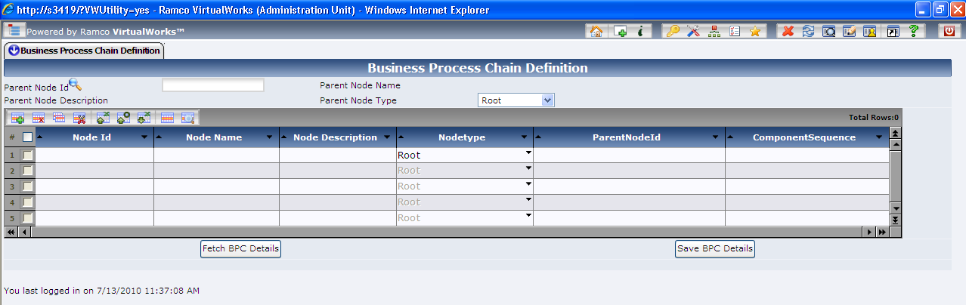

|  |  |
| --- | --- |
| Screen Elements | |
| Field | Description |
| Parent Node ID | Numeric which denotes parent node ID |
| Parent Node Name | Displays the parent node name. |
| Parent Node Description | Displays the description of parent node. |
| Parent Node Type | Predefined values displayed in the combo like ‘Root’ and ‘Intermediate’ |
| Node ID (ML) | Auto-generated, display only field, which displays the node ID. |
| Node Name (ML) | Enter node name, it is short name for node. |
| Node Description (ML) | Enter node description, it is the name displayed in the application. |
| Node Type (ML) | Predefined values displayed in the combo like ‘Root’, ‘Intermediate’ and ‘Leaf’. |
| Parent Node ID (ML) | Display only, which displays the parent node ID. |
| Component Sequence (ML) | Specify a numeric value (running serial no.) to display the components / BPC process names to display in a specific sequence. |

ML: denotes Multiline screen elements

To view Node details:

1. 144. Enter Parent Node ID and click on ‘Fetch BPC Details’ pushbutton. The system will display all the child node details defined for the given node in the multiline. If Parent Node id is left blank (or) Parent Node id is Zero ‘0’ then the system displaysall the details of node type ‘Root’ in the multiline.

To add Node details:

1. 145. Enter Parent Node ID and give appropriate child node details (i.e., Node Name, Node Description, Node type) in the multiline. Click ‘Save BPC Details’. If Parent Node ID is left blank (or) Parent Node id is Zero ‘0’, only the root node type can be defined.

Application Installation Guide

*Note: A Root Node can have an intermediate type node or leaf type node as its child nodes, whereas an Intermediate type of node can have only leaf type of nodes under it. Leaf type of node cannot bear children. The node name, description and type are entered in the multi line are saved as Child Node details for the given Parent Node ID. Leaf type of nodes should be a valid component name as node name. If the node description is not given for a node, the node description will be defaulted with node name.*

To delete Node details:

1. 146. Fetch the node details in the multiline, select the node details check box in the multiline, click the “Delete” icon above the multiline and press ‘Save BPC Details’.

*Note: All child nodes/intermediate nodes must be deleted before deleting the root node. Similarly, before deleting the intermediate nodes; all child nodes must be deleted.*

Help on Parent Node

1. 147. This link is provided to get help on root / intermediate type of nodes defined in the application.

Step 14:Activity: Set User Defaults (Administration process)

This activity is used to set the default Role, default OU and default language for the user to login to the application. You can Login by giving the username and password alone. The login would happen in the default role, OU and language mentioned in this activity.

*Note: Ensure that the Users, OU Instances and Roles and Mapping between the Users – Roles – Ous are already defined*.

1. 148. Click the activity. The main page appears.

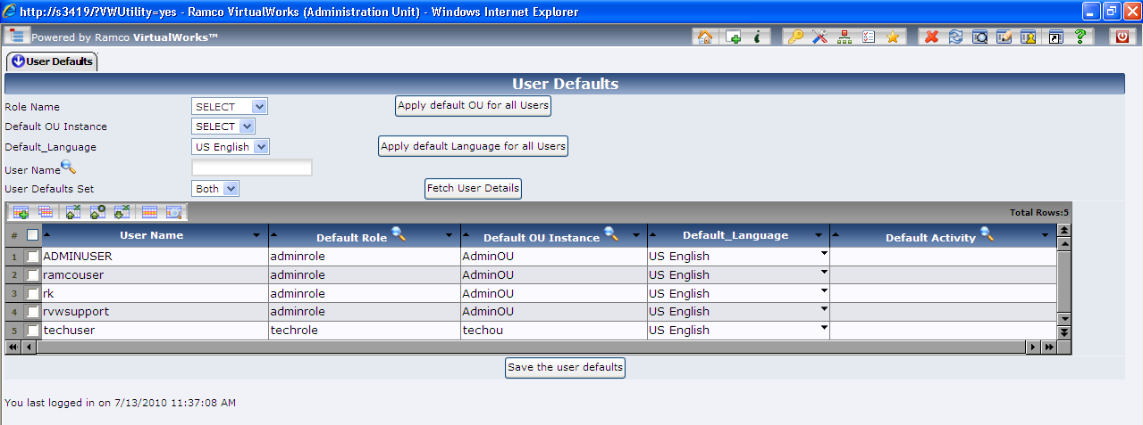

|  |  |
| --- | --- |
| Screen Elements | |
| Field | Description |
| Role Name | Select the Role Name |
| Default OU Instance | Select the default OU instance that can be applied to all unmapped user details. |
| Default_Language | Select the default Language that can be applied to all unmapped user details. |
| User Name | Filter criteria – select a specific user alone |
| User Defaults Set | File to display only unmapped users / mapped user or both. |
| User Name (ML) | Enter User name |
| Default Role (ML) | Enter the default Role for the User. |
| Default OU Instance (ML) | Enter the default OU for the User. |
| Default Language (ML) | Select the default language for the User. |
| Default Activity | Specify the Activity ID that should be launched as soon as the user logs in into the system. |

ML: denotes Multiline screen elements

To view User Defaults:

1. 149. On launch of the page, all the users and their default settings (if) defined will be retrieved. If no default settings exist for a user, then OU Instance and Role will be blank and the Language will be defaulted to ‘US English’.

To update User Defaults:

1. 150. On launch of the page, all the users and their default settings (if) defined will be retrieved. If no default settings exist for a user (or) if the existing setting for the user needs to be changed, change only default Role, OU and Language. Click on ‘Save The User Defaults’.

*Note: You cannot delete the default values set.*

‘Help on OU Instance’ and ‘Help on Roles’ links are provided to get help on OU instance details and Roles respectively.

If required to add more components for predefined OU Instance, Role, User, Resource and their mapping exists. Then the following steps must be executed:

1. • ‘Deployment meta data scripts’ for the components has to be executed in the deployment database of the application server.
2. • Step 2: Activity - Perform OU Instance - Component Mapping (Implementation process)
3. • Step 4: Activity - Map Enterprise Roles (Implementation process)
4. • Step 7: Activity - Map Components to RM Server (Deployment Process)
5. • Step 8: Activity - Map Components to App server (Deployment Process)
6. • Step 13: Activity - Business Process Chain Definition (Administration process)

There are some more activities in the deployment workbench that are not vital during ‘Configuration of Business component’. These activities are just used for viewing details or to perform some tasks. Some of the activities and tasks are briefly explained below:

1. 151. Activity: Map Implementation model - Component interaction details (Implementation Process). This activity comprises interaction between components. This is mandatory when two components interact with each other, when components are defined in same OU or different OU.
2. 152. Activity: Password Policy (Administration Process). This activity is used to restore Password Policy, Default Values or Update Password Policy Details.
3. 153. Activity: Set Defaults for User Preferences (Administration Process). This activity is used to maintain various defaults details regarding the preferences like formats and styles for Number, Time, Date and Error display type etc.
4. 154. Activity: Precision Type Definition (Administration Process). The decimal length of the Precision Type can be updated in this activity.
5. 155. Activity: Change User Status (Administration Process). The activity comprises of unlocking and enabling user accounts.
6. After performing these steps Config dlls have to generate using ConfigGenerator.Exe as mentioned in section 3.6 or 3.7.

Corporate Office and R&D Center

Ramco Systems Limited, 64, Sardar Patel Road, Taramani Chennai – 600 113, India

Tel: +91 (44) 2235 4510. Fax +91 (44) 2235 2884

www.ramco.com