VirtualWorksTM Runtime Installation Document – Prerequisites

DISCLAIMER

**©2009 Ramco Systems Ltd. All rights reserved. All trademarks acknowledged.**

This document is published by **Ramco Systems Ltd.** without any warranty. No part of this document may be reproduced or transmitted in any form or by any means, electronic or mechanical, for any purpose without the written permission of **Ramco Systems Limited.**

Improvements and changes to this text necessitated by typographical errors, inaccuracies of current information or improvements to software programs and/or equipment, may be made by Ramco Systems Limited, at any time and without notice. Such changes will, however, be incorporated into new editions of this document. Any hard copies of this document are to be regarded as temporary reference copies only.

The documentation has been provided for the entire Aviation solution, although only a part of the entire solution may be deployed at the customer site, in accordance with the license agreement between the customer and Ramco Systems Limited. Therefore, the documentation made available to the customer may refer to features that are not present in the solution purchased / deployed at the customer site.

Revision History

|  |  |  |  |
| --- | --- | --- | --- |
| Version | Date | Author | Description |
| 1.0 | 21/04/2010 | Manigandan R | Created |
| 1.0 | 18/06/2010 | Vijayalakshmi G | Reviewed and incorporated the changes |
|  |  |  |  |
|  |  |  |  |
|  |  |  |  |

**Table of Contents**

1. Prerequisites 5

1.1. Server Settings before proceeding with installation 5

1.1.1. Environment Variables Settings 7

1.1.2. User Access Control Settings 9

1.1.3. Server Roles Settings 12

*1.1.3.1.* *WEB Server* 12

*1.1.3.2.* *APP Server* 15

1.1.4. Disabling Internet Protocol Version 6 (TCP/IPv6) 16

1.1.5. RMSERVER Settings 18

1.1.6. Component Services Settings 19

1.1.7. Entries in LMHOSTS and HOSTS file (Host Table files) 22

2. Enabling VirtualWorksTM Runtime specific ports in Firewall 24

This document walks through the prerequisites before start installing VirtualWorksTM .Net Runtime (Microsoft Version) installation.

# Prerequisites

|  |  |
| --- | --- |
| Operating System | Windows 2008/2008 R2. (with latest Service Packs) Note: Application and RM (Database) Servers should always have same OS + Service Pack |
| .Net Framework Version | V 2.0.50727 |
| VC 7 Runtime | Installer for this application is packaged along with the installation kit itself. Run the file VC7RuntimeSetup.MSI that is given with the installation kit. |
| XML | MSXML 4.0 + SP2 or above |
| DAC | MDAC 2.8 or WDAC 6.0 or above (in case of Win 2K8 OS). To check the installed version goto regedit --> HKEY_LOCAL_MACHINE\Software\Microsoft\DataAccess , against Key Name: FullInstallVer, you can see the version number |

# Server Settings before proceeding with installation

Before proceeding with the installation, make sure that,

* All Servers have sufficient Disk space (as per the Hardware Specification & COTS List) and also partitioned. It is recommended to have atleast one more drive apart from Default “C” Drive. It is advisable to install the VirtualWorksTM in the User partitioned Drive, instead of System Drive (C:)
* System Drive should have partitioned with minimum of 20GB allocation and User Drive with remaining
* User Drives for RM Server should be partitioned to keep Database files and Log files separately. This enhances performance of SQL Server IO operations
* Server name (across all layers) should not have any special characters. All server names participating in the VirtualWorksTM deployment architecture should start with alphabets and can contain numbers. Non-Alphanumeric characters are not allowed. Servers should also not have any VirtualWorksTM component name and part of the Server Name.
* Internet Information Services (IIS) and World Wide Web (W3SVC) services are not running in the WEB Server
* Windows Firewall is off for all state viz., Domain Profile, Public Profile and Private Profile.

During runtime installation, the app and web server will communicate through a port number (which will be defined during installation), to make sure firewall is not blocking this process, the following settings needs to be done.

Also refer section 2.0 Enabling VirtualWorksTM Runtime specific ports in Firewall to set firewall for the ports between the servers

To change Windows Firewall settings

Go to Server Manager (Start -> Programs -> Administrative Tools -> Server Manager) and click on “Configuration” option ->”Windows Firewall with Advanced Security” on the left pane.

In the right pane, Click “Windows Firewall Properties”, as highlighted in the below screenshot

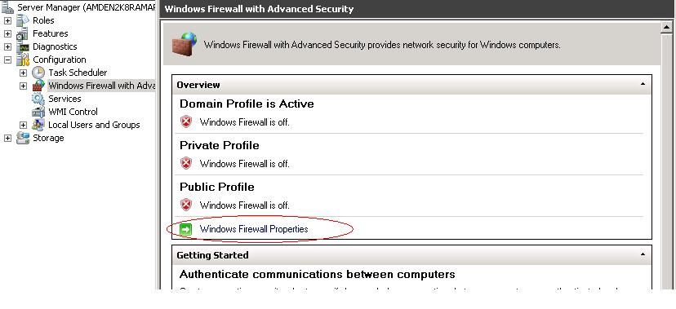

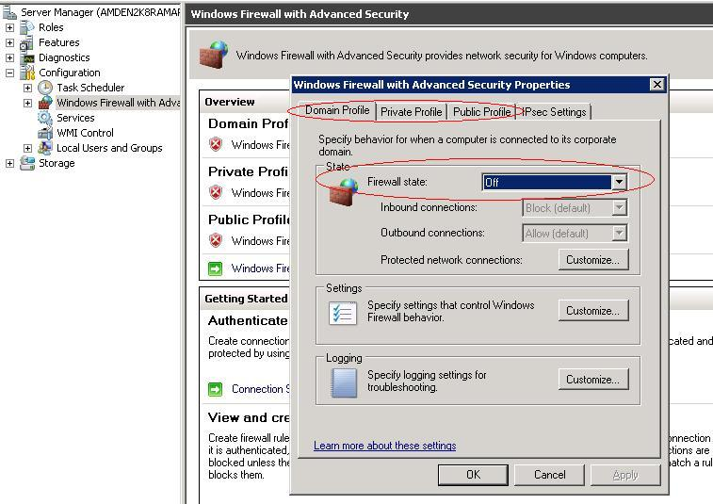

Ensure the above rounded firewall state setting is done for all three profiles under separate tabs.

# Environment Variables Settings

* Set .Net Framework V 2.0.50727 in environment path – Right click on My Computer -> Properties -> Advanced Tab -> Click on “Environmental Variables” button -> Select the “Path” variable from the “System Variables” group and click on “Edit” button. Add the .Net Framework folder path (for Ex. 32 bit machines - %systemroot%\ \Microsoft.NET\Framework\v2.0.50727, 64 bit machines - %systemroot%\ \Microsoft.NET\Framework64\v2.0.50727) at the end (after adding a ; [semicolon]) and click on OK.

*This setting is required to enable command line invocation of dotnet compiler program.*

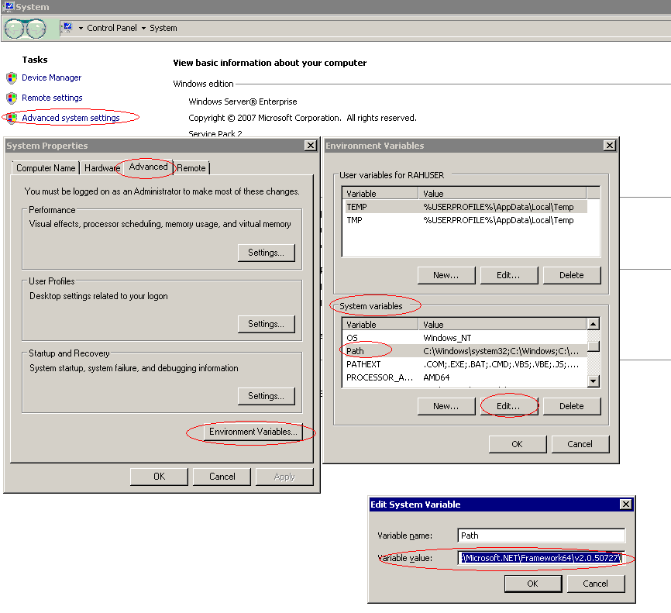

* In case if the installation should happen on a different drive other than the default system drive (for ex. instead of C:\Program Files, if the installation should be done on D:\Program Files), then change the Program Files directory path in Registry as below:
  + For 32 bit OS – Change the value of the Key ProgramFilesDir under the registry key HKEY_LOCAL_MACHINE\SOFTWARE\ \Microsoft\Windows\CurrentVersion from C:\Program Files to D:\Program Files
  + For 64 bit OS – Change the value of the Keys ProgramFilesDir and ProgramFilesDir(X86) under the registry key HKEY_LOCAL_MACHINE\SOFTWARE\Wow6432Node\Microsoft\Windows\CurrentVersion and HKEY_LOCAL_MACHINE\SOFTWARE\Microsoft\Windows\CurrentVersion from C:\Program Files (X86) to D:\Program Files (X86).

***Note:*** *This modifies the default program Files installation directory path for all new software installations. If this is acceptable then proceed with this settings, otherwise change the settings back to original after completing the runtime installation and also ensuring that the applications are launches properly.*

# User Access Control Settings

* If the installation is being done with a domain user or a local user account, make sure that this user is part of Administrators Group (This can be done through Computer Management Console -> Local Users and Groups -> Groups -> Administrators)
* If installation is going to be done on **WIN 2008** OS, make sure that the following setting is unchecked for the logged in user (domain user or a local user). This is applicable for APP, Web and RM Servers

Go to Control Panel -> Select User Accounts -> Click on the Link “Turn User Account Control on or off” -> Uncheck the checkbox “Use User Account Control (UAC) to help protect your computer” and click on OK.

***Note****: 1. In the below screenshot ‘RAHUser’ is a sample user account created for demonstration purpose. 2. This setting is required without which Create folder permission will not exist for a non- Administrator User account*

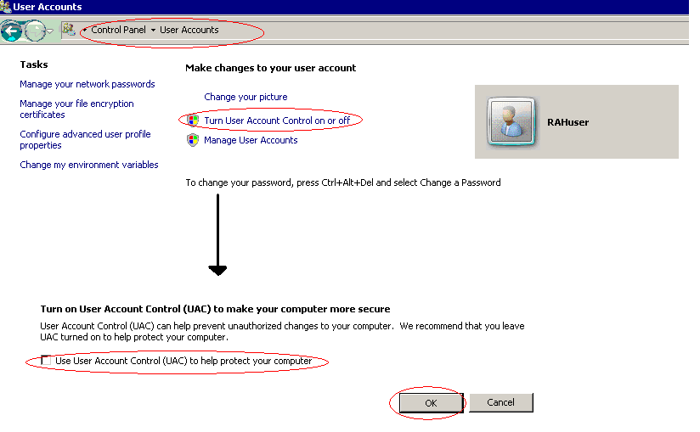

* If installation is going to be done on **WIN 2008 R2** OS, make sure that the following settings are done in WEB, APP & RM Servers.

1. Go to Control Panel -> Select User Accounts -> User Accounts -> Click Change User Account Control Settings -> Move the progress bar to “Never Notify” as shown in the below screenshot.

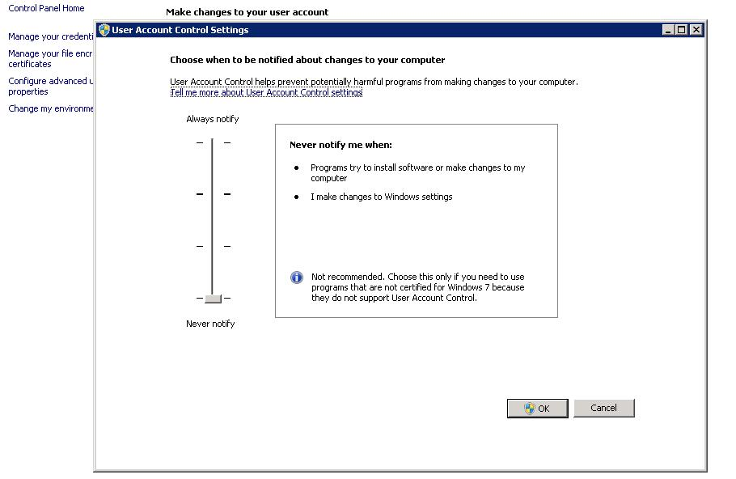

1. Goto Start -> Run -> Type Secpol.msc and click OK. A window will open as shown in the below screenshot. In the left pane of the window goto Local Policies -> Security Options.

In the right pane of the window, set the followings.

a) User Account Control: Detect application installations and prompt for elevation – **Disabled**

b) User Account Control: Behaviour of the elevation prompt for standard users - **Prompt for Credentials**

c) User Account Control: Run all administrators in Admin Approval Mode – **Disabled**

d) System Cryptography: Use FIPS Compliant Algorithms for Encryption, hashing and signing – **Disabled**

e) User Account Control: Admin Approval Mode for Built-in Administrator Account – **Disabled**

1. Restart the Servers

These settings are required without which Create folder permission will not exist for a non- Administrator User account

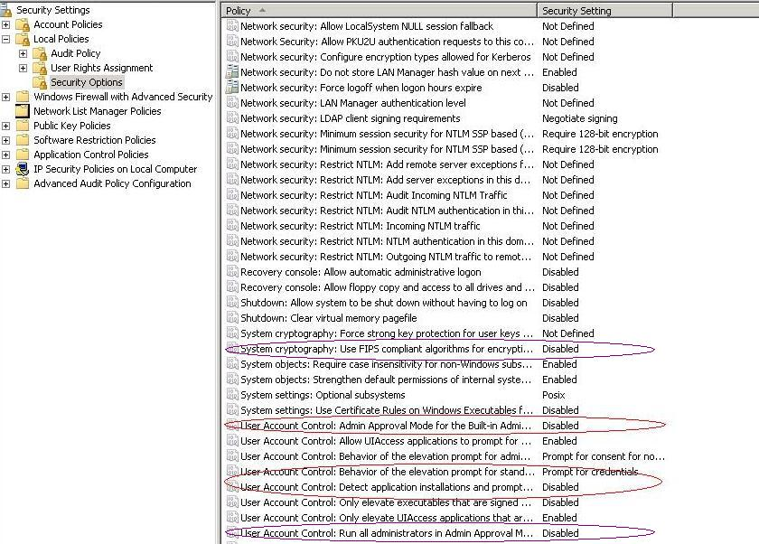

# Server Roles Settings

Generally in Windows 2008 or 2008 R2 server, most of the services are in uninstalled state and wherever we need, we could initiate the required services.

For installing VirtualWorksTM Runtime, it is mandatory to enable the following Services.

# *WEB Server*

1. Go to Server Manager (Start -> Programs -> Administrative Tools -> Server Manager) and click on Roles option on the left pane.
2. Select the Web Server (This should have been installed as part of OS. Otherwise click on Add Roles and select Web Server and install the same.) option and click on “**Add Role Services”** link on the right pane. Refer attached screenshots given below.
3. On the window that gets opened, select the options ISAPI Extensions, ASP.Net and IIS6 Management Compatibility Options and click on next and complete the installation.

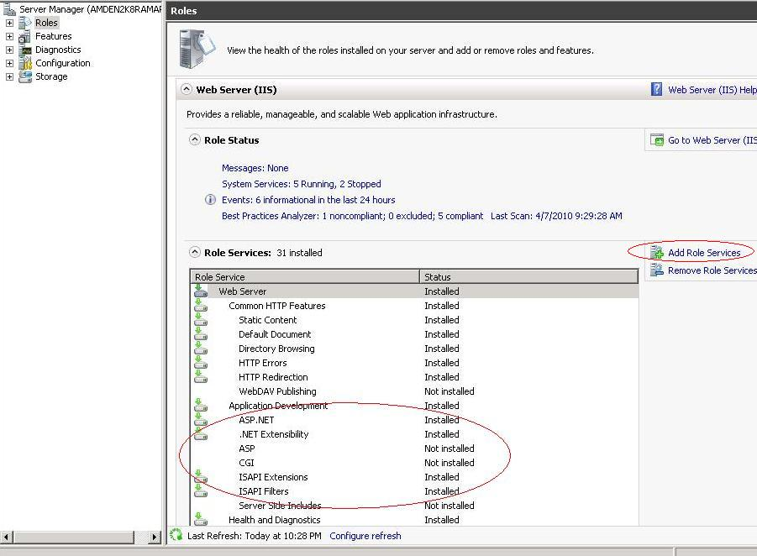

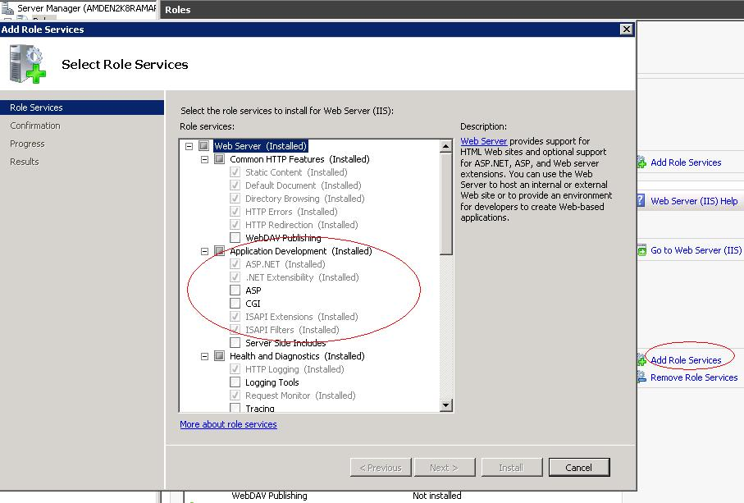

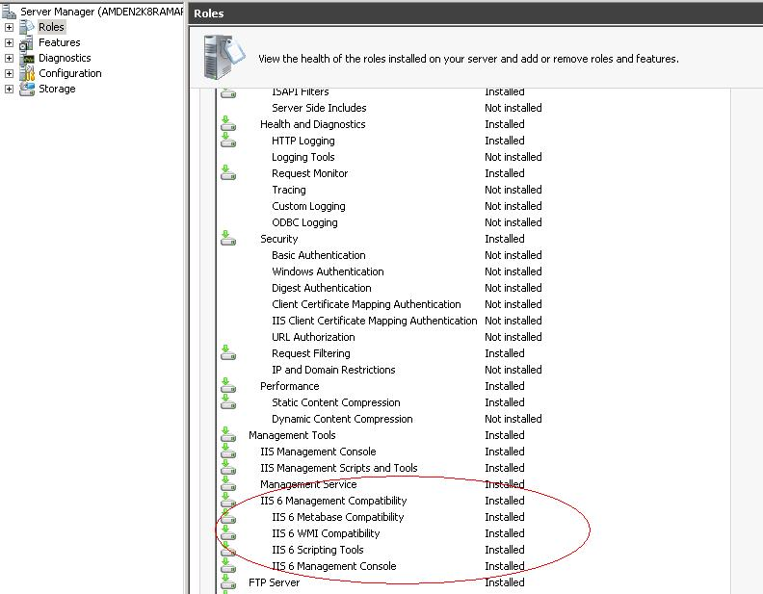

# *APP Server*

1. On the Server Manager Console, check if App Server Role appears under the Roles option in the left pane. If it does not exist, click on the Add Roles in the right pane and install the same.
2. The Services to be installed in the App Server are
   1. Com+ Network Access
   2. HTTP Activation
   3. Distribution Transactions & its child components, except WS-Atomic Transactions

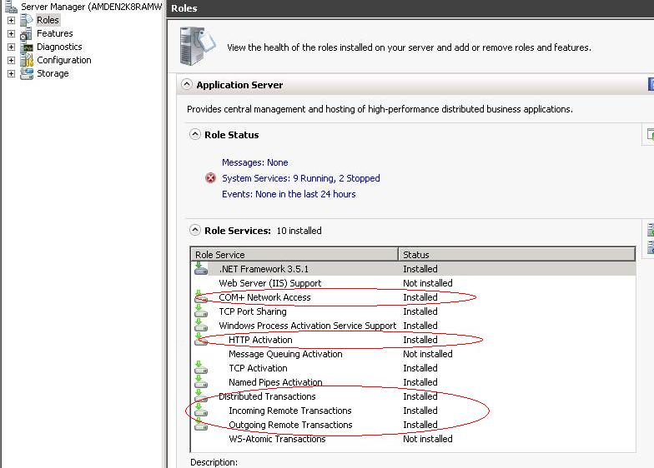

# Disabling Internet Protocol Version 6 (TCP/IPv6)

Currently VirtualWorksTM .Net Runtime supports TCP/IP V4 (Version 4). Therefore TCP/IP6 needs to be disabled.

Goto Start -> Network -> Right Click Properties -> Change Adapter Settings ->

Local Area Connection -> Right Click Properties -> Uncheck Internet Protocol Version 6 (TCP/IPv6)

(or)

Goto Start -> Control Panel -> View Network Status and Tasks (under Network and Internet) -> Change Adapter Settings -> Local Area Connection -> Right Click Properties -> Uncheck Internet Protocol Version 6 (TCP/IPv6)

*Note: This setting should be done in WEB, APP and RM Servers.*

Refer below given Screenshot

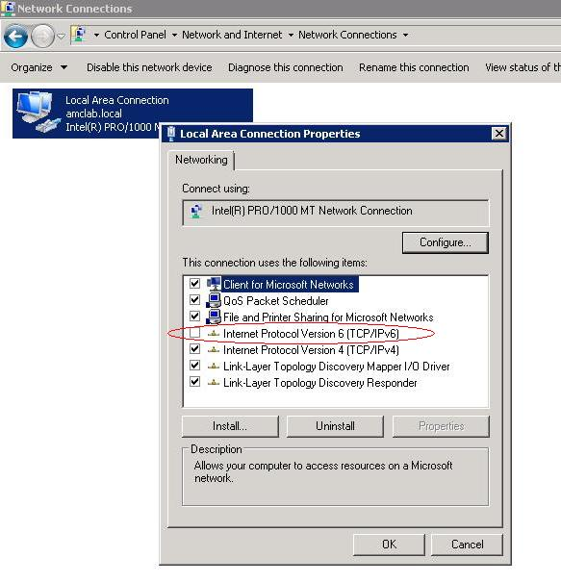

# RMSERVER Settings

1. Go to Start-> All Programs-> Microsoft Sql server 2008 -> Configuration Tools -> SQL Configuration Manager. Disable Shared Memory Protocol as this is not supported. This needs to be disabled under both "Protocols for SQL Server" as well as under "Client Protocols".
2. If Sql server is set with instance name and the VirtualworksTM Runtime executable is allowed to run RM server, then do the following settings

Create Alias name for the Server Instance through SQL Configuration Manager.

Goto SQL Configuration Manager -> SQL Native Client 10.0 Configuration -> Aliases -> Right click -> New Alias…

Give an Alias Name and TCP Port no (Default is 1433 if it is not changed during SQL Server installation, if TCP port no is changed during installation and not known while creating Alias then change the Protocol to “Named Pipes”).

Give Server Name with *ServerName\InstanceName* and Click OK

After this setting has done, the sql server should be able to connect with alias name, instead of *ServerName\InstanceName.* This Alias name should be given in Resource Manager (RM) Server Name during all the course of VirtualWorksTM Runtime installation.

Refer screenshot given below

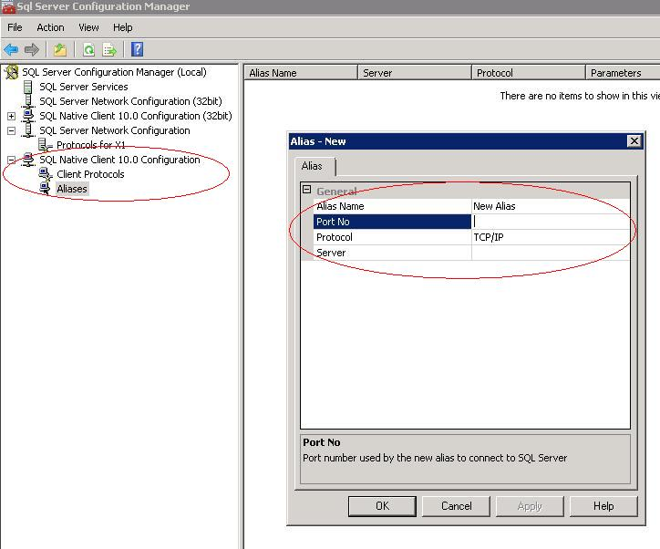

1. Restart SQL Server Services

# Component Services Settings

The following changes should be done in Com+ Explorer (To launch Component Services Goto Start -> Run -> Type dcomcnfg -> Ok). Please make sure that these points (1, 2, 4 and 5) are done in Database Layer machine also. If “APP Server” role is not available in Database layer machine, add the same and do these settings.

1. Open COM+ Explorer
2. Expand to “My Computer” node and go to the properties of “My Computer”
3. Go to the “Options” tab and set the value of “Transaction timeout (seconds)” value to 1200 seconds and click on Ok.

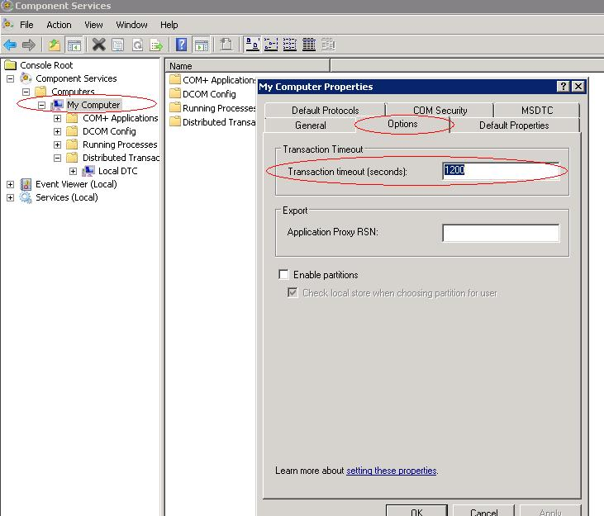

1. Expand Distributed Transactions -> Select Local DTC and click on properties and click on Security tab and choose the options as per the image below

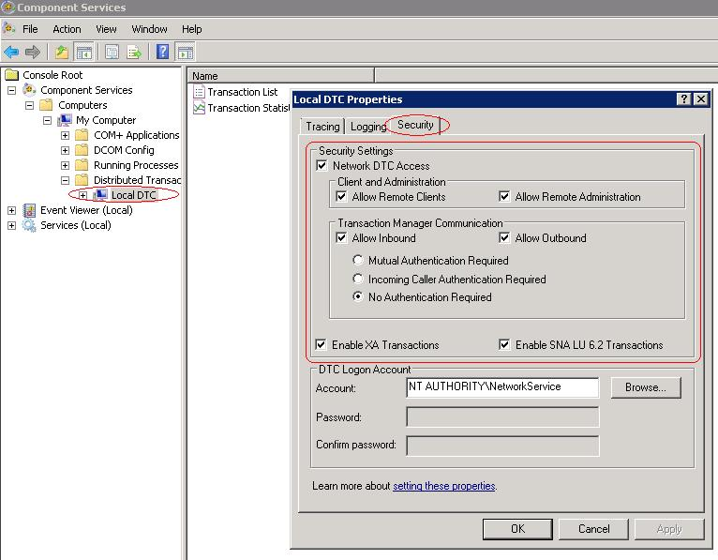

In Windows 2008 Server, “Enable SNA LU 6.2 Transactions” will not be exists. It is ignorable.

1. Choose Logging tab and change the Capacity to 40 MB. Click on OK.

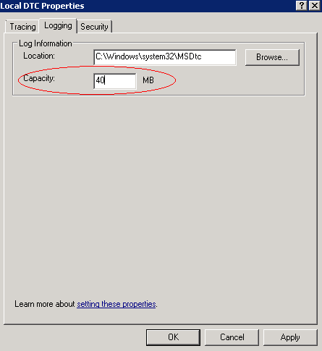

# Entries in LMHOSTS and HOSTS file (Host Table files)

To resolve naming resolution with the TCP/IP protocol, Windows provided an option to set user friendly name for IP of the machine. If the runtime is going to be installed in multi layer, it is required to set the entries of IP’s and Names in the Host Table files.

* 1. Open the LMHOSTS (without extension) file available under %systemroot%\SYSTEM32\Drivers\ETC folder and go to the end of the file.
  2. Add a new line and type the IP addresses of the App, WEB & RM Servers and the App server machine name separated by the tab space and save the file.

Above steps are applicable for HOSTS file, which is also available in the same folder path.

Refer attachment given below

Hosts File Table:

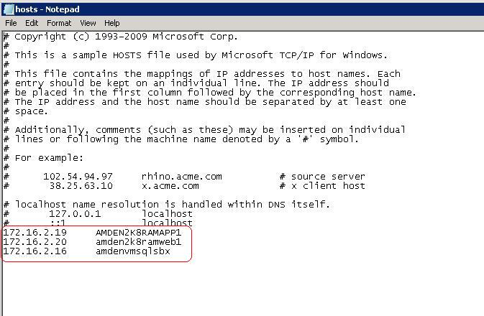

LMHosts File Table:

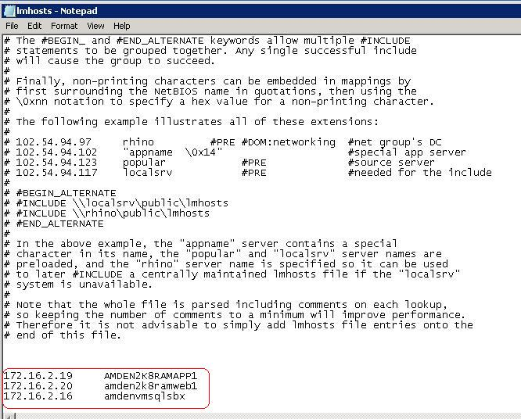

# Enabling VirtualWorksTM Runtime specific ports in Firewall

In case firewall needs to be set between WEB/APP/Database layers, open the following ports Bi-Directionally in the Firewall between the immediate source and the destination servers

|  |  |
| --- | --- |
| Service Name | Port No. |
| Internet Information Services (IIS) | Default Port 80 (If this is changed in IIS, then the modified port should be enabled in Firewall) |
| VWSocketServer | Whichever port is specified while generating WEBConfig and APPConfig DLLs through ConfigGenerator |
| Ramco Daemon Service (proprietary to VirtualWorksTM) | Default Port 1306 (Configurable through RDE Configuration) |
| MS SQL Server | Default Port 1433, 1434 (Can be changed at the time of installation of MS SQL Server) |
| MSDTC | This service uses 135 as a mandatory port and also another port for communication between APP and RM Layer. The second port is dynamic and can vary between the entire allowable TCP port ranges. This port range can be restricted manually through COM. Contact Runtime Support team on how to configure manual port ranges. |

**- End of Document -**

Corporate Office and R&D Center

Ramco Systems Limited, 64, Sardar Patel Road, Taramani Chennai – 600 113, India

Tel: +91 (44) 2235 4510. Fax +91 (44) 2235 2884

www.ramco.com