

www.ramco.com

Reliability Reports Tool
Installation Manual
Release 5.8



©2013 Ramco Systems Ltd. All rights reserved. All trademarks acknowledged.

This document is published by Ramco Systems Ltd. without any warranty.

No part of this document may be reproduced or transmitted in any form or by any means, electronic or mechanical, for any purpose without the written permission of Ramco Systems Limited.

Improvements and changes to this text necessitated by typographical errors, inaccuracies of current information or improvements to software programs and/or equipment, may be made by Ramco Systems Limited, at any time and without notice. Such changes will, however, be incorporated into new editions of this document. Any hard copies of this document are to be regarded as temporary reference copies only.

1. Objective

Generation of Reliability Reports by Reliability Report generation tools

Reliability Analysis – (BASRA)

Table of Contents:-

- Pre-requisites---------------------------------------------------------------------------------------- 5

- Process Flow Overview-----------------------------------------------------------------------------6

- Steps to Install “ReliabilityReportGen” Tool---------------------------------------------------7

- Steps to Install “ReliabilityFileUpload” Tool --------------------------------------------------10

- ReliabilityReportGen Tool Configuration Settings -------------------------------------------13

- ReliabilityFileUpload Tool Configuration Settings -------------------------------------------14

- Steps to configure Reliability_Tool.exe in windows scheduler.-------------------------- 12

- Steps to configure TRANSFER_FTP_PATH.exe in windows scheduler.----------------- 20

- Tool testing and troubleshooting guidelines--------------------------------------------------21

Pre-requisites: -

- Schedule report path should be given write share in the report server.

- Open DwAppSettings.xml from the below path.

D:\Ramco Decision Works \DW\DW_REFACTOR\com\ramco\dw\ApplicationXML\Property

- In DwAppSettings.xml file find the following key

<add key="ScheduleReportPath" value="\\SERVERNAME OR SERVER IP\Scheduled Reports" />

Note: The report server’s public IP to be mentioned.

- In value path we have give the value as like this "\\172.26.7.214\Scheduled Reports"

Ex:

<add key="ScheduleReportPath" value="\\bavnwasnmv03\ScheduledReports" />

This path should be as share path.

Note: The report server’s public IP to be mentioned.

- Document attach web service dll for file upload

Below two dll’s attached to ReliabilityFileUpload Tool. While installation it will automatically added to installed folder. We have to make sure the latest dll is attached to tool

AVN.DocAth.Helper.dll

AvnDocAttachServiceProxy.dll

- In utilities ->objects attachment→ Set Option
In that Reliability analysis, we have to choose Replace in “Action if files Exists” column.

Process Flow Overview:

ReliabilityReportGen Tool:

Tool will Read data from view (“BASRA_REPORTNAME_VW1”) and build the formatted string with data and send the request to DW web service with formatted string for report generation.

Web service will out the batch id for the request and back update the Batch id, status to “IP” (In-progress) from “UP” (Under Processing) in Table “BASRA_RRSD_Reliability_Reports_Dtl” for the requested reports.

ReliabilityFileUpload Tool:

This tool will read data from view (“BASRA_REPORTNAME_FTP_VW”) and build formatted string with data and send request to DW service with that string

Web service will out the status of report generation (success or failure) and generated file path of report for File upload to Document attached specified folder. it will back update the status as “G” generated in Table (“BASRA_RRSD_Reliability_Reports_Dtl”) and generated report file name. ”

Once all mapped reports generated for specified fleet, it will update status as “G” (Generated) in table “BASRA_RRSH_Reliability_Reports_Hdr”.

3. Steps to Install “ReliabilityReportGen” Tool:-

- If DW is classic version

- Please extract the files “ReliabilityReportGen.zip” & “ReliabilityFileUpload.zip” from the path ..\IIS\EXTUI\BASRA\.

“..\ReliabilityReportGen\setup.exe”
“..\ReliabilityFileUpload\setup.exe”

- IF DW is componentized version

- Please extract the files “ReliabilityReportGen_cmp.zip” & “ReliabilityFileUpload_cmp.zip” from the path ..\IIS\EXTUI\BASRA\.

“..\ReliabilityReportGen_cmp\setup.exe”
“..\ReliabilityFileUpload_cmp\setup.exe”

Installation steps for Reliability Report Generation Tool:

Steps:
Run the setup.exe file

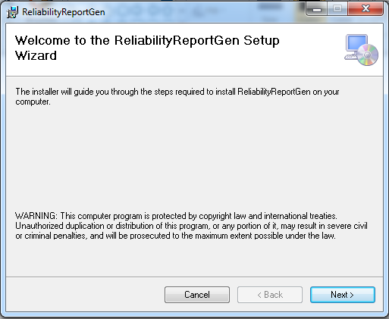
Select “Next” to start the installation
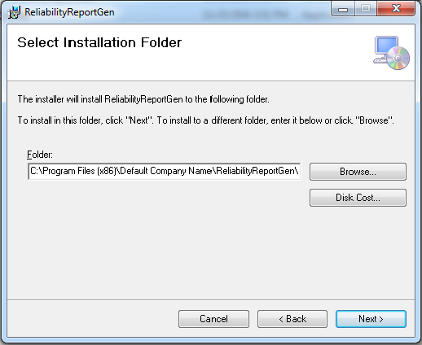

By Default installer will choose the above path (as shown in screen shot). If we want we can choose different path

Ex:
D:\ReliabilityReportGen\
Or
E:\ReliabilityReportGen\

Select “Next” to confirm the Installation
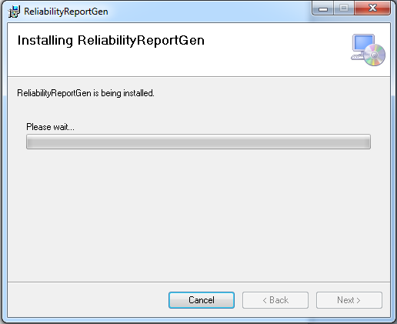
Installation started.

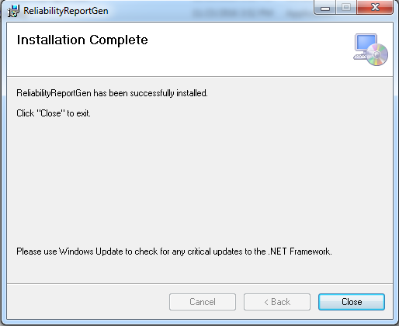

Installation completed for Reliability Report Gen Tool.
4. Steps to Install “ReliabilityFileUpload” Tool:-

Installation Steps:

Run the setup.exe file

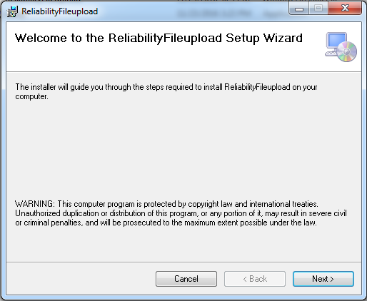

Select “Next” to start the installation

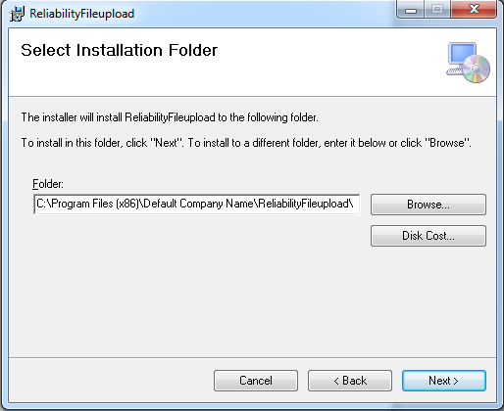

By Default installer will choose the above path (as shown in screen shot). If we want we can choose different path

Ex:
D:\ReliabilityFileUpload\
Or
E:\ ReliabilityFileUpload \

Select “Next” to confirm the Installation

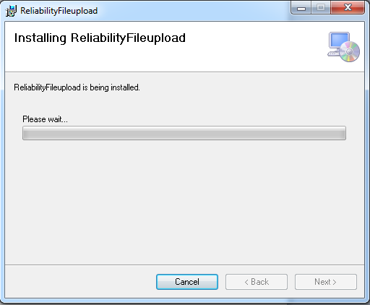
Installation started

.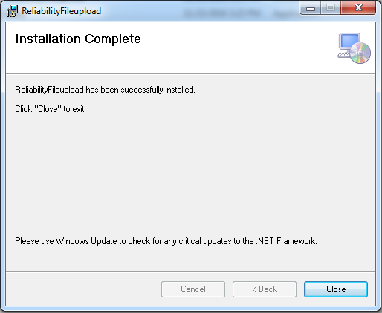

Installation completed for Reliability File Upload Tool.

5. ReliabilityReportGen Tool configuration Settings:

In ReliabilityReportGen Tool Folder, we have to change “Reliability_Tool.exe.config” config file.

“Reliability_Tool.exe.config” file located in following folder structure

Ex: “D:\ReliabilityReportGen\Reliability_Tool.exe.config”

In Reliability_Tool.exe config we have to change the following settings.

- In appsetting section we have to change the values for key “LogFilePath”

Report Log File Path – In the value field we have to change the path, for report status & Error Log. The path is like

<!--Report Log File Path-->
<add key="LogFilePath" value=" LOG PATH"/>
Ex: “ ..\ReliabilityReportGen\Log\”

- Please add the HOST Name
<!—Host name-- >
<add key=”Host name” value=”SERVER NAME”

- Please provide the connection string details of “Application server(RM Layer)”:

<Server Name>, < Database Name>, <User Name>, <Password>

Please provide the connection string details:

Ex: <connectionStrings>
<add name="Reliability_Connection" connectionString="server=RMSERVERNAME;database=avnappdb;uid=sa;pwd=PASSWORD" />
</connectionStrings>

- In ApplicationSettings Section inside we have to change the server Name.
Server Name is Report Server(App Layer) where DW report is Installed.
Eg: <value>http://<ServerName>/extui/decisionworks/Infrastructure/InfrastructureServices/DwBulkReportGenerationService.asmx </value>

6. ReliabilityFileUpload Tool Configuration Settings:

In ReliabilityFileUpload Folder, we have to change “TRANSFER_FTP_PATH.exe.config” config file.

“TRANSFER_FTP_PATH.exe.config” config file located in following folder structure

Ex: “D:\ReliabilityFileUpload\TRANSFER_FTP_PATH.exe.config”

In TRANSFER_FTP_PATH.exe.config config we have to change the following settings.

- Report Log File Path – In the value field we have to change the path, for report status & Error Log. The path is

<!--Report Log File Path-->
<add key="LogFilePath" value=" D:\ReliabilityFileUpload\Log\”"/>

- Please provide the connection string details of “Report server (RM Layer)”:
<Server Name>, < Database Name>, <User Name>, <Password>.

- In ApplicationSettings Section inside we have to change the server Name.
Server Name is Report Server (App Layer), where DW report is Installed.
Eg: <Value>http://<ServerName>/extui/decisionworks/Infrastructure/InfrastructureServices/DwBulkReportGenerationService.asmx </Value>

7. Steps to configure Reliability_Tool.exe in windows scheduler

- In task scheduler we have to add this exe to execute the tool.

Steps to add the exe file in windows scheduler:

Give the scheduler name details in tab 1 (General)

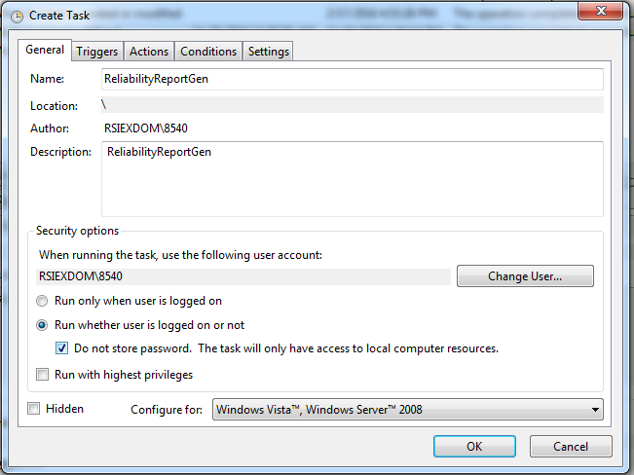

As highlighted in the “General” Tab,
i. Provide “Name”
ii. Select the option “Run whether user is logged on or not”
iii. Check the option “Do not store password. The Task will only have access to local computer resources”

Tab 2 : Go to second tab add the scheduler triggering details. Configure the scheduler for every 30 minutes.

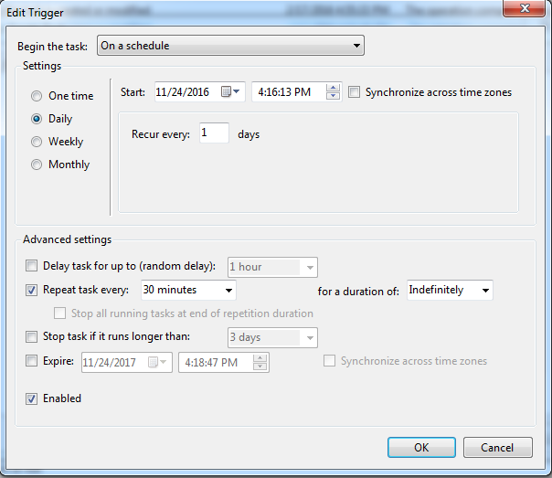

i. In the Advanced settings check the “Repeat task every”, select 30 minutes and “for a duration of” as “Indefinitely”

Tab 3: Go to tab3 action give the reliabilityReportgen tool path up to the application in program/script.

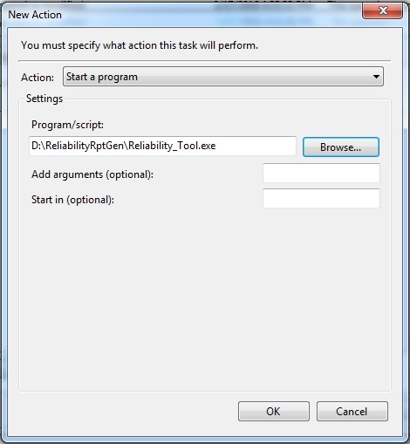

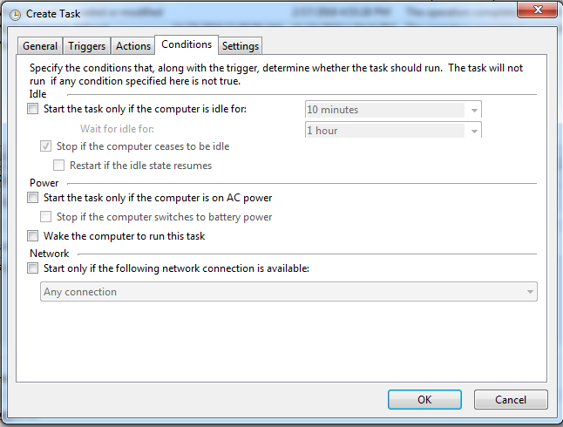

As highlighted in the “Conditions” tab, uncheck “Start the task only if the computer is on AC power”

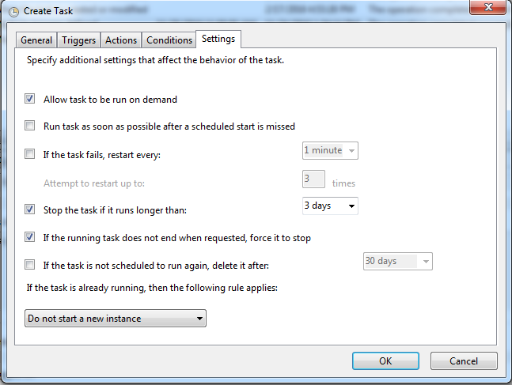

As highlighted in above screenshot, complete the “Settings” tab which ends the completion of Task Scheduler for Reliability

8. Steps to configure TRANSFER_FTP_PATH.exe in windows scheduler

- The same thing which did for ReliabiltyReportGen tool we have to do scheduler for Transfer FTP also.

- In task scheduler we have to add exe file to execute the tool.

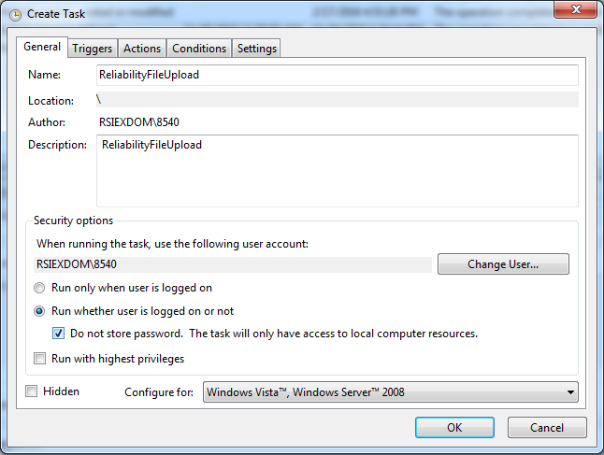

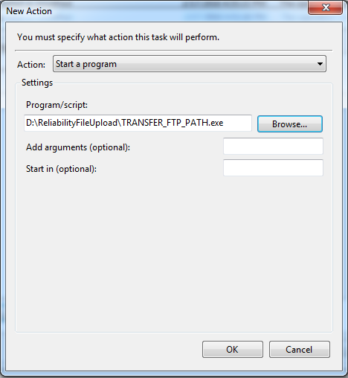

9. Tool testing and troubleshooting guidelines:

Error log table:
BASRA_ERROR_LOG_TABLE

