1.0 Automatic Material Movement Document (AutoMMD) Printing
The MMD Printing is associated with a material movement transactions like material issue, after a material movement document is authorized, the respective warehouse in-charge will get notified by a document printed at the printer located in that warehouse. The notification can also be an email to the warehouse in-charge.

Architecture

Building MMD Print Queue
On Clicking the MMD Printing for selected transaction from the Ramco aviation Solution, The system identifies the report associated with that particular transaction and finds the warehouse–zone information associated with that transaction (warehouse printer).
The warehouse– Printer mapping information is maintained in the server. Using this metadata the system identifies the warehouse–zone and printer where the document needs to be printed and updates the information in a MMD Print queue. The MMD Print queue collects all the MMD print requests and maintains the same.

MMD Processing

MMD processing is executed by a scheduler. This Scheduler is designed to process MMD queue. It will be installed and configured with a time interval to process the MMD queue. This queue also contains the information like warehouse/zone and printer information.
The scheduler processes the queue by calling decision work web service Method to generate the Report PDF File in report server for WEB version. Generated PDF file is stored from URL to local path and PDF file info is recorded in Table AUTOMMD_PRINTPDF. The generated PDF file info is stored in table AUTOMMD_PRINTPDF and MMDPrintPDF exe processes the information in the table AUTOMMD_PRINTPDF with the records of the PDF files with flag “W” for Printing through windows task scheduler.

Separate batch Printing Task Scheduler prints the selected report in the specified warehouse printer.

Sequence
- Application Clients request for MMD printing.
- Data base find the warehouse and printer information and adds the request to the MMD queue.
- A scheduler will be installed in the web server to process the MMD queue and print the reports in appropriate printer.
- Database maintains the metadata for Warehouse-Printer mapping for all the identified warehouses.
- All the warehouse/zone printers will be shared or drivers will be installed in the web server.

Pre-Requisites
Hard ware and Software Requirements

Hardware
- All the warehouse printers to be shared or printer drivers’ needs to be installed and configured in the web server.
- All network warehouse printers need to be part of the same intranet.
- Net Framework 4.0.

Software
Web Server:
- Printer drivers for all the printers to be installed and configured in the web server.
- Adobe Reader need to installed in Web server for batch printing. If the Adobe version is (Adobe XI(11.0.3)) , then need to uncheck the option in Adobe. Edit ->Preferences - >Security (Enhanced) Unchecked the Option “Enable Protected mode”

- RVW_Desktop v3.0 for decision works: Both batch files (EXCEL_REPORT.BAT, PDF_REPORT.BAT) should be configured and run from relative path (...\RDW_Desktop\v3.0\RDW_Desktop\Report Services)

- Note: When Adobe reader is updated or it’s upgraded to newer version,
Ensure that option (Edit ->Preferences -> Security (Enhanced) -> “Enable Protected mode” is unchecked

Implementation of MMD printing

MMD printing is implemented by configuring all the warehouse printers in the web server.
- Share the printers located in the warehouses where the MMD printing is enabled.
- Configure the printers the in the web server as a Network Printers of the warehouses.
- Install Printer drivers in the web server for printers where installation of printer drivers is mandatory.
- Please print the test page for each printer before using MMD. This is to ensure the printer driver installation completeness.
- Prepare and upload the metadata for warehouse- printer mapping for all the printers and warehouses.
- Printer Name in the metadata should be same as the printer name configured in the web server.(any change in this name should be updated in the metadata table)
- Install and configure the scheduler in the web server.
- Add code to insert MMD request in to the MMD queue table in the database where the MMD printing needs to be enabled.

MMD Approach
Automatic MMD printing is developed for printing the MMD document in the warehouse/Zone printer as and when the document is authorized. Following are the main points.
MDCF excel sheets are used to capture the following option setup and printer setup information.
- 1) Metadata: - Transaction type is metadata

- 2) Option setup: - captures the details like printing level, transaction type printing, report name, printing enabled (yes or no) etc

- 3) Printer setup: - captures the details of the printers mapped to warehouse and zone

Following are the important advantages.
- 1) Document can be printed in multiple printers based on the printer setup for warehouse / zone
- 2) Transaction based printing: - If transaction based printing is specified for a particular transaction then separate printer can be specified for this transaction at warehouse/ zone level. Otherwise irrespective of the document type, printing will happen in the printer(s) specified for the warehouse/Zone
- 3) Printing level can be specified as warehouse or zone level for each document type. If printing level is warehouse for a document then printing will happen in printer(s) mapped for that warehouse.
- 4) If printing level is zone and printer is mapped for the zone then printing will happen in zone printer, if printer is not mapped for the zone then printing will happen in warehouse printer(s)
- 5) Separate report format can be used for each document type.

How auto MMD works

Setup information captured in following tables
MMD_MMDTRNTYPE_TRANS_TYPE metadata
MMD_MMDOPTSET_OPTION_SETTING Option setup
MMD_PRINTER_SETUP Printer setup

Steps
During the authorization of the document the sp MMD_DOCUMENT_LOG_INSERT_SP is called which will insert the details of the document in the table MMD_DOCUMENT_LOG with flag either as ‘W’ (Waiting for printing) or ‘H’ (Hold)
MMD scheduler has to be executed from App server. This can be configured to run continuously or in fixed interval. The scheduler calls the sp MMD_Document_Fet_SP, this will fetch the details like document no, document type, line no ( if any), printer name etc if printer is mapped for the warehouse/ zone and MMD printing is enabled , otherwise the flag is set to ‘E’ (Error)
Scheduler set the input string with required input parameters to call SP: MMD_RPT_MMDDOC_SP from method for WEB version and generated PDF File info is recorded in table AUTOMMD_PRINTPDF.
MMDPrintPdf Task Scheduler will process the table AUTOMMD_PRINTPDF send the PDF to the printer(s) and the document will get printed in the printer(s). If the printer is not physically available then the scheduler will update the flag to ‘E’ (Error) else the flag is updated to ‘P’ (printed).
Capturing master data using MMD MDCF
1) Provide RM server login information in the login page of MDCF
2) In the option setup page specify options for each transaction type as follows
Transaction type - Combo loaded with metadata.
OU - OU Instance
MMD Enabled - Combo loaded with Y and N.
Level - Combo loaded with WH and ZONE. Based on this MMD will be printed In WH or Zone for the transaction type.
Report Name - Enter complete path of the report file. (Provision for using different report file for each transaction type is provided).
For Tran type ‘GRCPT’ report name is GRSDoc_F_Ent_CreateRetWH.rpt.
For Tran type ‘MRAOG’ report name is Pending_AOGMR_Automatic.rpt.
For Tran type other than the above mentioned the report name is StockManagementReports_Automatic.rpt.
Transaction Based Printing – Combo loaded with Y and N. Select whether the printing is based on transaction or not.
Mode flag- Select mode flag based on the task

In the printer setup page provide following details
Warehouse # - Warehouse No
Transaction Type – Combo loaded with metadata. Select the transaction type only if the transaction based printing is selected in the option setup
Warehouse OU – OU instance of the warehouse
Zone #- Zone number. (For the warehouse printer leave zone # as blank)
Printer Name – Name of the printer (In case of network printer give printer name alone. In case of shared printer give \\machinename\printername). Use printers option in the control panel for identifying printer names
Use Fetch, Upload and Validate buttons for the corresponding task.

How to configure MMD scheduler
1) Install windows service based MMD scheduler in the web server by following the below installing Auto Print MMD Service steps
2) Run the table scripts under the table folder in RM server in the database avnappdb (This may be already installed as part of database dump restoration or script based installation)
3) Run SP scripts under SP folder in RM server in the database avnappdb (This may be already installed as part of database dump restoration or script based installation)
4) Run metadata script under the folder Metadata in RM server (This may be already installed as part of database dump restoration or script based installation)
5) Copy the relevant RPT file under the folder path mentioned in the table MMD_MMDOPTSET_OPTION_SETTING in web server (It’s not applicable for DW version MMD)
6) Automatic MMD can be printed in both network printer and shared printer. Install network printers in app server using correct printer driver and establish connection to the shared printers
7) Launch the application after uploading configuration information through MDCF.
8) Check the MMD service (RamcoAutoPrintMMDService) is started and MMD will be printed in the printers based on the configuration and the document.

Installing Auto Print MMD Service:

1) Create new folder to copy the package under
..\DotnetAutommd\

2) Go to command prompt and run Install.bat which is available under the folder:
..\DotnetAutommd\bin\debug

If error occurs, go to command prompt (run from installutil path as mentioned below)
- change directory as "cd c:\Windows\Microsoft.NET\Framework\v4.0.30319"
ii) Run the script with path in Install.bat
Eg: installutil d:\DotnetAutommd\bin\debug\AutoPrintMMDService.exe
- if it’s already installed uninstall the exe and Install it
Eg: installutil /u d:\DotnetAutommd\bin\debug\AutoPrintMMDService.exe

Configuring MMDsettings.ini:

Find MMDsetting.ini file from path: (...\DotnetAutommd\bin\debug) for Auto MMD Service

Eg:
<SERVER> | ramcovm380x
<USER> | sa
<PWD> | password12$
<DB> | avnappdb
<PATH> | NA provide mmd rpt path (future use)
<OU> | 4 (Future use)
<CMS SERVER> | NA for decision works version
<CMS USER> | NA for decision works version
<CMS PWD> | NA for decision works version
<CMS AUTHEN> | NA for decision works version
<LOGO PATH> | NA for decision works version
<PAPER SIZE> | NA for decision works version
<WEB/DESKTOP (OFFLINE)> | EX: ‘1’ for Web Edition and ‘2’ for Desktop(Offline) Edition
<WEB SERVICE URL> | ‘NA’ for Desktop(Offline) Version
 | for Web Version use Web Service Url Like below
 | EX:http://<SERVERNAME(ex:ramcobl352)>/reimsweb/Infrastructure/InfrastructureServices/DwGenerateReportService.asmx
<CUSTOMER> | By Default Give ZERO ('0'). for Multi tenant Customer Name need to passed
 | EX: ASTRA
<USERID> | By Default Give 'ADMIN'. for Multi Tenant Give Decision work server Login user ID
 | EX: ASTRA_ADMIN
<REPORTLOGO> | for Multi Tenant Logo File Name need Given
 | EX: ASTRALOGO.BMP
 | BY DEFAULT GIVE ‘REPORTLOGO.BMP’

Find MMDsetting.ini file from path: (...\ MMDPrintPDF\MMDPrintPDF\bin\Debug) for MMDPrintPDF Batch printing

Eg :
<SERVER> | ramcovm380
<USER> | SA
<PWD> | password12$
<DB> | Avnappdb
<PATH> | NA provide mmd rpt path (future use)

Configuring “app.config” for mmd service name specification:

Add below code in “app.config” file under <configuration> tag

<appSettings>
<add key="ServiceName" value="RamcoAutoPrintMMDService1"/>
</appSettings>

App.config file in Dotnetautommd relative path: “...\DotnetAutommd\ app.config”

2) After successful installation run Start Service.bat under folder
..\DotnetAutommd\bin\debug

3) Need to check

1) Validate printer in table MMD_PRINTER_SETUP
2) Check RamcoAutoPrintMMDService windows service is started

Configuring RDWDesktopSettings.xml:

Find the file in relative path : (..\DotnetAutommd\bin\Debug\RDWDesktopSettings.xml)

Need to set path for below tags

<REPORT_PATH> → path to store the report PDF files (eg: ..\DotnetAutommd\bin\Debug\ReportFiles\)
<LOG_PATH> → path to generate log file (eg: ..\DotnetAutommd\bin\Debug\Log\)
<EXE_PATH> → path of Auto Print MMD service (eg: ..\DotnetAutommd\bin\Debug\Log\)

Configuring Shared printer:

- Configure the network printer to server and Share the printer from that server
- Configure the share printer to our machine (add port with shared printer path ex:\\lppi1006\hp4100)

Shared printer path specification:
For example:
Printer Server: lppi1006
Printer name: hp4100

We should use Shared printer path like \\Servername\\Printername. EX: \\lppi1006\hp4100

After configured shared printer use the path in Start → Run to ensure it’s configured correctly, it will open the printer queue

Note: Make sure that Printer name should not contain any spaces or special characters

In case of shared printer, add the printer name in ‘General’ tab and ‘Sharing’ tab like screen shot below. Make sure the printer name specified in both the tab should be same

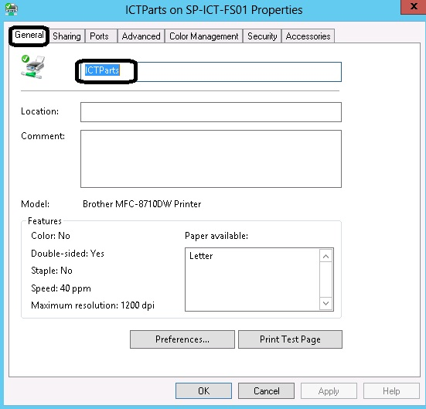

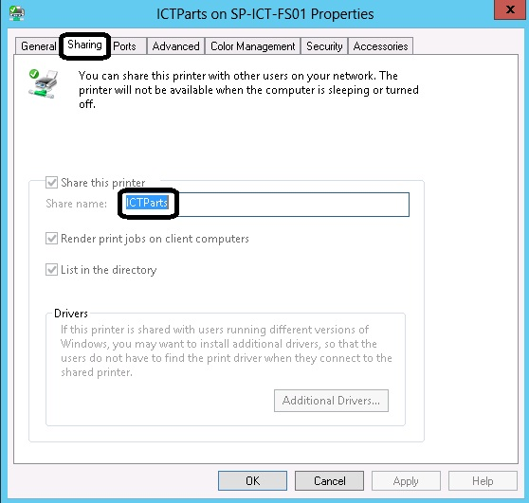

Configuration to enable MMDPrintPDF batch printing:

- In the server, where AutoPrintMMDservice is installed, login as Administrator or any other user with Administrative privilege. Go to “Control Panel” -> “Administrative Tools” and open “Task Scheduler”.

2. Select “Task Scheduler Library” and click “New Folder” from “Actions” pane. Provide the name of the folder. Eg: MMDPrintJob

3. Select the newly created folder and click “Create Task” from “Actions” pane.

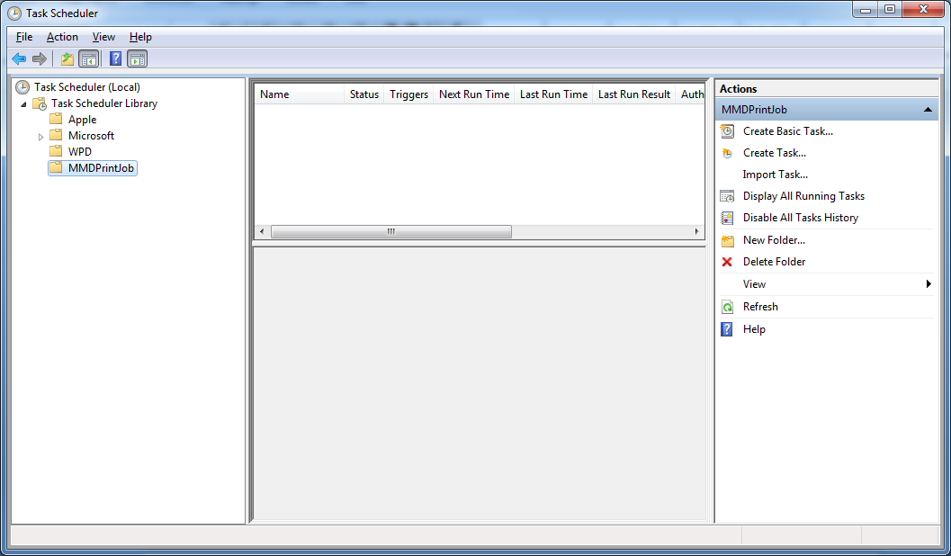

3. Select the newly created folder and click “Create Task” from “Actions” pane.

4. In “General” tab, provide appropriate name and description and select “Run whether user is logged on or not” option from “Security Options” cluster.

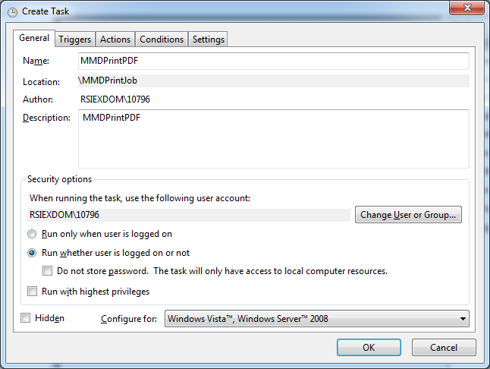

5. Go to “Triggers” tab and click “New”. Provide the configuration details as shown below and click “OK”.

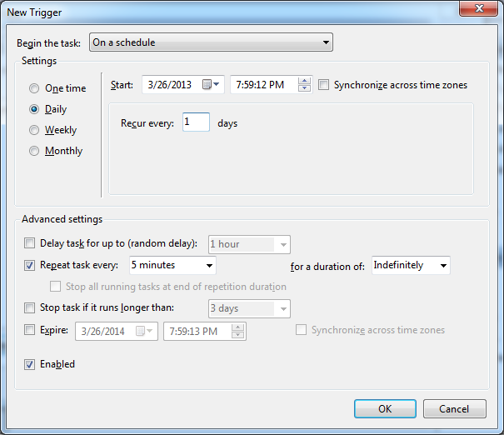

6. Go to “Actions” tab and click “New”. Select “Start a program” from “Action” combo and provide the MMDPrintPDF.exe path in “Program/Script” and click “OK”. Typically this exe is available in the MMDPrintPDF’
installed folder “..\MMDPrintPDF” folder.

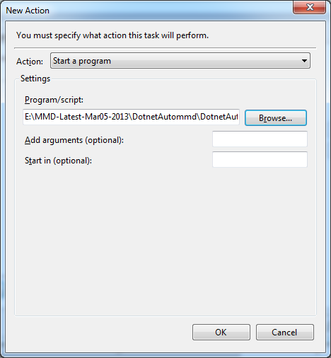

7. Go to “Conditions” tab and check “Wake the computer to run this task” option available under “Power” cluster.

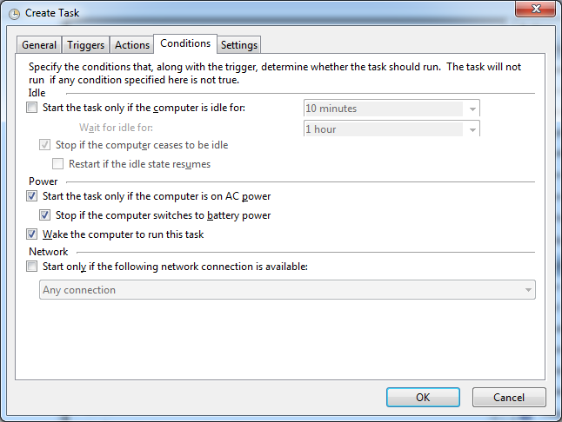

8. Go to “Settings” tab and ensure to check “Allow task to be run on demand” and “Run Task as soon as possible after a scheduled start is missed” choices.

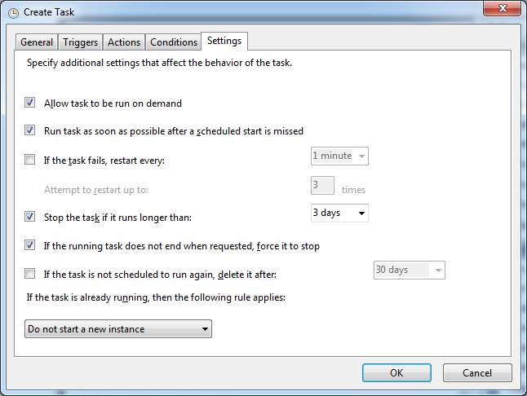

9. Accept other default values and click “OK”. Provide the credential to successfully create the job.
Note:
i) if the password is changed for the user account, with which this job is configured then update the same for this job.

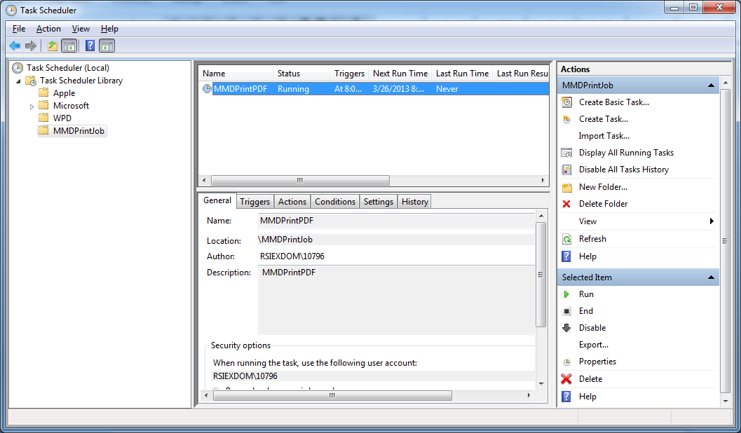

Trouble shooting Guide
- Make sure that option setup is provided.
- Make sure that printer setup is provided.
- Check any record is available in the table MMD_DOCUMENT_LOG with value ‘W’ in the MMD_FLAG column.
- If record available in step 3 then execute the sp MMD_Document_Fet_SP in the RM server. This will show the records that will be printed by the scheduler. If it is not giving any records as output then problem with printer setup or option setup. Check the MMD_FLAG of the records. It will be updated to ‘E’ (Error).
- If records available in step4 then execute the sp MMD_RPT_MMDDOC_SP with the output of step4. If this is not giving any records. Problem with document.
- If record available in step 5 then either the name of the printer specified is incorrect or the printer is not physically available.
- Check the Error Log table AUTOPRINT_MMD_ERRLOG for Error description

