
Ramco Aviation Solution
Version 5.7
Server Side Mandatory Settings
DISCLAIMER

©2014 Ramco Systems Ltd. All rights reserved. All trademarks acknowledged.

This document is published by Ramco Systems Ltd. without any warranty. No part of this document may be reproduced or transmitted in any form or by any means, electronic or mechanical, for any purpose without the written permission of Ramco Systems Limited.
Improvements and changes to this text necessitated by typographical errors, inaccuracies of current information or improvements to software programs and/or equipment, may be made by Ramco Systems Limited, at any time and without notice. Such changes will, however, be incorporated into new editions of this document. Any hard copies of this document are to be regarded as temporary reference copies only.
The documentation has been provided for the entire Aviation solution, although only a part of the entire solution may be deployed at the customer site, in accordance with the license agreement between the customer and Ramco Systems Limited. Therefore, the documentation made available to the customer may refer to features that are not present in the solution purchased / deployed at the customer site.

Table of Contents

1.0 Timeout issue with long running queries 4

1.0 Timeout issue with long running queries

In certain application screens, when the back end SP takes more than 5 minutes to complete, system throws errors as mentioned in the images below:

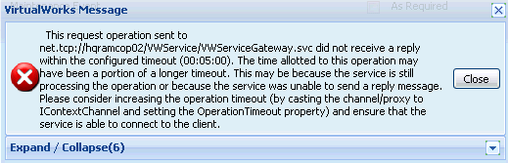

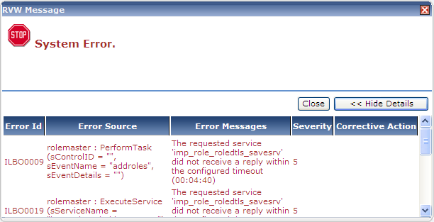

Changes to be done in APP Server:

- Check the Framework version on which the VWService APP Pool (or the pool on which VWService Virtual Directory is running) is configured. This setting can be checked through IIS Console.
- Open Machine.Config file from the path as given in the table below:

Processor | Framework Version on which VWService App Pool runs | Machine.Config file Path
32 Bit | V 2.0 | C:\Windows\Microsoft.NET\Framework\v2.0.50727
32 Bit | V 4.0 | C:\Windows\Microsoft.NET\Framework\v4.0.30319
64 Bit | V 2.0 | C:\Windows\Microsoft.NET\Framework64\v2.0.50727
64 Bit | V 4.0 | C:\Windows\Microsoft.NET\Framework64\v4.0.30319
- Modify System.Transactions section in machine.config by setting the allowDefinition attribute to “MachineToApplication” (from MachineOnly).

<sectionGroup name="system.transactions" type="System.Transactions.Configuration.TransactionsSectionGroup, System.Transactions, Version=2.0.0.0, Culture=neutral, PublicKeyToken=b77a5c561934e089, Custom=null">
<section name="defaultSettings" type="System.Transactions.Configuration.DefaultSettingsSection, System.Transactions, Version=2.0.0.0, Culture=neutral, PublicKeyToken=b77a5c561934e089, Custom=null" />
<section name="machineSettings" type="System.Transactions.Configuration.MachineSettingsSection, System.Transactions, Version=2.0.0.0, Culture=neutral, PublicKeyToken=b77a5c561934e089, Custom=null" allowDefinition=" MachineToApplication" allowExeDefinition=" MachineOnly" />
</sectionGroup>

Note: If any .Net Framework or OS related security updates / patches is being run in future, there is a possibility that the above setting would get overwritten. So please re-confirm this setting after updating any security patches.

- Open the WEB.Config file from the path ..\virtualworks\VWService folder and add the section given below:

<system.transactions>
<machineSettings maxTimeout="01:00:00" />
</system.transactions>

Where to add the above code in WEB.Config file?

<?xml version="1.0" encoding="UTF-8"?>
<configuration>
<configSections>
<section name="vwComponentSettings" type="Ramco.VW.RT.Config.VWComponentSettingsSection, VWHelper, Version=1.4.3.12, Culture=neutral, PublicKeyToken=3a721247b727f8b9" />
</configSections>
<vwComponentSettings configSource="VWComponentSettings.config" />

<system.transactions>
<machineSettings maxTimeout="01:00:00" />
</system.transactions>

<system.web>
<compilation debug="false">
<assemblies>
<add assembly="Ramco.VW.RT.GatewayServer, Version=1.4.3.12, Culture=neutral, PublicKeyToken=3a721247b727f8b9" />
</assemblies>
</compilation>

</system.web>
...
...
...

</configuration>

- Open the file VWComponentSettings.config from the folder ..\VirtualWorks\VWService and modify the transTimeout value from 300 (5 mins) to 3600 (60 mins)
<vwComponentSettings>
<properties componentName="*" transTimeout="3600" transIsolation="" extended="false"/>
</vwComponentSettings>

- Restart the services W3SVC and Ramco.VW.RT.GatewayServicesHost from the Services Console.

