
Ramco Aviation Solution
Version 5.7
Preferences-Synch-BITS

DISCLAIMER
©2014 Ramco Systems Ltd. All rights reserved. All trademarks acknowledged.

This document is published by Ramco Systems Ltd. without any warranty. No part of this document may be reproduced or transmitted in any form or by any means, electronic or mechanical, for any purpose without the written permission of Ramco Systems Limited.
Improvements and changes to this text necessitated by typographical errors, inaccuracies of current information or improvements to software programs and/or equipment, may be made by Ramco Systems Limited, at any time and without notice. Such changes will, however, be incorporated into new editions of this document. Any hard copies of this document are to be regarded as temporary reference copies only.
The documentation has been provided for the entire Aviation solution, although only a part of the entire solution may be deployed at the customer site, in accordance with the license agreement between the customer and Ramco Systems Limited. Therefore, the documentation made available to the customer may refer to features that are not present in the solution purchased / deployed at the customer site.

Revision History
Version | Date | Author | Description
1.0 | 05 – 10 – 2007 | Saravanakumar J | Initial Document on Usage and installation
1.1 | 10 – 10 – 2007 | Lakshman | Included changes for Directory junction to avoid Appdomain restart
2.0 | 25-Nov-2007 | Gangireddy | Multiple directory support.
3.0 | 16-Aug-2012 | Karthik | Modified with WIN 2008 snapshots
4.0 | 25-Sep-2012 | Karthik | Modified

Synchronization of documents on NLB Servers using BITS

Background Intelligent Transfer Service asynchronously transfers files in the foreground or background, throttles the transfers to preserve the responsiveness of other network applications, and automatically resumes file transfers after network disconnects and machine restarts.

Although FTP is commonly used to transfer files over the Internet, it's somewhat unfriendly to firewalls, because of the various ports that need to be opened. A Microsoft solution for Internet file transfer is the Background Intelligent Transfer Service, BITS for short. BITS runs in the background (hence its name) as a service and it transfers files over the browser ports (80, 443) using HTTP or HTTPS. In addition, BITS transfers are restartable, so if the transfer of a large file gets interrupted, it will resume where it left off.( BITS is the underlying technology in some Microsoft Internet capabilities, such as downloads with Microsoft Update.) This has high level of built in fault tolerance.

Prerequisites on Web server:
OS: Windows 2003 or greater

IIS: IIS 6.0 / IIS 7 / 7.5. The IIS virtual directory must be enabled for uploads and have the BITS IIS extensions configured.

Component: BITS 2.5 Version
Available at: http://support.microsoft.com/kb/923845 (Link applicable only for Win 2003 servers)

Note: Step to check which version of BITS in the server.
- %windir%\system32\Qmgr.dll – Version No 6.7.3790.4088 (2.5 version)

Deployment:

The Deliverables used are:
- System.Net.BITS.dll
This third-party component provides managed environment to work with the underlying BITS COM component. (This acts as Runtime Callable Wrapper over unmanaged COM Component).

To be deployed in Web Server: GAC

- VWNotificationService.exe
This managed NT Service watches the change event in the configured folder and propagate the change to servers, which take part in the NLB.

To be deployed in Web Server: ..\Virtualworks\RT2
Note: Deployed as NT Service using
C:\\...\RT2>installutil.exe /i VWNotificationService.exe

- VWNotificationService.exe.config
VWNotification service is configured through this configuration file.

To be deployed in Web Server ..\Virtualworks\RT2

- Linkd.exe
Kindly copy the linkd.exe and store it in Rt2 Folder.

Configuration:

- Internet Information Service (IIS):
  - Check if BITS Server Extension tab is available in Virtual Directory Properties.

If not, Install BITS Extn component using Add/Remove Windows Components -> Application Server -> Details -> Internet Information Service -> Details Background Intelligent Transfer Service Server Extension – Check and Finish.

(Note: In Windows 2008 and above, the same will be available as part of WEB Server Roles installation through Server Manager. Open Server Manager -> Features -> Add Features -> Select “Background Intelligent Transfer Services” and click on Next / Install to complete the installation. Refer image below for details).

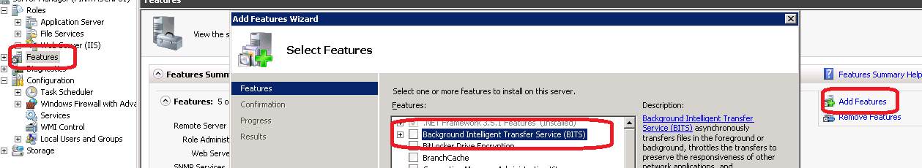

  - Create a folder name “BITSPreferences” under VirtualWorks (not under VirtualWorks\IIS folder). Create a Virtual Directory (with the name of BitsPreferences) in Server 1 and set the settings of the Virtual Directory as given in the image below. Create a new App Pool in IIS called “BitsPreferences” and map this new Virtual Directory under this App Pool. The App Pool settings for this newly created App Pool will follow the same settings as that of the App Pool under which RVW Virtual Directory is mapped. The new virtual directory “Bits Preferences” will run under Anonymous Authentication only.

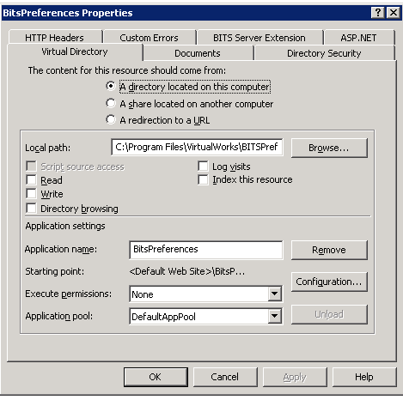

If preferences folder under IIS is having any <user>_preferences.xml , then kindly take the backup of the files and delete all the files in the folder, perform the below step C and copy them back into Preferences folder.

  - Link BITSPreferences folder with Preferences folder under IIS. This can be done through command prompt. Go to command prompt and go to the RT2 folder under Virtual Works and run linkd.exe. The syntax for running this command is given below:

LINKD.EXE <IIS preferences folder path> <BITSPreferences Folder path>

(Check at the end of the document for LinkD EXE behavior)

Note 1: IIS Preferences folder should not contain any file while running linkd.exe. Else link cannot be created.

Note 2: After linking two directories, BITSPreferences folder should not be deleted. This will disable personalization feature

  - Go to IIS and go to properties of the newly created BitsPreferences virtual directory and in the BITS Server Extension tab, Check “Allow clients to transfer data to this virtual directory” and allow “Use default settings”.

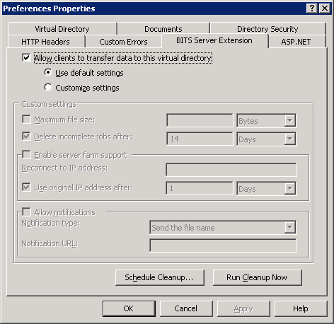

(for Win 2008 and above, see image below)

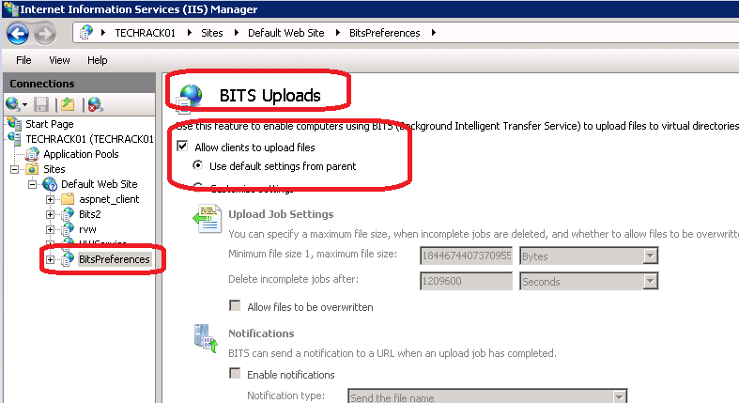

This option(/screen pasted above) will be available under the BITS Uploads icon under the BitPreferences virtual directory (in Win 2008 family).

Apply the changes made.

  - To Enable Over-Write in the folder

    - In command prompt, change to C:\InetPub\AdminScripts folder.

    - To enable overwrites, go to command prompt and browse to the path c:\inetpub\adminscripts and run the command:
cscript.exe adsutil.vbs SET w3svc/1/root/BITSAllowOverwrites 1

    - Restart IIS

(To disable overwrites, go to command prompt and browse to the path c:\inetpub\adminscripts and run the command and restart IIS:
cscript.exe adsutil.vbs SET w3svc/1/root/BITSAllowOverwrites 1)

- VWNotificationService.exe.config

This file contains the details on which file extensions needs to be synchronized between the web servers. The sample file given along with this document has details about how to synchronize user personalization XML files between the preferences folders across two different web servers. This can be extended to synchronize across multiple web servers. Same way the same file can be extended to synchronize different file extensions across multiple web servers. See the picture below for more details on how to add the entries in this file. A brief description has also been given below. The path details specified in the image and in the below explanation are only examples. The path needs to be modified to the respective Preferences folder depending on the target folder path where VirtualWorks is installed.

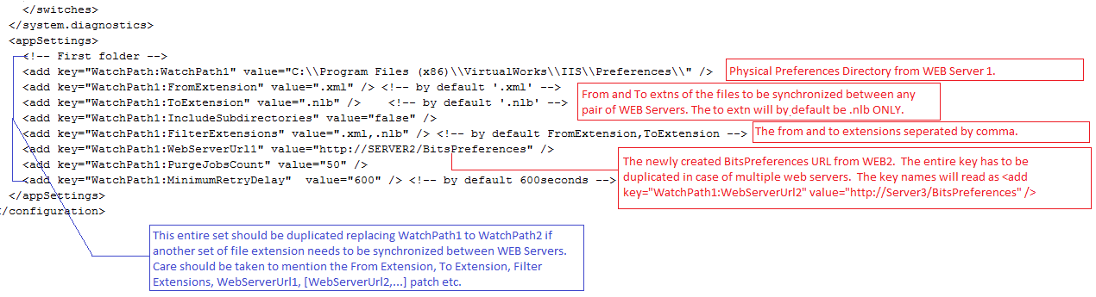

<appSettings>
<add key="WatchPath:WatchPath1" value="C:\\Program Files\\VirtualWorks\\IIS\\Preferences" /> <!—First folder -->

WatchPath = Determines the valid folder path which has to be listened.
..\IIS\Preferences

<add key=" WatchPath1:FromExtension" value=".xml" /> <!-- by default '.xml' -->
<add key=" WatchPath1:ToExtension" value=".nlb" /> <!-- by default '.nlb' -->
To avoid recursive file transfers between NLB servers. FromExtension denotes the file to be transered and ToExtension denotes the extension in which the file is uploaded.

<add key=" WatchPath1:IncludeSubdirectories" value="false" />
Should the Watcher component include subdirectories for listening? Default is false.

<add key=" WatchPath1:FilterExtensions" value=".xml,.nlb" />
Filter Extensions are the group of extension (separated by commas) to be listened.

<add key=" WatchPath1:WebServerUrl1" value="http://server1/preferences" />
<add key=" WatchPath1:WebServerUrl2" value="http://server2/preferences" />
<add key=" WatchPath1:WebServerUrl3" value="http://server3/preferences" />
List of server URL’s (part of NLB’s) with the key “WebServerUrl<Sequence no>”

<add key=" WatchPath1:PurgeJobsCount" value="50" />
Purge Jobs Count determine when to start purging old jobs, lower the better.

<add key=" WatchPath1:MinimumRetryDelay" value="600" /> <!-- by default 600seconds -->
Minimum retry delay to resume the job when transient error happen.

</appSettings>

Limitations:

1. Virtual Directory should be configured with Anonymous Authentication enabled.
2. BITSPreferences folder should not be renamed or deleted which may disable personalization feature

Linkd :
Linkd.exe is used to create/delete links between two different folders so that any file copied into one folder gets copied automatically into the other folder.
Usage:
c:\>linkd "source" "destination"
Behaviors:
When a source directory is linked with a destination directory
- Source Folder should be Empty before linking folders using Linkd.exe
- All events firing in the source will be reflected in destination also
- Destination folder should not be deleted or renamed. If deleted, Source folder cannot be opened. Following error will come.
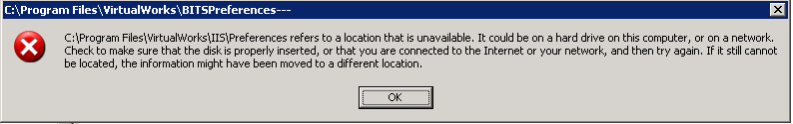
A folder with the same name as destination folder needs to be created to make the source folder accessible in this case.
4. linkd <Source Folder> /d is used to remove the source folder and the link if exists.

Note: Synchronization of Runtime folders (IIS, ILRT, RT2) are not allowed and may result in unexpected behavior.
Corporate Office and R&D Center
Ramco Systems Limited,
64, Sardar Patel Road, Taramani,
Chennai – 600 113, India
Office + 91 44 2235 4510 / 3090 4000
Fax +91 44 2235 2884
Website - www.ramco.com

