Title:
Subtitle:



Ramco Aviation Solution
Version 5.7
VW Report Process Isolation

©2014 Ramco Systems Ltd. All rights reserved. All trademarks acknowledged.
Title
Sub-Title

This document is published by Ramco Systems Ltd. without any warranty. No part of this document may be reproduced or transmitted in any form or by any means, electronic or mechanical, for any purpose without the written permission of Ramco Systems Limited.
Improvements and changes to this text necessitated by typographical errors, inaccuracies of current information or improvements to software programs and/or equipment, may be made by Ramco Systems Limited, at any time and without notice. Such changes will, however, be incorporated into new editions of this document. Any hard copies of this document are to be regarded as temporary reference copies only.
The documentation has been provided for the entire Aviation solution, although only a part of the entire solution may be deployed at the customer site, in accordance with the license agreement between the customer and Ramco Systems Limited. Therefore, the documentation made available to the customer may refer to features that are not present in the solution purchased / deployed at the customer site.

Table of Contents

1.0 Introduction 5
2.0 Prerequisites 5
3.0 Configuration settings 5
4.0 Steps for Creating Application Pool 5
5.0 Steps for Creating Virtual Directory 9

- Introduction
Currently VirtualWorks Applications and Crystal Reports execute in a single process. Crystal Report’s 64-Bit support is also not available across its wide product range and is currently limited to only higher-end product range. Hence it is required to isolate Crystal Reports process from VirtualWorks Applications. The advantages are process isolation and leveraging 64-Bit features for VirtualWorks Applications.

- Prerequisites
- Client browsers should have a valid certificate when using the Hypertext Transfer Protocol Secure (HTTPS).

- Configuration settings
- In the web.config file available in virtualworks\iis report virtual directory, the following information should be available. Under <appSettings> node add the key value <add key="ReportDirectory" value="<virtual directory name>" />. If the key is not available or key value is empty then report will work in the same VirtualWorks application process.
- Report isolation virtual directory should be associated with a 32 bit application pool.
- EXTUI application virtual directory should be preferable set to 64 bit application pool.
- Both EXTUI Application virtual directory and Report isolation virtual directory should point to the same physical folder.

- Steps for Creating Application Pool
To create Application Pool in IIS, Expand the Server menu from the Connection Tree (in the left pane) and click “Application Pools”, as shown in the below screenshot.

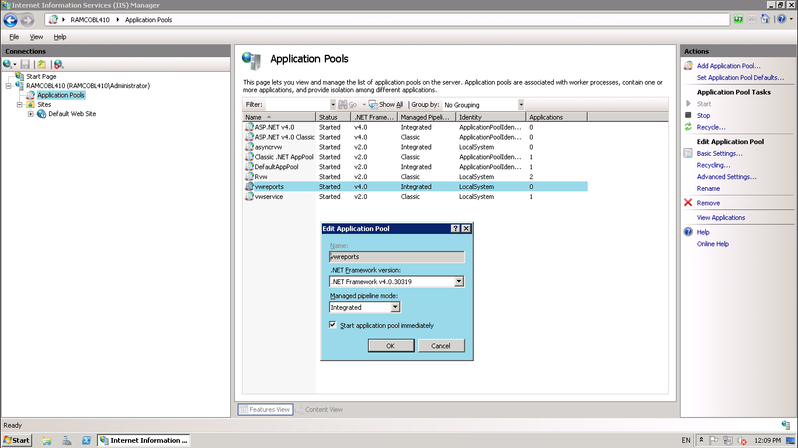

- Click “Add Application Pool…”
- Provide Application Pool name as “vwreports”
- Set .Net Framework Version as “.Net Framework V4.0.30319”, this is mandatory to make application work with Windows 2008/ 2008 R2 server.
- Set the Managed pipeline mode to “Integrated”

Once the Application Pool is created, select the “application pool” Name and click Advanced Settings. It will open a properties window as shown in the below screenshot.

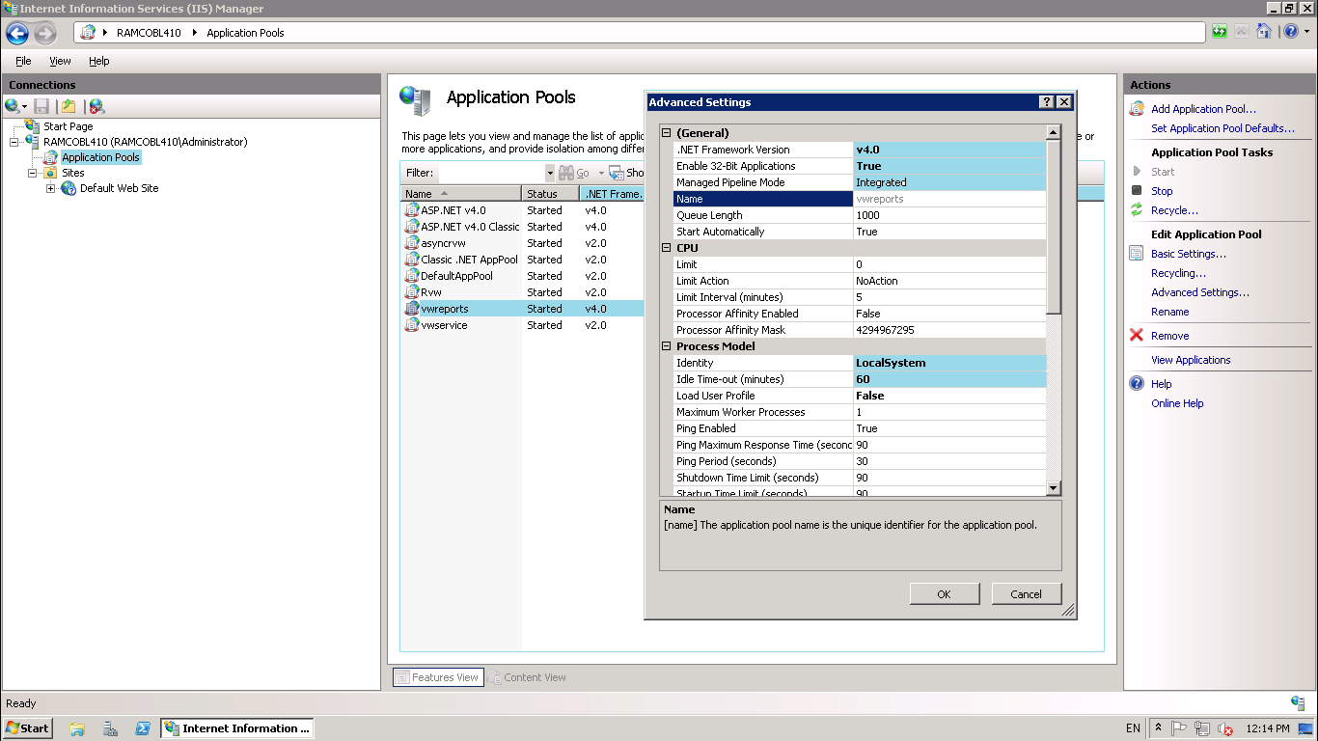

Set the properties as highlighted.
- .Net Framework Version to v4.0
- Enable 32-Bit Applications to True.
- Ensure Managed Pipeline Mode to “Integrated”
- Under the ProcessModel,set “Identity” to “LocalSystem”
- Idle Time-out (Minutes) to 60 (recommended value). It can be changed on wish.

Continue the settings as shown in the below screenshot with the

- Rapid-Fail Protection – “Enabled” to False
- Expand “Generate Recycle Event Log Entry” and set “Regular Time Interval” to False
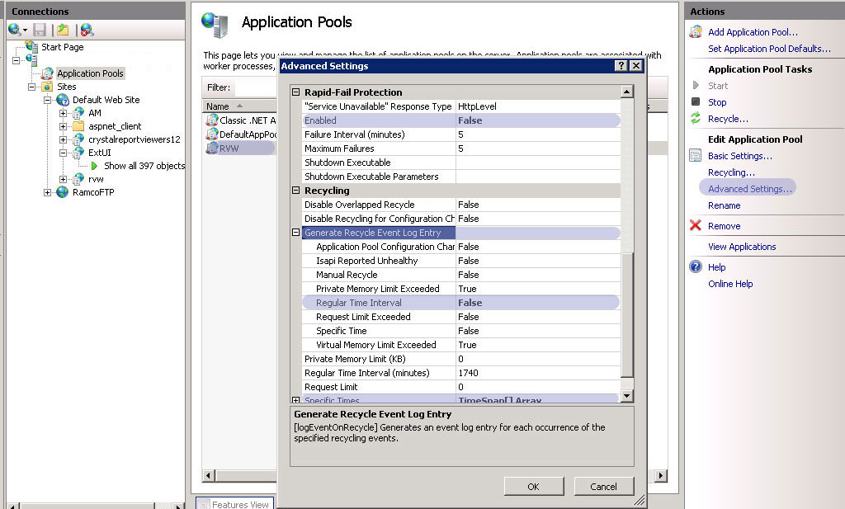

Expand “Specific Times” and Click the button enable on the right corner. It opens a new window as shown in the below screenshot.

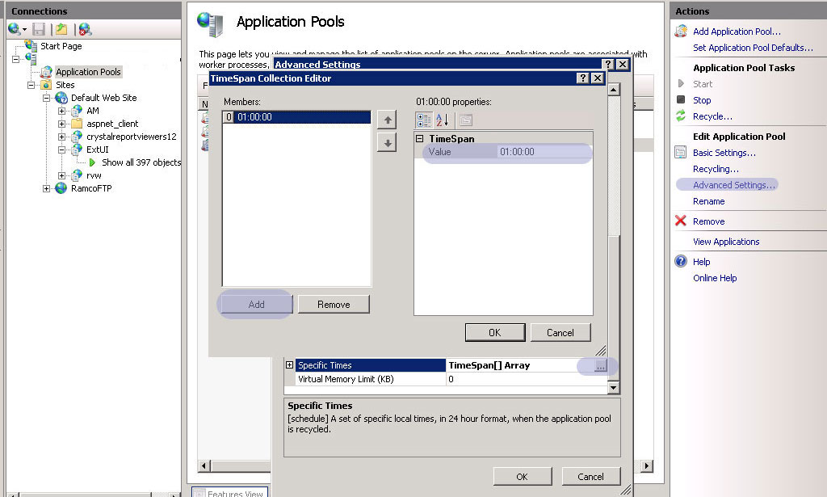

Add TimeSpan with the value “01:00:00” and click ok.

This completes Adding “Application Pool“and Settings the required properties.

Go to Advance Settings of Application Pool EXTUI and change the Enable 32-Bit Applications to "False”. This setting is required to isolate the Crystal Reports process from EXTUI Application Process for better performance.

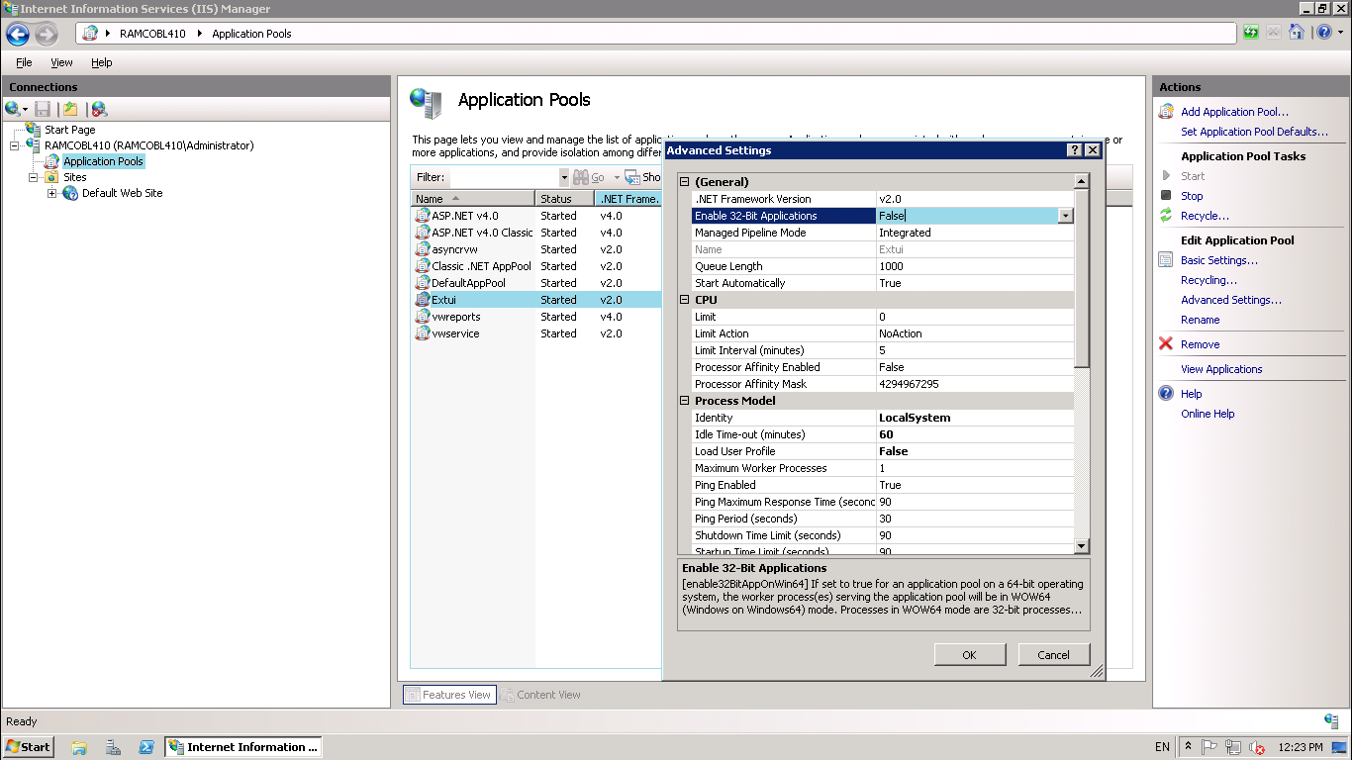

- Steps for Creating Virtual Directory
To create Virtual Directory, Right click “Default Web Site” and click “Add Virtual Directory…”. It will open a window as shown in the below Screenshot. In the below screenshot, example given to create a virtual directory in the name “extui”.

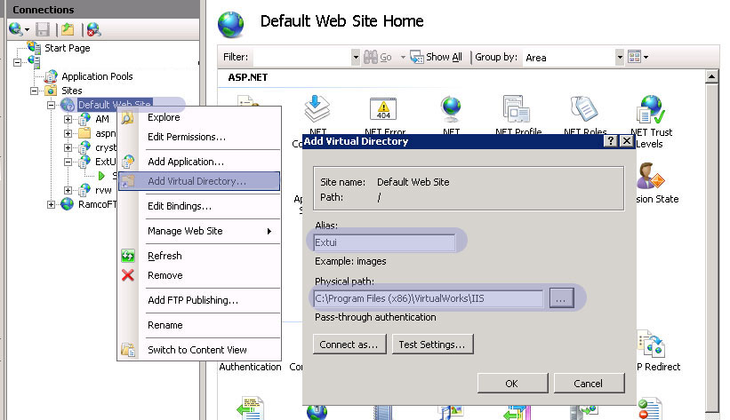

- Provide an Alias name as “vwreports”. Provide the Physical Path as full path of “IIS” folder available in the “Program Files (x86)\VirtualWorks” and click Ok.

This creates the virtual directory.

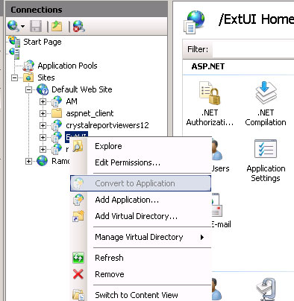

As shown in the above screenshot, right click on the virtual directory and click “Convert to Application”.
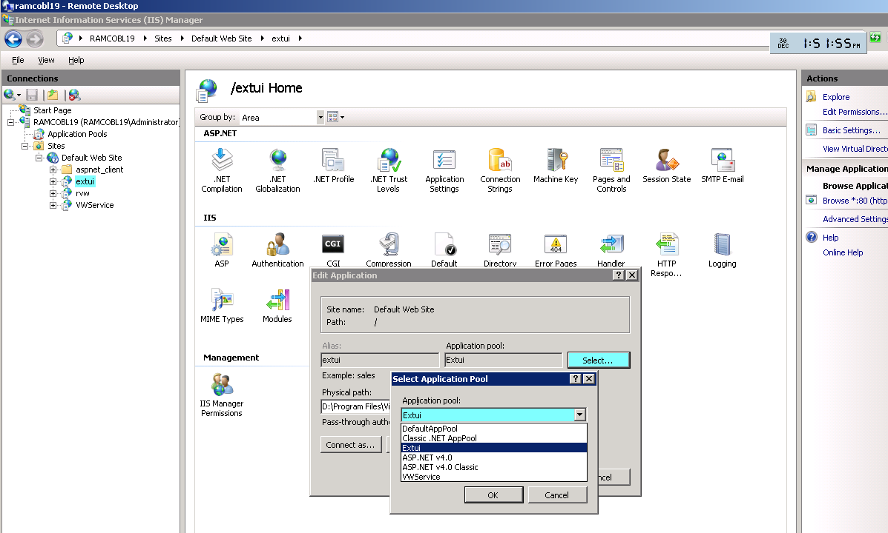

As shown in the above Screenshot, Select the virtual Directory and click “Basic Settings”.
- Click “Select” button against the Application Pool.
- From the dropdown, Select the Application Pool “EXTUI” and click Ok.

This completes the Virtual Directory creation and setting its property.

Corporate Office and R&D Center
Ramco Systems Limited,
64, Sardar Patel Road, Taramani ,
Chennai – 600 113, India
Office + 91 44 2235 4510 / 3090 4000
Fax +91 44 2235 2884
Website - www.ramco.com

