
Title:
Subtitle:

Ramco Aviation Solution
Version 5.7
Report Configuration

DISCLAIMER
©2014 Ramco Systems Ltd. All rights reserved. All trademarks acknowledged.

This document is published by Ramco Systems Ltd. without any warranty. No part of this document may be reproduced or transmitted in any form or by any means, electronic or mechanical, for any purpose without the written permission of Ramco Systems Limited.
Improvements and changes to this text necessitated by typographical errors, inaccuracies of current information or improvements to software programs and/or equipment, may be made by Ramco Systems Limited, at any time and without notice. Such changes will, however, be incorporated into new editions of this document. Any hard copies of this document are to be regarded as temporary reference copies only.
The documentation has been provided for the entire Aviation solution, although only a part of the entire solution may be deployed at the customer site, in accordance with the license agreement between the customer and Ramco Systems Limited. Therefore, the documentation made available to the customer may refer to features that are not present in the solution purchased / deployed at the customer site.

Table of Contents

1.0 Introduction 6
2.0 Prerequisites 6
3.0 Environment level report configuration 7
4.0 Report configuration for specific reports 9
5.0 Custom report launcher specification 13
6.0 Report email configuration 14
7.0 Runtime Configuration working procedure 15

- Introduction
VirtualWorks reporting tasks now has the capability to launch either crystal or decision works report engine. Report configuration component (Vwrep_customisation) is provided to capture all these report configuration details. All system level configurations (existed in web.config earlier) and report configurations which existed in xml files have been moved to this component.

- Prerequisites
1. RT Patch CD 15 - MSRVW_.netPat12_70 or above should be deployed.
2. For Extui environment, latest extui deliverables should be deployed.
3. To launch EDK screens and reports EDK Patch CD 3 – Fix83-INFRA_.Net_00759 or above should be deployed.
4. Generic type of Report aspx is used for launching the report.
5. VWReport deliverables patch 5 should be deployed
6. Latest depdb script (fw_req_activity_ilbo_task_local_info to include the table) should be generated from platform developer console and deployed in the deployment database

- Environment level report configuration
  - Report Configuration Default Values user interface
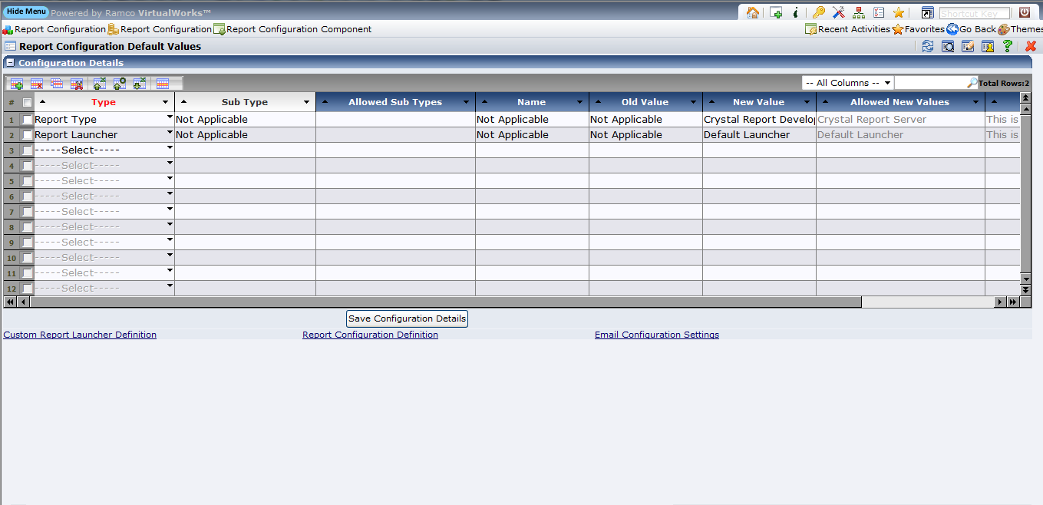

In this user interface the configuration settings required in environment level are specified here. Grid “Configuration details” is used to specify the configuration settings. Grid Configuration column details are available as follows

Type

The configuration details are available in this combo. The required configuration has to be selected.

Sub Type

If the selected configuration (Type column) contains one or more sub configuration then the sub configuration detail has to be specified here. The value entered here should be available in the allowed sub types column available in the same row. By default on selecting a configuration, a sub configuration will be displayed. On changing the sub configuration user has to press “Enter” key in the sub type column. If the sub type is not applicable for the selected configuration then “Not Applicable” will be available.

Allowed Sub Types

For the selected configuration its related sub configuration details will be displayed.

Name

For the selected configuration, if additional parameter has to be specified then that can be specified here. If the Name is not applicable for the selected configuration then “Not Applicable” will be available.

This is used for the following

Main report parameter incorporation. Parameter name is specified here.

Custom Size (paper size) incorporation. “Width” should be specified to specify the report width details. “Height” should be specified to specify the report height details.

Old Value

For the selected configuration, if the configuration has to be performed at runtime based on the available report state it can be specified here. If the Old value is not applicable for the selected configuration then “Not Applicable” will be available.

This is used when replace paper size is used. The report paper size is provided here. On launching the report at runtime if it report paper size is the same as the old value then the configuration paper size will be assigned to the report at runtime. This configuration is applicable for report launching, it will change the physical report deliverables.

New Value

This column is used to specify the configuration value.

Allowed New Values

For the specified configuration it’s allowed (new value column) values are available here.

Remarks

This column is used to provide more information about the selected configuration.

- Report configuration for specific reports
  - Report Configuration Definition user interface
This user interface can be launched on clicking the link “Report Configuration Definition” available in the user interface “Report Configuration Default Values”
In this user interface the configuration settings required in report task level are specified here. For the same report different configuration settings can be specified for
- Specific Role and OU
- Specific Role and All OU
- All Role and specific OU
- All Role and All OU

There are three modes available
- Add
On selecting this mode configuration details can be newly added for the report. More than one report with the same configuration can be specified here. If the configuration detail is already available for the report then the new configuration detail will over write the existing one.
- Modify
This mode is used to modify or remove the existing configuration detail for the report.
- View
This mode is used to view the configuration details for the report.

Add Mode :
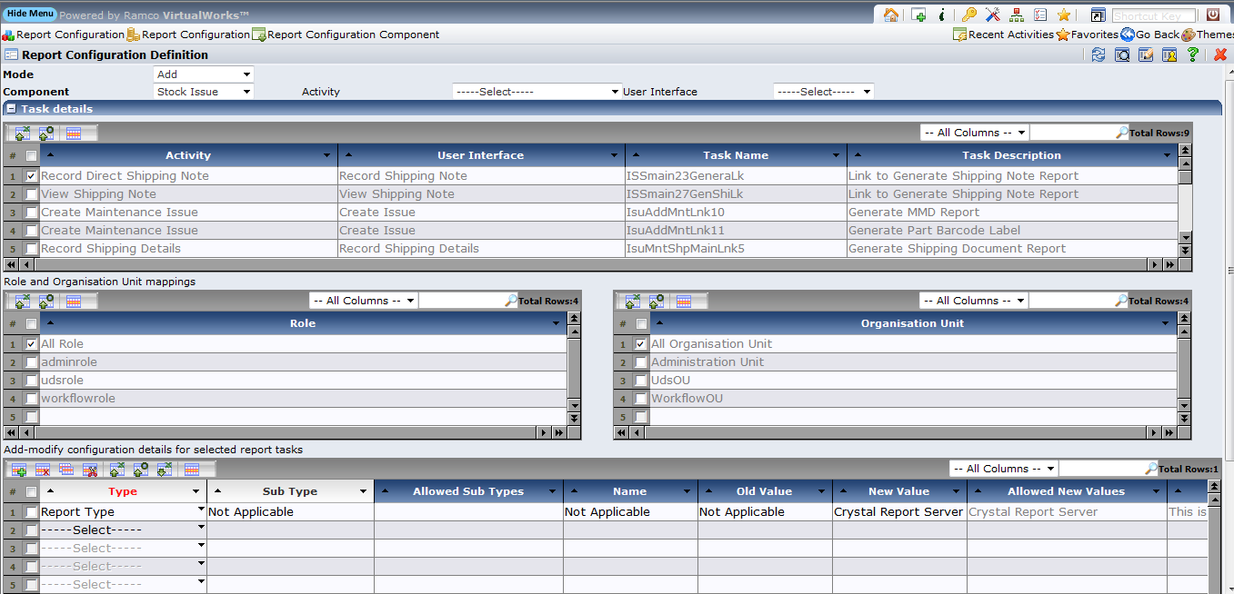

Select the component, the report task details available for that selected component will be shown in the “Task Details” grid. The task details can be further filtered by selecting the required activity and user interface combo.

In the Role and Organisation mappings, Roles and Organisation unit available in the deployment database are listed. In addition to that “All Role” and “All Organisation Unit” are available to provide configuration details for all role and organisation unit.

In the grid “Add-modify configuration details for selected report tasks” is used to provide the report configuration.

To add the configuration details, select (one or more) required report task in the “Task Details” grid, select the required (one or more) Role and Organisation Unit, provide the report configuration details in the grid “Add-modify configuration details for selected report tasks” and click on the button “Save”

Modify Mode :
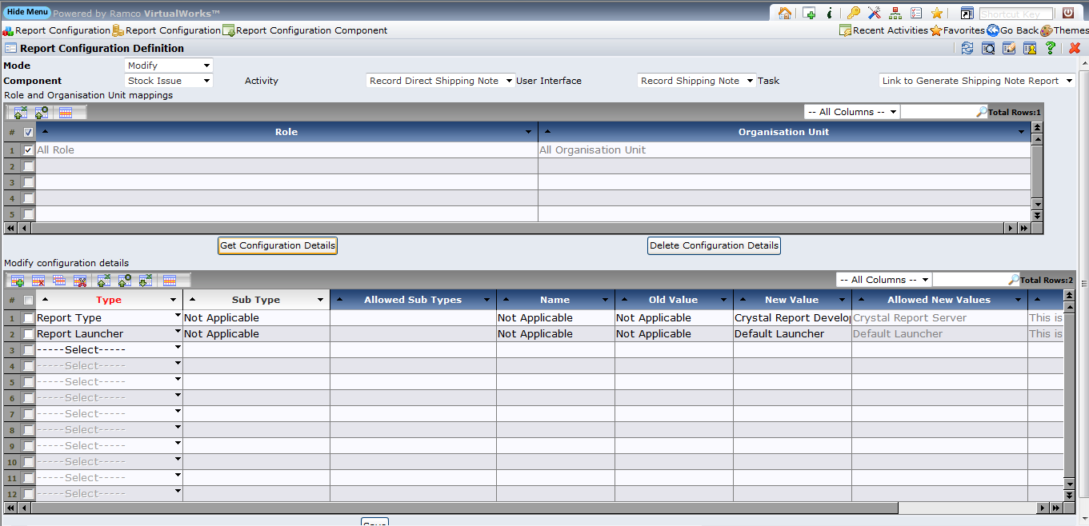

Select the required report task by selecting the combos Component, Activity, User Interface and Task. Already available role and organisation unit details will be shown in the grid “Role and Organisation Unit mappings”.

To modify the existing configuration details for the selected report task, select the required role, organisation unit mapping and click on the “Get Configuration Details” button to get the existing configuration details in the “Modify Configuration details” grid. The configuration can be modified and saved on click on the button “Save”.

To delete the existing configuration details for the selected report task, select the required role, organisation unit mapping and click on the “Get Configuration Details” button and click on the button “Delete Configuration Details”.

View Mode :
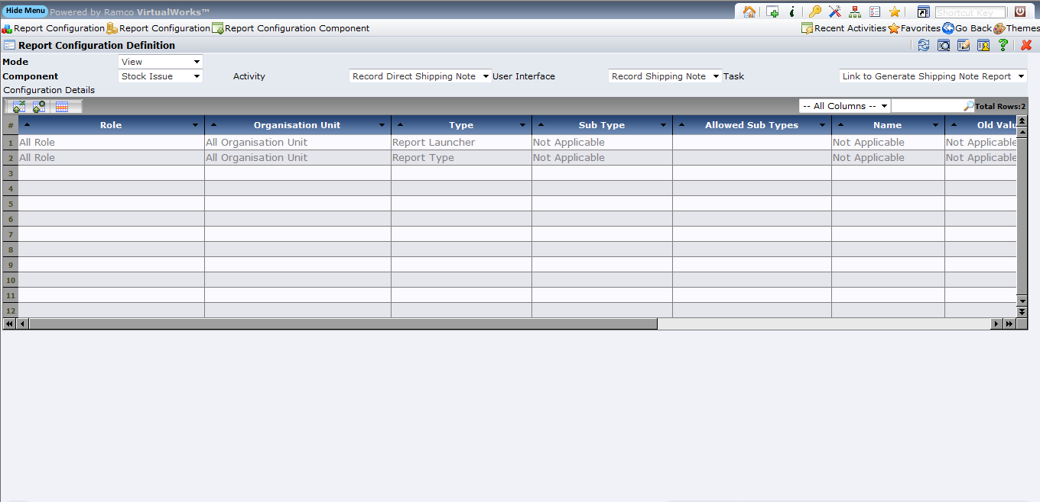
Select the required report task by selecting the combos Component, Activity, User Interface and Task. The report configuration details along with the role and organisation unit will be displayed in the grid “Configuration Details”.

- Custom report launcher specification
This user interface can be launched on clicking the link “Custom Report Launcher Definition” available in the user interface “Report Configuration Default Values”.

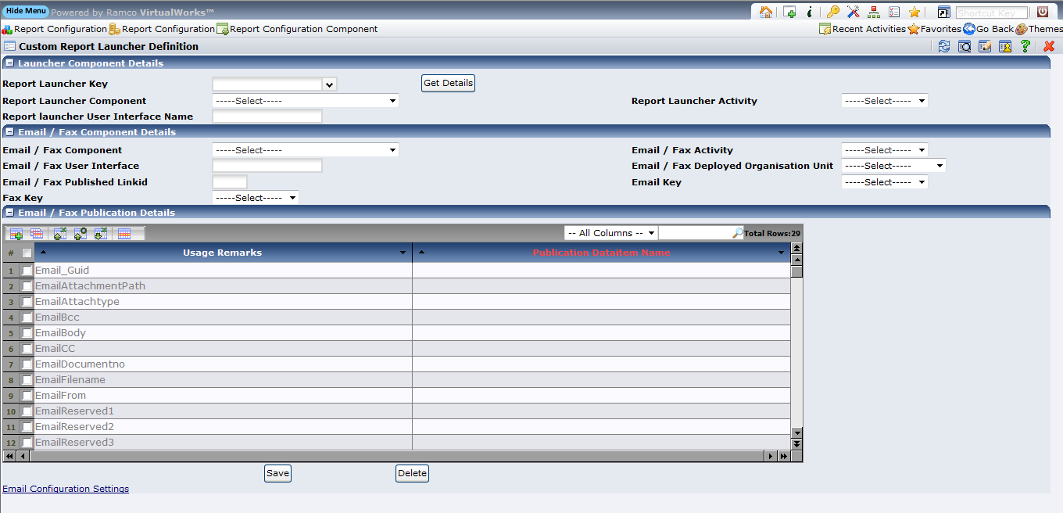

This user interface is used to specify the virtual works based modeled report launcher, so that the application teams email component can be shown to the user for sending report data in mail. This report launcher can launch the reports only in “Extjs” environment. In normal htm it will not work. This report launcher cannot be launched using new window. It will always launch only in same window.

For more details/clarifications about this contact support team.

Specify a report launcher key. This key is used to specify the report launcher details in report configuration. To provide the virtual works user interface based launcher, select the report launcher component, activity and user interface.

Application team email component information is specified in Email / Fax component details. Select the component, Activity and specify the user interface name. Select the organization unit in which the email component is deployed. Specify the link id using which the email related field data will be traversed. Based on the email application service data the email or fax is sent.

The email user interface publication usage has to be entered in the email/fax publication grid. Where based on the usage the applicable field has to be specified.

- Report email configuration
This user interface can be launched on clicking the link “Email configuration settings” available in the user interface “Report Configuration Default Values”

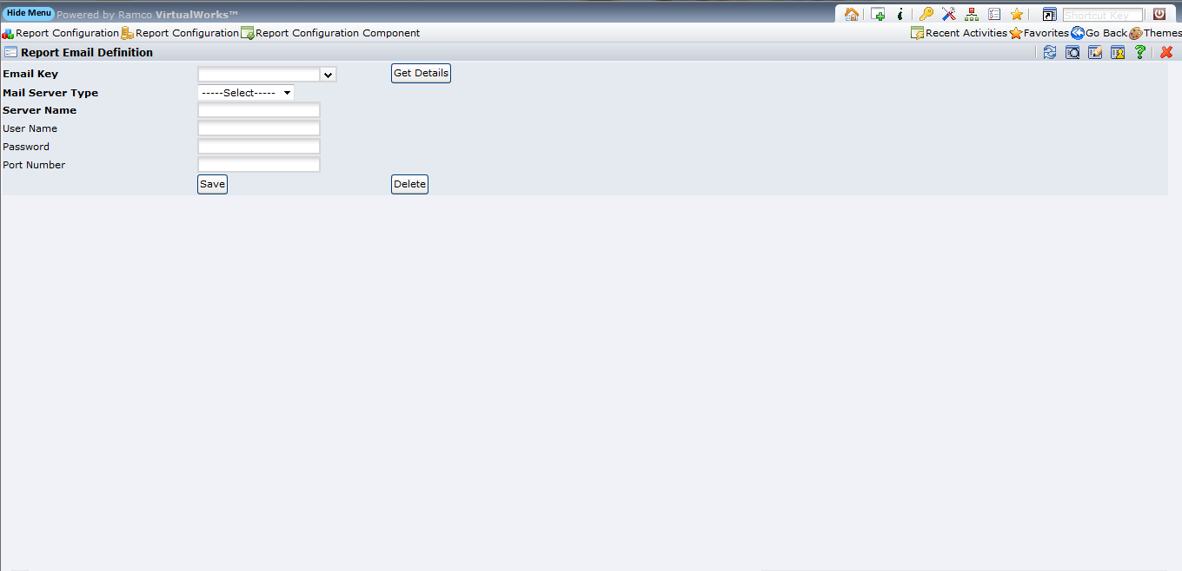

This user interface is used to specify the email configuration details that are used in the custom report launcher for sending the email or fax.

- Runtime Configuration working procedure
When the report task is fired, virtualworks context role, organization unit, user interface and report task name are considered. It verifies configuration availability in the following hierarchy.

- If the configuration details are available for the context “role and organisation unit” then it will be considered. If it is not available then the next hierarchy is verified.
- If the configuration details are available for the context “role and all organisation unit” then it will be considered. If it is not available then the next hierarchy is verified.
- If the configuration details are available for the context “organisation unit and all role” then it will be considered. If it is not available then the next hierarchy is verified.
- If the configuration details are available for the “all role and all organization unit” then it will be considered. If it is not available then the default configuration settings (applicable for all the reports) are considered. If there are no configuration detail available or configuration is available partly then error will be raised to the user.

Corporate Office and R&D Center
Ramco Systems Limited,
64, Sardar Patel Road, Taramani ,
Chennai – 600 113, India
Office + 91 44 2235 4510 / 3090 4000
Fax +91 44 2235 2884
Website - www.ramco.com

