Reporting Data Server



Ramco Aviation Solution
Version 5.8
Reporting Data Server
DISCLAIMER

©2016 Ramco Systems Ltd. All rights reserved. All trademarks acknowledged.

This document is published by Ramco Systems Ltd. without any warranty. No part of this document may be reproduced or transmitted in any form or by any means, electronic or mechanical, for any purpose without the written permission of Ramco Systems Limited.
Improvements and changes to this text necessitated by typographical errors, inaccuracies of current information or improvements to software programs and/or equipment, may be made by Ramco Systems Limited, at any time and without notice. Such changes will, however, be incorporated into new editions of this document. Any hard copies of this document are to be regarded as temporary reference copies only.
The documentation has been provided for the entire Aviation solution, although only a part of the entire solution may be deployed at the customer site, in accordance with the license agreement between the customer and Ramco Systems Limited. Therefore, the documentation made available to the customer may refer to features that are not present in the solution purchased / deployed at the customer site.

Revision History

Version | Date | Author | Description
1.0 | 21/03/2013 | Senthil Kumar C | Created

Table of Contents

1.1 Introduction 5
1.2 SQL Server 2012 Always On Configuration 6
1.3 DCUBE Configuration and Design 7
1.4 EDK Configuration and Design 7

Introduction

This document details the process of configuring DCUBE, EDK and RVW Reports in Reporting Data Server (RDS).

Application Server – is the one in which the application transactions are performed and source of data for reporting data server. It is also referred as RM server.

Reporting Data Server (RDS) – is the one into which the primary data server data populated using SQL server 2012 Always On. Identified reports are executed in the reporting data server. It also referred as Reporting RM server.

ARCHITECTURE 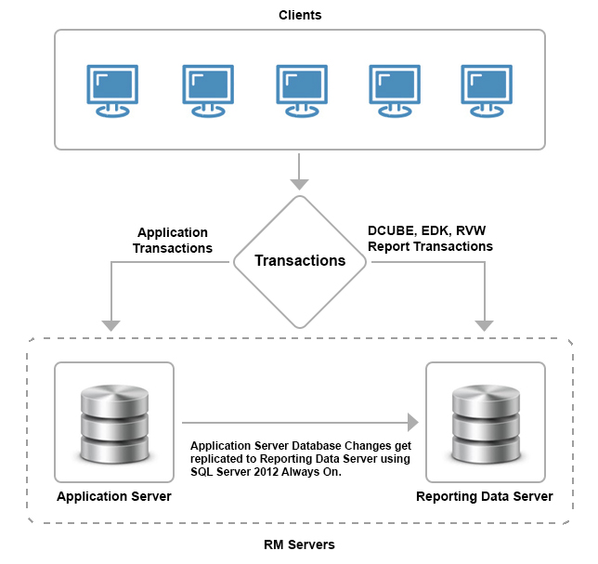

1.2 SQL Server 2012 Always On Configuration

- Prerequisite

- Need minimum two servers.
- Microsoft Windows Server 2008 R2 / 2012 Enterprise Edition.
- Microsoft SQL Server 2012 Enterprise Edition.
- Windows Failover Clustering configured between the hosts.
- As it was a cluster configuration, the SQL service account should run with domain account.
- Databases should be in FULL Recovery mode.
- Port 1433 and 5022 should be opened.

- DatabaseS List
- Application database (AVNAPPDB)
- Deployment Database (DEPDB)
- HRMS database (HRMS40)
- Workflow Database (WFM40)

All Databases should be in FULL recovery mode

- Always on Configuration Manual
The Embedded Microsoft Virtual lab document explains how to configure Always On.

Refer the below Microsoft link to know more about SQL Server 2012 AlwaysOn.

http://msdn.microsoft.com/en-us/sqlserver/gg490638

1.3 DCUBE Configuration and Design

Refer the embedded document for DCUBE configuration and design.

1.4 EDK Configuration and Design

Refer the embedded document for EDK configuration and design.

Corporate Office and R&D Center
Ramco Systems Limited,
64, Sardar Patel Road, Taramani ,
Chennai – 600 113, India
Office + 91 44 2235 4510 / 3090 4000
Fax +91 44 2235 2884
Website - www.ramco.com

