VirtualWorksTM Runtime Dot Net Installation Document – Post Installation Settings



Ramco Aviation Solution
Version 5.8
Post Installation Settings

DISCLAIMER
©2016 Ramco Systems Ltd. All rights reserved. All trademarks acknowledged.

This document is published by Ramco Systems Ltd. without any warranty. No part of this document may be reproduced or transmitted in any form or by any means, electronic or mechanical, for any purpose without the written permission of Ramco Systems Limited.
Improvements and changes to this text necessitated by typographical errors, inaccuracies of current information or improvements to software programs and/or equipment, may be made by Ramco Systems Limited, at any time and without notice. Such changes will, however, be incorporated into new editions of this document. Any hard copies of this document are to be regarded as temporary reference copies only.
The documentation has been provided for the entire Aviation solution, although only a part of the entire solution may be deployed at the customer site, in accordance with the license agreement between the customer and Ramco Systems Limited. Therefore, the documentation made available to the customer may refer to features that are not present in the solution purchased / deployed at the customer site
.

Revision History

Version | Date | Author | Description
1.0 | 24/05/2012 | Vinoth Kumar K | Created
1.1 | 21/03/2012 | Senthil Kumar C | Modified

Table of Contents

1.1 Enabling Audit in Deployment Database 5
1.2 Purging Deployment Database Audit Data 5
1.3 Enabling Deadlock Trace On SQL Server Startup 6
1.4 Post-Installation Checklist 7
1.5 Performance Monitor 7
1.6 RVWUSER Credentials Change and RDW Password Impact 7
1.7 Recommend Settings for RM Server performance Improvements 8
1.8 Customized Login Page 13

1.1 Enabling Audit in Deployment Database

Login/Logout time, User Name, Role, OU, Machine IP, Activity, Task, Service information will get insert into Deployment Database for Audit based on the value set in AuditState parameter.

For enabling audit in DEPDB, following changes needs to be done.

Audit State value needs to be changed in Web.Config file under IIS folder in Web Server and also in serversocket.exe.config under RT2 folder in App Server.

<add key="AuditState" value="" />

If Single Server Setup, then serversocket.exe.config file need not to be modified.

AuditState value can have the following values,

- If the Audit state is Blank, Then no tables will get inserted (Default Value)
- If the Audit state is 1, then fw_admin_audit_login table will be inserted.
- If the Audit state is 2, then fw_admin_audit_login, fw_admin_audit_activity tables will be inserted.
- If the Audit state is 3, then following tables will be inserted.
(i)fw_admin_audit_activity
(ii)fw_admin_audit_login
(iii)fw_admin_audit_srvdtl
(iv)fw_admin_audit_transport
(v)fw_admin_audit_service

1.2 Purging Deployment Database Audit Data

Compile the below embedded function and stored procedure in Deployment Database.

Execute the sp fw_audit_data_purging with 2 paramaters (from & to date). This will move the records to a new table and delete the data.

(e.g.) exec fw_Audit_data_purging '2011-02-03,'2011-02-09'

Refer schedulers list to configure this purging as SQL Jobs scheduler.

1.3 Enabling Deadlock Trace On SQL Server Startup

We first need to enable the sp_configure option called ‘scan for startup procs’.

EXEC sp_configure 'show advanced option', '1';
RECONFIGURE

EXEC sp_configure 'scan for startup procs', '1';
RECONFIGURE

Now, need to create a stored procedure that will be run when the SQL server service starts.

Use Master
GO

IF OBJECT_ID('enableDeadlockTrace') IS NOT NULL
DROP PROC enableDeadlockTrace
GO

CREATE PROC [dbo].[enableDeadlockTrace]
AS
BEGIN
DBCC TRACEON (3605,1204,1222,-1)
END
GO

The last step is to make the stored procedure that we created a start-up proc. sp_procoption is a system procedure that sets a stored proc for the start-up. Using sp_procoption, you can turn on or off the start-up proc.

Enable deadlock trace stored proc

EXEC sp_procoption N'enableDeadlockTrace', 'startup', 'on'

***Disable deadlock trace stored proc – Use this command if you want to disable

EXEC sp_procoption N'enableDeadlockTrace', 'startup', 'off'

1.4 Post-Installation Checklist

After installation, follow the checklist below to help ensure that you have a successful installation:

`

1.5 Performance Monitor

To monitor the application performance, various parameters are listed in the attached document. This has to monitored on a daily basis.

1.6 RVWUSER Credentials Change and RDW Password Impact

The embed document explain how to change rvwuser credentials in ramco aviation 5x series solution throughout the application.

- It contains the sequence of steps to do the rvwuser credentials change in application.

- Please refer screen shots in every section which makes a lot easier to use the document to achieve the task.

- Below attached document contains the sequence of steps on RDW Password Impact.

1.7 Recommend Settings for RM Server performance Improvements

1.7.1. SQL Server Memory Configuration

Right Click SQL server → Properties → Memory →
Define Min memory = 0
Max Memory = 75 Percentage of RAM

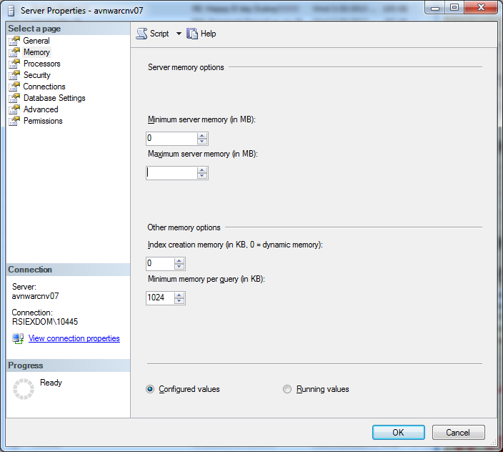

1.7.2 Database File Initialization

1. Click Start | Control Panel | Administrative Tools | Local Security Policy
2. In Local Security Policy window, expand Security Settings and then expand Local Policies.
3. In Local Policies, expand User Rights Assignment folder. All the user specific policies will be displayed on the right side panel.
4. In the right panel, double click Perform Volume Maintenance Tasks
5. This will open up Perform Volume Maintenance Tasks Properties window as shown in the below snippet.
6. On the Local Security Setting tab, click Add User or Groups… button, this will open up Select Users or Groups dialog box where you need to add the SQL Server Service Account and then Click OK to exit the Select Users or Groups dialog box.
7. Click OK to exit the Perform Volume Maintenance Tasks Properties window.
8. Finally click Start | Run and type the following command gpupdate /force to apply the modification in the security policy immediately.
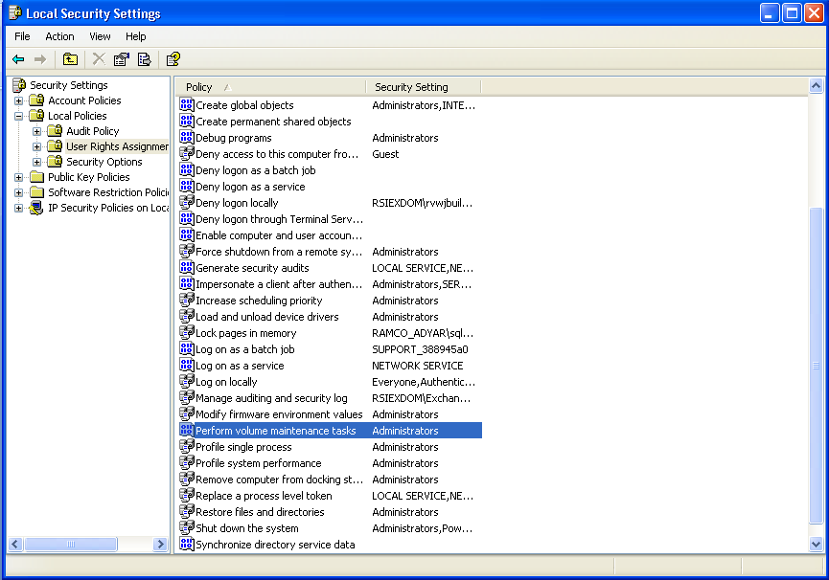

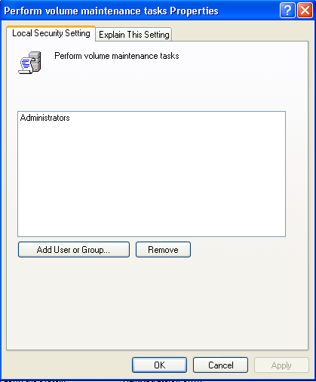

1.7.3 Lock Pages in Memory

- On the Start menu, click Run. In the Open box, type gpedit.msc.
The Group Policy dialog box opens.
- On the Group Policy console, expand Computer Configuration, and then expand Windows Settings.
- Expand Security Settings, and then expand Local Policies.
- Select the User Rights Assignment folder.
The policies will be displayed in the details pane.
- In the pane, double-click Lock pages in memory.
- In the Local Security Policy Setting dialog box, click Add.
- In the Select Users or Groups dialog box, add an account with privileges to run sqlservr.exe.

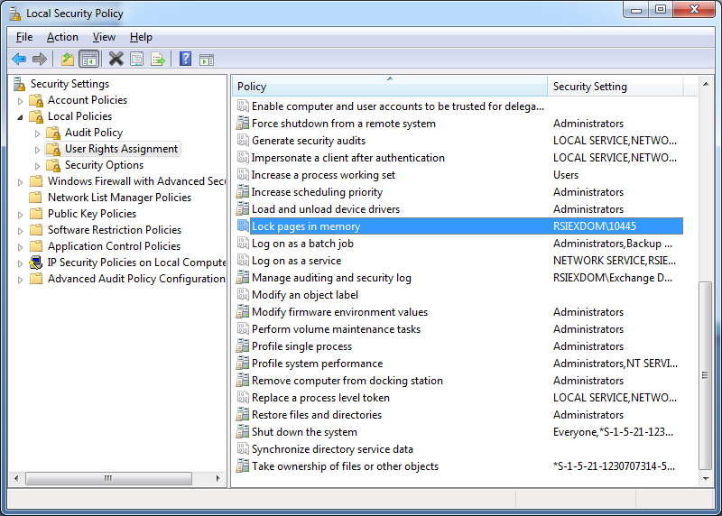

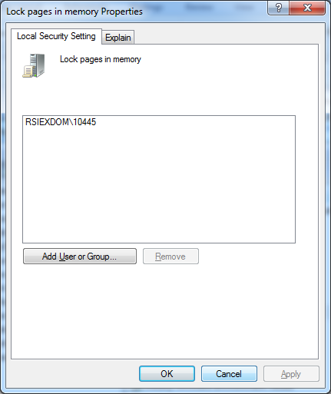

1.8 Customized Login Page

Following are the deliverables for customizing login page customer wise by putting their own custom image.

  - Customized Login Page : CustomLogin.htm (.../IIS/Extui/Security)
  - Style Sheet Name : style.css (.../IIS/Extui/resources/css)
  - Background Banner File Name : custombanner_bg.jpg
(.../IIS/Extui/resources/images)
  - Image File Name : customimg_bg.jpg
(.../IIS/Extui/resources/images)

User can put their customized image and deployed as specified above and set the value for defaultLoginPage parameter as “CustomLogin” in ApplicationSettings.js file under .../IIS/Extui

Corporate Office and R&D Center
Ramco Systems Limited,
64, Sardar Patel Road, Taramani ,
Chennai – 600 113, India
Office + 91 44 2235 4510 / 3090 4000
Fax +91 44 2235 2884
Website - www.ramco.com

