Internet Information Server (IIS) 7.0 Settings – Ramco Aviation Solution

DISCLAIMER

**©2009 Ramco Systems Ltd. All rights reserved. All trademarks acknowledged.**

This document is published by **Ramco Systems Ltd.** without any warranty. No part of this document may be reproduced or transmitted in any form or by any means, electronic or mechanical, for any purpose without the written permission of **Ramco Systems Limited.**

Improvements and changes to this text necessitated by typographical errors, inaccuracies of current information or improvements to software programs and/or equipment, may be made by Ramco Systems Limited, at any time and without notice. Such changes will, however, be incorporated into new editions of this document. Any hard copies of this document are to be regarded as temporary reference copies only.

The documentation has been provided for the entire Aviation solution, although only a part of the entire solution may be deployed at the customer site, in accordance with the license agreement between the customer and Ramco Systems Limited. Therefore, the documentation made available to the customer may refer to features that are not present in the solution purchased / deployed at the customer site.

**Table of Contents**

1. Introduction 4

1.1 Creating and Setting Properties for Application Pool 4

1.2 Creating and Setting Properties for Virtual Directory 7

1.3 Default Document Settings 9

1.4 Mime Type Settings 10

# 1. Introduction

This installation guide provides necessary guidelines and steps that have to be followed for configuring the Internet Information Server (IIS) 7.0 related to the Ramco Aviation Solution. IIS could be launched through Start 🡪 Administrative Tools 🡪 Internet Information Service(IIS) Manager (or) Start 🡪 Run 🡪 Type “inetmgr” 🡪 Click Ok.

This comprises the following configurations:

* Creating and Settings properties for Application Pool
* Creating and Settings properties for Virtual Directory
* Default Document Settings
* Mime Type Settings

## Creating and Setting Properties for Application Pool

To create Application Pool in IIS, 1. Expand the Server menu from the Connection Tree (in the left pane) and click “Application Pools”, as shown in the below screenshot.

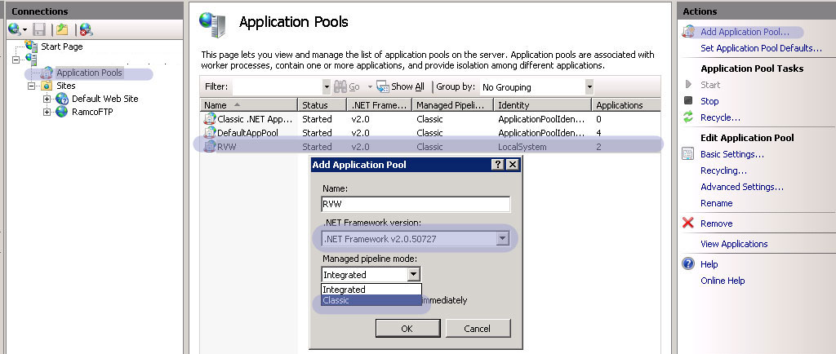

1. Click “Add Application Pool…”
2. Provide Application Pool name as “RVW”
3. Set .Net Framework Version as “.Net Framework v2.0.50727”, This is mandatory to make RVW work with Windows 2008/ 2008 R2 server.
4. Set the Managed pipeline mode to “Classic”

Once the Application Pool is created, select the “application pool” Name and click Advanced Settings. It will open a properties window as shown in the below screenshot.

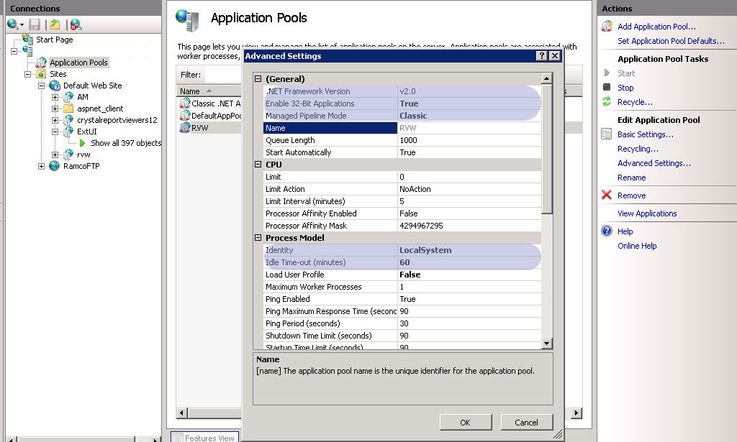

Set the properties as highlighted.

1. .Net Framework Version to v2.0
2. Enable 32-Bit Applications to True. This is required to enable crystal report 2008 in the server, as this support 32 bit only.
3. Ensure Managed Pipeline Mode to “Classic”
4. Under the ProcessModel,set “Identity” to “LocalSystem”
5. Idle Time-out (Minutes) to 60 (recommended value). It can be changed on wish.

Continue the settings as shown in the below screenshot with the

1. Rapid-Fail Protection – “Enabled” to False
2. Expand “Generate Recycle Event Log Entry” and set “Regular Time Interval” to False

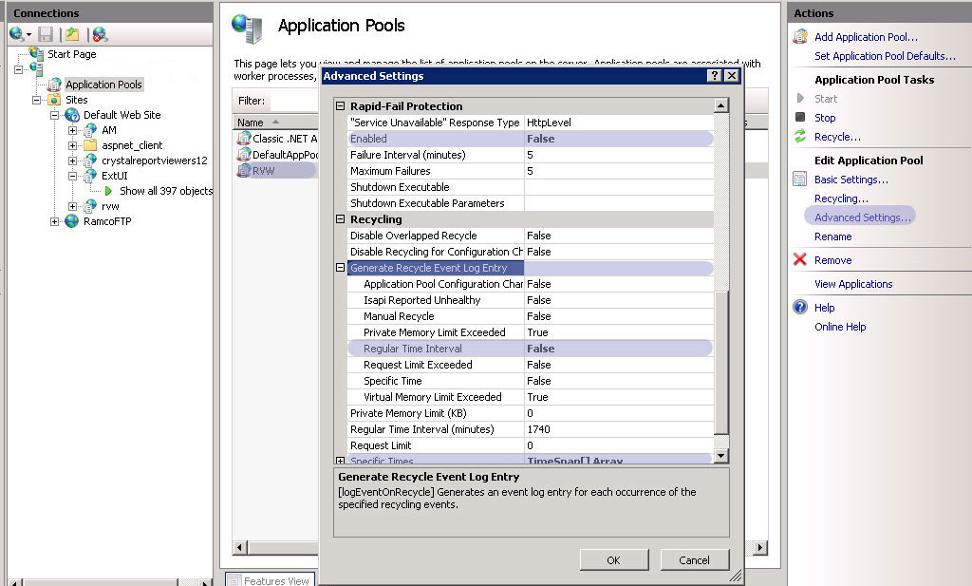

Expand “Specific Times” and Click the button enable on the right corner. It opens a new window as shown in the below screenshot.

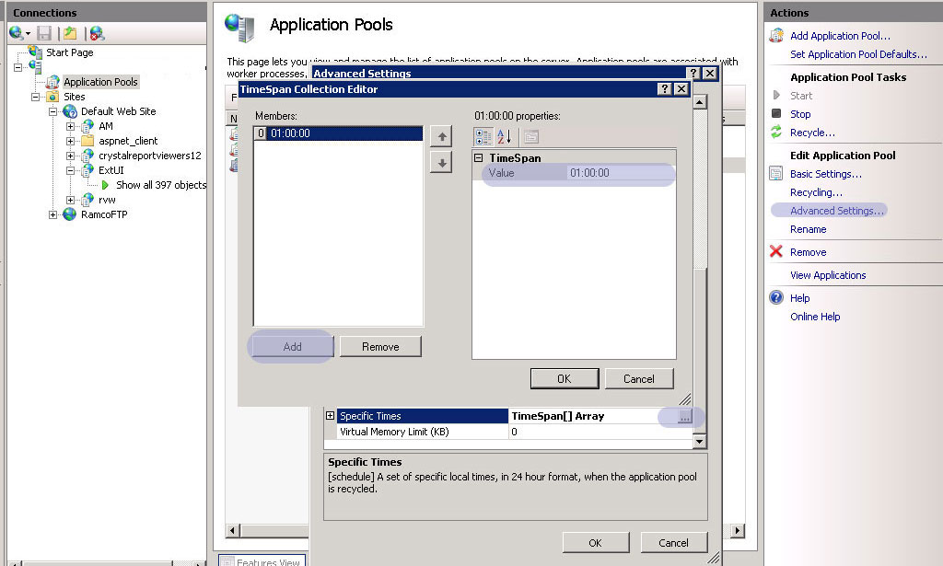

Add TimeSpan with the value “01:00:00” and click ok.

This completes Adding “Application Pool“and Settings the required properties.

## Creating and Setting Properties for Virtual Directory

To create Virtual Directory, Right click “Default Web Site” and click “Add Virtual Directory…”. It will open a window as shown in the below Screenshot.

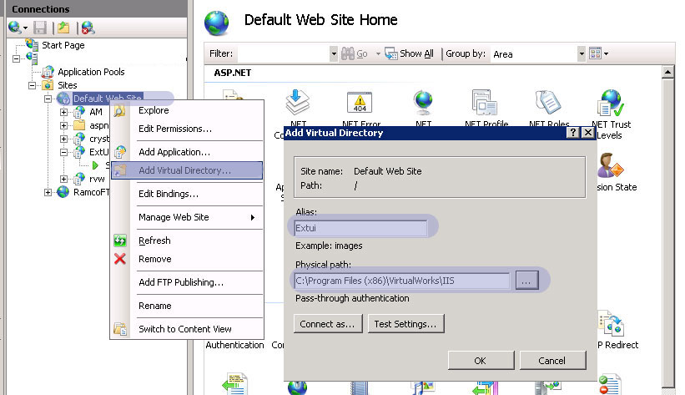

1. Provide an Alias name. It can be any name with which the application can be launched in Internet Explore with the convention <<http://servername/aliasname>>
2. Provide the Physical Path as full path of “IIS” folder available in the “Program Files (x86)\VirtualWorks” and click Ok.

This creates the virtual directory.

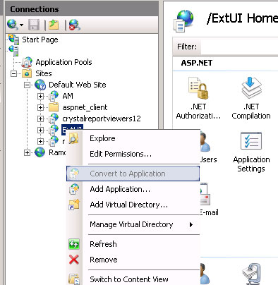

As shown in the above screenshot, right click on the virtual directory and click “Convert to Application”.

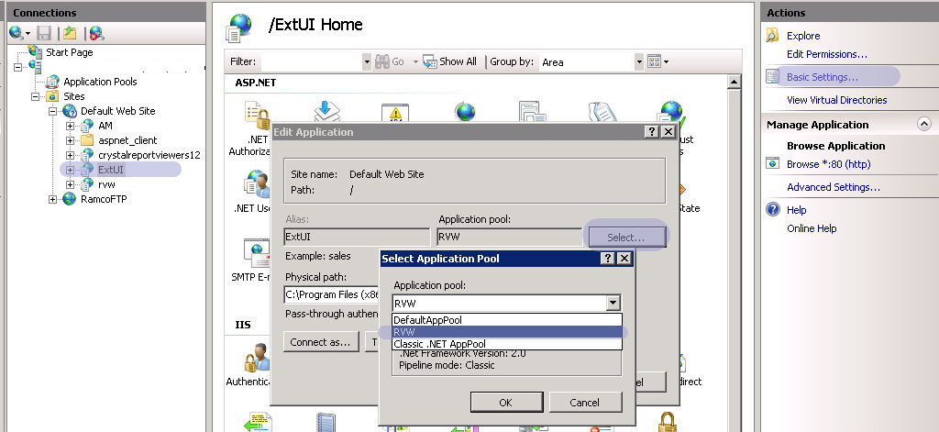

As shown in the above Screenshot, Select the virtual Directory and click “Basic Settings”.

1. Click “Select” button against the Application Pool.
2. From the dropdown, Select the Application Pool “RVW” and click Ok.

This completes the Virtual Directory creation and setting its property.

## Default Document Settings

Ramco’s RVW uses “extui.aspx” as the startup/default document. To set this, double click the Virtual Directory. In the center pane, under “IIS”, double click the “Default Document”, as shown in the below screenshot.

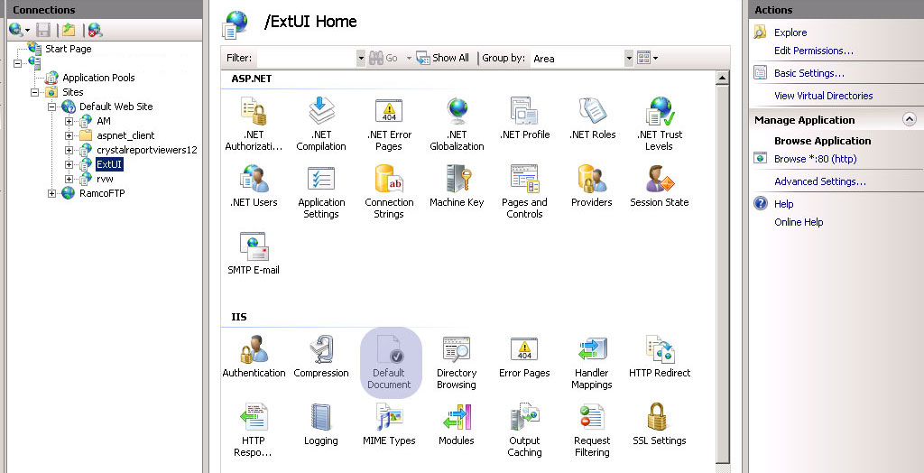

A new window will open, listed with all the default documents, as shown in the below screenshot

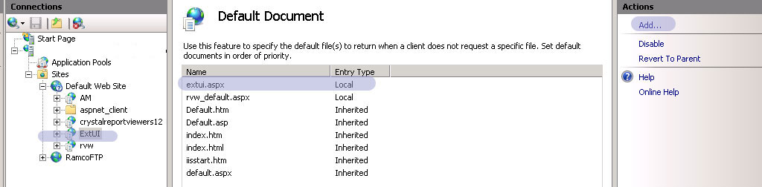

Click “Add…” link given on the right pane and provide Name as “extui.aspx”.

Ensure that the default document name “extui.aspx” is on first among the list.

## Mime Type Settings

Ramco Aviation application is integrated with Nertronics Varchart (Gantt chart Control) and also Microsoft Project. To enable these plugin’s in Internet explorer, we need to add respective mime types in the IIS.

To set this, double click the Virtual Directory. In the center pane, under “IIS”, double click the “Mime Types”, as shown in the below screenshot.

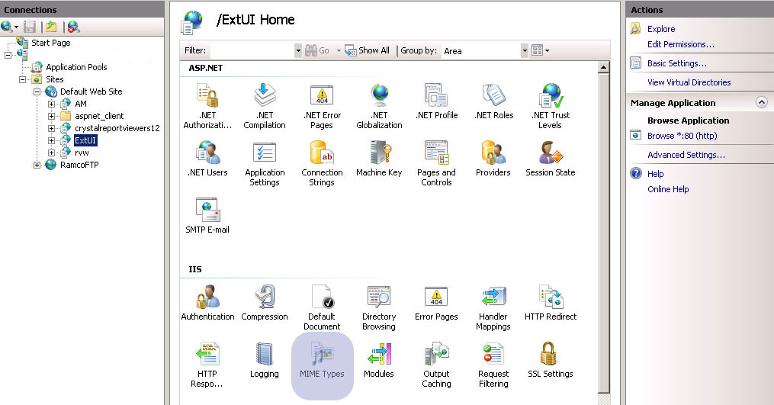

As shown in the below screenshot, in the Mime Type Window, Click “Add…” link.

Add the following Mime types one by one.

1. File Name Extension : “.ifd”; Mime Type: “text/xml”
2. File Name Extension : “.ini”; Mime Type: “text/xml”
3. File Name Extension : “.mpp”; Mime Type: “application/vnd.ms-project”
4. File Name Extension : “.mpt”; Mime Type: “application/vnd.ms-project”

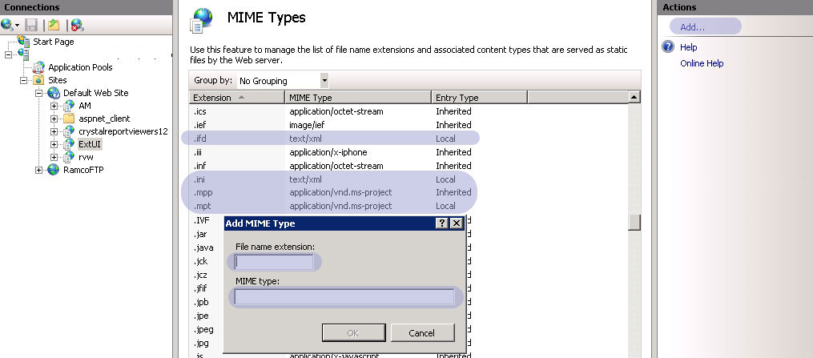

**- End of Document -**

\

Corporate Office and R&D Center

Ramco Systems Limited, 64, Sardar Patel Road, Taramani Chennai – 600 113, India

Tel: +91 (44) 2235 4510. Fax +91 (44) 2235 2884

www.ramco.com