Application Installation Manual

DISCLAIMER
©2012 Ramco Systems Ltd. All rights reserved. All trademarks acknowledged.

This document is published by Ramco Systems Ltd. without any warranty. No part of this document may be reproduced or transmitted in any form or by any means, electronic or mechanical, for any purpose without the written permission of Ramco Systems Limited.
Improvements and changes to this text necessitated by typographical errors, inaccuracies of current information or improvements to software programs and/or equipment, may be made by Ramco Systems Limited, at any time and without notice. Such changes will, however, be incorporated into new editions of this document. Any hard copies of this document are to be regarded as temporary reference copies only.
The documentation has been provided for the entire Aviation solution, although only a part of the entire solution may be deployed at the customer site, in accordance with the license agreement between the customer and Ramco Systems Limited. Therefore, the documentation made available to the customer may refer to features that are not present in the solution purchased / deployed at the customer site.

Table of Contents
1. Introduction 4
2. Installation of the Application -Dump Restoration Methodology 4
2.1 Prerequisite 4
2.2 Web & App Layer 4
2.3 Application Database 8

1. Introduction
This installation guide provides necessary guidelines and steps that have to be followed for installing the Ramco Aviation application suite.
This installation comprises the following major steps:
- Installation of Ramco Aviation Solution Business components through dump restoration methodology
- Manual Settings in Web, App and RM Servers
- Configuration of application Utilities

2. Installation of the Application -Dump Restoration Methodology

2.1 Prerequisite
Installation of Virtual Works RunTime(RT) and related setting in IIS.

2.2 Web & App Layer
Steps to be followed in Component Deployment:
- Extract..\\DVD2 - FE\IIS.rar files in the following path of Web Server.

….\VirtualWorks\
The extracted IIS Folder contains all component folders and Activity Assemblies Folder. Each Component Folder contains .htm,.js,.aspx,.rpt files.
All Component activity dlls are available in the Activity Assemblies Folder.
Note: After extracting IIS.rar to Virtual Works folder, drag and drop the following dlls into GAC from the path “...VirtualWorks\IIS\plf_gac”
- Excel.dll
- ICSharpCode.SharpZipLib.dll
- Itextsharp.dll

- The below settings are applicable for Release Version 5.5
Extract ...\\DVD2 - FE\\Servicedll.rar file in any local path of App Server -
The extracted Service dll folder contains latest ServiceDlls of all components and net modules component wise.
These entire Dot Net Service Dlls are required to be registered in Global Assembly Cache. To register these Dlls follow the below given steps.
For Registering Service Dlls in GAC, Microsoft Web Deploy v2 needs to be installed in APP Server which is already mentioned in Prerequisites document. Please ensure the same get installed.

Environment Variable named “msdeploypath” needs to be added. To add, Go to My Computer -> Properties -> Advanced System Settings. Click on Environment Variables button. Under System Variables Click on New button, and give Variable Name as msdeploypath and Variable Value as “…\Program Files\IIS\Microsoft Web Deploy V2”

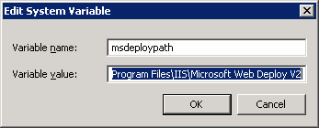

After setting this path, Re-Start Web Deployment Agent service in APP Server.

Copy the ServiceDllCopyApplication.exe to APP Server from …DVD2 – FE and Click on the Exe.

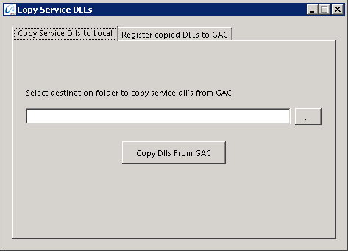

Click on the Register copied DLLs to GAC tab.

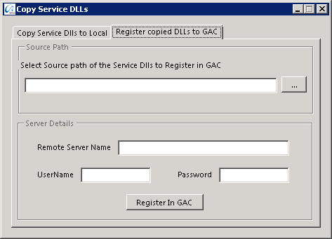

Enter the Required information’s like Local Extracted Path, Server Name, User Name & Password and then click on Register in GAC button.

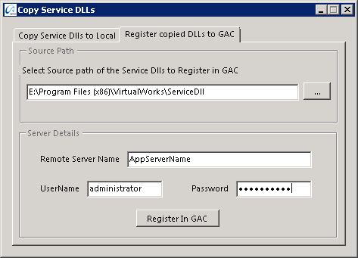

ServiceDll registration in GAC process has been started. This may take few hours to complete the Registration process.

After successful registration, local extracted folder having ServiceDlls can be deleted.

- The below settings are applicable for Release Version 5.4
Extract ...\\CD2 - FE\\Servicedll.rar and ServiceDlls.rar file in the following path of App Server.
….\Program Files(x86)\VirtualWorks\
The extracted Service dll folder contains Service dll of all components and net modules component wise.
All these dot net Service Dll’s are required to be registered in Global Assembly Cache. To register these Dll’s follow the below given steps.
For Aviation components double click the AvnBatchGen.vbs available in ..\CD2 - FE\Tools and provide the path of servicedll (..\\Program files(x86)\Virtual Works\Servicedll), it will generate a batch file named "RegDllsGAC.bat”. Run the batch file "RegDllsGAC.bat".
For HRMS components double click HRMSBatchGen.vbs avaiable in ..\CD2 - FE\Tools and provide the path of servicedlls (..\\Program files(x86)\Virtual Works\Servicedlls), it will generate one batch file in name "RegDllsGAC.bat" and run the same.
- To set the environment path for ITK as below:
In advanced tab of My Computer -> Properties -> Advanced System Settings Environment variable add New System Variable name as _ITKPATH_ and Variable Values as …\Virtual Works\IIS\ExtUi. Refer the screen shot below:
Note: This step needs to be added in Web Server.
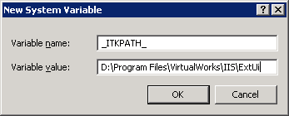

Crystal Report Isolation Feature Settings
Currently VirtualWorks Applications and Crystal Reports execute in a single process. Crystal Report’s 64-Bit support is also not available across its wide product range and is currently limited to only higher-end product range. Hence it is required to isolate Crystal Reports process from VirtualWorks Applications. The advantages are process isolation and leveraging 64-Bit features for VirtualWorks Applications.

Note: To enable the Crystal Isolation Setting, Refer the document available under following folder in WEB Server.
…VirtualWorks\IIS\EXTUI\Release Documentation\Feature Documents\VW Report Process Isolation.doc
Crystal Report Setup:
Refer the below document for the settings related to crystal report:
Document Name | Document Attachment | Reference Sections
12-Crystal Report Settings.docx |  | All

Once the above settings are done, restart the Web Server.

2.3 Application Database
Steps to be followed in Database Restoration:
  - Restore all the following databases from...\\ DVD3 - BE \:

- Deployment Database (DEPDB)
- Application database (AVNAPPDB)
- Application database TempDB Tables (AVNAPPDB_TempDB)
- HRMS database (HRMS40)
- HRMSTEMPDB database (HRMSTEMPDB)
- Workflow Database (WFM40)
- Audit Database (ENT_AUDIT)
- Data Update Database (Dataupd_Audit)
- Release Details Database (Proj_EnvDB)

Note: Application Database name and Application Database TempDb database should be in the name as specified above. If there are any changes in DB names, kindly contact Ramco Aviation Product Support
As of now Synonyms in AVNAPPDB are referring to AVNAPPDB_TempDB , if any new Application DB and respective TempDb added, then Synonyms scripts needs to be re-generated.

  - If the Depdb is not restored from the dump, kindly ignore the 3rd step and proceed with 4th step.

  - After restoration, run the embedded script (“DepDB_Resource_Config_SP.sql”) in Deployment Database (DEPDB).
After compiling the above embedded script, run the below command in DEPDB.

EXEC DepDB_Resource_Config_SP ‘<App Server Name>’,’<RM Server Name>’,’<Gateway Server Name>’,’<Web Server Name>’’

- Gateway Server Name is same as Web Server Name

  - Create two new sql user ‘rvwuser’ with password set as ‘rvw’ & ‘RVWDirAdmin’ with password ‘RVWDirAdmin’ in RM server, if they are not already exists..

  - Execute the below scripts in all the restored databases
sp_change_users_login 'update_one', 'rvwuser', 'rvwuser'
GO
sp_change_users_login 'update_one', 'rvwdiradmin', 'rvwdiradmin'
GO
  - After the above settings, configuration dlls needs to be re-generated and needs to be deployed in GAC. Please refer the step by step document below for Configuration Dll generation.

Document Name | Document Attachment | Reference Sections
11-Configuration DLL Generation.docx |  | All

Corporate Office and R&D Center
Ramco Systems Limited, 64, Sardar Patel Road, Taramani Chennai – 600 113, India
Tel: +91 (44) 2235 4510. Fax +91 (44) 2235 2884
www.ramco.com

