Application Installation Manual

DISCLAIMER

**©2009 Ramco Systems Ltd. All rights reserved. All trademarks acknowledged.**

This document is published by **Ramco Systems Ltd.** without any warranty. No part of this document may be reproduced or transmitted in any form or by any means, electronic or mechanical, for any purpose without the written permission of **Ramco Systems Limited.**

Improvements and changes to this text necessitated by typographical errors, inaccuracies of current information or improvements to software programs and/or equipment, may be made by Ramco Systems Limited, at any time and without notice. Such changes will, however, be incorporated into new editions of this document. Any hard copies of this document are to be regarded as temporary reference copies only.

The documentation has been provided for the entire Aviation solution, although only a part of the entire solution may be deployed at the customer site, in accordance with the license agreement between the customer and Ramco Systems Limited. Therefore, the documentation made available to the customer may refer to features that are not present in the solution purchased / deployed at the customer site.

**Table of Contents**

1. Introduction 4

2. Installation of the Application -Dump Restoration Methodology 4

2.1 Prerequisite 4

2.2 Web & App Layer 4

2.3 Application Database 8

# 1. Introduction

This installation guide provides necessary guidelines and steps that have to be followed for installing the Ramco Aviation application suite.

This installation comprises the following major steps:

* Installation of Ramco Aviation Solution Business components through dump restoration methodology
* Manual Settings in Web, App and RM Servers
* Configuration of application Utilities

# 2. Installation of the Application -Dump Restoration Methodology

## 2.1 Prerequisite

Installation of Virtual Works RunTime(RT) and related setting in IIS.

## 2.2 Web & App Layer

**Steps to be followed in Component Deployment:**

1. Extract..\\CD2 - FE\IIS.rar files in the following path.

….\Program Files(x86)\VirtualWorks\

The extracted IIS Folder contains all component folders and Activity Assemblies Folder. Each Component Folder contains .htm,.js,.aspx,.rpt files.

All Component activity dlls are available in the Activity Assemblies Folder.

*Note: After extracting IIS.rar to Virtual Works folder, drag and drop the following dlls into GAC from the path “...VirtualWorks\IIS\plf_gac”*

* *Excel.dll*
* *ICSharpCode.SharpZipLib.dll*
* *Itextsharp.dll*

1. Extract ...\\CD2 - FE\\Servicedll.rar and ServiceDlls.rar file in the following path.

….\Program Files(x86)\VirtualWorks\

The extracted Service dll folder contains Service dll of all components and net modules component wise.

These entire dot net Service Dll’s are required to be registered in Component Services and Global Assembly Cache. To register these Dll’s follow the below given steps.

*For Aviation components double click the AvnBatchGen.vbs available in ..\CD2 - FE\Tools and provide the path of servicedll (..\\Program files(x86)\Virtual Works\Servicedll), it will generate two batch files named "RegDllsGAC.bat" and "RegDllsCOM.bat"*

*First run the "RegDllsGAC.bat" and if COM grouping is not required to be enabled then run the "RegDllsCOM.bat". If COM grouping is required then refer the document Trn-Bsg-Dep-Wizard-5Series.doc for enabling this which is available under folder ..* *CD6 - Tools\Deployment\Version - 5.1.0.5*

*For HRMS components double click HRMSBatchGen.vbs avaiable in ..\CD2 - FE\Tools and provide the path of servicedlls (..\\Program files(x86)\Virtual Works\Servicedlls), it will generate one batch file in name "RegDllsGAC.bat" and run the same.*

*And if COM grouping is not required to be enabled then run the batch file HRMS_COM.bat available in ..\CD2 - FE\Tools. If COM grouping is required then refer the document Trn-Bsg-Dep-Wizard-5Series.doc for enabling this which is available under folder ..* *CD6 - Tools\Deployment\Version - 5.1.0.5*

Once the components are deployed in the Component Services Screen, change the identity of all the application components from ‘Interactive Users – The current login in users’ to ‘Network Services – Built-in service account with network access’.

Refer below screenshot. You can select all the application components in the right pane and set the above mentioned point in one shot.

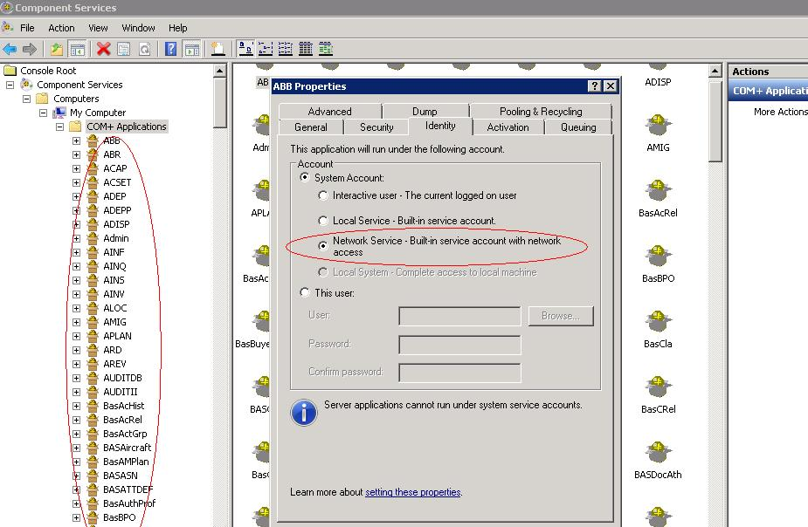

1. To set the environment path for ITK as below:

In advanced tab of My Computer -> properties -> Environment variable add New System Variable name as _ITKPATH_ and Variable Values as …\Virtual Works\IIS\ExtUi. Refer the screen shot below:

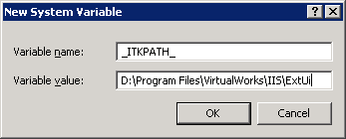

**Crystal Report Setup:**

1. Crystal Report should be installed in the web server
2. After installing restart the web server
3. Open the crystal report designer and perform the following steps
   1. Click on the blank report
   2. In the database expert click on the Create New Connection 🡪 More Data sources 🡪 Field Definitions Only
   3. Crystal will automatically install its required deliverables (on demand).
4. In the web server check for the folder C:\Inetpub\wwwroot\aspnet_client\system_web\2_0_50727 and verify whether crystalreportviewers12 is available. If it is not available then copy the crystalreportviewers12 folder from the following crystal installation directory.

“<Crystal Installation drive>:\ Program Files\Business Objects\Common\4.0”.

**Web.Config Settings:**

Change the RVW web.config file with the installed crystal report assembly version.

Web.Config file will be available in the path <drive>:\Program files\virtualworks\iis\

In the c:\windows\assembly crystal report assembly information (version and keytoken) will be available that have to specified in the web.config.

1. Find the Compilation Node in Web.Config file. Compilation Node will be in the order of <configuration> 🡪 <system.web> 🡪 <compilation>
2. The Crystal Assemblies to be referenced should come under <assemblies> node.
3. Create node <assemblies> under compilation node.
4. Add the following Crystal Assembly Reference under the assemblies node.

<add assembly="**CrystalDecisions.CrystalReports.Engine**, Version=<version>, Culture=neutral, PublicKeyToken=<keytoken>"/>  
 <add assembly="**CrystalDecisions.ReportSource**, Version=<version>, Culture=neutral, PublicKeyToken=<keytoken>"/>  
 <add assembly="**CrystalDecisions.Shared**, Version=<version>, Culture=neutral, PublicKeyToken=<keytoken>"/>  
 <add assembly="**CrystalDecisions.Web**, Version=<version>, Culture=neutral, PublicKeyToken=<keytoken>"/>

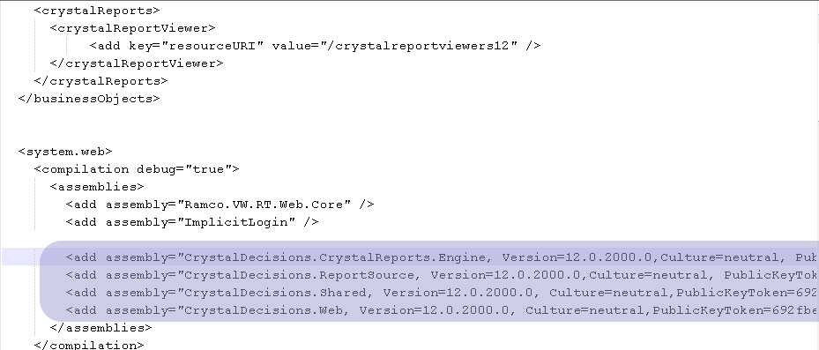  
Close the nodes </assemblies> & </compilation>

1. If the webserver version is below IIS7 or Application Pool - Managed pipleline mode is “classic” then Add the following Crystal Reference under System.Web node

<httpHandlers>

<add verb="GET" path="CrystalImageHandler.aspx" type="CrystalDecisions.Web.CrystalImageHandler, CrystalDecisions.Web, Version=<version>, Culture=neutral, PublicKeyToken=<keytoken>"/>  
 </httpHandlers>

1. If the webserver version is IIS7 or above and Application Pool - Managed pipleline mode is “Integerated” then Add the following Crystal Reference under system.webServer

<handlers>

<add name="CrystalImageHandler.aspx_GET" verb="GET" path="CrystalImageHandler.aspx" type="CrystalDecisions.Web.CrystalImageHandler, CrystalDecisions.Web, Version=<version>, Culture=neutral, PublicKeyToken=<keytoken>" preCondition="integratedMode"/>

</handlers>

<validation validateIntegratedModeConfiguration="false"/>

1. If the client machine uses IE 8.0 and crystal reports viewer gif files are not visible then follow the following steps
2. From the Crystal Report installation folder Copy the folder crystalreportviewers12 and paste it in VirtualWorks\iis\ folder
3. In the web.config add the following

<configSections>  
    <sectionGroup name="businessObjects">        
<sectionGroup name="crystalReports">  
<section name="crystalReportViewer" type="System.Configuration.NameValueSectionHandler" />  
</sectionGroup>  
</sectionGroup>  
</configSections>  
  <businessObjects>  
    <crystalReports>  
      <crystalReportViewer>  
           <add key="resourceURI" value="/crystalreportviewers12" />  
      </crystalReportViewer>  
    </crystalReports>  
  </businessObjects>

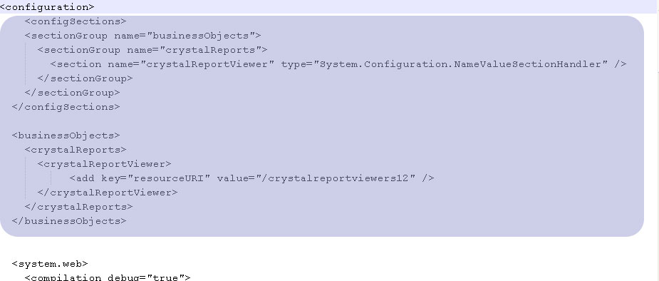

Once the above settings are done, restart the Web Server.

## 2.3 Application Database

**Steps to be followed in Database Restoration:**

* 1. Restore all the following databases from...\\ CD3- BE \:
* Deployment Database (*DEPDB*)
* Application database (*AVNAPPDB*)
* HRMS database (*HRMSDB*)
* Workflow Database (*WFM40*)
* Audit Database (*ENT_AUDIT*)
  1. After restoration, run the embedded script (“DepDB_Resource_Config_SP.sql”) in Deployment Database (DEPDB).



After compiling the above embedded script, run the below command in DEPDB.

EXEC DepDB_Resource_Config_SP ‘<App Server Name>’,’<RM Server Name>’,’<Gateway Server Name>’,’<Web Server Name>’’

* *Gateway Server Name is same as Web Server Name*
  1. Create two new sql user ‘rvwuser’ with password set as ‘rvw’ & ‘RVWDirAdmin’ with password ‘RVWDirAdmin’ in RM server, if they are not already exists..
  2. Execute the below scripts in all the restored databases

sp_change_users_login 'update_one', 'rvwuser', 'rvwuser'

GO

sp_change_users_login 'update_one', 'rvwdiradmin', 'rvwdiradmin'

GO

* 1. There are set of Configuration Dll’s deliverables that should be generated and registered in Global Assembly Cache (GAC). Generated Dll’s can also be registered manually by drag & drop into the assembly folder (C:\\Windows\Assembly). The detailed steps are give below.

Note: These configuration dll’s serves as connectors between App, Web and RM Servers.

“ConfigGenerator.exe” will be available in the path..\Program Files(x86)\VirtualWorks\RT2

Run this exe and the following screen will appear.

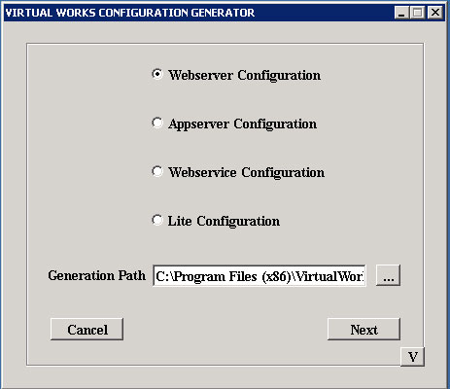

Select ‘Webserver Configutation’ option and provide the folder path in ‘Generation Path’ where the config. Generator deliverables will get generated and click “Next”.

In the Login screen (as shown in the below screenshot),

Select 1. “Server Type” as “SQL”

Provide 2. Sql Server Name (with instance name if any)

3.Sql User id

4.Sql Password

5. Select database as “DEPDB”, after fetching using ‘List’ button

Under Virtual works login information,

Provide application admin user id and password that are defined during Runtime Installation.

Click “Next” button.

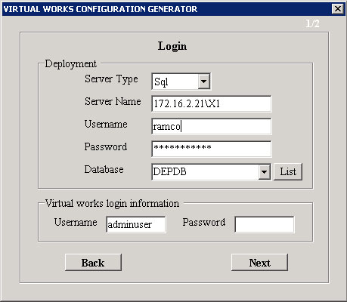

Web Server generator screen will be launched as shown in the below screen.

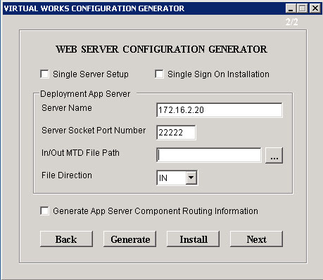

Check “Single Server Setup” only if all App, Web and RM are exists in same server. Otherwise, let it remain unchecked.

If application needs to be setup with “Single Sign On” (i.e., domain login will be used for Ramco Application login) , then check “Single Sign On Installation” checkbox.

Provide App Server Name and Server Socket Port Number (which is given during Runtime Installation). Leave other fields with default values and click “Generate” button. Click “Install” button.

Once you get “success” message, check “Generate App Server Component Routing Information” check box and click “Generate” button” again.

Click “Install” button.

Once you get “success” message then click “Next” button.

You will find the starting screen, which is having options for selecting Webserver/ Appserver Configuration and so on.

Now Select “Appserver Configuration” option and provide “Generation Path” if it is blank or you can also change this Generation Path.

Click “Next” button.

You need to provide SQL and Ramco virtual works login details again and click “Next” button.

Note: This configuration tool can also be used in Web and App servers separately for generating Web and App Configuration dlls respectively; hence the login information are prompted to enter two times.

You will find the screen as shown in the below screenshot

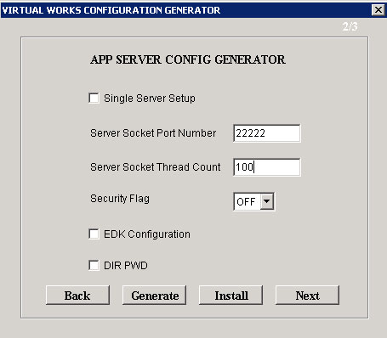

Check “Single Server Setup” only if all App, Web and RM are exists in same server. Otherwise, let it remain unchecked.

Provide Server Socket Port Number as defined during Runtime Installation

Provide Socket Thread Count. This is required to control Threadpools creating in App Server. The recommended value is “100”

Leave other fields with default values and click “Generate” button.

Note: If you are executing this exe in “APP” server and you are doing for Appserver Configuration, then you may click “Install” which will register the Generated dll’s in GAC.

Click “Next” button, It will open a screen as shown in the below screenshot

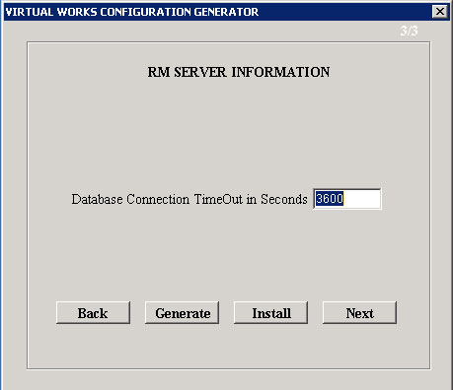

Set the database connection timeout in seconds. The recommended value is “3600”.

Click Generate button.

Note: If you are executing this exe in “APP” server and you are doing for Appserver Configuration, then you may click “Install” which will register the Generated dll’s in GAC.

Click “Next” button

You need to manually deploy the following generated dll’s in app server, if the exe is executed in web server.

Copy the following dlls’ from the “Generation Path” set in the Web server and paste it in App Server’s drive (It can be pasted in any folder, recommended path is “..\Program Files (x86)\VirtualWorks\RT2”)

1. Appconfig.dll
2. RMInfo.dll

Note: Stop the IIS before you start generate and install the config. Generator dlls.

Corporate Office and R&D Center

Ramco Systems Limited, 64, Sardar Patel Road, Taramani Chennai – 600 113, India

Tel: +91 (44) 2235 4510. Fax +91 (44) 2235 2884

www.ramco.com