VirtualWorksTM Runtime Dot Net Patch Installation Document

©2012 Ramco Systems Ltd. All rights reserved. All trademarks acknowledged.

This document is published by Ramco Systems Ltd. without any warranty. No part of this document may be reproduced or transmitted in any form or by any means, electronic or mechanical, for any purpose without the written permission of Ramco Systems Limited.

Improvements and changes to this text necessitated by typographical errors, inaccuracies of current information or improvements to software programs and/or equipment, may be made by Ramco Systems Limited, at any time and without notice. Such changes will, however, be incorporated into new editions of this document. Any hard copies of this document are to be regarded as temporary reference copies only.

The documentation has been provided for the entire Aviation solution, although only a part of the entire solution may be deployed at the customer site, in accordance with the license agreement between the customer and Ramco Systems Limited. Therefore, the documentation made available to the customer may refer to features that are not present in the solution purchased / deployed at the customer site.

Revision History
Version | Date | Author | Description
1.0 | 21/12/2009 | Karthik R | Created
2.0 | 01/11/2010 | Karthik R | Modified (for Patch 12 Release)

Table of Contents

1.1 VirtualWorksTM RT Patch Installation 5
1.2 Other Settings 8

VirtualWorksTM DotNet Runtime – Patch Installation
This document walks through the steps for installing VirtualWorksTM .Net Runtime (Microsoft Version) patch installation.

1.1 VirtualWorksTM RT Patch Installation
Copy the Runtime Patch installation file (VWRTPatch.MSI) from the VirtualWorksTM installation kit in to a local directory in all the layers viz., WEB, APP and RM (Database). Copy the file RemoveReadAttribute.bat also from the same VirtualWorksTM patch installation kit into the folder ..\Program Files\VirtualWorks. After copying the batch file, double click the batch file and execute the same. This batch file will remove read-only attribute from all the deliverables under the VirtualWorksTM folder.

- If the MSI package needs to be installed in particular user account then double click the file VWRTPatch.MSI to run the same.

- If the MSI package needs to be installed in ALL USERS instead of specific user account, then run the following command in Command Prompt.

Go to the folder where the MSI file exists and run the following command.

MSIEXEC /I VWRTPatch.MSI ALLUSERS=1

- The ‘Welcome to Ramco Installer’ screen will be launched.

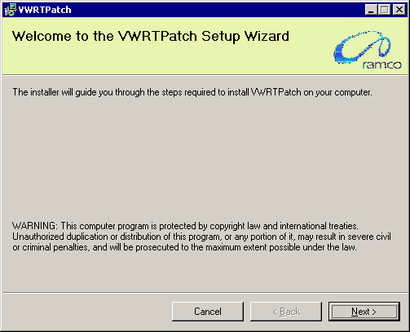

- Clicking ‘Next’ launches the ’Select Layer’ screen.

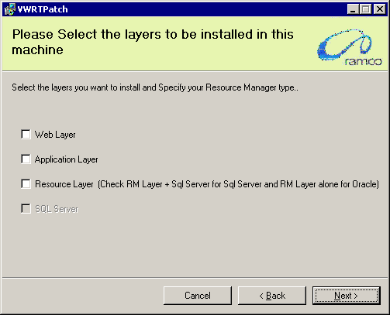

Note: VWRTPatch does not have any specific Layer-wise installer. The same MSI (VWRTPatch.MSI) will be used to install Runtime Patch for all layers (WEB, APP and Database). This document is a common document which can be used to individual layer machines appropriately.

In the above screen, the patch installer will display all the layers WEB, APP and RM. In this screen, select only those layers which are specific to that machine. While running this installer in RM (Database) layer, select the options “Resource Layer” as well as “SQL Server” which is mandatory.

- If Resource Layer option is selected, then the following screen will be displayed. Provide the Resource Layer (Database Layer) machine name. This name should be same as the RM Layer machine name that was given as part of RM Base installation. Also provide the Database user name (this should be same as the user that was used during Base RM installation), password and the deployment database name (Database name should be same as what was given during Base RM installation).
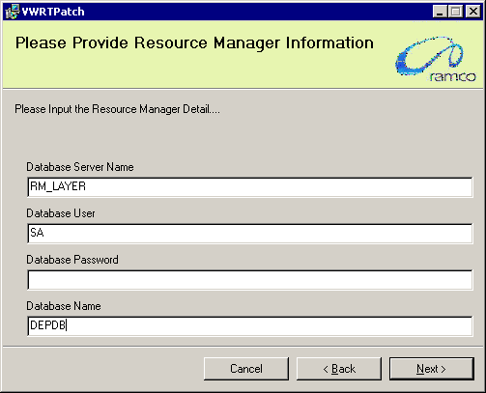

- On clicking ‘Next’, the “Confirm Installation” screen will be launched. This is only an information screen. Click ‘Next’ and start the installation.

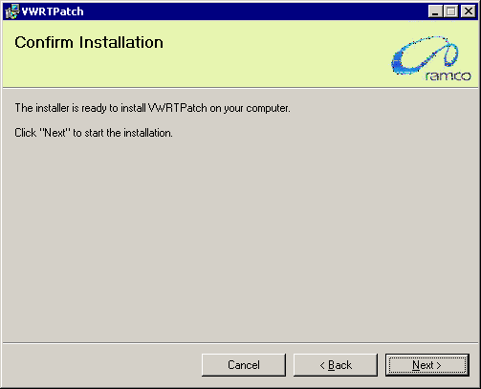

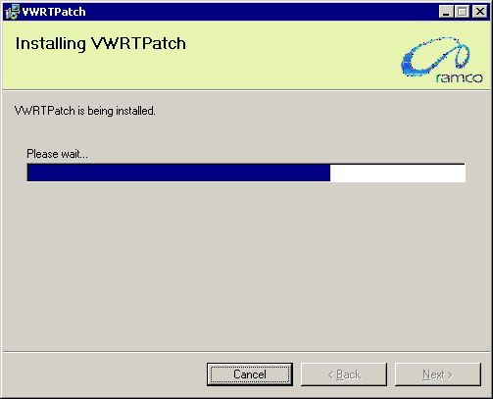

1.2 Other Settings

- Go to the properties of the folder..\VirtualWorks\IIS\Shortcut (in WEB Server) -> go to Security tab and provide Full Control permission to one of the following user group IIS_USRS or IIS_IUSRS (If this group does not exist, you may add the same using the Add button).

- Comment the <healthMonitoring> tag in Web.Config file which is available in the Web Server under path ..\VirtualWorks\IIS\ (e.g. D:\Program Files (x86)\VirtualWorks\IIS\web.config)

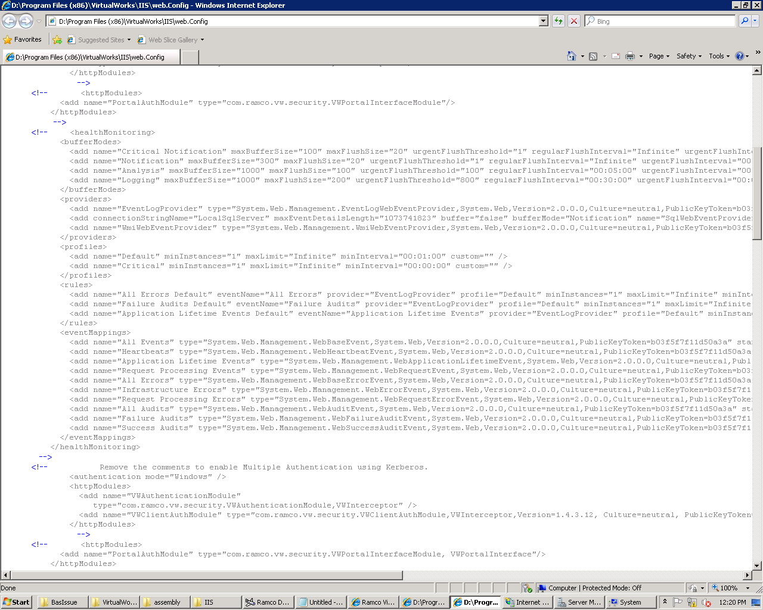

Corporate Office and R&D Center
Ramco Systems Limited, 64, Sardar Patel Road, Taramani Chennai – 600 113, India
Tel: +91 (44) 2235 4510. Fax +91 (44) 2235 2884
www.ramco.com

