VirtualWorksTM Runtime Dot Net Installation Document – File Server Installation

DISCLAIMER

**©2009 Ramco Systems Ltd. All rights reserved. All trademarks acknowledged.**

This document is published by **Ramco Systems Ltd.** without any warranty. No part of this document may be reproduced or transmitted in any form or by any means, electronic or mechanical, for any purpose without the written permission of **Ramco Systems Limited.**

Improvements and changes to this text necessitated by typographical errors, inaccuracies of current information or improvements to software programs and/or equipment, may be made by Ramco Systems Limited, at any time and without notice. Such changes will, however, be incorporated into new editions of this document. Any hard copies of this document are to be regarded as temporary reference copies only.

The documentation has been provided for the entire Aviation solution, although only a part of the entire solution may be deployed at the customer site, in accordance with the license agreement between the customer and Ramco Systems Limited. Therefore, the documentation made available to the customer may refer to features that are not present in the solution purchased / deployed at the customer site.

Application Supplementary Configurations

Application Supplementary Configurations

n

Revision History

|  |  |  |  |
| --- | --- | --- | --- |
| Version | Date | Author | Description |
| 1.0 | 21/12/2009 | Karthik R | Created |
| 1.1 | 21/04/2010 | Manigandan R | Modified |
|  |  |  |  |
|  |  |  |  |
|  |  |  |  |

**Table of Contents**

1.1 File Server Installation 4

1.1.1 Deployment Setup 7

**VirtualWorksTM** **DotNet Runtime – File Server Installation**

This document walks through the steps for installing VirtualWorksTM .Net Runtime (Microsoft Version).

# 1.1 File Server Installation

Copy the base installation CD content from the VirtualWorksTM installation kit (..\CD1- RT\RTCD) in to a local directory in the system identified for File Server installation and run the file RSSetup.EXE.

***Note: If there is no separate file server, then consider web server as file server and proceed the installation.***

1. The ‘**Welcome to Ramco Installer’** screen will be launched.

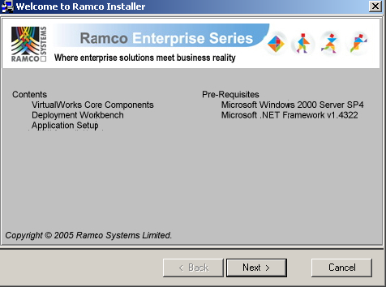

1. Clicking ‘Next’ launches the **’Select Layer’** screen.

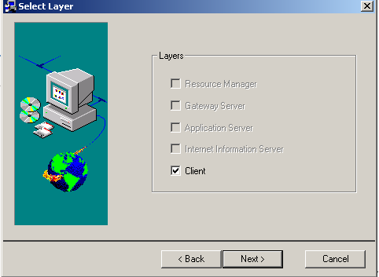

***Note:*** *Only Client option will be selected by default. Leave this option as it is and proceed further by clicking the Next button.*

1. On clicking ‘Next’ the ‘**Select Components**’ screen will be launched. This is only an information screen. Click ‘Next’ and proceed further.

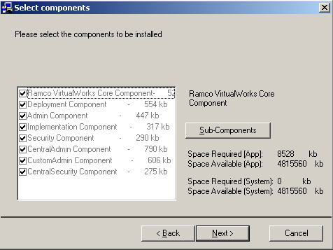

1. The list of components to be installed will be listed in this screen. On clicking ‘Next’ the ‘Confirmation’ screen will be launched.

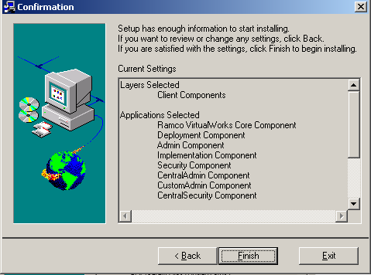

1. Click ‘**Finish**’ to complete the installation.

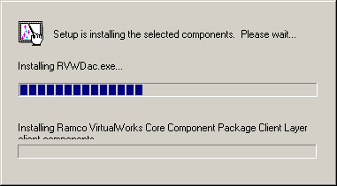

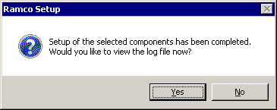

You can choose Yes to check the Installation log file though this is not mandatory.

## 1.1.1 Deployment Setup

After completing the above steps, run the DEPWIZ.EXE from the path ..\Program Files\VirtualWorks (X86)\ADS folder.

1. Launch the Deployment Setup Wizard on the file/web server. Select RM type as SQL.

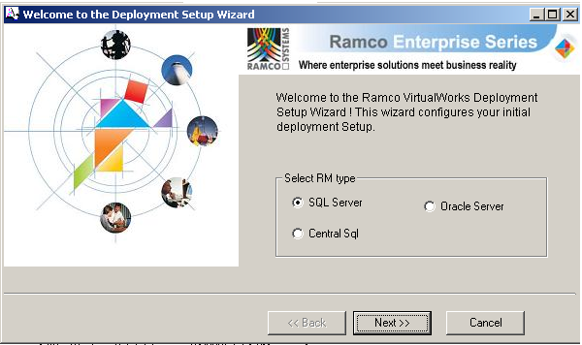

1. Click Next to continue. The ‘**System Parameters Info**’ screen would appear:

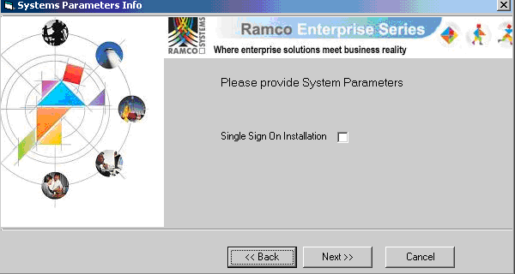

Select the option “Single Sign On Installation” if the application authentication at Runtime should happen based on Windows User base authentication instead of Application’s internal Security database.

1. Click ‘Next’ to continue. The following ‘**Specify Deployment Topology**’ screen is launched. Here provide the WEB Server (where the presentation layer components would be deployed) and APP Server Name (where the COM components would be deployed – This forms the middle layer)

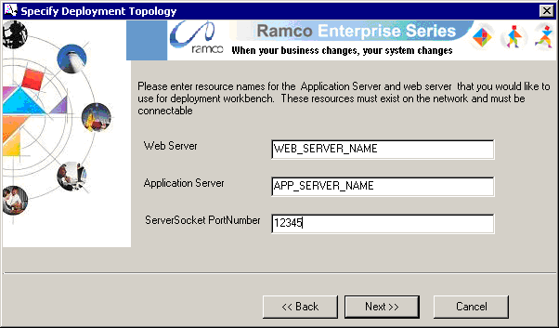

Note that the ServerSocket Port Number control would be enabled only if the WEB and App server names are different. Meaning, this will be enabled only if the WEB and APP layer installations happen on two different physical machines. Server Socket Port number can be any valid number between the range 1024 to 65535 which is not used by any other application running in the Application Server. In the above screen shot, the installation assumes the port number to be 12345.

1. Enter the Resource Manager (Database Server) Name, Database, SQL Instance name (in case SQL Server is running on a named instance instead if default instance), Deployment Admin SQL Username and Deployment Admin Password.

***Note:*** *The Deployment user name and password specified below will be used by the VirtualWorksTM application at Runtime. The SQL DBA must not modify this SQL user and password through Enterprise Manager (/Management Studio). This user account will be automatically created by the installer.*

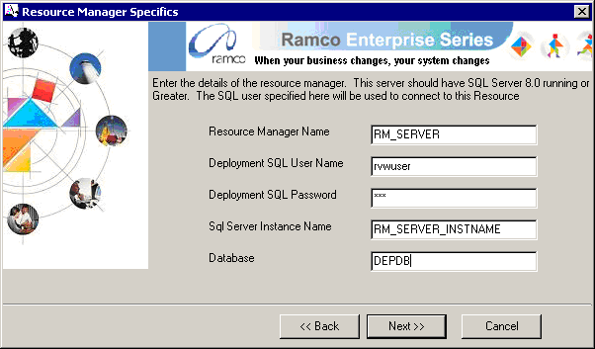

1. Click ‘Next’ to continue. The following ‘**Initial Role Specifics**’ screen will be launched. Provide the Role name that should be used as Administrator Role and the password for “AdminUser” user account. The option Password Case Sensitivity can be selected based on if the user account passwords that are created in the application’s security database should be case sensitive. Click on Finish to complete the installation.

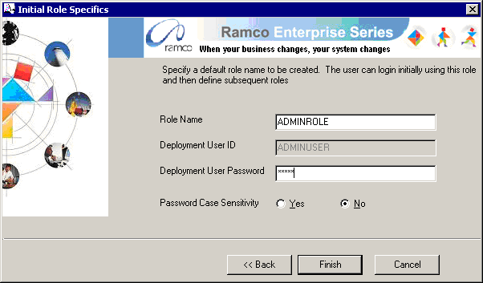

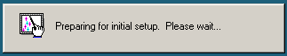

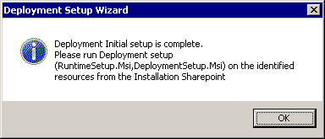

This completes the installation of File Server component.

**- End of Document -**

Corporate Office and R&D Center

Ramco Systems Limited, 64, Sardar Patel Road, Taramani Chennai – 600 113, India

Tel: +91 (44) 2235 4510. Fax +91 (44) 2235 2884

www.ramco.com