Crystal Report Setup

DISCLAIMER
©2012 Ramco Systems Ltd. All rights reserved. All trademarks acknowledged.

This document is published by Ramco Systems Ltd. without any warranty. No part of this document may be reproduced or transmitted in any form or by any means, electronic or mechanical, for any purpose without the written permission of Ramco Systems Limited.
Improvements and changes to this text necessitated by typographical errors, inaccuracies of current information or improvements to software programs and/or equipment, may be made by Ramco Systems Limited, at any time and without notice. Such changes will, however, be incorporated into new editions of this document. Any hard copies of this document are to be regarded as temporary reference copies only.
The documentation has been provided for the entire Aviation solution, although only a part of the entire solution may be deployed at the customer site, in accordance with the license agreement between the customer and Ramco Systems Limited. Therefore, the documentation made available to the customer may refer to features that are not present in the solution purchased / deployed at the customer site.

Table of Contents

1. Crystal Report 2008 Developer Edition 4
2. Crystal Report 2008 Server Edition 7

1. Crystal Report 2008 Developer Edition
Crystal Report Settings:
- Crystal Report should be installed in the web server
- After installing restart the web server
- Open the crystal report designer and perform the following steps
  - Click on the blank report
  - In the database expert click on the Create New Connection → More Data sources → Field Definitions Only. Click OK.
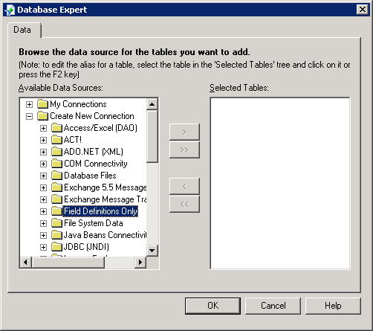

  - Crystal will automatically install its required deliverables (on demand).

Web.Config Settings:
Change the RVW web.config file with the installed crystal report assembly version.
Web.Config file will be available in the path <drive>:\Program files\virtualworks\iis\
In the c:\windows\assembly crystal report assembly information (version and keytoken) will be available that have to specified in the web.config.
- Find the Compilation Node in Web.Config file. Compilation Node will be in the order of <configuration> → <system.web> → <compilation>
- The Crystal Assemblies to be referenced should come under <assemblies> node.
- Create node <assemblies> under compilation node.
- Add the following Crystal Assembly Reference under the assemblies node.

<add assembly="CrystalDecisions.CrystalReports.Engine, Version=<version>,
Culture=neutral, PublicKeyToken=<keytoken>"/>
<add assembly="CrystalDecisions.ReportSource, Version=<version>,
Culture=neutral, PublicKeyToken=<keytoken>"/>
<add assembly="CrystalDecisions.Shared, Version=<version>, Culture=neutral,
PublicKeyToken=<keytoken>"/>
<add assembly="CrystalDecisions.Web, Version=<version>, Culture=neutral,
PublicKeyToken=<keytoken>"/>
Close the nodes </assemblies> & </compilation>
- If the webserver version is below IIS7 then Add the following Crystal Reference under System.Web node
<httpHandlers>
<add verb="GET" path="CrystalImageHandler.aspx" type="CrystalDecisions.Web.CrystalImageHandler, CrystalDecisions.Web, Version=<version>, Culture=neutral, PublicKeyToken=<keytoken>"/>
</httpHandlers>
- If the webserver version is IIS7 or above and Application Pool - Managed pipeline mode is “Integrated” then Add the following Crystal Reference under system.webServer
<handlers>
<add name="CrystalImageHandler.aspx_GET" verb="GET" path="CrystalImageHandler.aspx" type="CrystalDecisions.Web.CrystalImageHandler, CrystalDecisions.Web, Version=<version>, Culture=neutral, PublicKeyToken=<keytoken>" preCondition="integratedMode"/>
</handlers>
<validation validateIntegratedModeConfiguration="false"/>
- If the client machine uses IE 8.0 and crystal reports viewer gif files are not visible then follow the following steps
- From the Crystal Report installation folder Copy the folder crystalreportviewers12 and paste it in VirtualWorks\iis\ folder
- In the web.config add the following under the node configuration
<configSections>
<sectionGroup name="businessObjects">
<sectionGroup name="crystalReports">
<section name="crystalReportViewer" type="System.Configuration.NameValueSectionHandler" />
</sectionGroup>
</sectionGroup>
</configSections>
<businessObjects>
<crystalReports>
<crystalReportViewer>
<add key="resourceURI" value="/crystalreportviewers12" />
</crystalReportViewer>
</crystalReports>
</businessObjects>
Note: Kindly ignore the above steps if already done.

- Web.config changes (available in VirtualWorks\IIS folder)
  - Under the <appSettings> node add the key <add key="EDKReportType" value=" " />
  - The applicable values for value are
    - CrystalDeveloper
This is used for launching the reports in Crystal reports developer edition
<add key="EDKReportType" value=" CrystalDeveloper" />
- If Virtual Directory’s Application Pool is pointing to .Net Framework Version: v4.0 then add the following piece of code in Web.Config file.
Existing Code : <httpRuntime executionTimeout="3600" />
Modified Code : <httpRuntime executionTimeout="3600" requestValidationMode="2.0"/>
Note:
1) Copy the font named Code39AzaleaWide2 available in web server C:\Windows\fonts and paste into the client machine’s (C:\Windows\fonts ) for barcode fonts to get displayed in the reports.
2) If the web server OS is 64 bit then for launching report IIS should run in 32 bit mode
To enable IIS to run in 32 bit on 64 bit server follow the steps given in main installation manual.

2. Crystal Report 2008 Server Edition
Note:
- Crystal Report Client should be installed in the web server
- After installing restart the webserver
- In the web server check for the folder
C:\Inetpub\wwwroot\aspnet_client\system_web\2_0_50727 and verify
whether crystalreportviewers12 is available. If it is not available then
copy the crystalreportviewers12 folder from the following crystal
installation directory.
“<Crystal Installation drive>:\ Program Files\Business Objects\Common\4.0”.
Web.Config Settings
Change the RVW web.config file with the installed crystal report assembly version.
Web.Config file will be available in the path <drive>:\Program files\virtualworks\iis\
In the c:\windows\assembly crystal report assembly information (version and keytoken) will be available that have to specified in the web.config.
- Find the Compilation Node in Web.Config file. Compilation Node will be in the order of <configuration> → <system.web> → <compilation>
- The Crystal Assemblies to be referenced should come under <assemblies> node.
- Create node <assemblies> under compilation node.
- Add the following Crystal Assembly Reference under the assemblies node.
<add assembly="CrystalDecisions.CrystalReports.Engine, Version=<version>,
Culture=neutral, PublicKeyToken=<keytoken>"/>
<add assembly="CrystalDecisions.ReportSource, Version=<version>,
Culture=neutral, PublicKeyToken=<keytoken>"/>
<add assembly="CrystalDecisions.Shared, Version=<version>, Culture=neutral,
PublicKeyToken=<keytoken>"/>
<add assembly="CrystalDecisions.Web, Version=<version>, Culture=neutral,
PublicKeyToken=<keytoken>"/>
Close the nodes </assemblies> & </compilation>
- If the webserver version is below IIS7 then Add the following Crystal Reference under System.Web node
<httpHandlers>
<add verb="GET" path="CrystalImageHandler.aspx" type="CrystalDecisions.Web.CrystalImageHandler, CrystalDecisions.Web, Version=<version>, Culture=neutral, PublicKeyToken=<keytoken>"/>
</httpHandlers>
- If the webserver version is IIS7 or above and Application Pool - Managed pipeline mode is “Integrated” then Add the following Crystal Reference under system.webServer
<handlers>
<add name="CrystalImageHandler.aspx_GET" verb="GET" path="CrystalImageHandler.aspx" type="CrystalDecisions.Web.CrystalImageHandler, CrystalDecisions.Web, Version=<version>, Culture=neutral, PublicKeyToken=<keytoken>" preCondition="integratedMode"/>
</handlers>
<validation validateIntegratedModeConfiguration="false"/>
- If the client machine uses IE 8.0 and crystal reports viewer gif files are not visible then follow the following steps
- From the Crystal Report installation folder Copy the folder crystalreportviewers12 and paste it in VirtualWorks\iis\ folder
- In the web.config add the following under the node configuration
<configSections>
<sectionGroup name="businessObjects">
<sectionGroup name="crystalReports">
<section name="crystalReportViewer" type="System.Configuration.NameValueSectionHandler" />
</sectionGroup>
</sectionGroup>
</configSections>

<businessObjects>
<crystalReports>
<crystalReportViewer>
<add key="resourceURI" value="/crystalreportviewers12" />
</crystalReportViewer>
</crystalReports>
</businessObjects>
NOTE: Kindly ignore the above steps if already done.
- Web.config changes (available in VirtualWorks\IIS folder)
  - Under the <appSettings> node add the key <add key="EDKReportType" value=" " />
  - The applicable values for value are CrystalServer
This is used for launching the reports in Crystal reports server edition
<add key="EDKReportType" value="CrystalServer" />
The following keys are additionally required for crystal reports server
<add key="EDKReportAssemblyFramework "
Version=<crystal version>, Culture=neutral, PublicKeyToken=<crystal public key token>" />
<add key="EDKReportAssemblyInfoStore"
value="CrystalDecisions.Enterprise.InfoStore, Version=<crystal version>, Culture=neutral, PublicKeyToken=<crystal public key token>" />
<add key="EDKReportServer" value=" " />
In this above key value need to provide the CMS Server name. Value should be encrypted
<add key="EDKReportUserId" value=" " />
In this above key value CMS User name has to be provided. Value should be encrypted using encryption utility.

<add key="EDKReportPassword" value=" " />
In this above key value CMS Password has to be provided. Value should be encrypted using encryption utility.
<add key="EDKReportAuthType" value="secEnterprise" />
In this above key value provide the authentication type. Example “secEnterprise”
<add key="EDKReportRASFolderName" value=" " />
In this above key value provide the CMS folder name where the report rpts are deployed.
Please Note: The encryption and decryption utility is available

- If Virtual Directory’s Application Pool is pointing to .Net Framework Version: v4.0 then add the following piece of code in Web.Config file.
Existing Code : <httpRuntime executionTimeout="3600" />
Modified Code : <httpRuntime executionTimeout="3600" requestValidationMode="2.0"/>
NOTE:
1). If the web server OS is 64 bit then for launching report iis should run in 32 bit mode
To enable IIS to run in 32 bit on 64 bit server follow the steps given in main installation manual.
2). Copy the font named Code39AzaleaRegular3 available in report server C:\Windows\fonts and paste into the client machine’s (C:\Windows\fonts ) for barcode fonts to get displayed in the reports.
3). There is a change in report logo settings for the report server 2008 edition.
Please follow the below steps to configure report logo
Step 1).Create a folder named reportlogo in the Report Server.
Step 2).Place the company logo file under the folder created in the Step 1.
Step 3).In the xml CustomReporting.xml which will be available in web server in the path "..\Program Files\VirtualWorks\IIS\Extui\ilrt", search for the node <ReportDefaultParameters> and the attribute Value to be replaced with the folder path created in the Step 1.

Find the below example for the same:

<ReportParameter Name="reportlogo" Value="D:\Program Files\ReportLogo\reportlogo.bmp"
SubReportName="" />

Publishing Report
For the Report to launch using crystal report server edition, the .rpt files should be published in crystal report server. Use the following steps to publish the reports.

Go to Web Server where crystal report client is installed.
Start -> Publishing Wizard

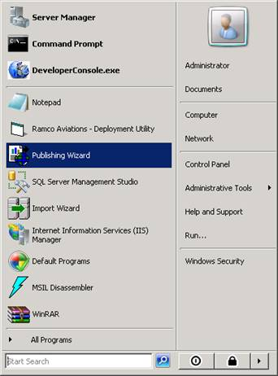

Click Next.
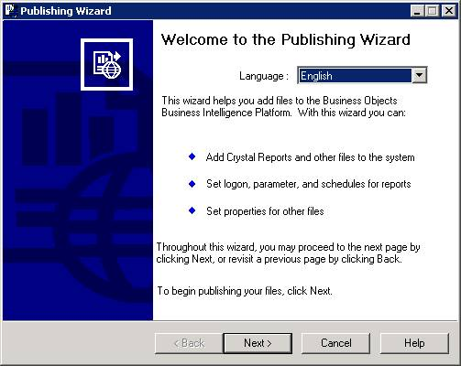

Enter the login credentials
System: Report Server Name.
User Name: administrator
Password: admin12*
Authentication: Enterprise
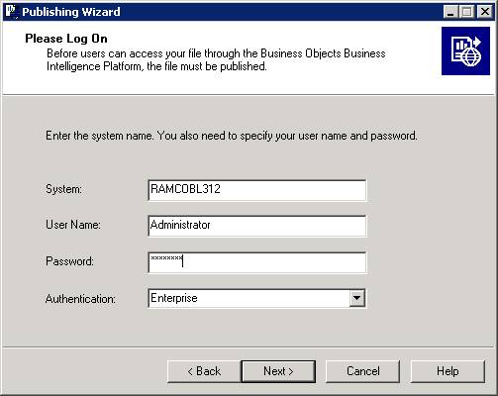
Click on Add Files.
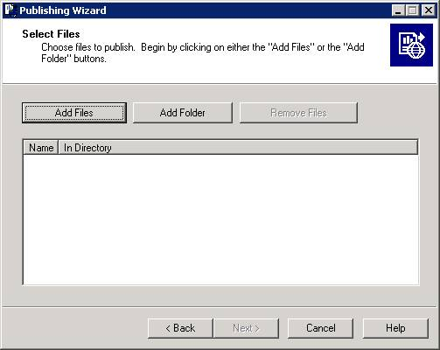

Browse for the folder where the .rpt file is available and choose the file and click open.
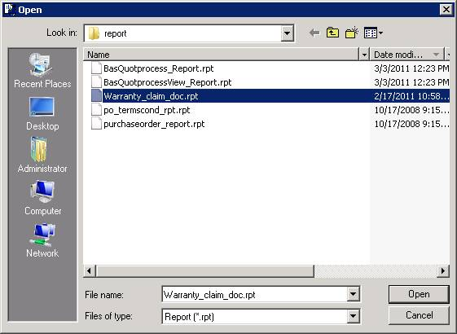
Multiple files can also be selected.
Click Next
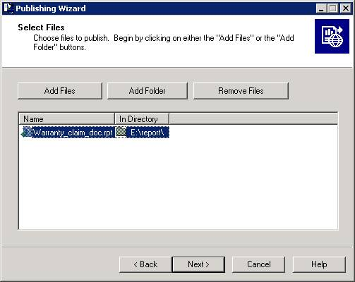
Create a new folder using icon available in the top right corner to publish the rpt and click on that folder and click next.
Eg: 5.4 development
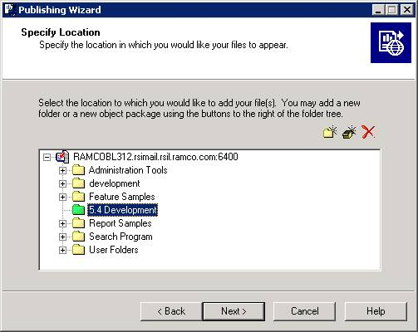
Now the rpt file you selected will come under the folder 5.4 development. Click Next.
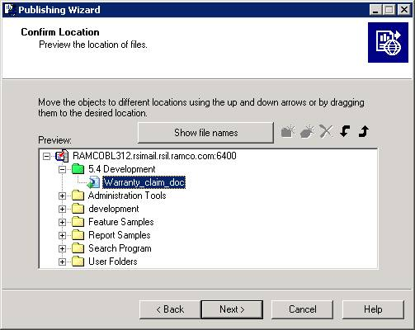
Select Administrator and click Next.
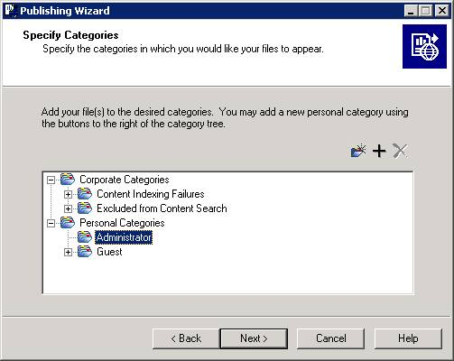
Click Next
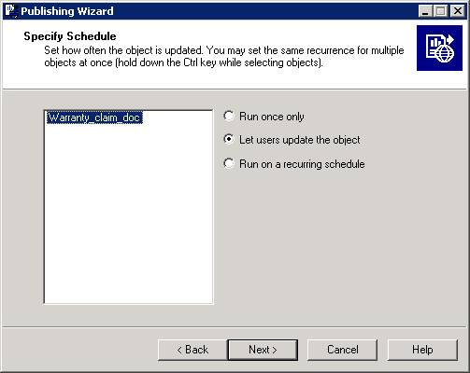
Click Next
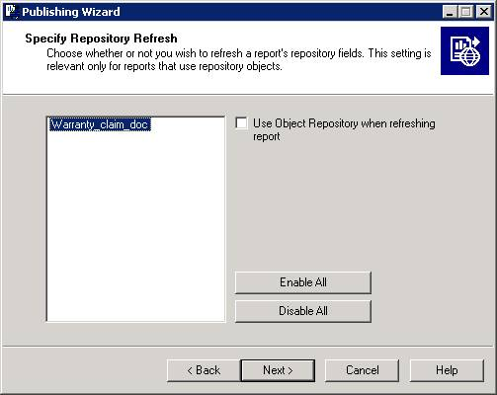
Click Next
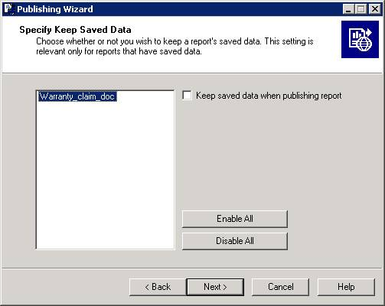
Click Next
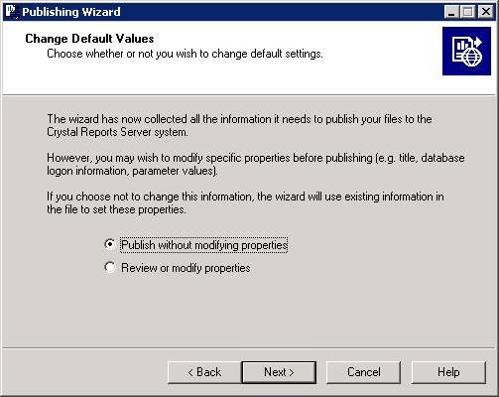
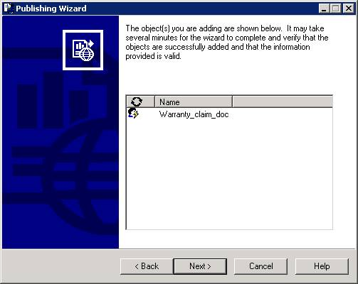
Click Finish.
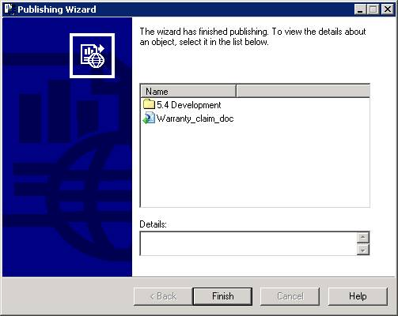

Publishing All Report Files in Report Server

Following are the steps for publishing all the report files in report server for the first time.

- Search for *.rpt from …IIS\EXTUI folder
- Copy and paste it in one common folder where it will overwrite if report files are in same name.
- Publish the Report Files (rpts) from this folder in report server using Publish Wizard explained above in this section.

Similarly if the RPT files are shipped in Regular Shipment, then note will be added in Shipment Release Note to publish the RPT files shipped incrementally.

Corporate Office and R&D Center
Ramco Systems Limited, 64, Sardar Patel Road, Taramani Chennai – 600 113, India
Tel: +91 (44) 2235 4510. Fax +91 (44) 2235 2884
www.ramco.com

