VirtualWorksTM Runtime Dot Net Installation Document – Configuration DLL Generation

DISCLAIMER
©2012 Ramco Systems Ltd. All rights reserved. All trademarks acknowledged.

This document is published by Ramco Systems Ltd. without any warranty. No part of this document may be reproduced or transmitted in any form or by any means, electronic or mechanical, for any purpose without the written permission of Ramco Systems Limited.

Improvements and changes to this text necessitated by typographical errors, inaccuracies of current information or improvements to software programs and/or equipment, may be made by Ramco Systems Limited, at any time and without notice. Such changes will, however, be incorporated into new editions of this document. Any hard copies of this document are to be regarded as temporary reference copies only.

The documentation has been provided for the entire Aviation solution, although only a part of the entire solution may be deployed at the customer site, in accordance with the license agreement between the customer and Ramco Systems Limited. Therefore, the documentation made available to the customer may refer to features that are not present in the solution purchased / deployed at the customer site.

Revision History
Version | Date | Author | Description
1.0 | 08/02/2011 | Vinoth Kumar K | Created

Table of Contents

1.1 Steps to Generate Configuration DLLs 5

VirtualWorksTM DotNet Runtime – Configuration DLL Generation

CONFIG file generation should happen whenever any of the following activities are completed:
- Installation of VirtualWorksTM Base RT CD.
- Installation of VirtualWorksTM Runtime Patches.
- Creation of New Organization Units (OUs) and mapping new/existing components to it through Deployment Workbench.
- Creation of new Resources and mapping new/existing OU & Components to it through Deployment Workbench.
- Modification of Existing Organization Units (OUs) to map/un-map new/existing components to it through Deployment Workbench.
- Modification of Existing Resources to map/un-map new/existing OU & Components to it through Deployment Workbench.
This document walks through the steps for generating configuration dlls VirtualWorksTM .Net Runtime (Microsoft Version).

1.1 Steps to Generate Configuration DLLs

There are set of Configuration Dll’s deliverables that should be generated and registered in Global Assembly Cache (GAC). Generated Dll’s can also be registered manually by drag & drop into the assembly folder (C:\\Windows\Assembly). The detailed steps are give below.

Note: These configuration dll’s serves as connectors between App, Web and RM Servers.
“ConfigGenerator.exe” will be available in the path..\Program Files(x86)\VirtualWorks\RT2

- Run this exe and the following screen will appear.

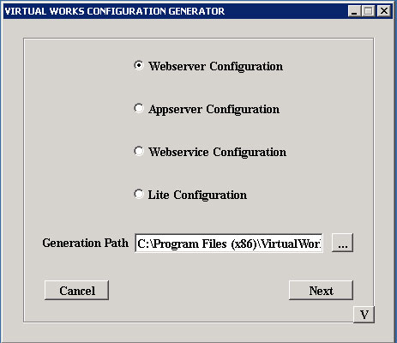

- Select ‘Webserver Configutation’ option and provide the folder path in ‘Generation Path’ where the config. Generator deliverables will get generated and click “Next”.

- In the Login screen (as shown in the below screenshot),
- Select “Server Type” as “SQL”
- Provide

- Sql Server Name (with instance name if any)
- Sql User id
- Sql Password
- Select database as “DEPDB”, after fetching using ‘List’ button

- Under Virtual works login information, provide application admin user id and password that are defined during Runtime Installation.
- Click “Next” button.

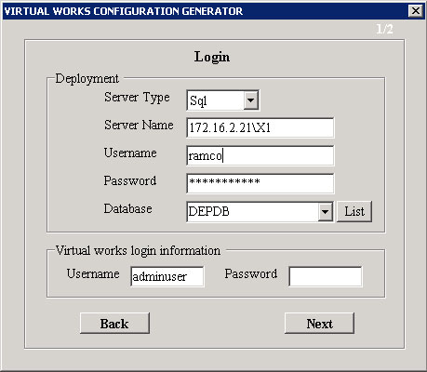

- Web Server generator screen will be launched as shown in the below screen.

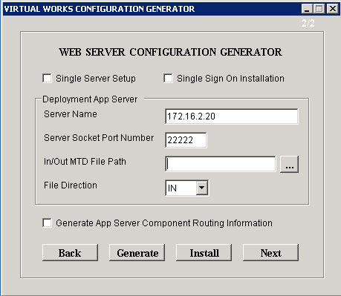

- If application needs to be setup with “Single Sign On” (i.e., domain login will be used for Ramco Application login), then check “Single Sign On Installation” checkbox.

If Web and App layers are installed in two different machines, then Server Name will be App Server Name else if Web and App layers are installed in same machine then Server Name will be either Web or App Server Name as both are same.

User should provide the APP Server name and the Server socket port number (recommended – any value between 1024 and 65535). Please note that this port number should match the port number that was given during File Server installation through DepWiz.EXE (Deployment Wizard).

- Do not provide any File path and file direction (select this as None) in the “In/Out MTD File Path” and “File Direction”. These controls will be used by the VirtualWorksTM support team for debugging purposes. Enabling these options will slow down the system drastically degrading the performance. So, select File Direction as “NONE”.

- Click on “Generate” button. Click “Install” button to install the generated DLL in GAC.

- Once you get “success” message, check “Generate App Server Component Routing Information” check box and click “Generate” button” again.

- Click “Install” button.

- Once you get “success” message, click “Next” button.

You will find the starting screen, which is having options for selecting Webserver/ Appserver Configuration and so on.

- Now Select “Appserver Configuration” option and provide “Generation Path” if it is blank or you can also change this Generation Path.

- Click “Next” button.

- You need to provide SQL and Ramco virtual works login details again and click “Next” button.

Note: This configuration tool can also be used in Web and App servers separately for generating Web and App Configuration dlls respectively; hence the login information are prompted to enter two times.

You will find the screen as shown in the below screenshot.

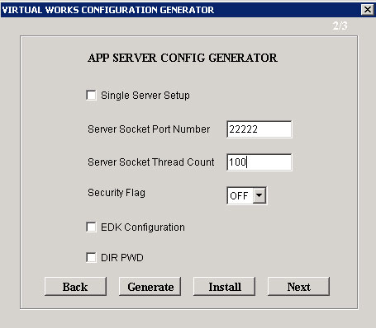

- Provide the same server socket port number that was provide while generating WEB Server Config generation. For “Server Socket Thread Count”, depending up on the number of concurrent requests that could hit the Database Layer while the application goes live, select an appropriate value. For ex. if there will be approx. 200 – 250 concurrent users, select a value of 100.

Server Socket Thread Count value can be 0 for unlimited number of users.

- Leave other fields with default values and click “Generate” button.

Note: If you are executing this exe in “APP” server and you are doing for Appserver Configuration, then you may click “Install” which will register the Generated dll’s in GAC. If you are executing this exe in Web Layer, please do not click on Install Button.

- Click “Next” button, It will open a screen as shown in the below screenshot

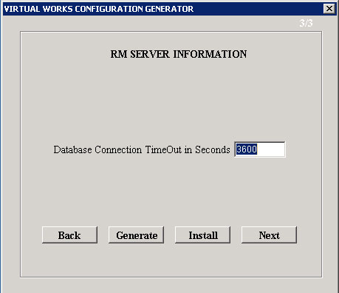

- Set the database connection timeout in seconds. The recommended value is “3600”.Click Generate button.

Note: If you are executing this exe in “APP” server and you are doing for Appserver Configuration, then you may click “Install” which will register the Generated dll’s in GAC. If you are executing this exe in Web Layer, please do not click on Install Button.

- Click “Next” button

- If the exe is executed in web server, copy the following dll’s from the “Generation Path” set in the Web server and paste it in App Server’s drive (It can be pasted in any folder, recommended path is “..\Program Files (x86)\VirtualWorks\RT2”) and drag and drop the copied DLLs into GAC (C:\Windows\Assembly)

- Appconfig.dll
- RMInfo.dll

And the other two DLLs, WebConfig.dll and ComponentRouting.dll should be in Web Server.

Corporate Office and R&D Center
Ramco Systems Limited, 64, Sardar Patel Road, Taramani Chennai – 600 113, India
Tel: +91 (44) 2235 4510. Fax +91 (44) 2235 2884
www.ramco.com

