**RAMCO AVIATION SOLUTION**

**ADAPTIVE CARDS - SETUP CONFIGURATION**

©2020 Ramco Systems Ltd. All rights reserved. All trademarks acknowledged

©2020 Ramco Systems Ltd. All rights reserved.

All trademarks acknowledged.

This document is published by **Ramco Systems Ltd.** without any warranty.

No part of this document may be reproduced or transmitted in any form or by any means, electronic or mechanical, for any purpose without the written permission of **Ramco Systems Limited.**

Improvements and changes to this text necessitated by typographical errors, inaccuracies of current information or improvements to software programs and/or equipment, may be made by Ramco Systems Limited, at any time and without notice. Such changes will, however, be incorporated into new editions of this document. Any hard copies of this document are to be regarded as temporary reference copies only.

The documentation has been provided for the entire Aviation solution, although only a part of the entire solution may be deployed at the customer site, in accordance with the license agreement between the customer and Ramco Systems Limited. Therefore, the documentation made available to the customer may refer to features that are not present in the solution purchased / deployed at the customer site.

Actionable Messages 4

Introduction 4

Technical Architecture 4

Prerequisites 5

1) Host Application 5

2) Actionable Message Assistance Mail-ID 5

3) Inbox Monitor 5

4) Actionable messages Utility 5

5) API INFRA 5

Installation and Configuration: 6

# Actionable Messages

## Introduction

Adaptive Cards are platform-agnostic snippets of UI, authored in JSON, that apps and services can openly exchange. When delivered to a specific app, the JSON is transformed into native UI that automatically adapts to its surroundings. It helps design and integrates light-weight UI for all major platforms and frameworks.

## Technical Architecture

Aviation product leverages the capability of inbox monitoring utility which is part of RVW framework to pull the adaptive card into mailbox by user to do context specific transaction without logging into the application and without comprising in security aspect.

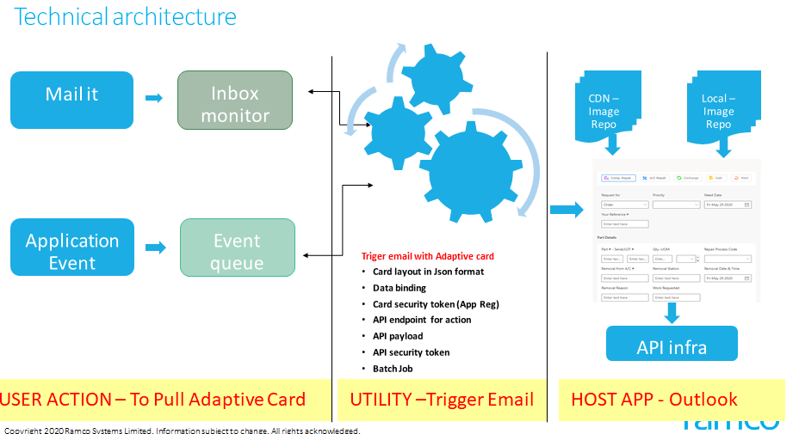

## Prerequisites

### Host Application

* Actionable messages are built for different applications like BOT Framework, Outlook Actionable messages etc.,
* Actionable messages will be only visible in the outlook version above 2016 and in the outlook web application.

### Actionable Message Assistance Mail-ID

* A unique O365 mail-id will be used to send the Actionable message to the user based on the request.
  + - Example: [**ramcoassistant@<domain.com**](mailto:ramcoassistant@%3cdomain.com)**>**
* End User can send the request to pull the actionable message from [ramcoassistant@<domain.com](mailto:ramcoassistant@%3cdomain.com)> with defined subject keywords.

### Inbox Monitor

* The Inbox Monitor utility is an Add-in and it is integrated directly into Microsoft Outlook. It provides “Transaction Mail Requests” and “Reply Mail Request” features.
* This utility will be used to listen to the configured email id’s inbox, gathers email content into the database.

### Actionable messages Utility

* Actionable messages Utility is used to send the requested actionable messages to the user.
* This utility listens to the inbox monitor and gathers the user’s context specific data and sends the Actionable messages to the users corresponding mail id.

### API INFRA

* API INFRA is required to host API’s which can be consumed in actionable messages.

### Actionable Master (Intermediate Service)

## Actionable Master (Intermediate Service) is an API which is used to manage the O365 token validation proposed by Microsoft and consuming the application API with necessary tokens.

## Installation and Configuration:

|  |  |  |  |
| --- | --- | --- | --- |
| **SL.No** | **Configurations** | **Document** | **Key Values from configuration** |
| 1 | Ms graph Configuration |  | Client ID, Client Secret |
| 2 | Adaptive cards originator configuration |  | Originator Id |
| 3 | Inbox Monitoring |  |  |
| 4 | API Runtime Setup |  |  |
| 5 | Client credentials generation |  | Client ID, Client secret |
| 6 | Actionable card utility configuration |  |  |
| 7 | Windows Scheduler configuration |  |  |
| 8 | Actionable Master Installation  (Intermediate Service) |  |  |

Corporate Office and R&D Center

Ramco Systems Limited,  
64, Sardar Patel Road, Taramani,  
Chennai – 600 113, India

Office + 91 44 2235 4510 / 6653 4000

Fax +91 44 2235 2884

Website - [www.ramco.com](http://www.ramco.com/)